Name : AJAKAYE JADESOLA STELLA
MATRIC NUMBER : 18/SCI01/010
COURSE CODE : CSC 206
QUESTION:
- Given two strings str1 and str2: Str1 : “ Department of Mathematical and Physical Sciences”. Str2: “ Computer Programming II”.
i) Concatenate not more than n characters ( n should be 8) of string 2 into string 1. ii) Convert the second string to uppercase iii) Find the length of the first string .
b) Given two strings str1 and str2: Str1 : “ I am a member of COSSA”. Str2: “ I am a member of NACOSS ”.
i) Copy up to n character of string 1 into string 2 ii) Reverse string iii) Compare string1 and string2 lexographically with by a specific character.
c) Given three strings : str1, str2, str3 Str1:” Do you really want to be a good programmer?”, Str2: “ Then you must love programming “ Str3:” Can you join me to program”
i) Convert string 1 to lowercase ii) Compare string 1 and string 2 iii) Find the first occurrence of ‘m’ in string3
d) Write a C program for these given strings Str1:”NIGERIA” Str2: “Nigeria NIGERIA niger
a) Compare the two strings b) Compare at most n characters of the two strings c) Use strnset() to replace specified characters in this string

A)i)
#include<stdio.h>
#include<string.h>
int main()
{
char str1[100]="Department of Mathematics and Physical Science";
char str2[100]="CompUter PROGRAMMINg II";
char *result;
result=strncat(str1,str2,8);
printf(" Concatenation result is:%s\n",result);
return 0;
}

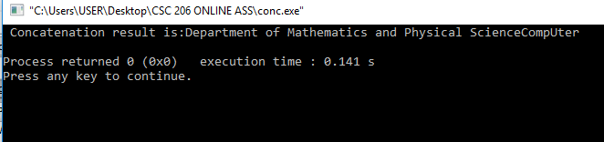
Aii
#include<stdio.h>
#include<string.h>
int main()
{
char str1[100]="Department of Mathematics and Physical Science";
char str2[100]="CompUterPROGRAMMINg II";
char *uppercase;
uppercase=strupr(str2);
printf("uppercase of str2 is:%s\n",uppercase);
return 0;
}
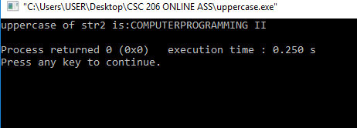
A)iii)
#include<stdio.h>
#include<string.h>
int main()
{
char str1[100]="Department of Mathematics and Physical Science";
char str2[100]="CompUterPROGRAMMINg II";
int l;
l=strlen(str1);
printf("length of the string=%d",l);
getch();
}
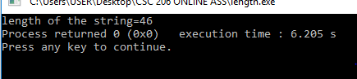
B)i)
#include<stdio.h>
#include<string.h>
int main()
{
char str1[50]=" I am a Member of COSSA";
char str2[50]=" I am also a MEMBER of NACOSS";
char *result;
result=strncpy(str2,str1,23);
printf("result is:%s\n",result);
return 0;
}
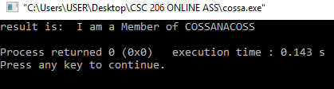
B)ii)
#include<stdio.h>
#include<string.h>
int main()
{
char str1[50]=" I am a Member of COSSA";
char str2[50]=" I am also a MEMBER of NACOSS";
char *result;
result=strrev(str2);
printf("result after reverse is:%s",result);
return 0;
}

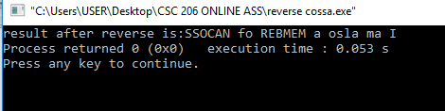
B)iii)
#include<stdio.h>
#include<string.h>
int main(){
char string1[ ] =" I am a member of COSSA";
char string2[ ] =" I am a member of NACOSS";
strncpy( string2,string1 ,12);
printf("(i) copied string is : %s ", string2);
strrev(string2);
printf("\n\n(ii) reverse of string2 is: %s", string2);
if (strcmp(string1,string2)==0)
{
printf("\n\n(iii)string1 and string2 are equal");
}
else {
printf("\n\n(iii)string1 and string2 are different");
}
return 0;
}
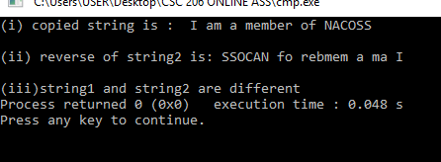
C)i)
#include<stdio.h>
#include<string.h>
int main()
{
char str1[100]=" Do you really WANT to be a gOOd Programmer";
char str2[100]=" Then you must LOVE PROgraMMing";
char str3[100]=" Can you join me program?";
char *result;
result=strlwr(str1);
printf("result is:%s\n",result);
return 0;
}
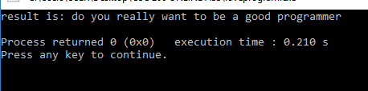
C)ii)
#include<stdio.h>
#include<string.h>
int main()
{
char str1[ ]=" NIGERIA";
char str2[ ]=" Nigeria NIGRIA niger";
int *result;
if (strcmp(str1,str2)==0)
{
printf("str1 and str2 are equal");
}
else {
printf("str1 and str2 are different");
}
return 0;
}
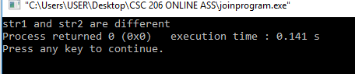

C)iii)
#include<stdio.h>
#include<string.h>
int main()
{
char str1[100]=" Do you really WANT to be a gOOd Programmer";
char str2[100]=" Then you must LOVE PROgraMMing";
char str3[100]=" Can you join me program?";
char e='m';
char *result;
result=strchr(str3,e);
printf("result is:%s\n",result);
return 0;
}
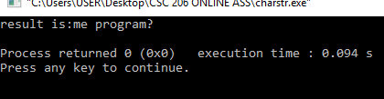
D)a)
#include<stdio.h>
#include<string.h>
int main()
{
char str1[ ]=" NIGERIA";
char str2[ ]=" Nigeria NIGRIA niger";
int *result;
if (strcmp(str1,str2)==0)
{
printf("str1 and str2 are equal");
}
else {
printf("str1 and str2 are different");
}
return 0;
}
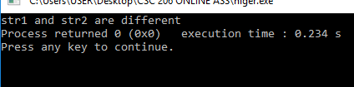
D)b)
#include<stdio.h>
#include<string.h>
int main(){
char str1[ ]=" NIGERIA";
char str2[ ]=" Nigeria NIGERIAniger";
int *result;
if (strncmp(str1,str2 ,1)==0)
{
printf("str1 and str2 are equal");
}
else {
printf("str1 and str2 are different");
}
return 0;
}
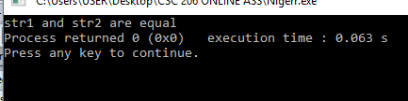
D)c)
#include<stdio.h>
#include<string.h>
int main(){
char str1[50]=" NIGERIA";
char str2[50]=" Nigeria NIGERIAniger";
char *result;
result=strnset(str2,'$',18);
printf("result is:%s\n",result);
return 0;
}
