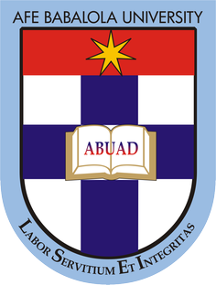

Andidiong Inemesit Usoro

17/ENG05/041

SUBMITTED TO
ENGR. DR.OYEBODE

AFE BABALOLA UNIVERSITY, ADO-EKITI, EKITI STATE.

IN PARTIAL COMPLETION OF THE CONTINUOUS ASSESSMENT (C.A) FOR THE ENGINEERING LAW AND MANAGERIAL ECONOMICS (ENG 384) COURSE. MAY 21, 2020

SHORT TEST
You have been invited by the current president of Nigeria, General Muhammadu Buhari to make an argument for the optimization of engineering resources in the country. As an aspiring Engineer, briefly discuss your view on this and make viable recommendations that will facilitate timely completion of engineering projects within the allocated budget without jeopardizing economic and legal regulations of Nigeria

An efficient work flow ensures an efficient execution of processes and timely completion of projects. Optimization of engineering resources is very important in the country to reduce wastage of useful materials and pollution of our immediate environment. The resulting effects of impaired work flow systems and programs is largely due to incompetence and negligence on the part of project managers and engineers.
In order to enforce optimization of resources, optimization reports should be requested for as part of the tender/reports for bidding for a contract. This optimization report should be carefully reviewed and approved as by standard before awarding contracts. Furthermore time stamps on the gradual completion of the project should be included in order to ensure timely completion of the project. Project budgets however should also include all possible costs to avoid an overrun while carrying it out. Also contractors should not be given their full remuneration until total or agreed partial completion of a project to ensure dedicated service is rendered.

