- Torus interconnection network: A torus interconnect is a switch-less network topology for connecting processing nodes in a parallel computer system. A torus interconnected is a network topology for connecting processing nodes in a parallel computer system. It can be visualized as a mesh interconnected with nodes arranged in a rectilinear array of N=2, 3 or more dimension with processors connected to their neighbors, and corresponding processor on opposite edges of the array connected. They are also found in more commercial architecture, like the Alpha 21364 (two-dimensional Torus), that are targeted at application domains such as database servers, web servers, and Telecommunication. Torus network are frequently utilized on top performing supercomputers.
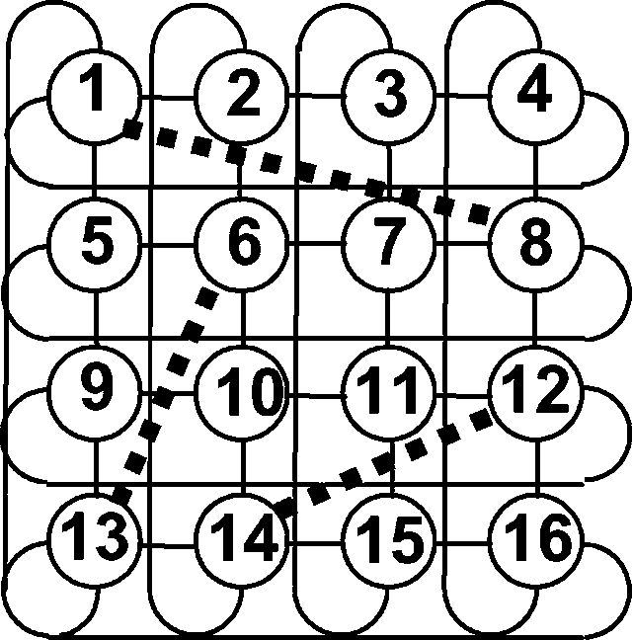Diagram of torus interconnection network
- Hypercube Interconnection Network: Hypercube networks are a type of network topology used to connect multiple processors with memory modules and accurately route data. Hypercube networks consist of 2^{m} nodes. These nodes form the vertices of squares to create an internetwork connection. A hypercube is basically a multidimensional mesh network with two nodes in each dimension. Due to similarity, such topologies are usually grouped into a k-ary d-dimensional mesh topology family where d represents the number of dimensions and k represents the number of nodes in each dimension.
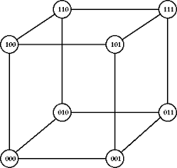Diagram of hypercube interconnection network

