NAME: SOJI- OYE IREOLUWA

MATRIC NUMBER: 17/MHS05/019

DEPARTMENT: MEDICINE AND SURGERY

COURSE TITLE: RENAL PHYSIOLOGY BODY FLUID AND TEMPERATURE REGULATION

ASSIGNMENT
- The kidneys’ contributions to maintaining glucose homeostasis are significant and include such functions as;
- release of glucose into the circulation via gluconeogenesis, uptake of glucose from the circulation to satisfy their energy needs, and reabsorption of glucose at the level of the proximal tubule (by means of sodium–glucose co-transporter 2 (SGLT2)) .
- Renal release of glucose into the circulation is the result of glycogenolysis and gluconeogenesis, respectively involving the breaking down and formation of glucose-6-phosphate from precursors (eg, lactate, glycerol, amino acids).

With regard to renal reabsorption of glucose, the kidneys normally retrieve as much glucose as possible, rendering the urine virtually glucose free. The glomeruli filter from plasma approximately 180 grams of D-glucose per day, all of which is reabsorbed through glucose transporter proteins that are present in cell membranes within the proximal tubules. If the capacity of these transporters is exceeded, glucose appears in the urine. The process of renal glucose reabsorption is mediated by active (sodium-coupled glucose cotransporters) and passive (glucose transporters) transporters. The precise regulation of plasma glucose concentrations is mainly determined by hormonal and neural factors, which regulate endogenous production of glucose . Acute glucoregulatory mechanisms involve insulin, glucagon and catecholamines, which can effect changes in plasma glucose levels over a matter of minutes. Insulin suppresses glucose release in both the liver and kidney by direct enzyme activation/deactivation, as well as by reducing the availability of gluconeogenic substrates and actions on gluconeogenic activators. Glucagon has no effect on the kidney, but increases both gluconeogenesis and glycogenolysis in the liver. Catecholamines have multiple acute actions, including stimulation of renal glucose release, inhibition of insulin secretion, stimulation of glucagon secretion, and increases in gluconeogenic substrate supply, stimulation of lipolysis and reduced tissue glucose uptake.
Growth hormone, thyroid hormone and cortisol influence glucose levels over a period of hours by altering the sensitivity of the liver, kidney, adipose tissue and muscle to insulin, glucagon and catecholamines, and by altering the activity of key enzymes, which effect glycogen stores and availability of gluconeogenic precursors (lactate, glycogen and amino acids)
In hyperglycemia, the kidneys may play an exacerbating role by reabsorbing excess glucose, ultimately contributing to chronic hyperglycaemia, which in turn contributes to chronic glycaemic burden and the risk of microvascular consequences. On the other hand, the body must also defend itself against hypoglycaemia, which can cause cardiac arrhythmias, neurological dysfunction, coma, seizures and death.
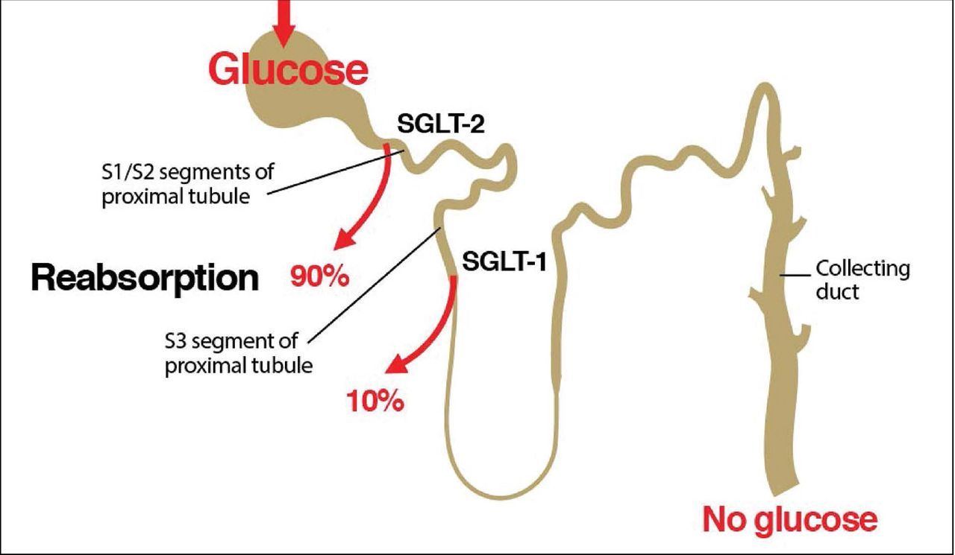

- Micturition is a process where urine is expelled from the body. It is brought about by reflex contraction of a detrusor muscle after voluntary relaxation of the sphincter muscle. We depend on micturition to eliminate organic waste products, which are produced as a result of cell metabolism in the body. The urinary system also regulates the concentrations of sodium, potassium, chloride and other ions in the blood as well as helping to maintain normal blood pH, blood pressure and blood volume.

Stages of Micturition
The urinary bladder has two distinct stages or phases:
- Resting or filling stage
- Voiding stage

Resting or Filling Stage
It is in this phase of the bladder that the urine is transported from the kidneys via the ureters into the bladder. The ureters are thin muscular tubes that arise from each of the kidneys and extend downwards where they enter the bladder obliquely.
The oblique placement of the ureters in the bladder wall serves a very important function. The opening of the ureter into the urinary bladder is not guarded by any sphincter or muscle. Therefore, this oblique nature of opening prevents the urine from re-entering the ureters. At the same time, the main muscle of the urinary bladder, the detrusor muscle, is relaxing allowing the bladder to distend and accommodate more urine.

Voiding Stage
During this stage, both the urinary bladder and the urethra come into play together. The detrusor muscle of the urinary bladder which was relaxing so far starts to contract once the bladder’s storage capacity is reached.
The urethra is controlled by two sets of muscles: The internal and external urethral sphincters. The internal sphincter is a smooth muscle whereas the external one is skeletal. Both these sphincters are in a contracted state during the filling stage.

Physiology of Micturition

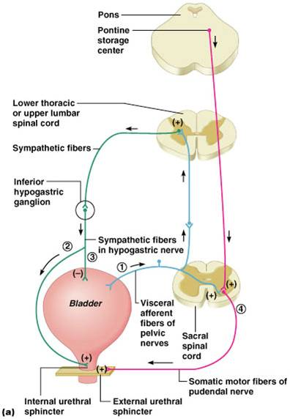
As mentioned earlier, the process of micturition is governed by both the nervous and muscular systems. Within the nervous system, the process is governed by the autonomous nervous system and the somatic system. Once the urinary bladder reaches its maximum capacity, the stretch receptors in the walls of the bladder send an impulse via the pelvic nerve to the brain via the spinal cord.
The micturition reflex is ultimately generated from the level of the spinal cord after it receives reflexes from the pontine region in the brain. Once the bladder and the urethra receive the signals to empty the bladder, the two sphincters relax and the detrusor muscle causes the contractions of the bladder.
Along with these muscles, the muscles of the abdomen also play a role by putting pressure on the bladder wall. This leads to complete emptying of the bladder.

Juxtaglomerular Apparatus
The juxtaglomerular apparatus is a specialized structure formed by the distal convoluted tubule and the glomerular afferent arteriole. It is located near the vascular pole of the glomerulus and its main function is to regulate blood pressure and the filtration rate of the glomerulus. The macula densa is a collection of specialized epithelial cells in the distal convoluted tubule that detect sodium concentration of the fluid in the tubule. In response to elevated sodium, the macula densa cells trigger contraction of the afferent arteriole, reducing flow of blood to the glomerulus and the glomerular filtration rate. The juxtaglomerular cells, derived from smooth muscle cells, of the afferent arteriole secrete renin when blood pressure in the arteriole falls. Renin increases blood pressure via the renin-angiotensin-aldosterone system. Lacis cells, also called extraglomerular mesangial cells, are flat and elongated cells located near the macula densa. Their function is possibly to relay the signals from macula densa to the granular cells after modulating the signals. In this way, a decreased intraluminal Na+ load, Cl– load, or both in the region of macula densa stimulates the JG cells to secrete rennin.
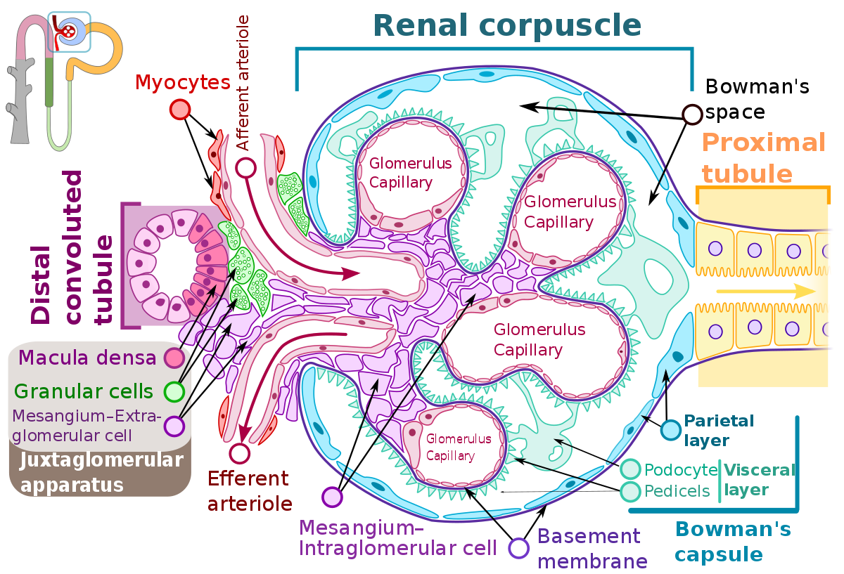

- ROLES OF THE KIDNEY IN REGULATIONS OF BLOOD PRESSURE
The kidneys play a central role in the regulation of arterial blood pressure. Renal artery perfusion pressure directly regulates sodium excretion; a process known as pressure natriuresis, and influences the activity of various vasoactive systems such as the renin–angiotensin–aldosterone (RAS) system. Along with vessel morphology, blood viscosity is one of the key factors influencing resistance and hence blood pressure. A key modulator of blood viscosity is the renin-angiotensin system (RAS) or the renin-angiotensin-aldosterone system (RAAS), a hormone system that regulates blood pressure and water balance.

The blood pressure in the body depends upon:

• The force by which the heart pumps out blood from the ventricles of the heart - and this is dependent on how much the heart muscle gets stretched by the inflowing blood into the ventricles.

• The degree to which the arteries and arterioles constrict-- increases the resistance to blood flow, thus requiring a higher blood pressure.

• The volume of blood circulating round the body; if the volume is high, the ventricles get more filled, and the heart muscle gets more stretched.

The kidney influences blood pressure by:

• Causing the arteries and veins to constrict
• Increasing the circulating blood volume

Specialized cells called macula densa are located in a portion of the distal tubule located near and in the wall of the afferent arteriole. These cells sense the Na in the filtrate, while the arterial cells (juxtaglomerular cells) sense the blood pressure. When the blood pressure drops, the amount of filtered Na also drops. The arterial cells sense the drop in blood pressure, and the decrease in Na concentration is relayed to them by the macula densa cells. The juxtaglomerular cells then release an enzyme called renin.

Renin converts angiotensinogen (a peptide, or amino acid derivative) into angiotensin-1. Angiotensin-1 is thereafter converted to angiotensin-2 by an angiotensin-converting enzyme (ACE), found in the lungs. Angiotensin-2 causes blood vessels to contract -- the increased blood vessel constrictions elevate the blood pressure. When the volume of blood is low, arterial cells in the kidneys secrete renin directly into circulation. Plasma renin then carries out the conversion of angiotensinogen released by the liver to angiotensin-1. Angiotensin-1 is subsequently converted to angiotensin-2 by the enzyme angiotensin converting enzyme found in the lungs. Angiotensin-2m a potent vasoactive peptide causes blood vessels to constrict, resulting in increased blood pressure. Angiotensin-2 also stimulates the secretion of the hormone aldosterone from the adrenal cortex.
Aldosterone causes the tubules of the kidneys to increase the reabsorption of sodium and water into the blood. This increases the volume of fluid in the body, which also increases blood pressure. If the renin-angiotensin-aldosterone system is too active, blood pressure will be too high. Many drugs interrupt different steps in this system to lower blood pressure. These drugs are one of the main ways to control high blood pressure (hypertension), heart failure, kidney failure, and harmful effects of diabetes. It is believed that angiotensin-1 may have some minor activity, but angiotensin-2 is the major bioactive product. Angiotensin-2 has a variety of effects on the body: throughout the body, it is a potent vasoconstrictor of arterioles

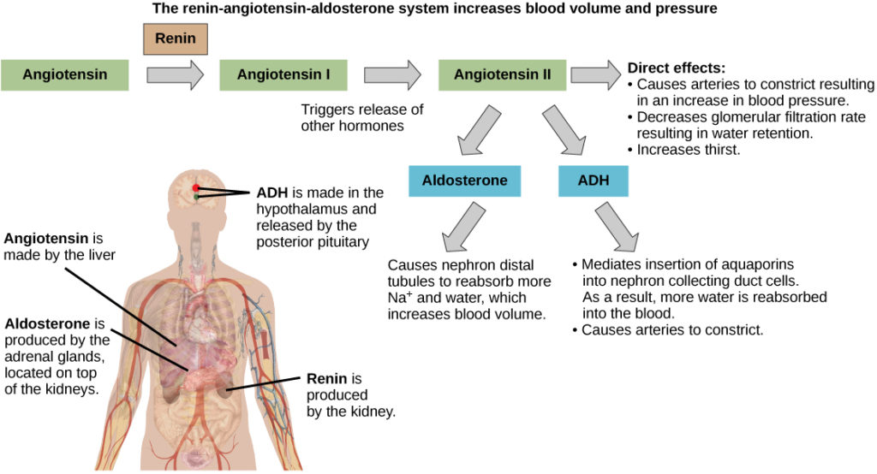

- ROLES OF THE KIDNEY IN CALCIUM HOMEOSTASIS

In humans who have a GFR of 170 liters per 24 hours, roughly 10 g of calcium is filtered per day. The amount of calcium excreted in the urine usually ranges from 100 to 200 mg per 24 hours; hence, 98%–99% of the filtered load of calcium is reabsorbed by the renal tubules. Approximately 60%–70% of the filtered calcium is reabsorbed in the proximal convoluted tubule, 20% in the loop of Henle, 10% by the distal convoluted tubule, and 5% by the collecting duct. The terminal nephron, although responsible for the reabsorption of only 5%–10% of the filtered calcium load, is the major site for regulation of calcium excretion.

The reabsorption of calcium in the proximal convoluted tubule parallels that of sodium and water. Proximal tubular calcium reabsorption is thought to occur mainly by passive diffusion and solvent drag. This is based on the observation that the ratio of calcium in the proximal tubule fluid to that in the glomerular filtrate is 1:1.2. The passive paracellular pathways account for approximately 80% of calcium reabsorption in this segment of the nephron. A small but significant component of active calcium transport is observed in the proximal tubules. The active transport of calcium proceeds in a two-step process, with calcium entry from the tubular fluid across the apical membrane and exit though the basolateral membrane. This active transport is generally considered to constitute 10%–15% of total proximal tubule calcium reabsorption and it is mainly regulated by parathyroid hormone (PTH) and calcitonin.

No reabsorption of calcium occurs within the thin segment of the loop of Henle. In the thick ascending limb of the loop of Henle, 20% of the filtered calcium is reabsorbed largely by the cortical thick ascending limb, through both transcellular and paracellular routes. Calcium transport in the thick ascending limb of the loop of Henle is also influenced by the calcium-sensing receptor (CaSR), which is localized in the basolateral membrane.

Hormonal and Other Factors Regulating Renal Calcium Handling

PTH; Many physiologic, pharmacologic, and pathologic factors influence renal calcium absorption. The most important regulator is PTH, which stimulates calcium absorption. PTH is a polypeptide secreted from the parathyroid gland in response to a decrease in the plasma concentration of ionized calcium. Therefore, the major physiologic role of the parathyroid gland is to regulate calcium homeostasis. PTH acts to increase the plasma concentration of calcium in three ways:

(a) it stimulates bone resorption,

(b) it enhances intestinal calcium and phosphate absorption by promoting the formation within the kidney of 1,25(OH)₂D

(c) it augments active renal calcium absorption. These effects are reversed by small changes in the serum calcium concentration that lower PTH secretion.

