NAME: NWANDU UCHENNA SANDRA
MAT NO: 18/MHS02/120
SHORT NOTE ON IMPLANTATION
The term "implantation" is used to describe process of attachment and invasion of the uterus endometrium by the blastocyst (conceptus). This process begins at the end of week 1, with most successful human pregnancies the conceptus implants 8 to 10 days after ovulation, and early pregnancy loss increases with later implantation. The implantation process continues through the second week of development. An implantation of the blastocyst outside this zone means an extra-uterine pregnancy with serious consequences for the person's health. The implantation stages of the blastocyst in the uterine endometrium can be seen as taking place in three phases: apposition, adhesion and the embedding in the endometrium. Implantation is the stage of pregnancy at which the already fertilized egg adheres to the wall of the uterus. At this stage of prenatal development, the conceptus is called a blastocyst. It is by this adhesion that the fetus receives oxygen and nutrients from the mother to be able to grow.
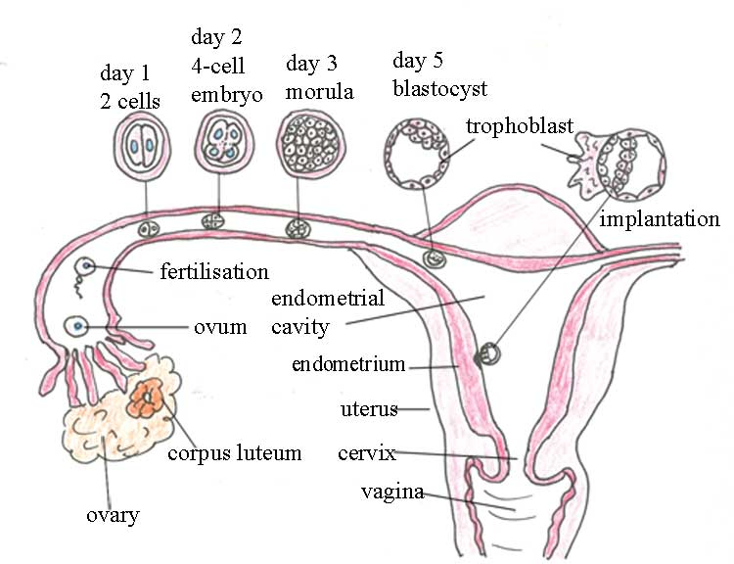
IMPLANTATION PROCESS

The adherence of a fertilized egg to a surface in the reproductive tract, usually to the uterine wall, so that the egg may have a suitable environment for growth and development into a new offspring. Fertilization of the egg usually occurs after the egg has left the ovary and is being transported through the fallopian tubes. Male sperm cells deposited in the female reproductive tract travel up to the fallopian tubes to unite with the egg. Once fertilized, the egg begins to undergo a series of cell divisions. The egg takes up to seven days to reach the uterus, by this time the single-celled egg has divided numerous times, so that it is a ball of approximately 200 cells.
The uterus has thick walls suitable for egg attachment and growth. A female hormone knownas progesterone, secreted by the corpus luteum in the ovary, influences the readiness of the uterine wall for egg implantation. It increases the blood supply in the wall, water content, and secretion of glycogen, a nutrient for the surrounding tissue and developing egg. If the uterus is not first prepared by progesterone, the egg will not attach itself. Progesterone also inhibits muscular contractions in the uterine wall that would tend to reject the adhering egg.
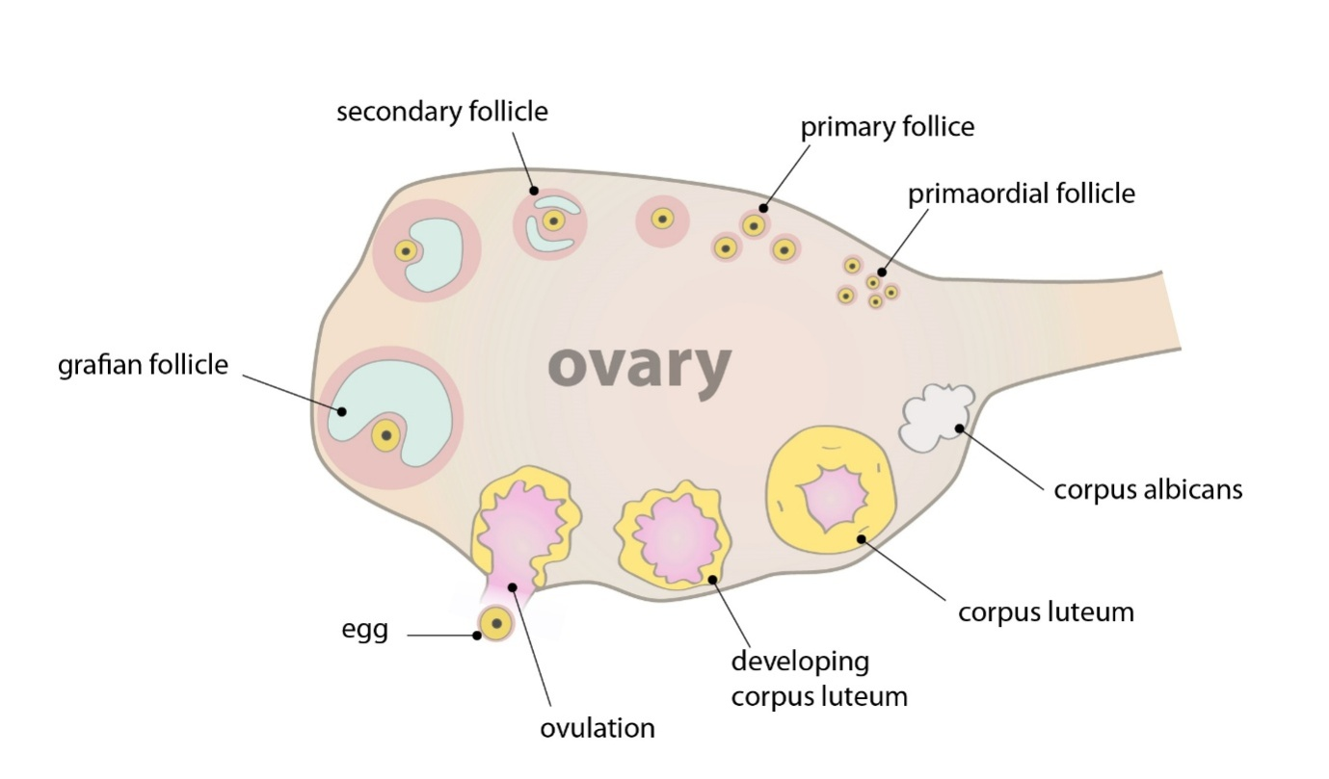
When the egg reaches the uterus, it usually remains free in the uterine cavity for about a day. It then attaches to the uterine lining (the endometrium). Cells in the outer surface of the egg grow rapidly once contact is made with the uterine wall. The egg disrupts the surface of the endometrium and actively burrows into the deeper tissue. By the 11th day after fertilization, the egg has completely embedded itself into the endometrium. The product of conception, first the fertilized egg and then the developing child and the placenta ,normally remains implanted in the human uterus for nine months.

