NAME: ALI QUEEN-ESTHER EBOH
MATRIC NUMBER: 18/MHS02/039
COLLEGE: MEDICINE AND HEALTH SCIENCES
DEPARTMENT: NURSING SCIENCE
ASSIGNMENT TITLE: FERTILIZATION
COURSE TITLE: PHYSIOLOGY
COURSE CODE: PHS 212

QUESTION:
Write a short note on implantation.
ANSWER:
WHAT IS IMPLANTATION?
In human, implantation is the stage of pregnancy at which the embryo adheres to the walls of the uterus. At this stage of prenatal development, the conceptus is called a blastocyst. It is by this adhesion that the embryo receives oxygen and nutrients from the mother to be able to grow.
PROCESS OF IMPLANTATION
In humans, implantation of a fertilized ovum is most likely to occur around nine days after ovulation. However, this can range between 6 and 12 days. Once the uterus reaches the blastocyst stage, approximately five to six days after fertilization, it hatches out of the zona pellucida and begins the process of implantation in the uterus. In nature, 50 percent of all fertilized eggs are lost before a woman’s missed menses.
Implantation is a process in which a developing embryo, moving as a blastocyst through a uterus, makes contact with the uterine wall and remains attached to it until birth.
Implanting gives the blastocyst a blood supply so that it can start growing into a fetus. Along with cramping, you may experience what is called implantation bleeding.
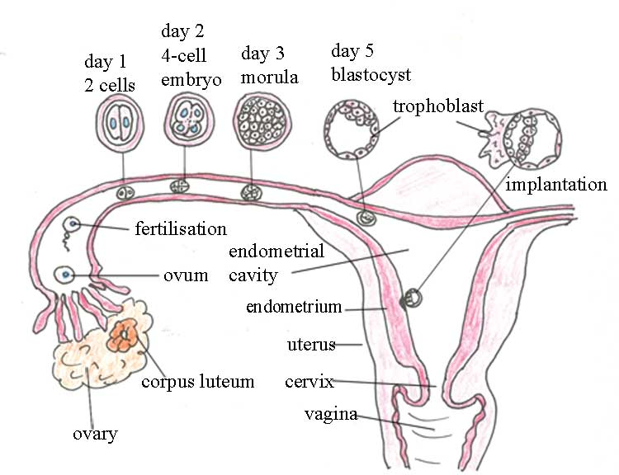

SYMPTOMS OF IMPLANTATION
The most common implantation symptoms of early pregnancy include;
- Implantation cramps
- Implantation bleeding
- Nausea
- Tender breasts
- Constipation and bloating
- Fatigue
- Headaches
- Mood swings

When the egg reaches the uterus, it usually remains free in the uterine cavity for about a day. It then attaches to the uterine lining (the endometrium). Cells in the outer surface of the egg grow rapidly once contact is made with the uterine wall. The egg disrupts the surface of the endometrium and actively burrows into the deeper tissue. By the 11th day after fertilization, the egg has completely embedded itself into the endometrium. The product of conception, first the fertilized egg and then the developing child and the placenta, normally remains implanted in the human uterus for nine months.
