Odukoya Treasure Ewaogooluwa
18/MHS05/010
Physiology
ANA 204
Question.
1. Critically examine the renal function of desert dwellers and the anatomical basis of their unique adaptation
2. Write extensively on the clinical importance of the glomerular filtration barrier.
Answer.
1. Desert mammals do not readily find water, hence they must excrete very less amount of water. They are able to produce highly concentrated urine. 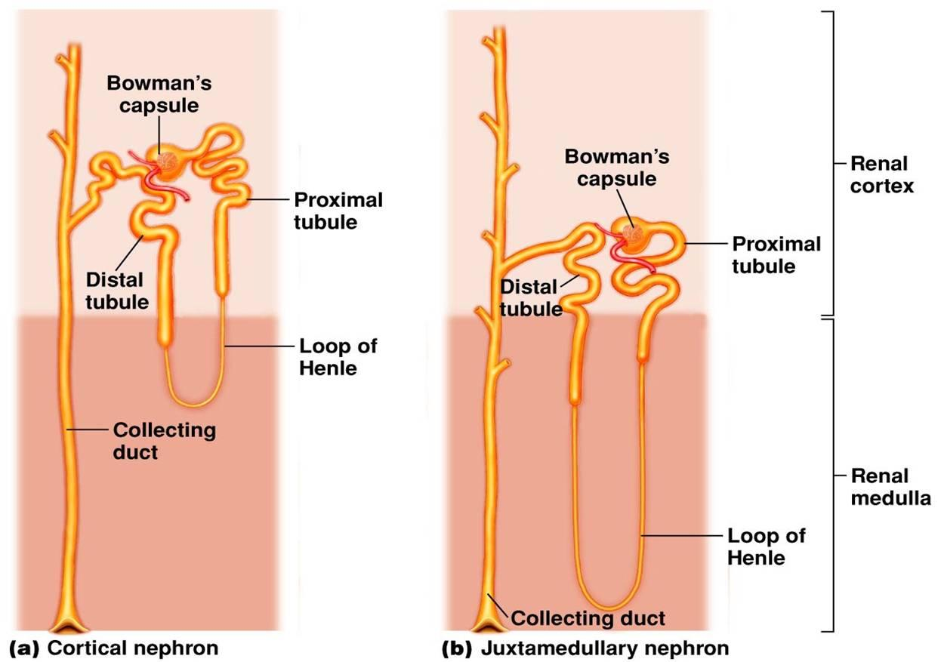
From the accompanying diagram you would be able to see that the Henle's loop of juxtamedullary ( =adjacent to medulla of kidney) nephron goes deep down into the medulla. This is why medulla of camel's kidney is thicker than that of other mammals, but it is most well developed in another desert mammal, the kangaroo rats.
The Henle's loops of juxtamedullary nephrons along with counter flowing blood vessels, called vasa recta, help in conservation of water.
Blood first flows along ascending limb of Henle, which is impermeable to water. Solutes can leave the filtrate and enter the blood along this stretch. When this blood flows along descending limb, water is reabsorbed from filtrate but not the solutes. Longer the Henle's loop, more amount of solute will be reabsorbed and hence more amount of water could be removed from filtrate.
2. The plasma filtration and formation of the urine is a very complex process necessary for the elimination of metabolites, toxins, and excessive water and electrolytes from the body. The initial process of urine formations is done by the glomerular filtration barrier inside the glomeruli. This specialized barrier consists of three layers, fenestrated endothelium, basement membrane, and podocytes, which ensure that water and small molecules pass through while cells and large molecules are retained. The glomerular filtration barrier is found with abnormal morphology in several diseases and is associated with renal malfunction; thus, it is interesting to study these structures in different experimental and clinical conditions. The normal glomerular barrier and its alterations in some conditions (hypertension, diabetes, and fetal programming) are discussed. Furthermore, some methods for studying the glomerular filtration barrier are by electron microscopy, both by qualitative and quantitative methods.
The normal glomerular filtration barrier
The glomerulus is a highly irrigated structure that performs selective filtration of the plasma. Inside the Bowman’s capsule, several tortuous arterioles receive the blood and filtrate it forming the primary urine, which then passes to the proximal tubule. The glomerular capillaries are lined by a fenestrated endothelium, covered externally by specialized cells, called podocytes. Between the cell layers, there is a basement membrane, which also has an important filtering function. Together, the endothelial cells, the basement membrane, and the podocytes form the glomerular filtration barrier.
The glomerular filtration barrier is highly permeable to water and small molecules. Moreover, it is slightly permeable to macromolecules and acts as a physical and electrical barrier for the filtration process. These characteristics are dependent of the cellular structures, and its function is influenced by factors such as molecular weight and electric charge. Moreover, changes in the cell junctions of the glomerular barrier prejudice the glomerular function.
Internally, the glomerular filtration barrier is constituted by the glomerular fenestrated endothelium. These endothelial cells have a glycocalyx over its luminal surface, which form a highly negatively charged coating. Thus, glycocalyx covers the endothelium and promotes a first selection of molecules passing through the barrier by electric charge. The endothelium coating the glomerular capillaries is very thin and has several fenestrae with 70–90 nm of diameter. These pores can filtrate only large molecules and blood cells.
The endothelial cells are supported by a basement membrane (about 100–150 nm), which is the only continuous layer of the glomerular filtration barrier. As this membrane is thought to be the fusion of the endothelial and epithelial basement membranes, two laminae lucida (interna and externa) and, between them, a lamina dense are found. The basement membrane is composed of a complex network of glycosaminoglycans and fibrous proteins (laminin and collagen type IV), which are continuously produced and deposited by podocytes and mesangial cells. These proteins adhere to the cell membranes by surface receptors and form the glomerular filtration barrier.
Podocytes are specialized epithelial cells found in the external layer of the glomerular filtration barrier and exhibit several long cellular processes, which bears various secondary processes, named as foot processes. The foot processes involve capillaries by interdigitations, and small gaps are left in between. These small gaps measure about 20–30 nm and is named as slit diaphragm being responsible for passage of small molecules, whereas larger ones are retained. Further, the slit diaphragm is filled with nephrin and podocin, the transmembrane proteins that are also important for the correct function of glomerular filtration barrier. Experimental studies have shown that mutations in expression of these proteins can alter the filtration barrier and probably is the cause of nephrotic syndrome].
In addition to adhesion receptors from integrin family, there are also proteoglycan transmembrane receptors such as those of syndecan family. Also, the junction of podocytes membrane is seen by electron microscopy, showing zipper-like structure where binding proteins form cell junctions and small pores, as previously mentioned on filtration slit. Thus, it is important to consider all glomerular ultrastructure in the filtration process and renal function. Some diseases provoke changes in glomerular ultrastructure, which promote irregular filtration rates, proteinuria, and even kidney failure, further discussed here. Electron microscopy and correlate techniques allow better to understand these pathological changes and become an effective and important method in the study of renal function.
In conclusion
The glomerular filtration barrier is a main component for the filtration of the plasma and formation of primary urine. It is composed of specialized cells and noncellular structures that, together, can avoid the loss of important plasma components but permit the passage of water and undesirable molecules. For this functionality, this barrier has a specific morphology with a fenestrated endothelium covered with glycocalyx, a basement membrane, and a set of slit diaphragms formed by the foot processes of podocytes.
The glomerular filtration barrier morphology has been studied in several diseases and is directly associated with kidney malfunction. Morphological alterations of components explain some physiopathological findings in clinical setting and correlate with kidney function. For this, scanning and transmission electron microscopy suits perfectly for obtaining high-quality images of this barrier.

