NAME; EJEMEKA OBISINACHI MIRACLE

MATRIC NO; 18/LAW01/086

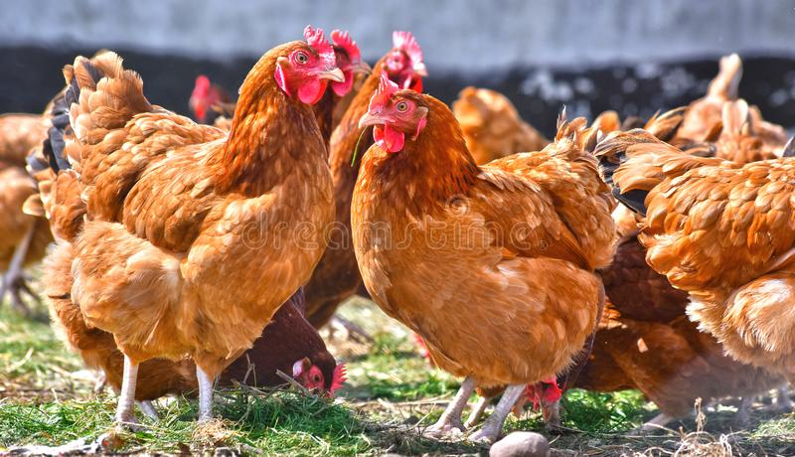

Daddy’s smart poultry farm Intl.

Table of content
Executive summary ........................................................................
Business description and services.........................................
Market research................................................................
Competitor analysis.............................................................
Sales and marketing plan ..................................................
Management and structure .................................................
Financial plan and projection...............................................
SWOT Analysis......................................................................

Introduction

Poultry farming is the form of animal husbandry which raises domesticated birds such as chickens, ducks, turkeys and geese to produce meat or eggs for food. Poultry – mostly chickens – are farmed in great numbers. ... Chickens raised for eggs are known as layers, while chickens raised for meat are called broilers

Why poultry farm, one may ask;
Several benefits offered by poultry farming:
- It requires less investment compared to rearing other livestock. ...
- It gives rapid return on investment. ...
- Broilers intake of feed is comparatively very low while it produces maximum possible amount of food for us. ...
- Poultry farming is a continuous source of income

BUSINESS DESCRIPTIONS AND SERVICES
Daddys smart poultry will be specialized in the production of chicken stock, turkey and sales of manure from chicken dungs.
The continuous request for chicken stock has placed it at number on in the meat market , or it would be profiting to join the train of supply of these poultry birds.

There are various types of poultry birds such as;
- Chickens. Shutter stock. As the best known backyard farm bird, chickens are valued because they are easy keepers and quite useful. ...
- Geese. Kirsten Lie-Nielsen. ...
- Ducks. Kirsten Lie-Nielsen. ...
- Guinea Fowl. LHG Creative Photography/Flickr. ...
- Quail. iStock/Thinkstock. ...
- Turkeys. Hendrix Genetics.

Business plan in details

Having Investment Cash Ready
Poultry farming requires investment. You can arrange the money by your own or you can apply for bank loan. Both govt. and non-govt. bank loans are available for starting poultry farming business. You should contact your desired bank for the loan process. As a beginner, you should start with a minimum number of birds which will cost you pretty less money.

Knowing the Production Type
This involves me determining the production type of my poultry farm. I can raise broiler chickens for meat production purpose and choose layers if I want to produce eggs commercially. I can also start my poultry farm for selling poultry products and breeding stocks directly to your local customers. I have to Determine my production purpose, select proper poultry breeds according to my desired production and go for the detailed planning.

Set Farm Location
Selecting a good farm location for my business is very important. It would be advised to select such a location which has all required facilities and favorable for my business. It can be slightly far from the town, where land and labor is pretty cheap. But not too far from the town. Because most of the towns have high density population, and you have to target that market. Also the farm would not be set up in a residential area, because poultry farms produce offensive odor. While selecting the farm location, I would also consider transportation system and medication facilities also.

Construction of poultry House.
After selecting farm location, I will have to construct a good house for the birds. after ensuring all required facilities are available in the new house. There are three types of poultry housing system I can use. Extensive, semi intensive and intensive. For commercial production, intensive system is most convenient. The birds can be raised in floor or in cage system. On an average, broiler poultry needs about 2.5 square feet space and layer poultry needs about 4 square feet space. For example, if I want to raise 200 layers then I have to ensure about 800 square feet space is available. About 4 square feet space is required per bird in cage system. Without forgetting to add proper lighting and ventilation system in the house.

Purchase Required Equipment
There is a need to purchase some equipment for the poultry farm. List of required equipment are listed below for running a poultry farm successfully.
- 10 Feeders---------------------------------------------------- N400(unit)
- 10 Waterers---------------------------------------------------N800(unit)
- 5 Nests-----------------------------------------------------------1200(roll)
- 5 Cages-----------------------------------------------------------70,000
- 3 Coops----------------------------------------------------------15,000
- Crates----------------------------------------------------------100(unit)
- 1 Incubator-------------------------------------------------------35,000
- 5 Egg tray--------------------------------------------------------1,500(unit)
- 10 Lighting instruments(60 waltz bulb) ----------------------500(unit)
- Perches------------------------------------------------------------- not needed for chickens
- Brooders or heaters-----------------------------------------------30,000(unit)
- Ventilation system---------------------------------------------------inbuilt
- Waste disposal system-----------------------------------------------manual

Labor or Manpower
Based on the number of birds, I need more or less manpower/labor. As a beginner, if I start with a minimum number of birds (200-500) then I can manage my farm by myself easily. If I plan for raising more birds then I will need additional manpower. I have to ensure cheap labor is available in my selected area.

Purchasing Chicks
After setting everything up and having everything ready, I will purchase quality chicks from trusted breeder in my area and start caring them. Set the brooder ready before arriving the chicks from breeding house to the farm. As a beginner, it is wise to start with day old chicks instead of older chicks. a complete beginner without any prior experience, should keep the number of chicks to minimum (anyhow not more than 500).
Day old Chicks(broilers)----------------------------------------------------- N250
Day old turkey------------------------------------------------------ N1,800
Day old chicks layers ------------------------------------------------- N280

Feeding
Feeding is the most important part of poultry farming business. After constructing house and purchasing equipment and chicks, I have to spend a large amount of money for feeding my birds. About 70% of your total project expenses will go towards the feeding. And the success in the business also depends on quality and adequate feeding. I can purchase the feed ingredients from the market and prepare the feed by myself or purchase ready-made poultry feeds from the market. Different types of commercial poultry feeds are available in the market for each type of birds.

Health Management
As mentioned above, I have to ensure proper medication system in my area. Poultry birds are prone to various types of diseases and I have to be ready for controlling them. We know ‘prevention is better than cure’, so I have to be conscious and take proper care of the birds to keep them safe. Vaccinate them timely and always try to provide them fresh water and food. Also stock some required vaccine and medicine so that they can be used when needed.

Drugs like;
VITAMINS-------------------------------------- N800
TETRACYCLINE ----------------------------- N500
CONFLOX 20% BH--------------------------- N 3,000
DAFFONOR------------------------------------- N 1,500
STRESROAK------------------------------------ N 5,000

Marketing
Good marketing strategies influence the profit from my business. If I can sell my products in the market easily, then it will encourage me in getting more production. It is always recommend determining marketing facilities in the area before starting any farming business. Because the business will not be much profitable if you can’t market your products properly.
SWOT ANALYSIS - Competitive position To guarantee a better identification of Daddys Smart Poultry competitive position, SWOT analysis was conducted
Strength; innovative, bulk stocks, strong poultry bird species , easy adaptation to the market, versatility with taste.
Weakness; few resources, absence of history, new farm.
Opportunities; growing of global concern, global expansion, novelty is temporary.
Threats; economic environment, several strong farms already competitive, new customer needs.
IN CONCLUSION,
This business plan aims at serving as a guild line to ensure less damage and more expectancy during the course of my farm .

