Asibor Osemhanhu Immanuella
18/mhs01/087

The nephrons in desert mammal Camel are equipped with well developed Henle's loop and number of juxtamedullary nephrons in kidneys is very high, about 35% (in man this number is about 15%).Desert mammals do not readily find water, hence they must excrete very less amount of water. They are able to produce highly concentrated urine.

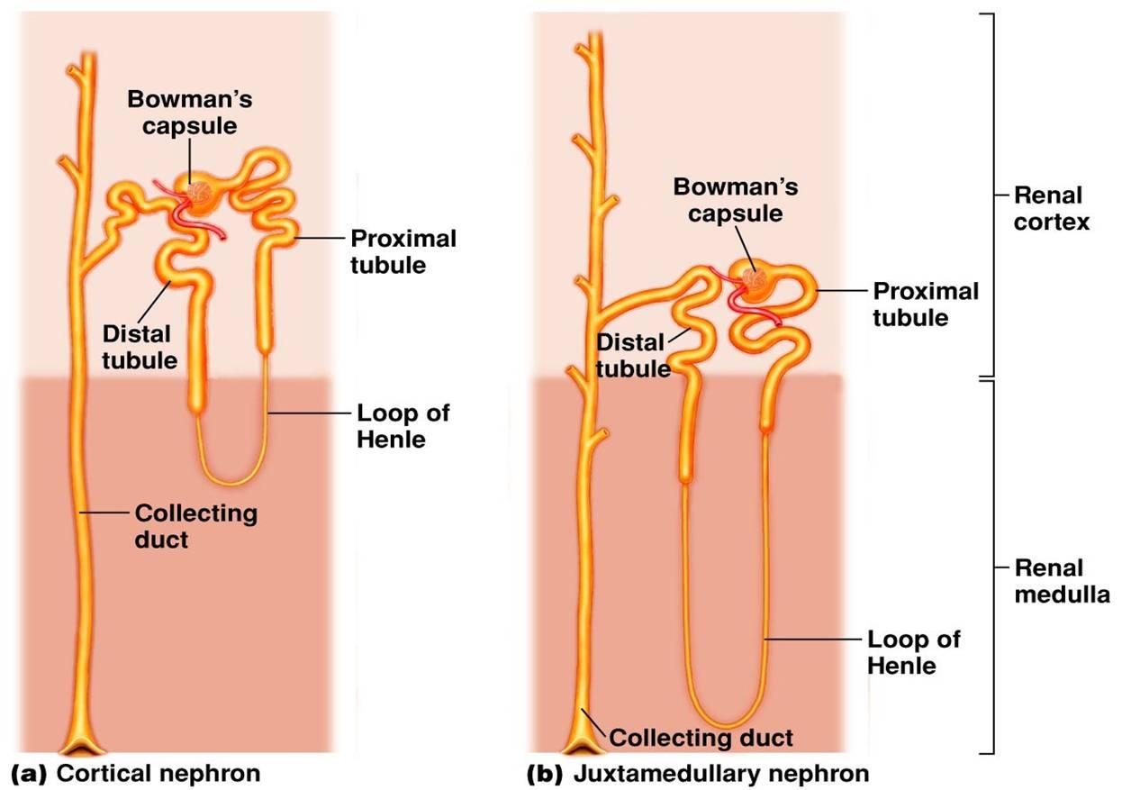

From the accompanying diagram you would be able to see that the Henle's loop of juxtamedullary ( =adjacent to medulla of kidney) nephron goes deep down into the medulla. This is why medulla of camel's kidney is thicker than that of other mammals, but it is most well developed in another desert mammal, the kangaroo rats.
The Henle's loops of juxtamedullary nephrons along with counter flowing blood vessels, called vasa recta, help in conservation of water.
Blood first flows along ascending limb of Henle, which is impermeable to water. Solutes can leave the filtrate and enter the blood along this stretch. When this blood flows along descending limb, water is reabsorbed from filtrate but not the solutes. Longer the Henle's loop, more amount of solute will be reabsorbed and hence more amount of water could be removed from filtrate.

2. Glomerular filtration is a physiological function of kidney nephrons. The ultrafiltrate, which appears in the lumen of the proximal convoluted tubule, is composed of water and solutes that can pass through the filtering membrane of the capillaries. Under physiological conditions, the large molecular weight proteins and blood cells do not pass through the capillary wall and hence do not appear in the luminal fluid. Therefore, glomerular filtration is relatively nonselective. The benefits of the filtration process are that it disposes of excess fluid, solutes, and metabolism byproducts and that it serves to detoxify the system by disposing of chemicals identified as foreign. The glomerular filtration barrier determines the composition of the plasma ultra filtrate. It restricts the filtration of molecules primarily on the basis of size. In general, molecules with a radius smaller than 20 Å are filtered freely, molecules larger than 42 Å are not filtered, and molecules between 20 and 42 Å are filtered to various degrees. For example, serum albumin, an anionic protein that has an effective molecular radius of 35.5 Å, is filtered poorly. Because the filtered albumin and other small proteins normally are reabsorbed avidly by the proximal tubule, almost no protein appears in the urine of persons with normal renal function.∗

