19/MHS/11/034
ASSIGNMENT
1. CLASSIFICATION OF ALCOHOLS
A.) Based on the number of Hydrogen atoms attached to the carbon carrying the hydroxyl group.

NUMBER OF HYDROGEN ATOM | CLASSIFICATION WITH EXAMPLE
Three or two hydrogen atoms | Primary alcohol-CH3OH (Methanol)
One hydrogen atom | Secondary alcohol-CH3CH[OH]CH3 (Propan-2-ol)
No hydrogen atom | Tertiary alcohol-[CH3]3C-OH (2-Methylpropan-2-ol)

B.) Based on the number of hydroxyl group present in the alcohol structure.

NUMBER OF HYDROXYL GROUP PRESENT | CLASSIFICATION WITH EXAMPLE
One | Monohydric alcohol –CH3OH (Methanol)
Two | Dihydric alcohol –HOCH2CH2OH (Ethane-1,2-diol)
Three | Trihydric alcohol
More than three | Polyhydric alcohol

2. SOLUBILITY OF ALCOHOLS
- In water
Lower alcohols with up to three carbons in their molecules and polyhydric alcohols are soluble in water because of their ability to form hydrogen bond with water molecules. This characteristic decreases with increase in molecular mass.
- In organic solvents
All monohydric alcohols are soluble in organic solvents.

3. INDUSTRIAL MANUFACTURE OF ETHANOL
Carbohydrates such as starch are major group of natural compounds that can be made to yield about 95% ethanol by the biological process of FERMENTATION.
1) Starch containing material such as potatoes is warmed with malt to 60°C for a specific period of time and is converted to MALTOSE by the enzyme DIASTASE contained in the malt.
2(C6H10O5)n + n(H2O) ――――――> n(C12H22O11)
Carbohydrate 60°C/diastase Maltose
2) The maltose is broken down into GLUCOSE by addition of yeast which contains the enzyme MALTASE at a temperature of 15°C.
C12H22O11 + H2O ――――――― > 2C6H1206
Maltose 15°C/maltase Glucose
3) The glucose at constant temperature of 15°C is then converted to ETHANOL by the enzyme ZYMASE also contained in yeast.
C6H12O6 ―――――――> 2CH3CH20H + 2CO2
Glucose 15°C/Zymase Ethanol

4. GRIGNARD SYNTHESIS
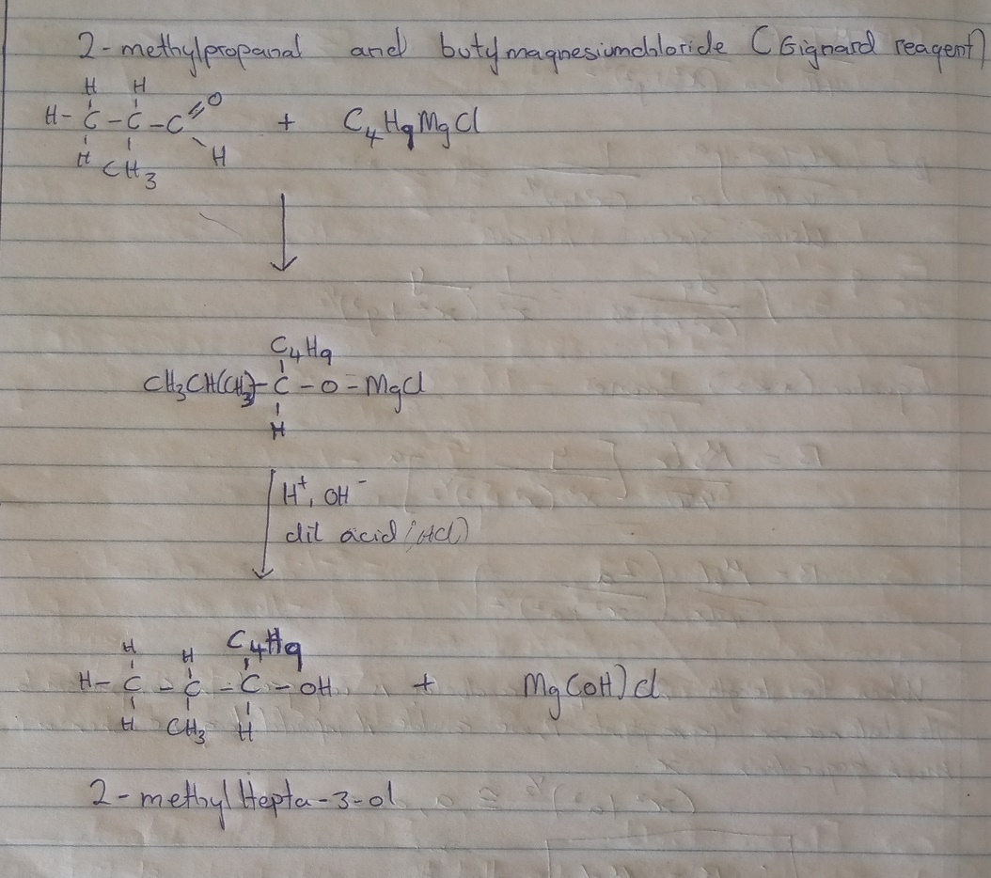
5. 2-METHYLPROPANONE DOES NOT EXIST
6. 2-METHYLPROPANONE DOES NOT EXIST
7.REDUCTION REACTION OF 2-METHYLPROPANAL
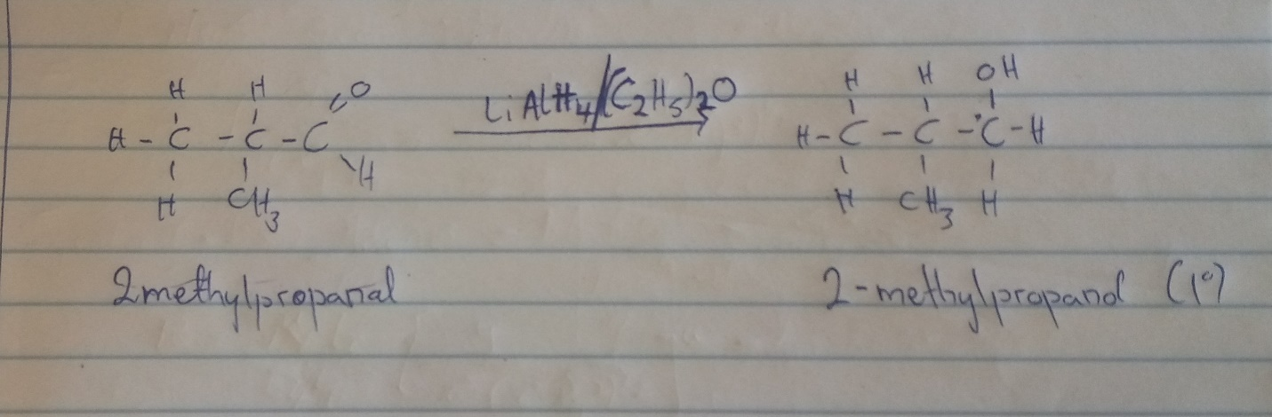

8. CONVERSION OF PROPAN-1-OL TO PROPAN-2-OL