NAME: AKINBODE OLAJUMOKE ADESOLA
MATRIC NUMBER: 18/SCI05/002
DEPARTMENT: NURSING SCIENCE
COURSE CODE: PHS 212
COURSE TITLE: PHYSIOLOGY

The flagellum of the sperm provides a whip-like movement in order to propel it forwards. The sperm cannot swim backwards due to the nature of the flagellar movement and propulsion. The sperm consists of a head that is 5 µm by 3 µm in size and a flagellum of around 50 µm in length.

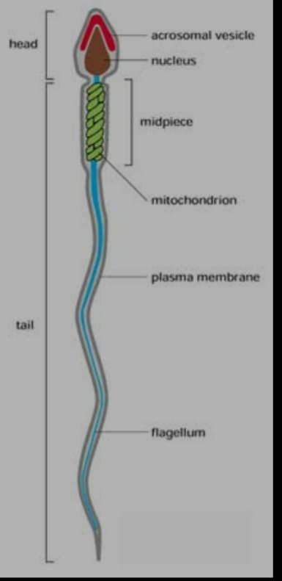
There is little cytoplasm within the sperm and much of it is the DNA. The head contains the cell’s DNA, tightly packaged into 23 chromosomes, while the neck of the sperm contains mitochondria to provide the sperm with energy. At the tip of the head is a package of enzymes that are needed to break down the protective layers that cover the egg’s surface. Nearly 1000 sperm are made in the human male testes per second. Once released, the sperm can survive for approximately 48 hours.

