NAME: BALOGUN ALI KOLADE
MATRIC NUMBER: 17/SCI01/019
COURSE CODE: CSC310
COURSE TITLE: Computer Architecture and Organization II

ASSIGNMENT
Question
Explain the following Interconnection networks:
- Torus
- Hypercube
Interconnection Network
Answer
Torus Interconnection Network : Torus interconnect is a switch-less topology that can be seen as a mesh interconnect with nodes arranged in a rectilinear array of N = 2,3, or more dimensions, with processors connected to their nearest neighbors, and corresponding processors on opposite edges of the array connected. In this lattice, each node has 2N connections. This topology got the nae from the fact that the lattice formed in this way is topologically homogeneous to an N-dimensional torus.
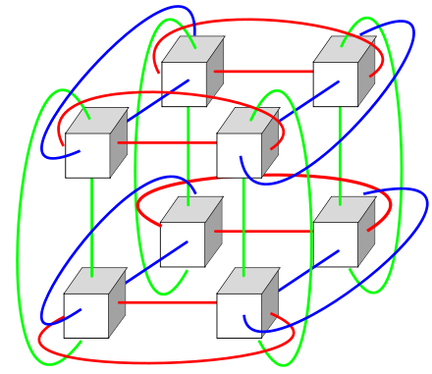
Fig1: Torus Interconnection network

Advantages
- Higher speed, lower latency:because of the connections on opposite edges data has more options to travel from one node to another greatly increasing speed.
- Better fairness: in a 4x4 mesh interconnection, the longest distance between nodes is from upper left corner to lower right corner. Each datum takes 6 hops to travel the longest path. But in a 4x4 torus interconnection, upper left can travel to lower right with only 2 hops.

Disadvantages
- Complexity of wiring:Extra wires can make the routing process in physical design phase more difficult.
- Cost

Hypercube Interconnection Network : Hypercube networks are a type of network topology used to connect multiple processors with memory modules and accurately route data. Hypercube networks consist of 2m nodes. These nodes form the vertices of squares to create an inter-network connection. A hypercube is basically a multidimensional mesh network with two nodes in each dimension. Due to similarity, such topologies are usually grouped into a k-array d-dimensional mesh topology family where d represents the number of dimensions and k represents the number of nodes in each dimension.
N = 2 ^{m}
where m is the number of bits that are required to label the nodes in the network. So, if there are 4 nodes in the network, 2 bits are needed to represent all the nodes in the network. The network is constructed by connecting the nodes that just differ by one bit in their binary representation. This is commonly referred to as Binary labelling. A 3D hypercube internetwork would be a cube with 8 nodes and 12 edges. A 4D hypercube network can be created by duplicating two 3D networks, and adding a most significant bit. The new added bit should be ‘0’ for one 3D hypercube and ‘1’ for the other 3D hypercube. The corners of the respective one-bit changed MSBs are connected to create the higher hypercube network. This method can be used to construct any m-bit represented hypercube with (m-1)-bit represented hypercube.

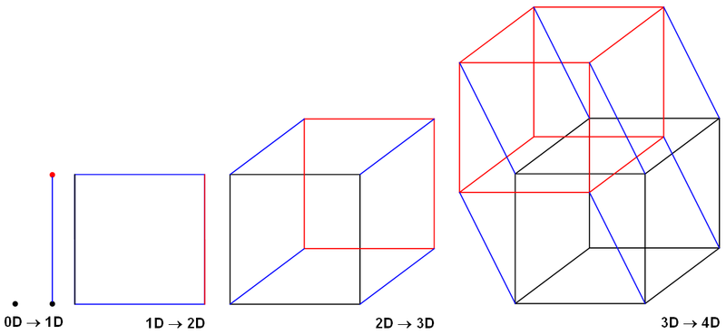
Fig2: Hypercube Interconnection network

