NAME: DAUDA OMOLAYO BALIKIS
MATRIC NUMBER: 18/MHS02/061
DEPARTMENT: NURSING
COURSE CODE: PHS 212

IMPLANTATION.
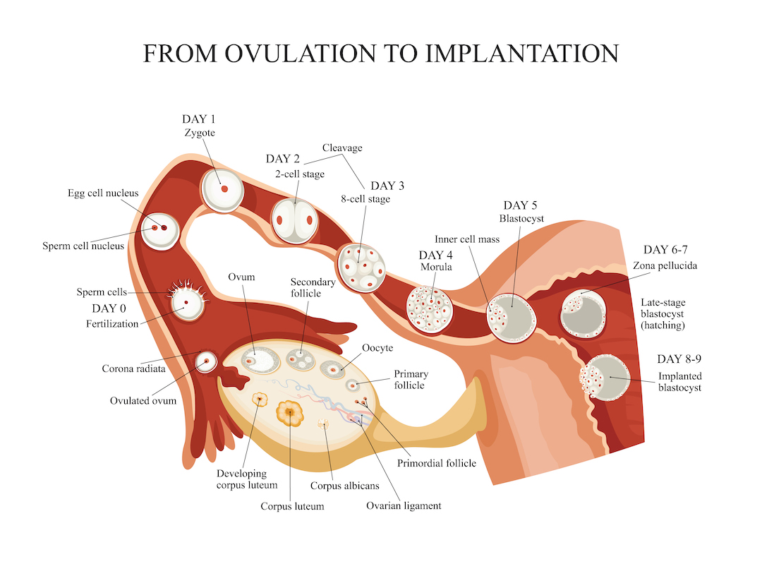
In humans, implantation is the stage of pregnancy at which the embryo adheres to the wall of the uterus. At this stage of prenatal development, the conceptus is called a blastocyst. It is by this adhesion that the embryo receives oxygen and nutrients from the mother to be able to grow.
In humans, implantation of a fertilized ovum is most likely to occur around nine days after ovulation; however, this can range between 6 and 12 days.
Implantation of the Blastocyst in the Uterus
After reaching the uterus, the developing blastocyst usually remains in the uterine cavity an additional 1 to 3 days before it implants in the endometrium; thus, implantation ordinarily occurs on about the fifth to seventh day after ovulation. Before implantation, the blastocyst obtains its nutrition from the uterine endometrial secretions, called “uterine milk”.
Implantation results from the action of trophoblast cells that develop over the surface of the blastocyst. These cells secrete proteolytic enzymes that digest and liquefy the adjacent cells of the uterine endometrium. Some of the fluid and nutrients released are actively transported by the same trophoblast cells into the blastocyst, adding more sustenance for growth. Once implantation has taken place, the trophoblast cells and other adjacent cells (from the blastocyst and the uterine endometrium) proliferate rapidly, forming the placenta and the various membranes of pregnancy.

