EDIDIONG IME- ESSIEN
CSC304
17/SCI01/041
- A finite automata is a simple idealized machine used to recognize patterns within improved taken from some character sets (or alphabets ) C. The job of an FA is to accept or reject an impulse depending on whether the pattern defined by the FA occurs in the inputs .

ii) Finite automata can be represented by input tape and finite control. Input tape: It is a linear tape having some number of cells. Each input symbol is placed in each cell. Finite control: The finite control decides the next state on receiving particular input from input tape.

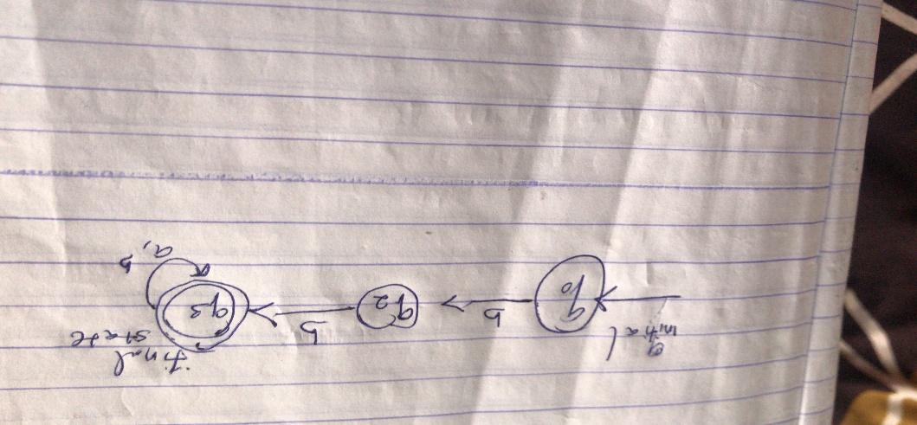

4&5(i&ii)
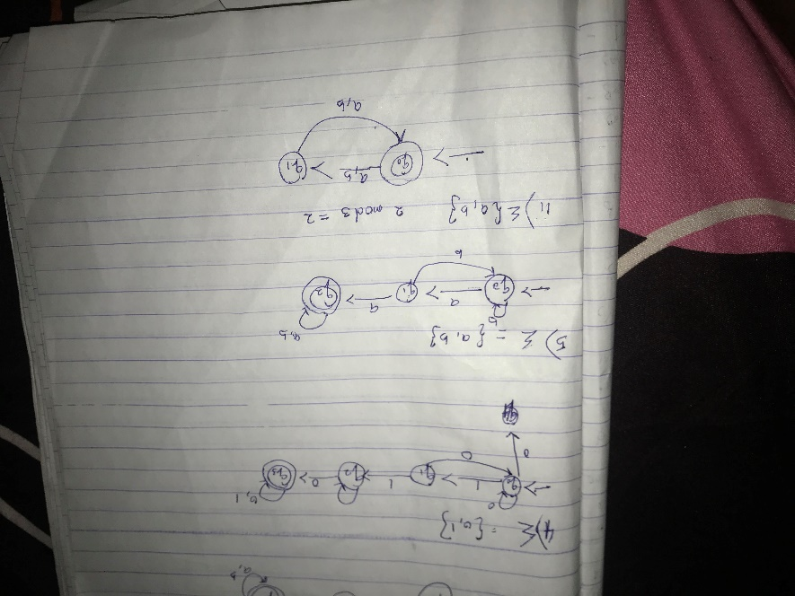

5(iii&iv)

