OSILAECHUU PATRICIA
18/sci17/003
Biochemistry
- Vitamins are classified into; fat soluble vitamins and water soluble vitamins
Biochemical significance of vitamins:
- Vitamin A (Retinol)is necessary for vision, proper growth, differentiation, reproduction and maintenance of epithelial cells.
- Vitamin D (cholecalciferol) plays an essential role as a hormone in the regulation of calcium and phosphorus metabolism. It also helps in the prevention of rickets.
- Vitamin E (Tocopherol) aids in cell maintenance and is involved in an active role in the maintenance of a healthy heart. It prevents the non-enzymatic oxidations of various cell components.
- Phylloquinone/menaquinone (vitamin K) is used by the liver for the production/formation of prothrombin, for the maintenance of strong bones, and promotion of blood clotting.
- Thymine (vitamin B1) is essential in carbohydrate metabolism and in the transmission of nerve impulses.
- Riboflavin (vitamin B2) is essential for the manufacturing of genetic material in cells.
- Niacin (vitamin B3) aids the normal functioning of tissues particularly the skin, gastrointestinal tract and so on.
- Panthotenic acid (vitamin B5) aids in fatty acid synthesis and metabolism, aids in reactions of citric acid cycle, synthesis of cholesterol and functions as part of Co-A and ACP.
- Pyridioxine (vitamin B6) aids metabolism of proteins, carbohydrates and lipids, controls cholesterol levels, prevents water retention, aids chemical balance between blood and tissue, it also builds haemoglobin.
- Biotin (vitamin B7) has a role in the regulation of cell cycle acting to biotinylate key nuclear proteins.
- Folic acid/folate (vitamin B9) aids digestion of proteins, improves circulation, It also reduces the risk of coronary heart disease.
- Cyanocobalamin (vitamin B12) promotes utilization of proteins, fats and carbohydrate, it is essential for the formation of red blood cells, builds nucleic acids and helps the nervous system.
- Ascorbic acid (vitamin C) enhances the absorption of iron, it is one of the most potent antioxidant vitamins, and it stops internal bleeding and strengthens blood vessels.
- Riboflavin is a component of two coenzyme; flavin mononucleotide (F.M.N) and flavin adenine dinucleotide (F.A.D) that participates in many redox reactions responsible for energy production. They are associated with certain enzymes involved in carbohydrate, lipid, protein and purine metabolisms besides the electron transport chain. For example, succinate dehydrogenase catalyzes the oxidation of succinate to form fumarate, this is an important reaction in energy production.
Panthotenic coenzyme (coenzyme A) carries an acetyl group to the site of the krebs cycle. It is an essential coenzyme that functions as a two carbon carrier (the acetyl group carrier). Co-A is the starting point in the citric acid cycle in the mitochondria where ATP is created, It is also important in the breakdown of fatty acids. Panthotenic acid has a central role in acyl group metabolism when acting as the pantetheine functional moiety of coenzyme A or acyl carrier protein (ACP). Co-A takes part in reactions of the citric acid cycle, fatty acid synthesis and oxidation, acetylations and cholesterol synthesis.
- Nomenclature of nucleotide, nucleoside and nucleic acid.
S/N | BASES | NUCLEOSIDE | NUCLEOTIDE | ABBREVIATION | NUCLEIC ACID
1 | Adenine | Adenosine  Deoxyadenosine | Adenylate  Deoxyadenylate | ADP  dADP | RNA  DNA
2 | Guanine | Guanosine  Deoxyguanosine | Guanylate  Deoxyguanylate | AGP  dAGP | RNA  DNA
3 | Cytosine | Cytidine  Deoxycytidine | Cytidylate  Deoxycytidylate | ACP  dACP | RNA  DNA
4 | Thymine | Deoxythymidine | Deoxythymidylate | dTMP | DNA
5 | Uracil | Uridine | Uridylate | UMP | RNA

- 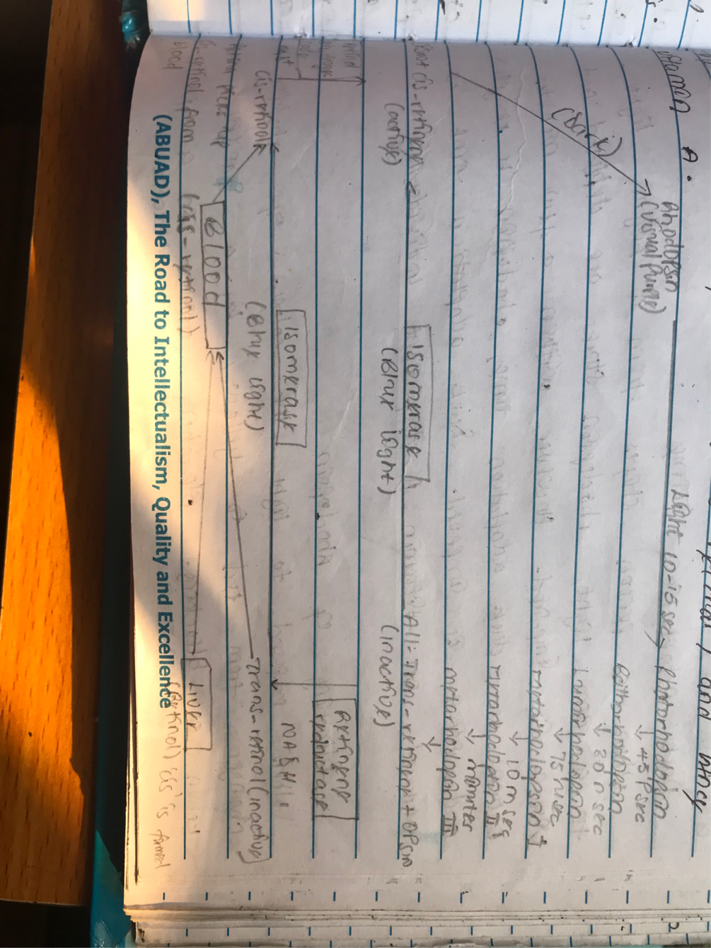
The retina contains two types of receptor cells; the rods which specialize for visual activity in dim light (night vision) and contain RHODOPSIN (visual purple) and cones which specialize for colored and detailed vision in bright light and contain IODOPSIN.
5. When a person shifts from a bright light to a dim light rhodopsin stored are depleted and vision is impaired. However within a few minutes known as dark adaptation time rhodopsin is resynthesied and vision is impaired. Dark adaptation time is increased in vitamin A deficient individuals. When exposed to light, the color of rhodopsin changed from red to yellow by a process called bleaching. This occurs in a few milliseconds and many unstable intermediates are formed during this process.
6. Cholecalciferol (vitamin D) is produced by U.V irradiation on the skin. During the course of cholesterol biosynthesis, 7- dehydrocholesterol is formed as an intermediate. On exposure to sunlight, 7-dehydrocholesterol is converted to cholecalciferol in the skin (the dermis and epidermis). The dark skin pigment (melanin) influences the synthesis of cholecalciferol (vitamin D3). The synthesis of vitamin D3 in the skin is proportional to the exposure to sunlight. Hence, its name the sunshine vitamin. Cholecalciferol has no significant biological activity so, it must be metabolized within the body to the biologically active form known as 1, 25-dihydroxycholecalciferol (calcitriol). This occurs within the liver where cholecalciferol is hydroxylated to 25-hydroxycholecalciferol (calcidiol) by the enzyme 25-hydroxylase and within the kidney where calcidiol serves as a substrate for 1-alpha-hydroxylase, yielding 1, 25-dihydroxycholecalciferol (the biologically active form).
7. Acid hydrolysis cleaves susceptible purine N-glycosyl bonds in both DNA and RNA. When RNA is boiled in dilute acid, adenine and guanine are released leaving an apurinic acid which may be further hydrolyzed to a mixture of pyrimidine nucleotides. Cleavage of N-glycosyl bonds can be achieved by heating with acid in an autoclave or sealed tube, this would release cytosine and uracil. During this process, cytosine can be deaminated to uracil.
Alkali hydrolysis of RNA produces a mixture of 2’ and 3’ nucleotides of cyclic 2’, 3’-monophosphate intermediates. These are further hydrolyzed by alkali to yield a mixture of 2’ and 3’ nucleoside monophosphates. DNA is not readily hydrolyzed by dilute alkali because it lacks the 2’ hydroxyl group.
8. James Watson and Francis Crick proposed the double helical structure of the DNA in 1953.
According to their findings, DNA replicates itself by separating into individual strands each of which became the template for a new double helix. The two strands are anti parallel; the width is 20degreeA; each strand of DNA has a hydrophilic deoxyribose phosphate backbone; each turn if the helix is 34 degrees A; the two poly nucleotide chains are of identical but complementary to each other due to base pairing
9. Differences between DNA and RNA
S/N | D.N.A | R.N.A
1 | It stands for deoxyribonucleic acid | It stands for ribonucleic acid
2 | It is a polymer of deoxyribonucleotides | It is a polymer of ribonucleotides
3 | It consists of two strands | It consists of a single strand
4 | Its sugar moiety is deoxyribose | Its sugar moiety is ribose
5 | Its nitrogenous bases are adenine, guanine, cytosine and thymine | Its nitrogenous bases are adenine, guanine, cytosine and uracil
6 | Adenine pairs with thiamine | Adenine pairs with uracil
7 | DNA cannot be subjected to alkali hydrolysis | RNA can be hydrolyzed by alkali to form 2’, 3’-cyclic diesters

10. Functions of nucleotides
- They are the activated precursors of DNA and RNA.
- They are required for the activation of intermediates in many biosynthetic pathways. For example, UDP-glucose for glycogen synthesis.
- Nucleotides of adenine acts as a carrier of methyl group in the form of S-adenosyl methionine (SAM).
- ATP (adenosine triphosphate) is a universal currency of energy in biological systems.
- GTP (guanosine triphosphate) is involved in protein biosynthesis as a source of energy.
- Adenine nucleotides are components of 3 major coenzymes. NAD⁺, FAD⁺ and Co-A.
- They are metabolic regulators. For example, C-AMP and C-GMP.
- C-AMP is a common second messenger produced in response to hormone and other chemical signals.

