AKINBUWA OLUWAFUNKE JOY
17/mhs01/042
MBBS/MHS
Physiology

1.Mechanisms of Glucose Homeostasis in the Kidneys
Maintenance of glucose homeostasis involves several complementary physiologic processes, including glucose absorption (in the gastrointestinal tract), glycogenolysis (in the liver), glucose reabsorption (in the kidneys), gluconeogenesis (in the liver and kidneys), and glucose excretion (in the kidneys).
In glucose homeostasis, the primary mechanisms include
- release of glucose into the circulation via gluconeogenesis,
- uptake of glucose from the circulation to satisfy the kidneys’ energy needs,
- reabsorption of glucose at the level of the proximal tubule.

Release of glucose
Renal release of glucose into the circulation is the result of glycogenolysis and gluconeogenesis. Glycogenolysis involves the breakdown of glycogen to glucose-6-phosphate from precursors (eg, lactate, glycerol, amino acids) and its subsequent hydrolysis (via glucose-6-phosphatase) to free glucose. Conversely, gluconeogenesis involves formation of glucose-6-phosphate from those same precursors and subsequent conversion to free glucose. Interestingly, the liver and skeletal muscles contain most of the body’s glycogen stores, but only the liver contains glucose-6-phosphatase. As such, the breakdown of hepatic glycogen leads to release of glucose, whereas the breakdown of muscle glycogen leads to release of lactate. Lactate (generated via glycolysis of glucose by blood cells, the renal medulla, and other tissues) may be absorbed by organs and reformed into glucose.
With regard to glucose utilization, the kidney may be perceived as 2 separate organs, with glucose utilization occurring predominantly in the renal medulla and glucose release limited to the renal cortex. These activities are separated as a result of differences in the distribution of various enzymes along the nephron.
Glucose Reabsorption
In addition to their important role in gluconeogenesis, the kidneys contribute to glucose homeostasis by filtering and reabsorbing glucose. Under normal conditions, the kidneys retrieve as much glucose as possible, rendering the urine virtually glucose free. The glomeruli filter from plasma approximately 180 grams of D-glucose per day, all of which is reabsorbed through glucose transporter proteins that are present in cell membranes within the proximal tubules.⁴ If the capacity of these transporters is exceeded, glucose appears in the urine. This maximum capacity, known as the tubular maximum for glucose (TmG), ranges from 260 to 350 mg/min/1.73 m² in healthy adults and children, and corresponds to a plasma glucose level of approximately 200 mg/dL.⁴ Once the TmG (the threshold) is reached and transporters are unable to reabsorb all the glucose (as in T2DM), glucosuria ocurrs.
Renal Glucose Transporters
The transport of glucose (a polar compound with positive and negative charged areas, making it soluble in water) into and across cells is dependent on specialized carrier proteins in 2 gene families: the facilitated glucose transporters (GLUTs) and the sodium-coupled glucose cotransporters (SGLTs). These transporters control glucose transport and reabsorption in several tissue types, including the proximal renal tubule, small intestine, blood-brain barrier, and peripheral tissues .GLUTs are involved in the passive transport of glucose across cell membranes, facilitating its downhill movement as it equilibrates across a membrane. SGLTs, on the other hand, mediate active transport of glucose against a concentration gradient by means of cotransport with sodium.
The regulation of glucose production, uptake, reabsorption, and elimination is handled by several organs, most notably (historically) the pancreas and liver. The kidneys’ contributions to maintaining glucose homeostasis are multifaceted and include such functions as gluconeogenesis and glucose reabsorption, the latter being mediated by active (SGLT) and passive (GLUT) transporters. Under normal circumstances, glucose filtered by glomeruli is completely reabsorbed, but in conditions of hyperglycemia or reduced resorptive capacity, glucosuria may occur. In hyperglycemia, the kidneys may play an exacerbating role by reabsorbing excess glucose, ultimately contributing to chronic hyperglycemia, and subsequently to pancreatic β-cell failure, insulin resistance, and decreased glucose uptake. Hyperglycemia in turn detrimentally affects the kidneys by damaging glomeruli, ultimately causing microalbuminuria and nephropathy. Knowledge of the kidneys’ role in glucose homeostasis and the effect of glucose dysregulation on the kidneys is critical to optimal management of T2DM and prevention of associated renal complications.

2. Micturition
Micturition or urination is the process of expelling urine from the bladder. This act is also known as voiding of the bladder. The excretory system in humans includes a pair of kidneys, two ureters, a urinary bladder and a urethra. The kidneys filter the urine and it is transported to the urinary bladder via the ureters where it is stored till its expulsion. The process of micturition is regulated by the nervous system and the muscles of the bladder and urethra. The urinary bladder can store around 350-400ml of urine before it expels it out.

Stages of Micturition
The urinary bladder has two distinct stages or phases:
- Resting or filling stage
- Voiding stage

Resting or Filling Stage
It is in this phase of the bladder that the urine is transported from the kidneys via the ureters into the bladder. The ureters are thin muscular tubes that arise from each of the kidneys and extend downwards where they enter the bladder obliquely.
The oblique placement of the ureters in the bladder wall serves a very important function. The opening of the ureter into the urinary bladder is not guarded by any sphincter or muscle. Therefore, this oblique nature of opening prevents the urine from re-entering the ureters. At the same time, the main muscle of the urinary bladder, the detrusor muscle, is relaxing allowing the bladder to distend and accommodate more urine.

Voiding Stage
During this stage, both the urinary bladder and the urethra come into play together. The detrusor muscle of the urinary bladder which was relaxing so far starts to contract once the bladder’s storage capacity is reached.
The urethra is controlled by two sets of muscles: The internal and external urethral sphincters. The internal sphincter is a smooth muscle whereas the external one is skeletal. Both these sphincters are in a contracted state during the filling stage.
PHYSIOLOGY OF MICTURITION
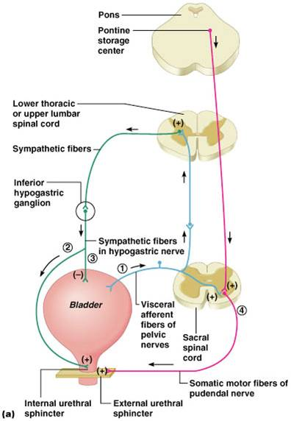
The process of micturition is governed by both the nervous and muscular systems. Within the nervous system, the process is governed by the autonomous nervous system and the somatic system. Once the urinary bladder reaches its maximum capacity, the stretch receptors in the walls of the bladder send an impulse via the pelvic nerve to the brain via the spinal cord.
The micturition reflex is ultimately generated from the level of the spinal cord after it receives reflexes from the pontine region in the brain. Once the bladder and the urethra receive the signals to empty the bladder, the two sphincters relax and the detrusor muscle causes the contractions of the bladder.
Along with these muscles, the muscles of the abdomen also play a role by putting pressure on the bladder wall. This leads to complete emptying of the bladder.

3.Juxtaglomerular Apparatus
The juxtaglomerular apparatus (JGA) is one component of an important feedback mechanism, the tubuloglomerular feedback mechanism, that is described in. The following structures make up the JGA:
1.The macula densa of the thick ascending limb
2.The extraglomerular mesangial cells
3.The renin- and angiotensin II–producing granular cells of the afferent arteriole
The cells of the macula densa represent a morphologically distinct region of the thick ascending limb. This region passes through the angle formed by the afferent and efferent arterioles of the same nephron. The cells of the macula densa are in contact with the extraglomerular mesangial cells and the granular cells of the afferent arterioles. Granular cells of the afferent arterioles are derived from metanephric mesenchymal cells. They contain smooth muscle myofilaments and they manufacture, store, and release renin. Renin is involved in the formation of angiotensin II and ultimately in the secretion of aldosterone. The JGA is one component of the tubuloglomerular feedback mechanism that is involved in the autoregulation of renal blood flow.

4.The Renin-Angiotensin System and Blood Pressure Control
Renin-angiotensin system, physiological system that regulates blood pressure. Renin is an enzyme secreted into the blood from specialized cells that encircle the arterioles at the entrance to the glomeruli of the kidneys (the renal capillary networks that are the filtration units of the kidney). The renin-secreting cells, which compose the juxtaglomerular apparatus, are sensitive to changes in blood flow and blood pressure. The primary stimulus for increased renin secretion is decreased blood flow to the kidneys, which may be caused by loss of sodium and water (as a result of diarrhea, persistent vomiting, or excessive perspiration) or by narrowing of a renal artery. Renin catalyzes the conversion of a plasma protein called angiotensinogen into a decapeptide (consisting of 10 amino acids) called angiotensin I. An enzyme in the serum called angiotensin-converting enzyme (ACE) then converts angiotensin I into an octapeptide (consisting of eight amino acids) called angiotensin II. Angiotensin II acts via receptors in the adrenal glands to stimulate the secretion of aldosterone, which stimulates salt and water reabsorption by the kidneys, and the constriction of small arteries (arterioles), which causes an increase in blood pressure. Angiotensin II further constricts blood vessels through its inhibitory actions on the reuptake into nerve terminals of the hormone norepinephrine.

ACE inhibitors, which block the formation of angiotensin II, are used in treating high blood pressure (hypertension), which is produced by excessive constriction of the small arteries. Drugs that block the binding of angiotensin II to its receptor can also be used.
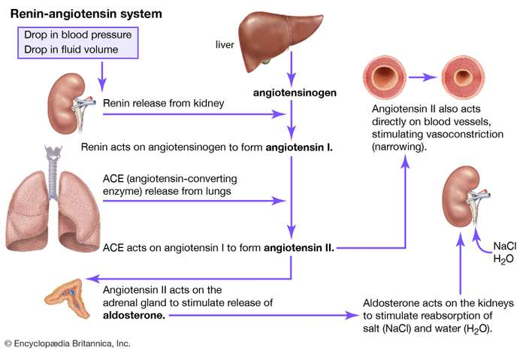

5.
Calcium Homeostasis
Calcium homeostasis is a complex process involving the following 4 key components: serum calcium, serum phosphate, 1,25-dihydroxyvitamin D-3, and parathyroid hormone (PTH).
A schematic diagram of calcium homeostasis can be seen below.
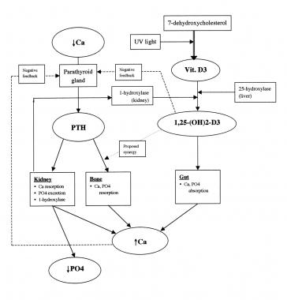
Parathyroid hormone (PTH)
Parathyroid hormone (PTH) is a polypeptide containing 84 amino acids that is secreted by the parathyroid glands. The major target end organs for parathyroid hormone (PTH) action are the kidneys, skeletal system, and intestine.
The primary response to parathyroid hormone (PTH) by the kidney is to increase renal calcium resorption and phosphate excretion. In the kidney, parathyroid hormone (PTH) blocks reabsorption of phosphate in the proximal tubule while promoting calcium reabsorption in the ascending loop of Henle, distal tubule, and collecting tubule.
Only 60% of plasma calcium is reabsorbed by the kidney. 1% of the plasma calcium is excreted. Out of the 60%; 65% is reabsorbed in the proximal tubules, 25-30% is reabsorbed in the loop of Henle and 4-9% is reabsorbed in the distal tubule and collecting tubules. An increase in calcium intake will increase the renal calcium excretion. Excretion of calcium in excess will decrease as a result of enhanced tubular excretion.
In the proximal the reabsorption takes place through the paracellular pathway; dissolved in water and carried with the reabsorped fluid between cells. Only 20% out of the 65% of calcium is rrabsorped through the transcellular pathway in 2 steps:
. Calcium diffuses from the tubular lumen into the cell down an electrochemical gradient due to much higher concentration of calcium in the lumen and there is a negative charge in the cell interior compared to the tubular lumen.
. Calcium exits the cell across the basolateral membrane by a calcium ATPase pump and by sodium-calcium counter transporter.
In the loop of Henle, it is restricted to the thick ascending limb. Out of the 25-30%, 50% occurs through the paracellular route by passive diffusion due to slight positive charge in the tubular lumen relative to the interstitial fluid. The other 50% occurs through the transcellular pathway; stimulated by the para-thyroid hormone.
In the distal tubule, calcium reabsorption occurs by active transport through the cell membrane. It involves diffusion across the luminal membrane through calcium channels and exit across the basolateral membrane by a calcium-ATPase pump. Para-thyroid hormone stimulates this mechanism.

