DATE: 23/05/2020
NAME: ADEKUNLE GLORIA. J
MATRIC. NO: 16/SCI01/001
COURSE CODE: CSC406
COURSE TITLE: HUMAN COMPUTER INTERACTION

LMS ASSIGNMENT 5
- Define Visual Perception and write on the three factors associated with visual perception
Solution
Visual perception is the ability of interpreting and integrating visual information with the other parts of the brain i.e. to perceive our surroundings through the light that enters our eyes. It is the connections that are made from the visual cortex to the visual association cortex it involves two main streams which are the dorsal / ambient stream and the ventral / focal stream.
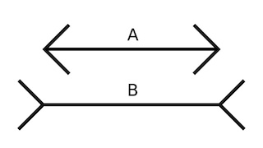
The visual perception of colors, patterns, and structures has been of particular interest in relation to graphical user interfaces (GUIs) because these are perceived exclusively through vision. An understanding of visual perception therefore enables designers to create more effective user interfaces.

Three factors that associated with visual perception may include;
- Visual spatial skills: Visual spatial skills are a group of skills that we utilize for the organizational through understanding directional concepts. This skills subset is one of the three components of visual perceptual processing.

- Visual analysis skills: Visual analysis skills refer to a group of skills that enable an individual to recognize the features related to the visual stimulus. These include figure ground, visual form recognition and constancy, visual closure, visual spatial memory, visual sequential memory, visualization, and visual span and speed.

- Visual integration skills: Visual integration skills are a set of skills under visual perceptual processing. They include the visual skills that enable a person to put together one sensory information with another of the same sense, or a group of sensory information of one sense with that of another sense.

