- Vitamins can be broadly classified into 2 main categories based on their solubility
- Fat soluble vitamins
- Water soluble vitamins
Biochemical importance include helping regulate cell growth, reproduction, digestion and they also act as antioxidants.

- Thymine- TDP is the coenzyme that is connected with the energy releasing reaction in carbohydrates metabolism; the enzyme dehydrogenase catalyses ( oxidative decarboxylation) the irreversible conversion of pyruvate to acetyl co-A
Riboflavin- FMN is the coenzyme that participates in many redox reaction responsive for energy production

Base | Nucleoside | Nucleotide | Abbreviation | Nucleic acid
Purine
Adenine | Adenosine  Deoxyadenosine | Adenylate  Deoxyadenylate | Amp  Damp | RNA  DNA
Guanine | Guanosine  Deoxyguanosine | Guanylate  Deoxyguanylate | Gmp  Dgmp | RNA  DNA
Pyrimidines
Cytosine | Cytidine  Deoxycytidine | Cytidylate  Deoxycytidylate | Cmp  Dcmp | RNA  DNA
Thymine | Deoxythymine | Deoxythymidylate | Dtmp | DNA
Uracil | Uridine | Uridylate | Ump | RNA

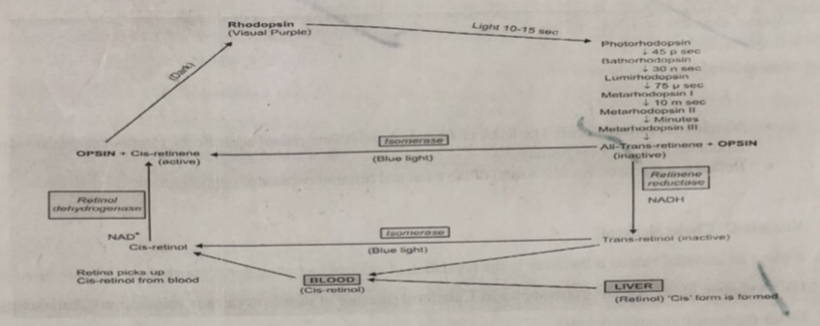
5. When a person shifts from a bright light to a dim light rhodopsin stored are depleted and vision is impaired. However within a few minutes known as dark adaptation time rhodopsin is resynthesized and vision is impaired. Dark adaptation time is increased in vitamin A deficient individuals.

6. Vitamin D is the unnamed vitamin and is absorbed in the small intestine for which bile is essential; vitaminD enters the circulation bound to plasma -alpha globulin and is distributed through the body

7. Acid hydrolysis cleaves susceptible Purine N- glycosyl bond in both DNA and RNA , when RNA is boiled in dilute acid adenine and guanine are released leaving an apurin acid which maybe further hydrolysis to a mixture of pyrimidine nucleotides. The pyrimidine are more resistant to acid hydrolysis
Alkali hydrolysis of RNA produces a mixture of 2 and 3 prime nucleotides of cyclic mono phosphate intermediate

8. The double helix structure was proposed by James Watson and Franck’s crick in 1953 and it can be compensated to a twisted ladder; the two strands are anti parallel; the width is 20degreeA; each strand of DNA has a hydrophilic deoxyribose phosphate backbone; each turn if the helix is 34 degrees A; the two poly nucleotide chains are of identical but complementary to each other due to base pairing
9.
 | RNA | DNA
Sugar moiety | Ribose | Deoxyribose
Nitrogenous bases | Adenine guanine cytosine and uracil | Adenine guanine thymine and cytosine
Pairing | Adenine pairs with uracil | Adenine pairs with thymine
Number of strand | One | Two
Reaction with alkali | Hydrolyses | No effect

10. Functions
- Nucleotides are activated precursors of DNA and RNA
- Nucleotides of adenine acts as carrier of methyl group in the form of S-adenoyl methionine
- ATP is a universal currency if energy in biological system
- Gtp is involved in protein synthesis as source of energy
- Adenine nucleotides are components of 3 major enzymes NAD+, FAD+, CoA
- Nucleotides are metabolic regulators e.g C-AMP and c GMP

