NAME: OMISORE DAMILOLA OLUWASENI
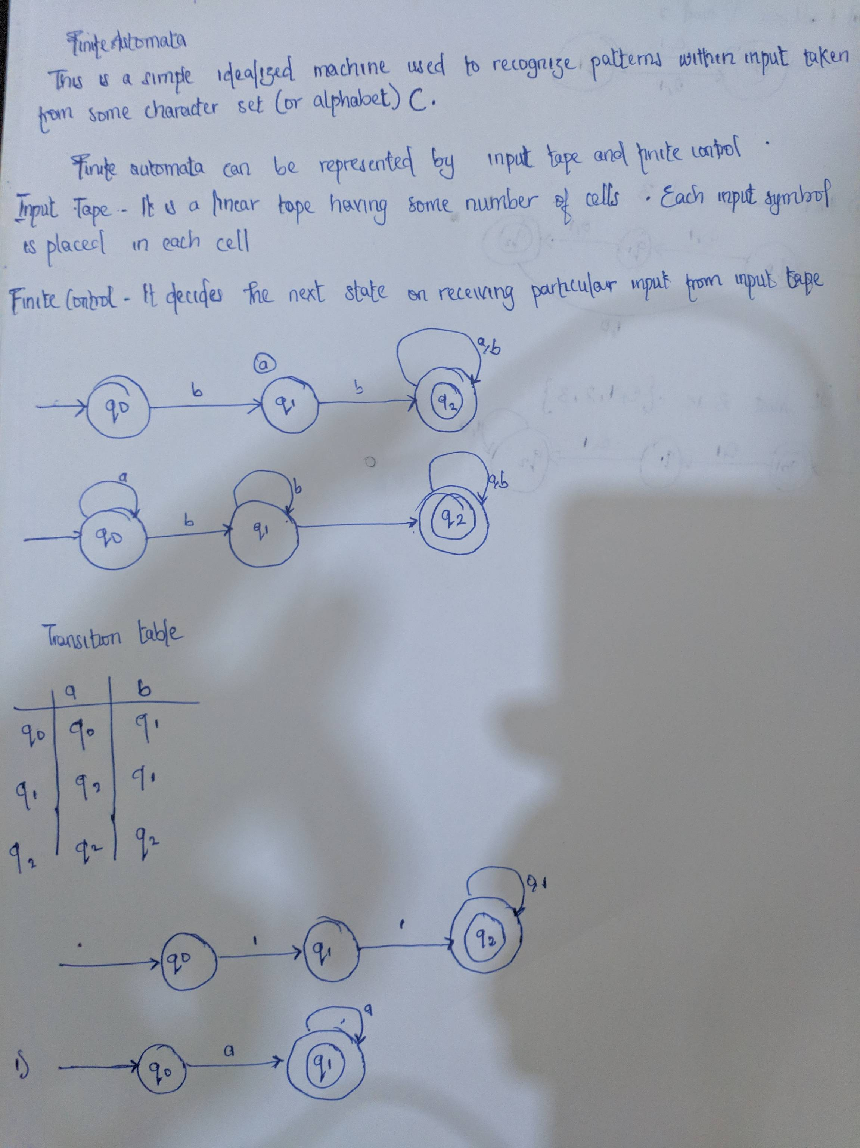
MATRIC NO: 17/SCI01/068
COURSE CODE: CSC 304

ASSIGNMENT

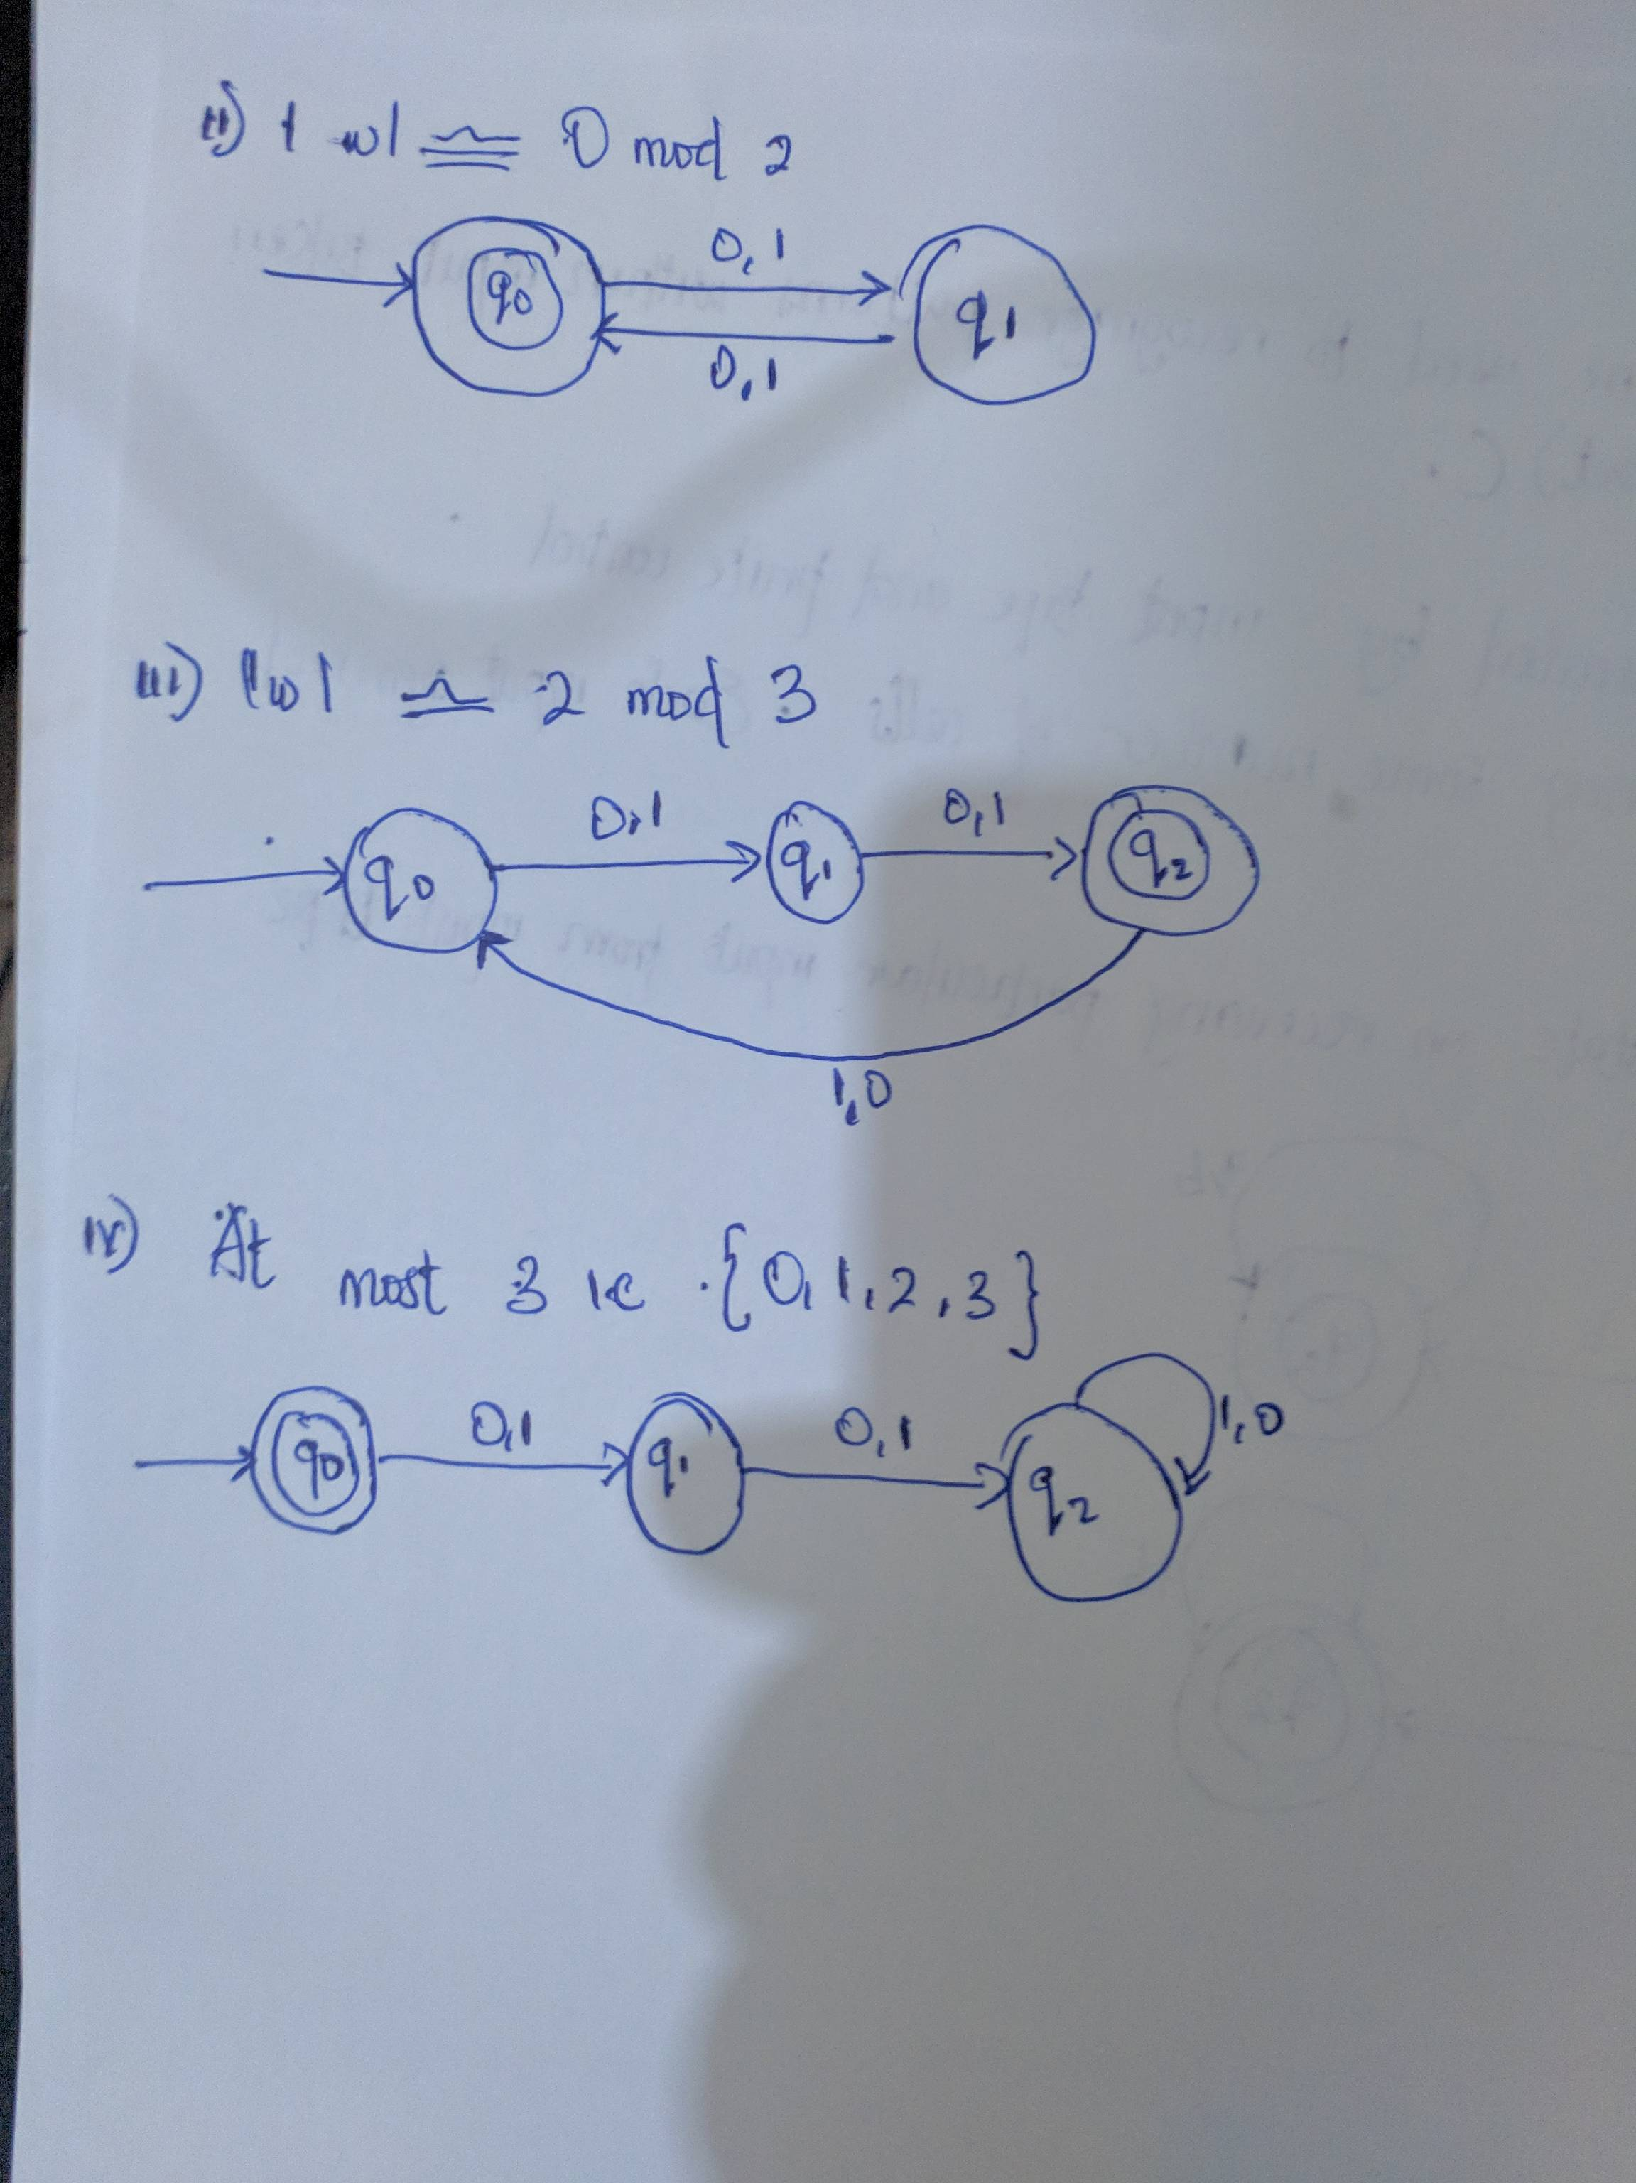

H

