OLAJIDE RAADIYYAH OYINLOLA
18/MHS06/041
MEDICAL LABORATORY SCIENCE
BCH202
ANS 1) Vitamins are generally classified as water-soluble vitamins and fat-soluble vitamins.
1. Fat-Soluble Vitamins
Vitamin A, D, E and K are fat-soluble. These are stored in adipose tissues and hence are called fat-soluble vitamins.
2. Water-Soluble Vitamins
Vitamins in B-group and vitamin C are water-soluble and cannot be stored in our bodies as they pass with the water in urine. These vitamins must be supplied to our bodies with regular diets
Biological importance of fat soluble vitamins
Vitamin A
Vision, support, support to immune system and inflammatory systems, cell growth and development, antioxidant activity, promoting proper cell communication
Vitamin D
Vitamin D is important for normal body functioning as its deficiency cause the malformation and softening of bones. Vitamin D increases the calcium absorption from food and reduces the losses through urine. It also maintains the blood calcium level by pulling out the calcium from bones but this option prevails only if there is sufficiently enough vitamin D in foods. Vitamin D is involved in maturation of white blood cells that is frontline for immunity responses.
Vitamin E
LDL (low-density lipoprotein) cholesterol is protected by vitamin E from oxidative damage caused by free radicals.
Vitamin K
Vitamin K is important for bone health and blood clotting.
Biochemical importance of water soluble vitamins
B1
Importance of vitamin B1 can be realized with the fact that it acts as gate keeper among the carbohydrate breakdown (less energy step), Krebs cycle (high energy step) and electron transport chain. So, this vitamin is central in energy metabolism and its deficiency can seriously impair the energy metabolism.
B2
Glutathione is most important antioxidant which provides antioxidative protection to body, and this antioxidant is recycled in the human body by vitamin B2. This vitamin promotes iron metabolism and its deficiency also increase the risk of anemia as iron is important element for red blood cell production.
B3
Starch is synthesized from niacin and stored in liver and muscles as energy source. NAD NADP and niacin containing enzymes are also quenchers of free radicals and protect the tissues from oxidative damage.
B5
Pantothenic acid is incorporated into Coenzyme A (CoA) which has central position for energy metabolism.
B6
Functionally B6 is very important vitamin as it is involved in red blood cell production, carbohydrate metabolism, liver detoxification, brain and nervous system health.
This vitamin is also involved in production of messaging molecules in brain and nervous system, known as neurotransmitter. Dopamine, GABA and serotonin are key neurotransmitters whose biosynthesis is dependent on vitamin B6.
B9
Well-known role of folates is to support the brain health. Messengers molecules are produced which are used by nerves to send the signals in whole body. BH4 cycle (tetrahydrobiopterin) reveals that there is close association between folates and neurotransmitters especially serotonin and dopamine. Folates regulate the homocysteine level in the blood.
B12
Besides these distinctions, this vitamin is also very important for cardiovascular health of human. Vitamin B12 is involved in production of red blood cells which are oxygen carrier throughout the blood stream with the help of hemoglobin pigment. Succinyl-CoA is the building block for hemoglobin and this building block is dependent on the vitamin B12.
Vitamin B12 maintains the supply of succinyl-coA for citric acid, so this vitamin has key role in aerobic energy metabolism. B12 also maintain the bone health as incidence of osteoporosis is increased with deficiency of this vitamin.
B7
Insulin, hormone that maintains sugar balance, production and functioning on cell are impaired due to deficiency of biotin. Biotin is needed for fat deposition in the skin. These fats are prerequisite for keeping the skin moist and supple whereas, in case of deficit fats, skin becomes irritated and flaky or scaly.
Vitamin c
This vitamin has antioxidant properties and protects the lens of eyes, molecules circulating in bloodstream and genetic material (DNA) from harmful effects of free radicals. This vitamin also transforms iron into a form which can be easily absorbed into intestines. This vitamin is needed for collagen production which is structural component of human body.

ANS2) Role of Pyridoxal phosphate the active form of vitamin B₆ is a coenzyme in a variety of enzymatic reactions. The Enzyme commission has catalogued more than 140 PLP-dependent activities, corresponding to ~4% of all classified activities. The versatility of PLP arises from its ability to covalently bind the substrate, and then to act as an electrophilic catalyst, thereby stabilizing different types of carbanionic reaction intermediates.
Role of coenzyme-A as a coenzyme synthesized by pantothenic acid
Pantothenic acid helps to synthesize coenzyme-A (CoA) which is an important coenzyme that reacts with carboxylic acids to form thioesters, thus functioning as an acyl group carrier. It assists in transferring fatty acids from the cytoplasm to mitochondria. A molecule of coenzyme A carrying an acyl group is also referred to as acyl-CoA.
ANS3)
BASES | PURINES |  | PYRIMIDINES
 | ADENINE(A) | GUANINE(G) | CYTOSINE(C) | URACIL(U)/ THYMINE(T)
NUCLEOSIDES | ADENOSINE | GUANOSINE | CYTIDINE | URIDINE | RNA
 | DEOXYADENOSINE | DEOXYGUANOSINE | DEOXYCYTIDINE | DEOXYTHYMIDINE | DNA
NUCLEOTIDES | ADENYLATE(AMP) | GUANYLATE(GMP) | CYTIDYLATE(CMP) | URIDYLATE(UMP) | RNA
 | DEOXYADENYLATE | DEOXYGUANYLATE | DEOXYCYTIDYLATE | DEOXYTHYMIDYLATE | DNA

ANS4) 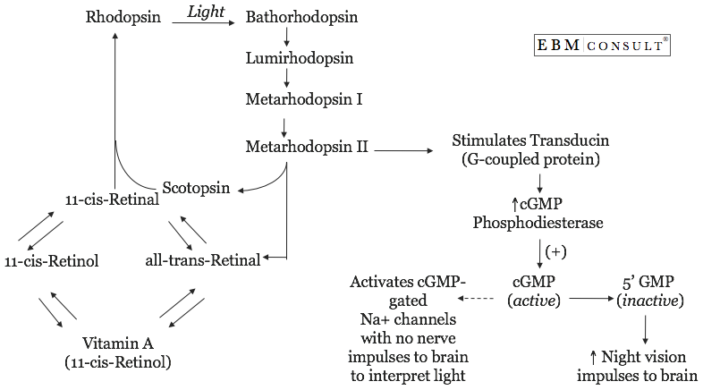

ANS5)
The pupil is an opening that lets light into the eye. Since most of the light entering the eye does not escape, the pupil appears black. In dim light, the individual’s pupil expands to allow more light to enter the eye. In bright light, it contracts. the pupil can range in diameter from 1/16 inch (1.5 mm) to more than 1/3 inch (8 mm). Light detected by the retina of the eye is converted to nerve impulses that travel down the optic nerve. Some of these nerve impulses go from the optic nerve to the muscles that control the size of the pupil. More light creates more impulses, causing the muscles to close the pupil. Part of the optic nerve from one eye crosses over and couples to the muscles that control the pupil size of the other eye. That’s why the pupil of one eye can change when you shine the light into your other eye.

ANS6)
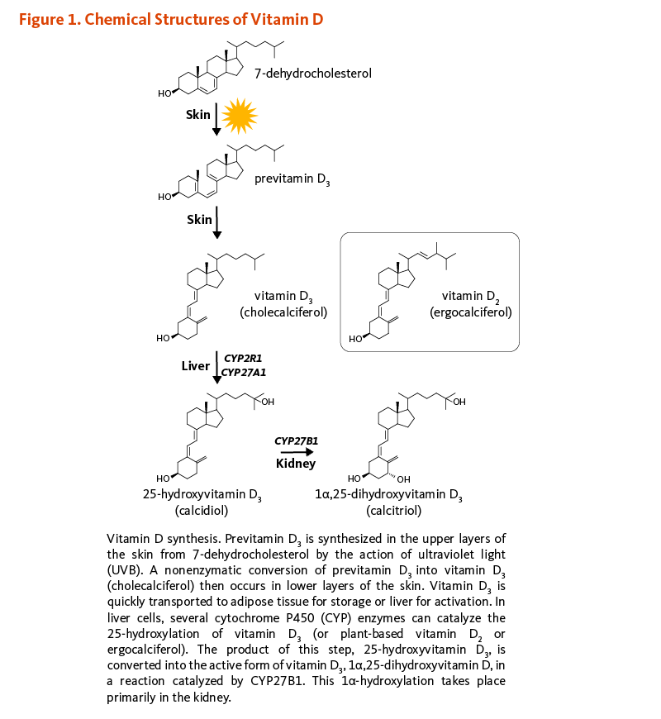

ANS7) The damage that an acid or an alkali can cause to DNA depends on the concentration in which you are exposing the nucleic acid to the respective chemical and also another major factor to be considered here is which type of DNA is considered, i.e. Genomic DNA or Plasmid DNA, if Genomic then whether prokaryotic, viral or eukaryotic, etc.
· Considering the effect of alkali to the genomic DNA:
1. If DNA is exposed to low concentration of alkali:
Low concentration of alkali will not be too harmful to the nucleic acid though some damage is obviously incurred like for instance denaturation of some binding proteins or breakage of a few hydrogen bonds of the base pairing,etc.
2. If DNA is exposed to moderate concentration of alkali:
Moderate concentrate of alkali causes deprotonation and the hydrogen bonding between the base pairs is disrupted causing the DNA to denature.
3. If DNA is exposed to high concentration of alkali:
High concentration of base will induce a hydrolysis of the phosphodiester bonds of the DNA and the DNA will be cleaved into smaller fragments.
Alkali treatment is often used for isolation of plasmid DNA or any other extra chromosomal material so as to ensure the degradation of genomic DNA to avoid contamination of it into the desired product.
Considering the effect of Acid on Genomic DNA:
1.If DNA is exposed to low pH conditions:
At low pH i.e. acidic conditions, the DNA is deprived of the purines. This causes DNA melting. Also since A+G content is lost 50% of the sequence of the DNA is lost.
2. If DNA is exposed to extremely low pH conditions (pH<3)
At extremely low pH i.e. high acidic conditions the phosphodiester bonding of the DNA is disrupted which cleaves the DNA into nucleosides and nucleotides.
The effect of acid on DNA is the reason as to why the pH in the stomach is low. Since the pH is nearing 2.0 most of the bacterial load is reduced prior to digestion and decontaminated food is passed further.

ANS8) Watson and Crick were not the discoverers of DNA, but rather the first scientists to formulate an accurate description of this molecule's complex, double-helical structure. Moreover, Watson and Crick's work was directly dependent on the research of numerous scientists before them, including Friedrich Miescher, Phoebus Levene, and Erwin Chargaff, contributed to Watson and Crick's derivation of the three-dimensional, double-helical model for the structure of DNA. Watson and Crick's discovery was also made possible by recent advances in model building, or the assembly of possible three-dimensional structures based upon known molecular distances and bond angles, a technique advanced by American biochemist Linus Pauling. In fact, Watson and Crick were worried that they would be "scooped" by Pauling, who proposed a different model for the three-dimensional structure of DNA just months before they did. In the end, however, Pauling's prediction was incorrect.
Using cardboard cutouts representing the individual chemical components of the four bases and other nucleotide subunits, Watson and Crick shifted molecules around on their desktops, as though putting together a puzzle. They were misled for a while by an erroneous understanding of how the different elements in thymine and guanine (specifically, the carbon, nitrogen, hydrogen, and oxygen rings) were configured. Only upon the suggestion of American scientist Jerry Donohue did Watson decide to make new cardboard cutouts of the two bases, to see if perhaps a different atomic configuration would make a difference. It did. Not only did the complementary bases now fit together perfectly (i.e., A with T and C with G), with each pair held together by hydrogen bonds, but the structure also reflected Chargaff's rule. Although scientists have made some minor changes to the Watson and Crick model, or have elaborated upon it, since its inception in 1953, the model's four major features remain the same yet today. These features are as follows:
DNA is a double-stranded helix, with the two strands connected by hydrogen bonds. Bases are always paired with Ts, and Cs is always paired with Gs, which is consistent with and accounts for Chargaff's rule.
Most DNA double helices are right-handed; that is, if you were to hold your right hand out, with your thumb pointed up and your fingers curled around your thumb, your thumb would represent the axis of the helix and your fingers would represent the sugar-phosphate backbone. Only one type of DNA, called Z-DNA, is left-handed.
The DNA double helix is anti-parallel, which means that the 5' end of one strand is paired with the 3' end of its complementary strand (and vice versa). As shown in Figure 4, nucleotides are linked to each other by their phosphate groups, which bind the 3' end of one sugar to the 5' end of the next sugar.
Not only are the DNA base pairs connected via hydrogen bonding, but the outer edges of the nitrogen-containing bases are exposed and available for potential hydrogen bonding as well. These hydrogen bonds provide easy access to the DNA for other molecules, including the proteins that play vital roles in the replication and expression of DNA
ANS9)

RNA | DNA
RNA is single stranded except in some viruses | DNA is double stranded except in few viruses
RNA have ribose sugar | DNA have deoxyribose sugar
Bases present are adenine, guanine, cytosine and uracil. | Bases present are adenine, guanine, cytosine and thymine
Adenine pairs with uracil | Adenine pairs with thymine
purine is not equal to pyrimidine | Purine is equal to pyrimidine (Chargaff’s rule)
regions having complementary nucleotides, pairs, and form hair pin loop like structure and helical | Complementary nucleotides are present throughout the length of the DNA.
RNA is genetic material in some viruses. | DNA is the genetic material in all living things.
Length of RNA is short consisting of only few thousands nucleotides | Length of DNA is quite large consisting of millions of nucleotides.

ANS10) Purine and pyrimidine nucleotides fill a variety of metabolic roles. They are the “energy currency” of the cell. In some cases, they are signaling molecules, acting like hormones directly or as transducers of the information. They provide the monomers for genetic information in DNA and RNA. Besides being the basic unit of genetic material for all living things, a nucleotide can have other functions as well. A nucleotide can be a base in another molecule, such as adenosine triphosphate (ATP), which is the main energy molecule of the cell. They are also found in coenzymes like NAD and NADP, which come from ADP; these molecules are used in many chemical reactions that play roles in metabolism. Another molecule that contains a nucleotide is cyclic AMP (cAMP), a messenger molecule that is important in many processes including the regulation of metabolism and transporting chemical signals to cells. Nucleotides not only make up the building blocks of life, but also form many different molecules that function to make life possible.

