NAME: NNAJI FAVOUR
MATRIC NUMBER: 17/MHS01/202
COURSE: PHS
QUESTION 1
ROLE OF KIDNEY IN GLUCOSE HOMEOSTASIS
The regulation of endogenous production of glucose is determined by hormonal and neural factors. In the acute phase, glucoregulatory mechanisms involve insulin, glucagon and catecholamines and they can effect changes in plasma glucose levels in a matter of minutes. Insulin is able to suppress glucose release in both the kidney and liver by direct enzyme activation deactivation and by reducing the availability of gluconeogenic substrates. Glucagon has no effect on the kidneys, but it stimulates glycogenolysis and gluconeogenesis in the liver. Catecholamines also have multiple acute actions. They can stimulate renal glucose release and glucagon secretion and inhibit insulin secretion.
The kidneys are involved in maintaining glucose homeostasis through three different mechanisms: gluconeogenesis; glucose uptake from the blood for its own energy requests and reabsorption into the general circulation of glucose from glomerular filtrate in order to preserve energy.
1. Renal gluconeogenesis
From the point of view of glucose utilization, the kidney is considered as 2 separate organs; the renal medulla is characterized mainly by glucose utilization and the renal cortex is responsible for glucose release. The separation of these activities represents the consequence of differences in the distribution of numerous enzymes along the nephron. The cells in the renal medulla can use only glucose for their needs (like the brain) and they have enzymes capable of glucose-phosphorylation and glycolysis. They can therefore phosphorylate important amounts of glucose and accumulate glycogen but, because these cells do not have glucose-6-phosphatase or any other gluconeogenic enzymes, they are unable to release glucose into the bloodstream. Moreover, the cells in the renal cortex have gluconeogenic enzymes and they can produce and release glucose into the circulation. However these cells cannot synthesize glycogen because they have little phosphorylating capacity.
After a 16-h overnight fast, approximately 10 µmol ⁄ (kg /min) of glucose is released into the circulation. Almost 50% of this is the result of glycogenolysis from the liver stocks and the other half is produced by liver and kidney gluconeogenesis. The renal cortex (like the liver) contains gluconeogenic enzymes and it can synthesize glucose-6-phosphate from precursors (lactate, glutamine, glycerol and alanine). Because it contains glucose-6-phosphatase, it is able to release glucose into the blood stream and the human liver and kidneys are the only organs that can perform gluconeogenesis. Therefore, after an overnight fast, the liver produces 75–80% of glucose released into the circulation and the remaining 20–25% is derived from the kidneys.
An important aspect is that kidney and liver use different gluconeogenic precursors and several hormones have different effects on their release of glucose. Lactate represents the predominant gluconeogenic precursor in both organs, but regarding the amino acids, the kidney prefers to use glutamine, whereas the liver preferentially uses alanine. Insulin can suppress glucose release in both organs with almost comparable efficacy, whereas glucagon stimulates hepatic glucose release only. Catecholamines normally have a direct effect only on renal glucose release, but their effect on both hepatic and renal glucose release may be indirect by increasing the quantity of gluconeogenic substrates available and by suppressing insulin secretion. Other hormones, such as growth hormone, cortisol and thyroid hormones can stimulate hepatic glucose release over a great period of time. Their effects on the kidneys regarding glucose release in humans are not completely deciphered.
2. Glycogenolysis
Glycogenolysis is the breakdown of glycogen to glucose-6-phosphate and a hydrolysis reaction (using glucose-6-phosphatase) in order to free glucose. The liver is the only organ that contains glucose-6-phosphatase. So, the cleavage of hepatic glycogen releases glucose, while the cleavage of glycogen from other sources can release only lactate. Lactate that is generated via glycolysis is often absorbed by other organs and helps regenerating glucose.
3. Glucose reabsorption
Apart from the important role in gluconeogenesis and the role of renal cortex in glucose uptake, the kidneys contribute to glucose homeostasis by filtering and reabsorbing glucose. In normal conditions, the kidneys can reabsorb as much glucose as possible, the result being a virtually glucose free urine. Approximately 180 grams of glucose are filtered by the glomeruli from plasma, daily but all of this quantity is reabsorbed through glucose transporters that are present in cell membranes located in the proximal tubules.
These glucose transporters have a limited capacity of reabsorption. If this capacity is exceeded, glucose usually appears in the urine. The tubular maximum for glucose (TmG), the term used for the maximum capacity, can vary from 260 to 350 mg/min/1.73 m² in healthy subjects. It corresponds to blood glucose levels of 180-200 mg/dL. When the blood glucose is very high and the TmG is reached, the transporters cannot reabsorb all the glucose and glucosuria occurs. Nevertheless, there can be slight differences between the nephrons and the inaccurate nature of biological systems may potentially lead to the development of glucosuria when blood glucose is below TmG. Glucosuria may occur at lower plasma glucose levels in certain conditions of hyperfiltration (e.g. pregnancy), but as a consequence of hyperfiltration and not of significant hyperglycemia.
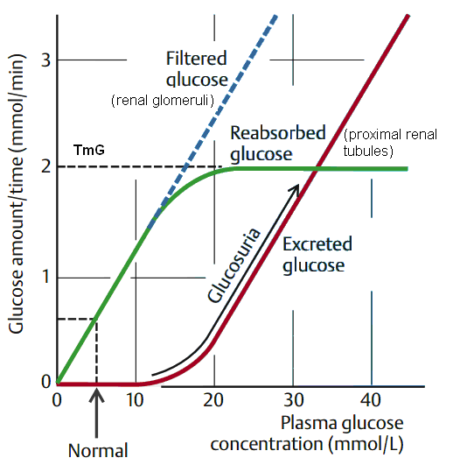
In a given day, the kidneys can produce, via gluconeogenesis, 15–55g glucose and it can metabolize 25–35g glucose. Regarding the glucose metabolic pathways, it is obvious that renal reabsorption represents the main mechanism by which the kidney is involved in glucose homeostasis. Therefore, the change in tubular glucose reabsorption may have a considerable impact on glucose homeostasis

QUESTION 2
DISCUSS PROCESS OF MICTURITION
Micturition
Micturition or urination is the process of expelling urine from the bladder. This act is also known as voiding of the bladder. The excretory system in humans includes a pair of kidneys, two ureters, a urinary bladder and a urethra. The kidneys filter the urine and it is transported to the urinary bladder via the ureters where it is stored till its expulsion. The process of micturition is regulated by the nervous system and the muscles of the bladder and urethra. The urinary bladder can store around 350-400ml of urine before it expels it out.
Stages of Micturition
The urinary bladder has two distinct stages or phases:
- Resting or filling stage
- Voiding stage
Resting or Filling Stage
It is in this phase of the bladder that the urine is transported from the kidneys via the ureters into the bladder. The ureters are thin muscular tubes that arise from each of the kidneys and extend downwards where they enter the bladder obliquely.
The oblique placement of the ureters in the bladder wall serves a very important function. The opening of the ureter into the urinary bladder is not guarded by any sphincter or muscle. Therefore, this oblique nature of opening prevents the urine from re-entering the ureters. At the same time, the main muscle of the urinary bladder, the detrusor muscle, is relaxing allowing the bladder to distend and accommodate more urine.
Voiding Stage
During this stage, both the urinary bladder and the urethra come into play together. The detrusor muscle of the urinary bladder which was relaxing so far starts to contract once the bladder’s storage capacity is reached.
The urethra is controlled by two sets of muscles: The internal and external urethral sphincters. The internal sphincter is a smooth muscle whereas the external one is skeletal. Both these sphincters are in a contracted state during the filling stage.
Physiology of Micturition
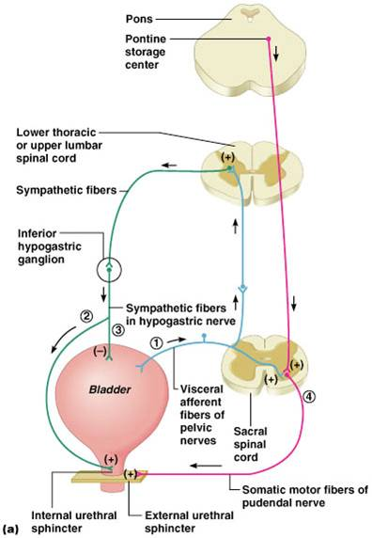
As mentioned earlier, the process of micturition is governed by both the nervous and muscular systems. Within the nervous system, the process is governed by the autonomous nervous system and the somatic system. Once the urinary bladder reaches its maximum capacity, the stretch receptors in the walls of the bladder send an impulse via the pelvic nerve to the brain via the spinal cord.
The micturition reflex is ultimately generated from the level of the spinal cord after it receives reflexes from the pontine region in the brain. Once the bladder and the urethra receive the signals to empty the bladder, the two sphincters relax and the detrusor muscle causes the contractions of the bladder.
Along with these muscles, the muscles of the abdomen also play a role by putting pressure on the bladder wall. This leads to complete emptying of the bladder.

QUESTION 3
EXPLAIN JUXTAGLOMERULAR APPARATUS
The juxtaglomerular apparatus is a microscopic structure in the kidney, which regulates the function of each nephron. The juxtaglomerular apparatus is named for its proximity to the glomerulus: it is found between the vascular pole of the renal corpuscle and the returning distal convoluted tubule of the same nephron. This location is critical to its function in regulating renal blood flow and glomerular filtration rate. The three cellular components of the apparatus are the macula densa of the distal convoluted tubule, smooth muscle cells of the afferent arteriole and juxtaglomerular cells.
Cells of the Juxtaglomerular Apparatus
The juxtaglomerular apparatus consists of: (1) the juxtaglomerular cells, (2) the macula densa, (3) the Lacis cells or extra mesangial cells.
Granular Cells
Granular cells are modified pericytes of glomerular arterioles. They are also known as juxtaglomerular cells (juxtaglomerular cells are not granular cells but are granulated as they release renin).
The juxtaglomerular cells secrete renin in response to:
- Beta-1 adrenergic stimulation
- Decrease in renal perfusion pressure (detected directly by the granular cells)
- Decrease in NaCl concentration at the macula densa, often due to a decrease in glomerular filtration rate, resulting in slower filtrate movement through the proximal tubule and thus more time for reabsorption.
Extraglomerular mesangial cells
Extraglomerular mesangial cells are located in the junction between the afferent and efferent arterioles. These cells have a contractile property similar to vascular smooth muscles and thus play a role in “regulating GFR” by altering the vessel diameter. Renin is also found in these cells.
Macula densa
At the point where the afferent arterioles enter the glomerulus and the efferent arteriole leaves it, the tubule of the nephron touches the arterioles of the glomerulus from which it rose. At this location, in the wall of the distal convoluted tubule, there is a modified region of tubular epithelium called the macula densa. Cells in the macula densa respond to changes in the sodium chloride levels in the distal tubule of the nephron via the tubuloglomerular feedback (TGF) loop.

The macula densa's detection of elevated sodium chloride, which leads to an increase in GFR, is based on the concept of purinergic signalling. An increase in the salt concentration causes several cell signals to eventually cause the adjacent afferent arteriole to constrict. This decreases the amount of blood coming from the afferent arterioles to the glomerular capillaries, and therefore decreases the amount of fluid that goes from the glomerular capillaries into the Bowman's space (the glomerular filtration rate (GFR)). When there is a decrease in the sodium concentration, less sodium is reabsorbed in the macular densa cells. The cells increase the production of nitric oxide and Prostaglandins to vasodilate the afferent arterioles and increase renin release.
QUESTION 4
ROLE OF KIDNEY IN BLOOD PRESSURE RGULATION
The kidney influences blood pressure by:
- Causing the arteries and veins to constrict
Specialized cells are located in a portion of the distal tubule located near and in the wall of the afferent arteriole. The distal tubule cells (macula densa) sense the Na in the filtrate, and the arterial cells (juxtaglomerular cells) sense the blood pressure. When the blood pressure drops, the amount of filtered Na also drops. The juxtaglomerular cells sense the drop in blood pressure and the decrease in Na is relayed to them by the macula densa cells. The juxtaglomerular cells then release an enzyme called renin. Renin converts angiotensinogen (a peptide, or amino acid derivative) into angiotensin I. Angiotensin I is then converted to angiotensin II by an angiotensin-converting enzyme (ACE), which is found mainly in the lungs. Angiotensin II causes blood vessels to contract -- the increased blood vessel constrictions elevate the blood pressure.
- Increasing the circulating blood volume
Angiotensin II also stimulates the adrenal gland to secrete a hormone called aldosterone. Aldosterone stimulates more Na reabsorption in the distal tubule, and water gets reabsorbed along with the Na. The increased Na and water reabsorption from the distal tubule reduces urine output and increases the circulating blood volume. The increased blood volume helps stretch the heart muscle and causes it to generate more pressure with each beat, thereby increasing the blood pressure.
QUESTION 5
ROLE OF KIDNEY IN CALCIUM HOMEOSTASIS
When blood calcium levels drop, proteins in the parathyroid glands that detect calcium send signals to help secrete parathyroid hormones, or PTH. This hormone helps convert vitamin D into its active form known as calcitriol. Calcitriol in the kidneys increases the absorption of calcium. Both PTH and calcitriol help release calcium in bones by activating osteoclasts. These cells help reabsorb calcium, decreasing calcium excretion in the urine, allowing it to be reabsorbed in the kidneys. When calcium is at a normal level, parathyroid glands cease secretion of PTH and excess calcium is expelled in the urine, which can lead to problems in the kidneys if your calcium level is high.

