NAME: OBUNADIKE CHINENYE

MATRIC NUMBER: 17/mhs01/225

COURSE CODE:PHS 303

ASSIGNMENT

1) DISCUSS THE ROLE OF THE KIDNEY IN GLUCOSE HOMEOSTASIS

2) DISCUSS THE PROCESS OF MICTURITION

3) EXPLAIN JUXTAGLOMERULAR APPARATUS

4) DISCUSS THE ROLE OF THE KIDNEY IN REGULATION OF BLOOD PRESSURE

5) DISCUSS THE ROLE OF THE KIDNEY IN CALCIUM HOMEOSTASIS.

**ROLE OF THE KIDNEY IN GLUCOSE REGULATION**

**INTRODUCTION**

Maintenance of glucose homeostasis is crucial in preventing pathological consequences that may result from hyperglycemia or hypoglycemia. Chronically uncontrolled hyperglycemia leads to a higher risk of macrovascular and microvascular complications, such as cardiovascular disease, nephropathy, neuropathy, and retinopathy.Hypoglycemia, on the other hand, may lead to a myriad of central nervous system complications (eg, confusion, behavioral changes, seizures, loss of consciousness, and even death), since the brain is the body’s largest consumer of glucose in the fasting or “postabsorptive” state. Maintenance of glucose homeostasis involves several complementary physiologic processes, including glucose absorption (in the gastrointestinal tract), glycogenolysis (in the liver), glucose reabsorption (in the kidneys), gluconeogenesis (in the liver and kidneys), and glucose excretion (in the kidneys). The kidneys are capable of synthesizing and secreting many important hormones (eg, renin, prostaglandins, kinins, erythropoietin) and are involved in a wide variety of metabolic processes such as activation of vitamin D3, gluconeogenesis, and metabolism of numerous endogenous compounds (eg, insulin, steroids). With respect to renal involvement in glucose homeostasis, the primary mechanisms include release of glucose into the circulation via gluconeogenesis, uptake of glucose from the circulation to satisfy the kidneys’ energy needs, and reabsorption of glucose at the level of the proximal tubule.

**THE KIDNEY INVOLVEMENT IN GLUCOSE HOMEOSTASIS**

The kidneys are involved in maintaining glucose homeostasis through three different mechanisms:

**1) Gluconeogenesis:** After a 16-h overnight fast, approximately 10 µmol ⁄ (kg /min) of glucose is released into the circulation. Almost 50% of this is the result of glycogenolysis from the liver stocks and the other half is produced by liver and kidney gluconeogenesis. The renal cortex (like the liver) contains gluconeogenic enzymes and it can synthesize glucose-6-phosphate from precursors (lactate, glutamine, glycerol and alanine). Because it contains glucose-6-phosphatase, it is able to release glucose into the blood stream and the human liver and kidneys are the only organs that can perform gluconeogenesis. Therefore, after an overnight fast, the liver produces 75–80% of glucose released into the circulation and the remaining 20–25% is derived from the kidneys. The kidney and liver use different precursors for gluconeogenesis, the kidney uses lactate and amino acid (glutamine). However, insulin suppresses in the kidney. Catecholamines have a direct effect on renal glucose release. Renal gluconeogenesis can increase by approximately twofold and it can represent ~60% of endogenous glucose production in the postprandial state . This mechanism is believed to facilitate the repletion of glycogen stocks in the liver.

**2)glucose uptake from the blood for its own energy requests** : From the point of view of glucose utilization, the kidney is considered as 2 separate organs; the renal medulla is characterized mainly by glucose utilization and the renal cortex is responsible for glucose release. The separation of these activities represents the consequence of differences in the distribution of numerous enzymes along the nephron. The cells in the renal medulla can use only glucose for their needs (like the brain) and they have enzymes capable of glucose-phosphorylation and glycolysis. They can therefore phosphorylate important amounts of glucose and accumulate glycogen but, because these cells do not have glucose-6-phosphatase or any other gluconeogenic enzymes, they are unable to release glucose into the bloodstream. Moreover, the cells in the renal cortex have gluconeogenic enzymes and they can produce and release glucose into the circulation. However these cells cannot synthesize glycogen be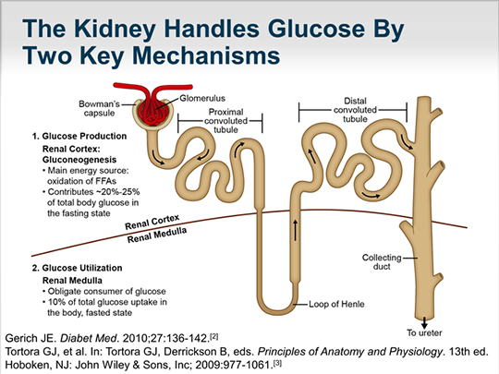

**KIDNEY MECHANISM FOR ITS OWN ABSORPTION**.

cause they have little phosphorylating capacity.

**3)Reabsorption into the general circulation of glucose from glomerular filtrate in order to preserve energy:** In addition to their important role in gluconeogenesis, the kidneys contribute to glucose homeostasis by filtering and reabsorbing glucose. Under normal conditions, the kidneys retrieve as much glucose as possible, rendering the urine virtually glucose free. The glomeruli filter from plasma approximately 180 grams of D-glucose per day, all of which is reabsorbed through glucose transporter proteins that are present in cell membranes within the proximal tubules. If the capacity of these transporters is exceeded, glucose appears in the urine. This maximum capacity, known as the tubular maximum for glucose (TmG), ranges from 260 to 350 mg/min/1.73 m2 in healthy adults and children, and corresponds to a plasma glucose level of approximately 200 mg/dL. Once the TmG (the threshold) is reached and transporters are unable to reabsorb all the glucose (as in T2DM), glucosuria ocurrs.The correlation between the degree of hyperglycemia and degree of glucosuria becomes linear when blood glucose concentrations have increased beyond a threshold.It should be noted that slight differences between individual nephrons and the imprecise nature of biological systems may alter this linear concentration/reabsorption curve, as indicated by a splay from the theoretical as the TmG is approached. As such, glucosuria may potentially develop before the expected TmG is reached. Glucosuria may also occur at lower plasma glucose concentrations in certain conditions of hyperfiltration (eg, pregnancy), but as a consequence of hyperfiltration rather than significant hyperglycemia. In a given day, the kidneys can produce, via gluconeogenesis, 15–55g glucose and it can metabolize 25–35g glucose. Regarding the glucose metabolic pathways, it is obvious that renal reabsorption represents the main mechanism by which the kidney is involved in glucose homeostasis. Therefore, the change in tubular glucose reabsorption may have a considerable impact on glucose homeostasis.

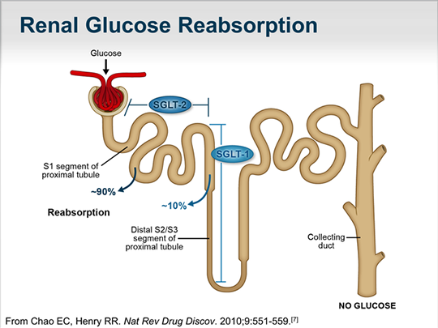

DIAGRAM SHOWING THE AREAS AND PERCENTAGE OF REABSORPTION IN THE KIDNEY THROUGH TRANSPORTERS.

**GLUCOSE TRANSPORTERS**

Glucose is a polar compound with positive and negative charged areas; therefore it is soluble in water. Its transport into and across cells is dependent on two specialized carrier protein families: the GLUTs (facilitated glucose transporters) and the SGLTs (sodium-coupled glucose cotransporters). These transporters are responsible for glucose passage and reabsorption in several tissue types, including the proximal renal tubule, blood-brain barrier, small intestine

* GLUTs are responsible for the passive transport of glucose across cell membranes, in order to equilibrate its concentrations across a membrane.
* SGLTs, on the other hand, are involved in active transport of glucose against a concentration gradient by means of sodium-glucose cotransport .

SGLT2 is considered the most important because, based on animal studies, it is responsible for the re-absorption of 90% of the glucose filtered at the glomerulus . The other 10% of glucose reabsorbed in the proximal tubule is ensured by SGLT1. Of the family of GLUT proteins expressed in the kidneys, GLUT2 is the major transporter and it releases into circulation the glucose reabsorbed by SGLTs in the proximal tubular cells.

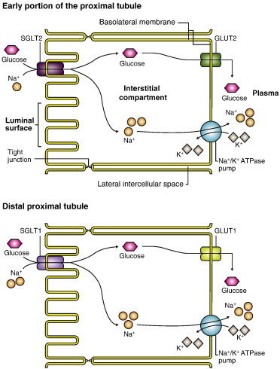

**DIAGRAM SHOWING THE TRANSPORTER OF GLUCOSE**

**QUESTION 2**  PROCESS OF MICTURITION

**DEFINITION:** Micturition is the process by which urinary bladder emptied when filled. The main physiological events in the processof micturition are:

* Filling of urinary bladder and
* Emptying of urinary bladder.

**FILLING OF URINARY BLADDER**

Transport of urine into urinary bladder through ureters

As urine collects in the renal pelvis, the pressure in the pelvis increases and initiates a peristaltic contraction beginning in the pelvis and spreading along the ureter to force urine towards the bladder.

Capacity of the bladder

Physiological capacity of the bladder varies with age, being 20–50 mL at birth, about 200 mL at 1 year, and can be as high as 600 mL in young adult males. In all cases, the physiological capacity is about twice that at which the first desire to void is felt.

**EMPTYING OF THE BLADDER**

Emptying of the bladder is basically a reflex action called the micturition reflex, which is controlled by supraspinal centres and is assisted by contraction of perineal and abdominal muscles. Therefore, emptying of the urinary bladder focuses on:

_ Micturition reflex,

_ Voluntary control of micturition and

_ Role of perineal and abdominal muscles in micturition

**Micturition reflex**

Initiation: Micturition reflex is initiated by the stimulation of the stretch receptors located in the wall of urinary bladder.

Stimulus: Filling of bladder by 300–400 mL of urine in adults constitutes the adequate stimulus for the micturition reflex to occur.

Afferents: The afferents from the stretch receptors in the detrusor muscle and urethra travel along the pelvic splanchnic nerves and enter the spinal cord through dorsal roots to S2, S3 and S4 segments to reach the sacral micturition centre

Sacral micturition centre is formed by the sacral detrusor nucleus and sacral pudendal nucleus.

Efferents: Efferents arising from the sacral detrusor nucleus are the preganglionic parasympathetic fibres, which relay in the ganglia near or within bladder and urethra . The post-ganglionic parasympathetic fibres are excitatory to the detrusor muscle and inhibitory to the internal sphincter.

Response: Once micturition reflex is initiated, it is self regenerative, i.e. initial contraction of the bladder wallfurther activates the receptors to increase the sensory impulses (afferents) from the bladder and urethra which cause further increase in the reflex contraction of detrusor muscle of the bladder. The cycle thus keeps on repeating itself again and again until the bladder has reached a strong degree of contraction

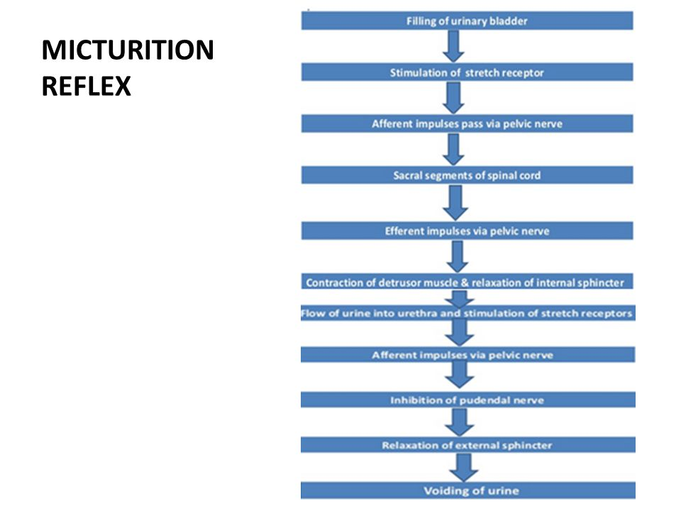

Diagram of micturition reflex.

**Voluntary control of micturition**

**Role of supraspinal centres**

The micturition reflex is fundamentally a spinal reflex facilitated and inhibited by higher brain centres (supraspinal centres) and, like defaecation, is subjected to voluntary facilitation and inhibition. In infants and young children, micturition is purely a reflex action. Voluntary control is gradually acquired as a learned ability of the toilet training.Once voluntary control is acquired, the supraspinal control centres exert final control of micturition by following

means:

_ The higher centres keep the micturition reflex partially inhibited all the time except when it is desired to micturate.

_ When the convenient time to urinate present, the higher centres facilitate the sacral micturition centre (SMC) to initiate a micturition reflex and inhibit the external urinary sphincter so that urination can occur.

Supraspinal control centres which control the micturition reflex (a completely automatic cord reflex) include the pontine micturition centre (PMC) and suprapontine centres.

Pontine micturition centre, corresponds to the locus ceruleus of the rostral pons. Neurons from PMC descend in the reticulospinal tract and exert control over the SMC and thoracolumbar sympathetics. Function of PMC is coordination of detrusor contraction and sphincter relaxation, which is important for proper micturition.

Suprapontine centres which relay their influence on the sacral micturition centre through the PMC are:

_ Cerebral cortex

_ Basal ganglion

_ Limbic system

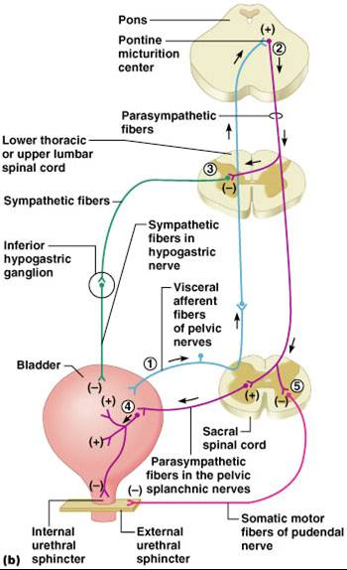

**Diagram of the control of micturition reflex.**

**Role of perineal and abdominal muscles in micturition**

Certain muscular movements, which aid the emptying of bladder, but are not the essential component of micturition process are:

_ At the onset of micturition, the levator ani and perineal muscles are relaxed, thereby shortening the post-urethra and decreasing the urethral resistance.

_ The diaphragm descends and

_ The abdominal muscles contract, accelerating the flow of urine by raising intra-abdominal pressure which in turn secondarily increase the intravesical pressure thereby increasing the flow of urine.

Note. Certain important facts about micturition are:

_ A voiding contraction, once initiated, is normally maintained until all the urine has been discharged from the urinary bladder. This is a function of facilitating impulses from the higher centres. However, if required so, the micturition can be voluntarily stopped in between by inhibitory impulses from the higher centres.

_ The bladder contracts in all directions like a toy balloon deflating from its neck.

_ After urination, the female urethra empties by gravity, whereas the urine remaining in the urethra of male is expelled by several contractions of bulbospongiosus muscle.

**Abnormalities of micturition**

* Effect of deafferentation or atonic bladder
* Transection of sympathetic supply
* Effect of spinal cord transaction.

**QUESTION 3**: JUXTAGLOMERULAR APPARATUS

** DEFINITION**

Juxtaglomerular apparatus is a specialized organ situated near the glomerulus of each nephron (juxta = near).

 **STRUCTURE OF JUXTAGLOMERULAR APPARATUS**

Juxtaglomerular apparatus is formed by three different structures:

1. Macula densa

2. Extraglomerular mesangial cells

3. Juxtaglomerular cells.

 **MACULA DENSA**

Macula densa is the end portion of thick ascendingsegment before it opens into distal convoluted tubule. It is situated between afferent and efferent arterioles of the same nephron. It is very close to afferent arteriole. Macula densa is formed by tightly packed cuboidal epithelial cells.

Characteristic features of macula densa cells are:

_ They are not well adapted for reabsorption.

_ They are not innervated.

_ These cells are in direct contact with the mesangial cells and in close contact with the JG cells.

_ They act as chemoreceptors and are stimulated by decreased NaCl concentration and thereby causing increased renin release

 **EXTRAGLOMERULAR MESANGIAL CELLS**

Extraglomerular mesangial cells are situated in the triangular region bound by afferent arteriole, efferent arteriole and macula densa. These cells are also called agranular cells, lacis cells or Goormaghtigh cells.

Glomerular Mesangial Cells Besides extraglomerular mesangial cells there is another type of mesangial cells situated in between glomerular capillaries called glomerular mesangial or intraglomerular mesangial cells. Glomerular mesangial cells support the glomerular capillary loops by surrounding the capillaries in the form of a cellular network. These cells play an important role in regulating the glomerular filtration by their contractile property.

Characteristic features of these cells are:

_ They are in contact with both the macula densa cells (on one side) and JG cells (on the other side).

_ Functionally, these cells possibly relay the signals from macula densa to the granular cells after modulating the signals. In this way, a decreased intraluminal Na+ load, Cl– load, or both in the region of macula densa stimulates the JG cells to secrete renin.

_ They also show granulation to secrete renin in conditions of extreme hyperactivity.

_ They also secrete various substances and take up immune complexes.



DIAGRAM OF THE GLOMERULUS

Glomerular mesangial cells are phagocytic in nature. These cells also secrete glomerular interstitial matrix, prostaglandins and cytokines.

 **JUXTAGLOMERULAR CELLS**

Juxtaglomerular cells are specialized smooth muscle cells situated in the wall of afferent arteriole just before it enters the Bowman capsule. These smooth muscle cells are mostly present in tunica media and tunica adventitia of the wall of the afferent arteriole. Juxtaglomerular cells are also called granular cells because of the presence of secretary granules in their cytoplasm.

Polar Cushion or Polkissen

Juxtaglomerular cells form a thick cuff called polar cushion or polkissen around the afferent arteriole before it enters the Bowman capsule.

Characteristic features of JG cells are:

_ They have well-developed Golgi apparatus and endoplasmic reticulum, abundant mitochondria and ribosomes.

_ They synthesize, store and release an enzyme called renin. Renin is stored in the secretory granules of JG cells and, therefore, these are also called granular cells.

_ They act as baroreceptors (tension receptors) and respond to changes in the transmural pressure gradient between the afferent arterioles and the interstitium.

_ They are densely innervated by the sympathetic nerve fibres and release their renin content in response to the sympathetic discharge.

_ As these cells act as vascular volume receptors, they monitor renal perfusion pressure and are stimulated by hypovolaemia or decreased renal perfusion pressure.

 **FUNCTIONS OF JUXTAGLOMERULAR APPARATUS**

Primary function of juxtaglomerular apparatus is the secretion of hormones. It also regulates the glomerular blood flow and glomerular filtration rate.

**QUESTION 4** :ROLE OF THE KIDNEY IN REGULATION OF BLOOD PRESSURE.

**The kidneys and their influence on blood pressure**

The kidneys play a central role in the regulation of arterial blood pressure. A large body of experimental and physiological evidence indicates that renal control of extracellular volume and renal perfusion pressure are closely involved in maintaining the arterial circulation and blood pressure. Renal artery perfusion pressure directly regulates sodium excretion; a process known as pressure natriuresis, and influences the activity of various vasoactive systems such as the renin–angiotensin–aldosterone (RAS) system. Along with vessel morphology, blood viscosity is one of the key factors influencing resistance and hence blood pressure. A key modulator of blood viscosity is the renin-angiotensin system (RAS) or the renin-angiotensin-aldosterone system (RAAS), a hormone system that regulates blood pressure and water balance.

The blood pressure in the body depends upon:

• The force by which the heart pumps out blood from the ventricles of the heart - and this is dependent on how much the heart muscle gets stretched by the inflowing blood into the ventricles.

• The degree to which the arteries and arterioles constrict-- increases the resistance to blood flow, thus requiring a higher blood pressure.

• The volume of blood circulating round the body; if the volume is high, the ventricles get more filled, and the heart muscle gets more stretched.

The kidney influences blood pressure by:

• Causing the arteries and veins to constrict

• Increasing the circulating blood volume

Specialized cells called macula densa are located in a portion of the distal tubule located near and in the wall of the afferent arteriole. These cells sense the Na in the filtrate, while the arterial cells (juxtaglomerular cells) sense the blood pressure. When the blood pressure drops, the amount of filtered Na also drops. The arterial cells sense the drop in blood pressure, and the decrease in Na concentration is relayed to them by the macula densa cells. The juxtaglomerular cells then release an enzyme called **renin.**

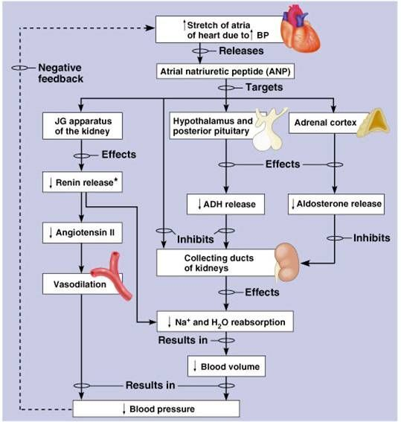

DIAGRAM OF THE REGULATION OF BLOOD PRESSURE

Renin converts angiotensinogen (a peptide, or amino acid derivative) into angiotensin-1. Angiotensin-1 is thereafter converted to angiotensin-2 by an angiotensin-converting enzyme (ACE), found in the lungs. Angiotensin-2 causes blood vessels to contract -- the increased blood vessel constrictions elevate the blood pressure. When the volume of blood is low, arterial cells in the kidneys secrete renin directly into circulation. Plasma renin then carries out the conversion of angiotensinogen released by the liver to angiotensin-1. Angiotensin-1 is subsequently converted to angiotensin-2 by the enzyme angiotensin converting enzyme found in the lungs. Angiotensin-2m a potent vasoactive peptide causes blood vessels to constrict, resulting in increased blood pressure. Angiotensin-2 also stimulates the secretion of the hormone aldosterone from the adrenal cortex.

Aldosterone causes the tubules of the kidneys to increase the reabsorption of sodium and water into the blood. This increases the volume of fluid in the body, which also increases blood pressure. If the renin-angiotensin-aldosterone system is too active, blood pressure will be too high. Many drugs interrupt different steps in this system to lower blood pressure. These drugs are one of the main ways to control high blood pressure (hypertension), heart failure, kidney failure, and harmful effects of diabetes. It is believed that angiotensin-1 may have some minor activity, but angiotensin-2 is the major bioactive product. Angiotensin-2 has a variety of effects on the body: throughout the body, it is a potent vasoconstrictor of arterioles.

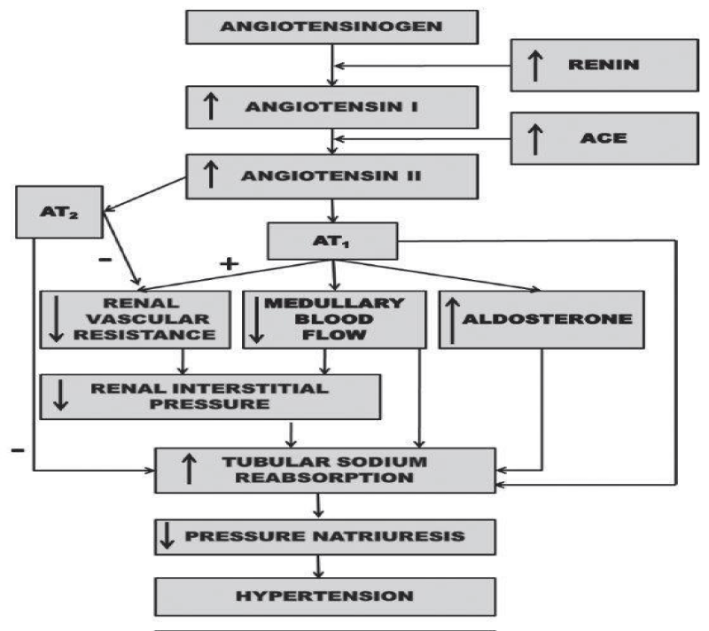

DIAGRAM OF RENIN- ANGIOTENSIN PATHWAY

**How the kidneys increase circulating blood volume**

Angiotensin-2 also stimulates the adrenal gland to secrete a hormone called aldosterone. Aldosterone stimulates more Na reabsorption in the distal tubule, and water gets reabsorbed along with the Na. The increased Na and water reabsorption from the distal tubule reduces urine output and increases the circulating blood volume. The increased blood volume helps stretch the heart muscle and causes it to generate more pressure with each beat, thereby increasing the blood pressure. The circulating blood volume is directly proportional to the stretch of the heart muscle.

The actions taken by the kidney to regulate blood pressure are especially important during traumatic injury, when they are necessary to maintain blood pressure and conserve the loss of fluids. The body stores calcium in the bones, but also maintains a constant level of calcium in the blood. If the blood calcium level falls, then the parathyroid glands in the neck release a hormone called parathyroid hormone. Parathyroid hormone increases calcium reabsorption from the distal tubule of the nephron to restore the blood calcium level. Parathyroid hormone aside from stimulating calcium release from bone also causes calcium absorption from the intestine.Vitamin D is also required by the body to stimulate calcium absorption from the kidney and intestine. Vitamin D is found in milk products. A precursor to vitamin D (cholecalciferol) is made in the skin and processed in the liver. The last phase in the conversion of an inactive form of cholecalciferol into active vitamin D takes place in the proximal tubule of the nephron. Once activated, vitamin D stimulates calcium absorption from the proximal tubule and from the intestine, thereby increasing blood calcium levels. Kidney stones are abnormalities usually caused by problems in the kidney’s ability to handle calcium. In addition, the kidney’s role in maintaining blood calcium is important in the bone disease osteoporosis that afflicts many elderly people, especially women.

The kidneys therefore function in the body to:

• Control the composition of the blood and eliminate wastes by filtration/reabsorption/secretion

• Influence blood pressure by renin secretion

• Help regulate the body’s calcium by vitamin D activation

If for any reason, the kidneys fail to function, then renal dialysis methods (artificial filtration methods) becomes the only alternative to assist the patient to survive by cleansing the blood. This is especially necessary when both kidneys fail

**QUESTION 5**: ROLE OF KIDNEY IN CALCIUM HOMEOSTASIS

**INTRODUCTION**

The usual rates of intake are about 1000 mg/day each for calcium and phosphorus, about the amounts

in 1 liter of milk. Normally, divalent cations such as calcium ions are poorly absorbed from the

intestines. However, as discussed later, vitamin D promotes calcium absorption by the intestines, and about 35 percent (350 mg/day) of the ingested calcium is usually absorbed; the calcium remaining , in the intestine is excreted in the feces. An additional 250 mg/day of calcium enters the intestines via secreted gastrointestinal juices and sloughed mucosal cells. Thus, about 90 percent (900 mg/day) of the daily intake of calcium is excreted in the feaces.

**REABSORPTION AND EXCRETION OF CALCIUM BY THE KIDNEY**

Approximately 10 percent (100 mg/day) of the ingested calcium is excreted in the urine. About 41

percent of the plasma calcium is bound to plasma proteins and is therefore not filtered by the

glomerular capillaries. The rest is combined with anions such as phosphate (9 percent) or ionized (50 percent) and is filtered through the glomeruli into the renal tubules.

Normally, the renal tubules reabsorb 99 percent of the filtered calcium and about 100 mg/day are

excreted in the urine. Approximately 90 percent of the calcium in the glomerular filtrate is reabsorbed in the proximal tubules, loops of Henle, and early distal tubules. Then in the late distal tubules and early collecting ducts, reabsorption of the remaining 10 percent is selective, depending on the calcium ion concentration in the blood. When calcium concentration is low, this reabsorption is great, so almost no calcium is lost in the urine. Conversely, even a minute increase in blood calcium ion concentration above normal increases calcium excretion markedly.The most important factor controlling this reabsorption of calcium in the distal portions of the nephron, and therefore controlling the rate of calcium excretion, is PTH.

Renal phosphate excretion is controlled by an overflow mechanism,That is, when phosphate concentration in the plasma is below the critical value of about 1 mmol/L, all the phosphate in the glomerular filtrate is reabsorbed and no phosphate is lost in the urine. But above this critical concentration, the rate of phosphate loss is directly proportional to the additional increase.

Thus, the kidneys regulate the phosphate concentration in the extracellular fluid by altering the rate of phosphate excretion in accordance with the plasma phosphate concentration and the rate of phosphate filtration by the kidneys. However, as discussed later in the chapter, PTH can greatly increase phosphate excretion by the kidneys, thereby playing an important role in the control of plasma phosphate concentration and calcium concentration.

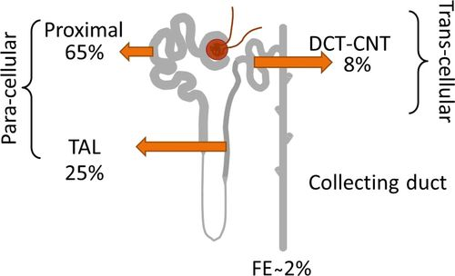

DIAGRAM SHOWING THE RE-ABSORPTION OF CALCIUM IN THE KIDNEY.

**Hormonal Control Systems**

Maintaining normal blood calcium and phosphorus concentrations is managed through the concerted action of three hormones that control fluxes of calcium in and out of blood and extracellular fluid.

[Parathyroid hormone](http://www.vivo.colostate.edu/hbooks/pathphys/endocrine/thyroid/pth.html) serves to increase blood concentrations of calcium. Mechanistically, parathyroid hormone preserves blood calcium by several major effects:

* Stimulates production of the biologically-active form of vitamin D within the kidney.
* Facilitates mobilization of calcium and phosphate from bone. To prevent detrimental increases in phosphate, parathyroid hormone also has a potent effect on the kidney to eliminate phosphate (phosphaturic effect).
* Maximizes tubular reabsorption of calcium within the kidney. This activity results in minimal losses of calcium in urine.

[Vitamin D](http://www.vivo.colostate.edu/hbooks/pathphys/endocrine/otherendo/vitamind.html) acts also to increase blood concentrations of calcium. It is generated through the activity of parathyroid hormone within the kidney. Far and away the most important effect of vitamin D is to facilitate absorption of calcium from the small intestine. In concert with parathyroid hormone, vitamin D also enhances fluxes of calcium out of bone.

[Calcitonin](http://www.vivo.colostate.edu/hbooks/pathphys/endocrine/thyroid/calcitonin.html) is a hormone that functions to reduce blood calcium levels. It is secreted in response to hypercalcemia and has at least two effects:

Suppression of renal tubular reabsorption of calcium. In other words, calcitonin enhances excretion of calcium into urine.

Inhibition of bone resorption, which would minimize fluxes of calcium from bone into blood.

Although calcitonin has significant calcium-lowing effects in some species, it appears to have a minimal influence on blood calcium levels in humans.

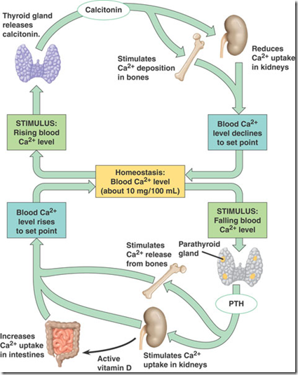

DIAGRAM SHOWING THE KIDNEY’S EFFECT ON CALCIUM HOMEOSTASIS