SURNAME:
OTHER NAME:
MATRIC NO:
COLLEGE: MHS DEPT: MBBS LEVEL: 100
COURSE: MAT 104
Integrate the following
1) ʃ2x²lnx dx

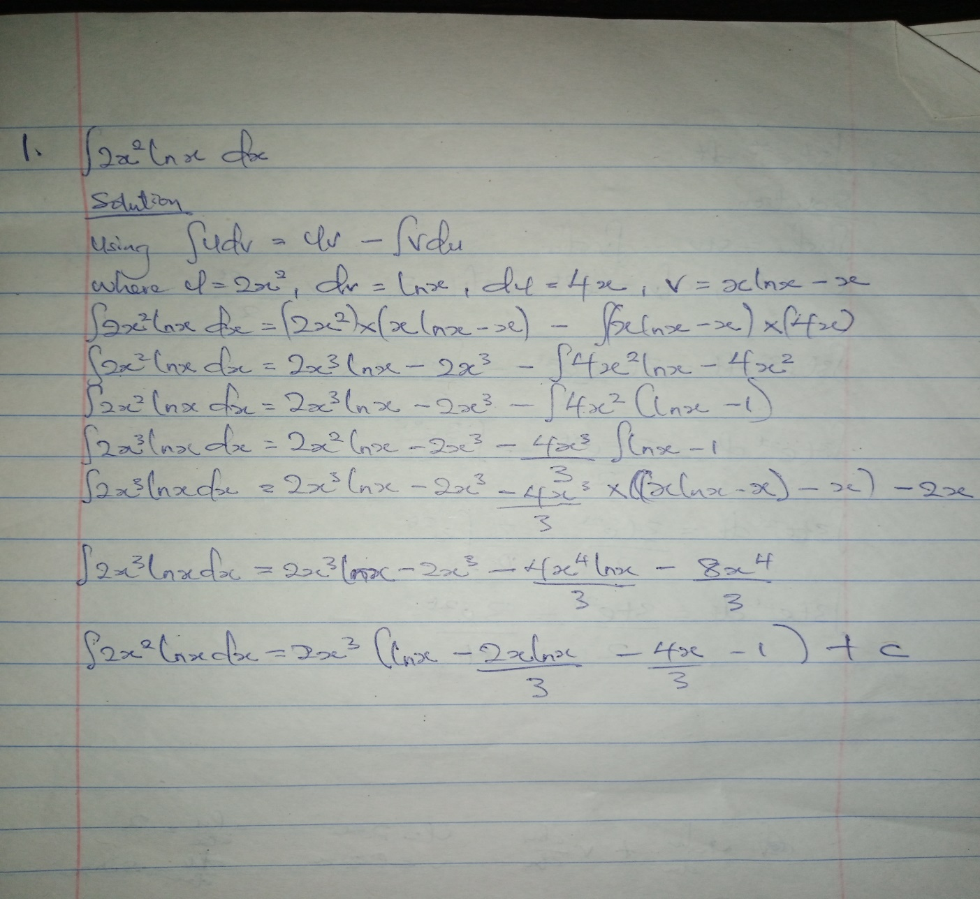

2) ʃ3te^{2t}dx
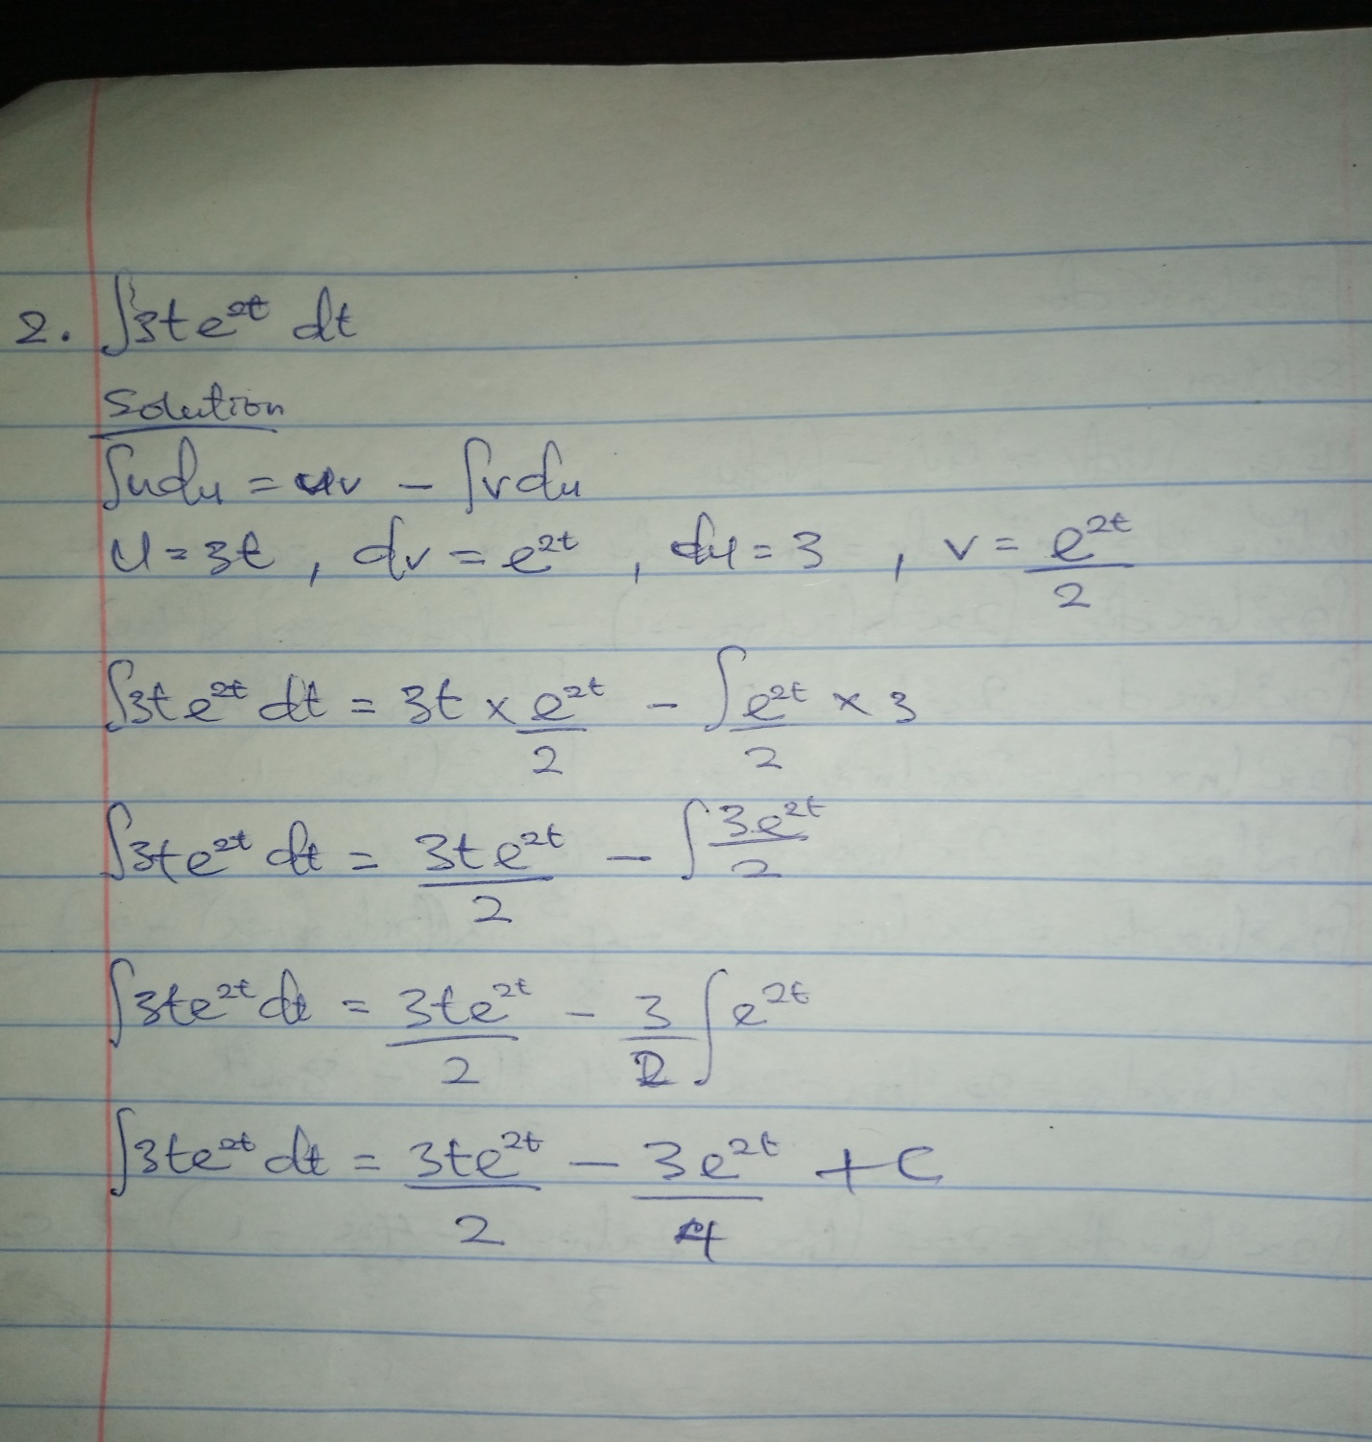

3) ʃx²sinx dx
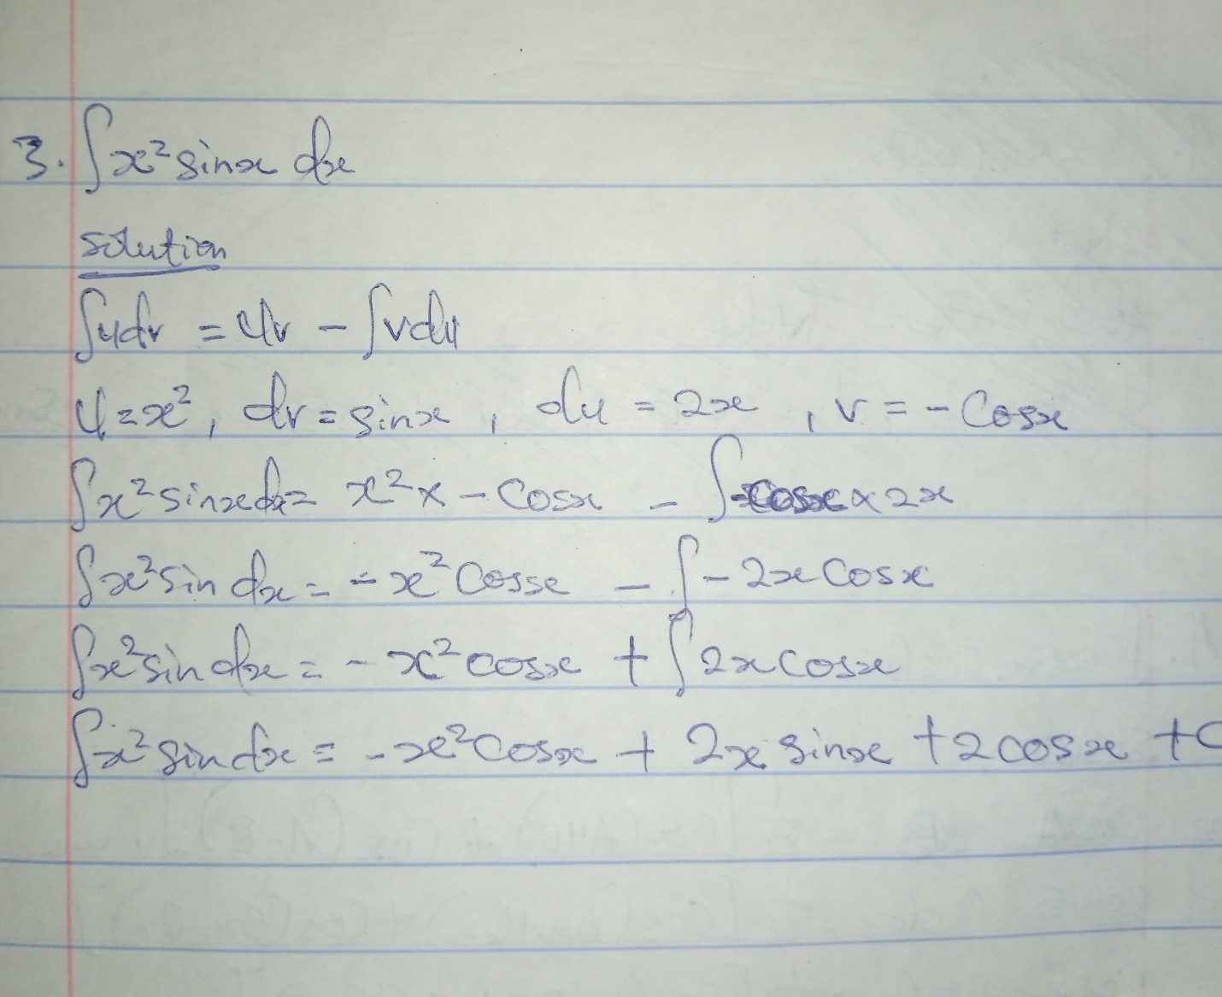

4)ʃcos5xcos6x dx
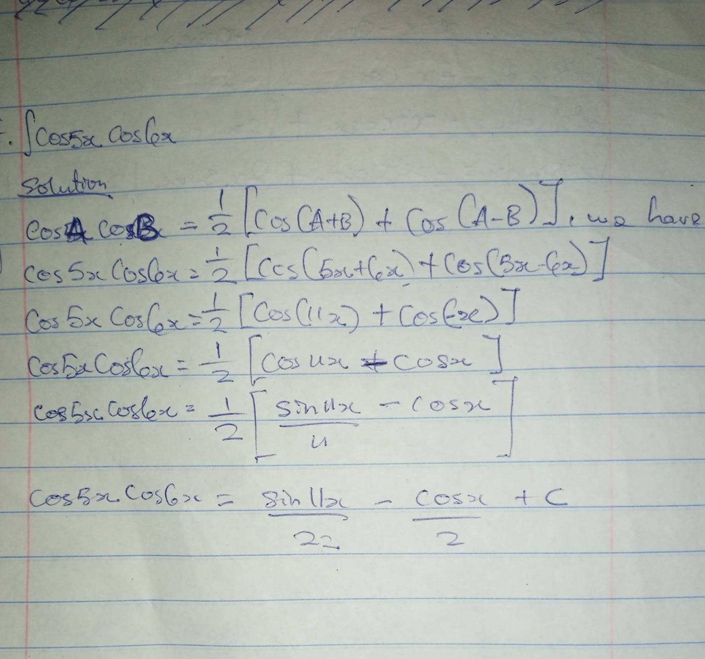

5) ʃsin7xcos2x dx
