- BCH 202 ASSIGNMENT
1. Classify vitamins. Hence, write on the biochemical significance of vitamins: Vitamins are classified based on their solubility. The fat-soluble vitamins are A, D, E and K. They can be stored in the body. The water-soluble vitamins are the B-complex vitamins and vitamin C.

BIOCHEMICAL SIGNIFICANCE OF VITAMINS

- Vitamins have diverse biochemical functions. Vitamin A acts as a regulator of cell and tissue growth and differentiation. Vitamin D provides a hormone-like function, regulating mineral metabolism for bones and other organs. The B complex vitamins function as enzyme cofactors (coenzymes) or the precursors for them.

- Water soluble vitamins are precursors of coenzymes. With the aid of two named vitamins, describe the role of coenzymes in metabolism.

Vitamin B₁ : Also named Thiamine or Thiamine diphosphate (TPP), Vitamin B₁ is a cofactor for oxidative decarboxylation both in the Kreb's Cycle and in converting pyruvate to acetyl-CoA (an important molecule used in the citric acid cycle of metabolism). It is widely available in the human diet and particularly potent in wheat germ and yeast. It's functionality results from a thiazole ring which stabilizes charge and electron transfer through resonance.

Vitamin B₂ :
Vitamin B₂ is known as riboflavin. Vitamin B2 is the precursor of Flavin adenine dinucleotide (FAD) and flavin mononucleotide (FMN) which are coenzymes used to oxidized substrates. FAD contains riboflavin and adenine. FMN contains riboflavin that is why it is called mononucleotide.
- Describe the nomenclature of nucleosides, , and nucleic acid.
Nucleotides and nucleic acids
Nucleotides are the building blocks of nucleic acids
Nucleotide
Nucleotides also play other important roles in the cell
RNA DNA

Structure of nucleotides
Nucleotides have three characteristic components:
A phosphate group
A nitrogenous base (pyrimidines or purine)
A pentose sugar

Structure of nucleosides
Remove the phosphate group, and you have a nucleoside.
H

The ribose sugar
1
Ribose
Ribose (β-D-furanose) is a pentose sugar (5- membered ring).

Note numbering of the carbons. In a nucleotide, "prime" is used (to differentiate from base numbering).

5 4
3 2
1

Ribose
An important derivative of ribose is 2'-deoxyribose, or just deoxyribose, in which the 2' OH is replaced with H.

Deoxyribose is in DNA (deoxyribonucleic acid)

Ribose is in RNA (ribonucleic acid).

The sugar prefers different puckers in DNA (C-2' endo) and RNA C-3' endo).

The purine or pyrimidine base

Pyrimidine and purine
Nucleotide bases in nucleic acids are pyrimidines or purines.
2
Major bases in nucleic acids
The bases are abbreviated by their first letters (A, G, C, T, U).

The purines (A, G) occur in both RNA and DNA

Among the pyrimidines, C occurs in both RNA and DNA, but

T occurs in DNA, and

U occurs in RNA

Nucleotides in nucleic acids
• Bases attach to the C-1' of ribose or deoxyribose
• The pyrimidines attach to the pentose via the N-1 position of
the pyrimidine ring
• The purines attach through the N-9 position
• Some minor bases may have different attachments.

Deoxyribonucleotides
2'-deoxyribose sugar
with a base (here, a purine, adenine or guanine)
attached to the C-1' position is a deoxyribonucleoside (here deoxyadenosine and deoxyguanosine).
Phosphorylate the 5' position and you have a nucleotide(here, deoxyadenylate or deoxyguanylate)
Deoxyribonucleotides are abbreviated (for example) A, or dA (deoxyA), or dAMP (deoxyadenosine monophosphate)

The major deoxyribonucleotides
3
Ribonucleotides
The ribose sugar with a base (here, a pyrimidine, uracil or cytosine) attached to the ribose C-1' position is a ribonucleoside (here, uridine or cytidine).

Phosphorylate the 5' position and you have a ribonucleotide (here, uridylate or cytidylate)

• Ribonucleotides are abbreviated (for example) U, or UMP (uridine monophosphate)

The major ribonucleotides

Nucleotide nomenclature
25
10/10/05

Nucleic acids
Nucleotide monomers
can be linked together via a phosphodiester linkage
formed between the 3' -OH of a nucleotide
and the phosphate of the next nucleotide.
Two ends of the resulting poly- or oligonucleotide are defined:
The 5' end lacks a nucleotide at the 5' position,
and the 3' end lacks a nucleotide at the 3' end position.
4
Sugar-phosphate backbone
The polynucleotide or nucleic acid backbone thus consists of alternating phosphate and pentose residues.

The bases are analogous to side chains of amino acids; they vary without changing the covalent backbone structure.

Sequence is written from the 5' to 3' end: 5'-ATGCTAGC-3'

Note that the backbone is polyanionic. Phosphate groups pKa ~ 0.

The bases can take syn or anti positions

Compare polynucleotides and polypeptides
As in proteins, the sequence of side chains (bases in nucleic acids) plays an important role in function.

Nucleic acid structure depends on the sequence of bases and on the type of ribose sugar (ribose, or 2'-deoxyribose).

Hydrogen bonding interactions are especially important in nucleic acids.

Interstrand H-bonding between DNA bases
Watson-Crick base pairing
5
DNA structure determination
33
• Franklin collected x-ray diffraction data (early 1950s) that indicated 2 periodicities for DNA: 3.4 Å and 34 Å.
• Watson and Crick proposed a 3- D model accounting for the data.
10/10/05

DNA structure
DNA consists of two helical chains wound around the same axis in a right-handed fashion aligned in an antiparallel fashion.

There are 10.5 base pairs, or 36 Å, per turn of the helix.

Alternating deoxyribose and

phosphate groups on the backbone form the outside of the helix.

The planar purine and pyrimidine bases of both strands are stacked inside the helix.

DNA structure
The furanose ring usually is puckered in a C-2' endo conformation in DNA.

The offset of the relationship of the base pairs to the strands gives a major and a minor groove.

In B-form DNA (most common) the depths of the major and minor grooves are similar to each other.

- With the aid of an adequate pathway, discuss the involvement of vitamin A in vision.

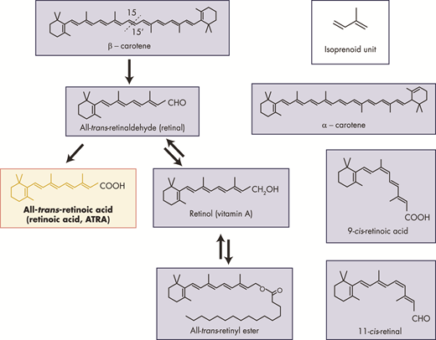
- Account for the response of an individual’s vision on exposure to bright light and dim light.
- The colored part of your eye, called the iris, controls the size of the pupil, the opening that lets light through. In dim light, the iris will cause your pupil to expand, allowing as much light as possible into your eye. In bright light, the iris causes the pupil to contract so that less light can enter.

- Describe the biosynthetic pathway involving the exposure of sunlight on skin, and its relation to a named vitamin.
The skin is responsible for producing vitamin D. During exposure to sunlight, ultraviolet radiation penetrates into the epidermis and photolyzes provitamin D3 to previtamin D3. ... Therefore, the skin is the site for the synthesis of vitamin D and a target tissue for its active metabolite.When the sun's ultraviolet rays touch the skin, they convert the precursor to a molecule called vitamin D₃, which then follows a metabolic pathway through the liver and finally to the kidneys, where it's converted into a molecule called calcitriol.Vitamin D is the sunshine vitamin that has been produced on this earth for more than 500 million years. During exposure to sunlight 7-dehydrocholesterol in the skin absorbs UV B radiation and is converted to previtamin D3 which in turn isomerizes into vitamin D3. Previtamin D3 and vitamin D3 also absorb UV B radiation and are converted into a variety of photoproducts some of which have unique biologic properties. Sun induced vitamin D synthesis is greatly influenced by season, time of day, latitude, altitude, air pollution, skin pigmentation, sunscreen use, passing through glass and plastic, and aging. Vitamin D is metabolized sequentially in the liver and kidneys into 25-hydroxyvitamin D which is a major circulating form and 1,25-dihydroxyvitamin D which is the biologically active form respectively. 1,25-dihydroxyvitamin D plays an important role in regulating calcium and phosphate metabolism for maintenance of metabolic functions and for skeletal health. Most cells and organs in the body have a vitamin D receptor and many cells and organs are able to produce 1,25-dihydroxyvitamin D. As a result 1,25-dihydroxyvitamin D influences a large number of biologic pathways which may help explain association studies relating vitamin D deficiency and living at higher latitudes with increased risk for many chronic diseases including autoimmune diseases, some cancers, cardiovascular disease, infectious disease, schizophrenia and type 2 diabetes. A three-part strategy of increasing food fortification programs with vitamin D, sensible sun exposure recommendations and encouraging ingestion of a vitamin D supplement when needed should be implemented to prevent global vitamin D deficiency and its negative health consequences.

7. Comment on the effects of acids and alkalis on nucleic acids.

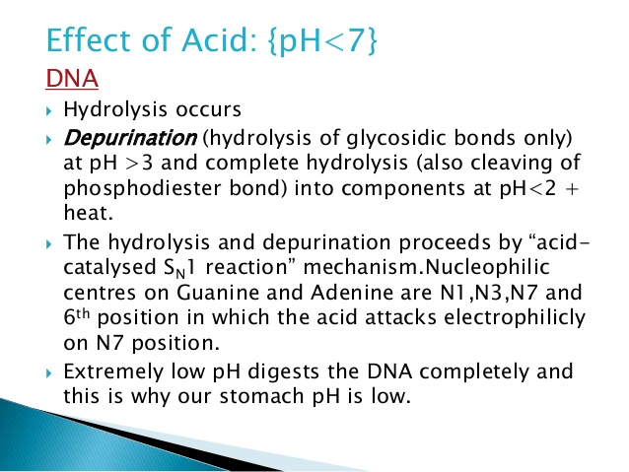
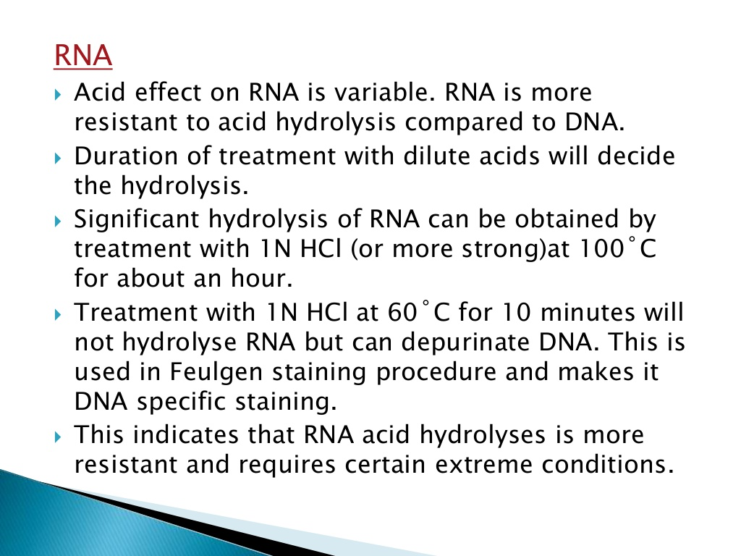
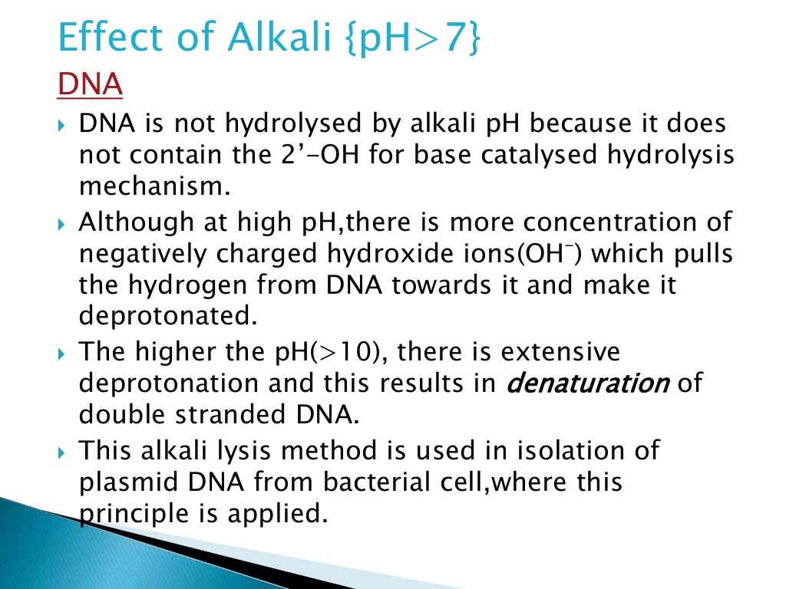
8 Write on the contributions of Watson–Crick in the structure of DNA.On this day in 1953, Cambridge University scientists James D. Watson and Francis H.C. Crick announce that they have determined the double-helix structure of DNA, the molecule containing human genes.
Though DNA–short for deoxyribonucleic acid–was discovered in 1869, its crucial role in determining genetic inheritance wasn’t demonstrated until 1943. In the early 1950s, Watson and Crick were only two of many scientists working on figuring out the structure of DNA. California chemist Linus Pauling suggested an incorrect model at the beginning of 1953, prompting Watson and Crick to try and beat Pauling at his own game. On the morning of February 28, they determined that the structure of DNA was a double-helix polymer, or a spiral of two DNA strands, each containing a long chain of monomer nucleotides, wound around each other. According to their findings, DNA replicated itself by separating into individual strands, each of which became the template for a new double helix. In his best-selling book, The Double Helix (1968), Watson later claimed that Crick announced the discovery by walking into the nearby Eagle Pub and blurting out that “we had found the secret of life.” The truth wasn’t that far off, as Watson and Crick had solved a fundamental mystery of science–how it was possible for genetic instructions to be held inside organisms and passed from generation to generation.
Watson and Crick’s solution was formally announced on April 25, 1953, following its publication in that month’s issue of Naturemagazine. The article revolutionized the study of biology and medicine. Among the developments that followed directly from it were pre-natal screening for disease genes; genetically engineered foods; the ability to identify human remains; the rational design of treatments for diseases such as AIDS; and the accurate testing of physical evidence in order to convict or exonerate criminals.
Crick and Watson later had a falling-out over Watson’s book, which Crick felt misrepresented their collaboration and betrayed their friendship. A larger controversy arose over the use Watson and Crick made of research done by another DNA researcher, Rosalind Franklin, whose colleague Maurice Wilkins showed her X-ray photographic work to Watson just before he and Crick made their famous discovery. When Crick and Watson won the Nobel Prize in 1962, they shared it with Wilkins. Franklin, who died in 1958 of ovarian cancer and was thus ineligible for the award, never learned of the role her photos played in the historic scientific breakthrough.
9. In a tabular form, differentiate between DNA and RNA.
S.N. | DNA | RNA
1. | DNA stands for Deoxyribonucleic Acid. The sugar portion of DNA is 2-Deoxyribose. | RNA stands for Ribonucleic Acid. The sugar portion of RNA is Ribose.
2. | The helix geometry of DNA is of B-Form (A or Z also present). | The helix geometry of RNA is of A-Form.
3. | DNA is a double-stranded molecule consisting of a long chain of nucleotides. | RNA usually is a single-strand helix consisting of shorter chains of nucleotides.
4. | The bases present in DNA are adenine, guanine, cytosine and thymine. | The bases present in RNA are adenine, guanine, cytosine and uracil.
5. | DNA is self-replicating. | RNA is synthesized from DNA on an as-needed basis.
6. | Base Pairing :AT (adenine-thymine)GC (guanine-cytosine). | Base Pairing :AU (adenine-uracil)GC (guanine-cytosine).

- Discuss the functions of nucleotides.
- Purine and pyrimidine nucleotides fill a variety of metabolic roles. They are the “energy currency” of the cell. In some cases, they are signaling molecules, acting like hormones directly or as transducers of the information. They provide the monomers for genetic information in DNA and RNA.

- Adenine nucleotides are components of the coenzymes, NAD(P)⁺, FAD, and CoA.

