Matric Number: 19/MHS01/309
Student's Name: Okam Emmanuel Chijioke
Department: Medicine and Surgery
Semester/Session: second / 2019/2020
Level: 100

Assignment Title: GENERAL BIOLOGY II
Course Title: General Biology II
Course Code: BIO 102 Question
- How are fungi important to mankind?
- Illustrate the cell structure of a unicellular fungus with a well labeled diagram.
- Outline the sexual reproduction in a typical filamentous form of fungi.
- How do Bryophytes adapt to their environment?
- Describe with illustration the following terminologies: (a) eusteles (b) atactostele (c) siphonostele (d) dictyostele.
- Illustrate the life cycle of a primitive vascular plant.

Que 1. How are fungi important to man?
- Fungi are responsible for mediation of decay of organic matter
- It is important in good industry of e.g. yeast.
- Food for human as in mushroom
- It mediates spoilage of food wood clothes and paper.
- Some are parasite to some offensive pests. It is an important biological control agent.

Que 2. Illustrate the Structure of a unicellular Fungus with a well labeled diagram

Fungi are eukaryotes and have a complex cellular organization. It contains a membrane-bound nucleus where the DNA is wrapped around histone proteins.

The shape of fungi cells may vary from circular spherical oral rectangular to triangular. The cells are minute. The cells are colourless but its colonies appear while, cream coloured or light brown. Each cell consists of tiny mass of protoplast surrounded by a definite cell wall.
The cell wall is doubled layered, thin delicate and flexible. It is composed of two complex polysacharids mannum and glucan with smaller quantity of protein. The protoplast which is the inner cell wall is cytoplasmic membrane or plasma membrane. It surrounds the cytoplasm and a nucleus. A hyaline structure which is visible by microscope occupies a large portion of the cell. The hyaline area represents a vacuole and nucleus beside. The vacuole is believed to have six pair of chromosomes. The nuclear membrane has pores. The cytoplasm contains glycogen proteins oil and refractile volutin granulus as reverse food materials.

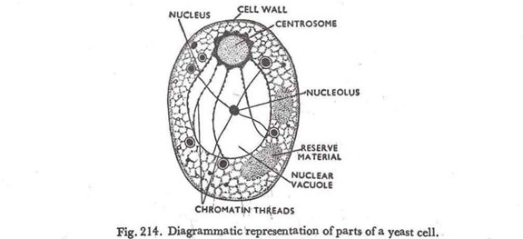

Nuclear structure of unicellular fungus (Yeast)

Que 3. Outline the sexual reproduction in a typical filamentous form of fungi.

Sexual reproductive occurs when two mating types of hyphae grow in the same medium.
There is a chemical interaction that occurs in the two mating types of hyphae which will induce growths perpendicular to the hyphae in opposite direction. Many nuclei are isolated by what is known a gametangium due to the delimitation of the walls caused by the growth induced by the hyphae. By plasmogamy the two gametangia fuse forming a zygote that on its own may undergo a resting stage.
The nuclei fuse in twos and undergo meiosis on their own. Under fgavourable conditions the zygote germinates to produce a fruiting which liberates haploid spores at maturity.
.

Que 4. How does Bryophyte adapt to their environment.
They adapt to their environment in two ways;
- Possessions of definite structures that help them absorb water and nutrition from the soil. Because of this the plant body is divided into two (aerial and subterranean portion). Subterranean is the rhizoid which is not a true root. The aerial portion being exposed to atmosphere has some modification that prevents excessive water loss through the body. Modification that permits elimination of excess water from the water plant. Hence the openings available on aerial part.

Que. 4. Describe with illustration the following terminologies:
- Eusteles (b) atatosele (c) siphnonostele (d) dictyostele
- Eustelis: The vascular bundles are discrete, concentric, collateral bundles of xylem and phloem

- Atactosele: The vascular bundles are scattered.

- Siphonstele: A higher vascular plant. The stele is a cylinder enclosing a parenchymatoes pith. A central pith is surrounded by a ring of xylem which is in turn surrounded by a ring of phloem.

Phloem

Xylem

- Dictyostele: The vascular supply to leaves is associated with leaf gaps and conducting cylinder is a dissected one.

Que. 5. Illustrate the life cycle of a primitive vascular plant
In the life cycle of psitotum (Whisk terns) dominant Sporophyte plant with trilebeld sporangia – produces homosporous spores. Homosporous spores germinate into haploid gametophytes.
Gametophyte is form mycorrhizal associated with fungi for nutrition and develops archegonia each with leg and antheridia with flagellated sperm. Diploid zygote forms after fertilization which develops into a sporophte plants in asexual reproduction psilotum the gemmae develop on the sporophyle.
**(Dominate sporophyte plant trillobed sporangia – homosporous spores – germinate into haploid gametophytes – forms mycorrhizal – archegoria each with 1 egg and antheriodia with flagellated sperm fertilization a diploid zygote develop into a sporophyte plant.
