Name: Anamelechi Ngozi Joy
Department: Medical laboratory science
Matric no: 18/mhs06/016
Level: 200 level
Bch 202 Assignment
- Biochemical significance of vitamins are:
- Vitamin E- its antioxidant effect, protecting molecules and tissues against the deleterious effect of free radicals. They also assist immune function and act as an antioxidant that protects cells from damage.
- Vitamin K- required for blood clotting and proper bone development.
- Vitamin A- necessary for proper vision and organic function.
- Vitamin D- promotes proper immune function and assist in calcium absorption and bone growth.
- Vitamin B7- plays a role in the metabolism of fatty acids, amino acids and glucose.
- Vitamin B1 ( Thiamine)- helps convert nutrients into energy.
2a) Role of coenzymes in metabolism
Riboflavin (B ₂ )- It is a precursor of enzymes FMN and FAD, which are required by several oxidation, reduction reaction in metabolism. FMN and FAD serve as coenzymes for oxidoreductase enzymes involved in carbohydrate, protein, lipid etc.
B) Pyridoxine (B6)- pyridoxal phosphate (PLP) acts as co-enzyme for many reactions in amino acid metabolism such as : Transamination, Decarboxylation etc.
3) Nomenclature of Nucleosides, Nucleotides and Nucleic acids

Base | Nucleoside | Nucleotide | Nucleic acid
Purines
Adenine | Adenosine  Deoxyadenosine | Adenylate  Deoxyadenylate | RNA  DNA
Guanine | Guanosine  Deoxyguanosine | Guanylate  Deoxyguanylate | RNA  DNA
Pyrimidines
Cytosine | Cytidine  Deoxycytidine | Cytidylate  Deoxycytidylate | RNA  DNA
Thymine | Thymidine or Deoxythymidine | Thymidylate or Deoxythymidylate | DNA
Uracil | Uridine | Uridylate | RNA

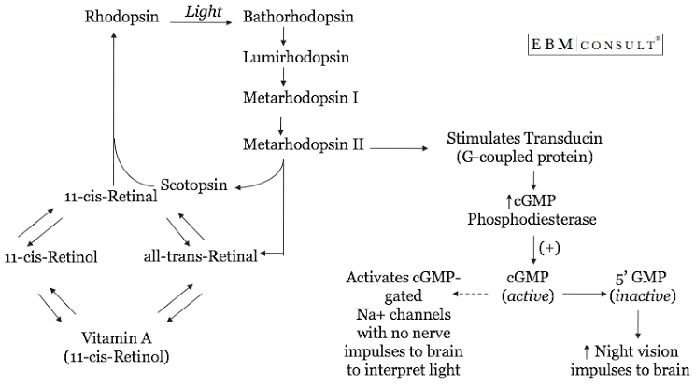
4) Vitamin A (all-trans-retinol) is a precursor to the formation of the photo pigment Rhodopsin, which is located in the rods. In order for Rhodopsin to be formed, vitamin A must be converted to 11-cis-retinal. This can occur in 2 ways; Vitamin A can be converted to 11-cis-retinal by isomerase. This 11-cis-retinol can thus be converted to 11-cis-retinal. Vitamin A is required for the maintenance of normal vision. A deficiency in vitamin A can lead to visual disturbance. In the eyes, a form of vitamin A called “retinal (active form of vitamin A)” is combined with a protein called “Opsin” to give “Rhodopsin”, an essential light absorbing molecule needed for colour vision and seeing in dim light.
5a) Bright light effect on the eye
The Iris serves as a main defense against bright light. When intense light Ray’s reach your eyes, the Iris respond by constricting the pupil thus protecting the retina and helping it process the incoming image better. When the retina’s light sensing cell become over stimulated from looking at a bright light, they release massive amounts of signaling chemicals, injuring the back of the eye as a result. The sun shines with such intensity that staring directly at it for just a few seconds can cause permanent retinal damage.
B) Dim light effect on the eye
It will tire your eyes out more quickly. Dim light makes our pupils larger (to maximise light entering the eye). This means more light Ray’s enter the eye through the edge of the pupil, which causes the light Ray’s to be refracted (bent) differently and create slightly blurred image at the end of the retina. Iris dilate the pupil to allow as much light as possible.
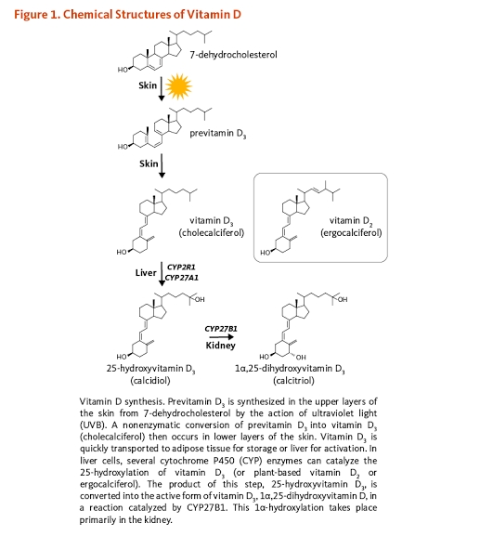
6) Vitamin D is a hormone not a vitamin. The skin is responsible for producing vitamin D during exposure to sunlight. Ultraviolet radiation penetrates into the epidermis and photolyzes provitamin D3 to provitamin D3. Vitamin D is also sensitive to sunlight. Aging, sunscreen and melanin all diminish the capacity of the skin to produce previtamin D3.

7a) Effect of base
DNA
- DNA is not hydrolysed by alkali PH because it does not contain the 2-OH for base catalyzed hydrolysis mechanism.
- The alkali lysis method is used in isolation of plasmid DNA from bacterial cell, where a principle is applied.
B) Effect of acid
DNA
- Hydrolysis occurs
- Extremely low PH digests the DNA completely and this is why our stomach PH is low.
8) Contribution of Watson-Crick in the structure of DNA
Structure of DNA was a double stranded helix polymer, or a spiral of two DNA strands, each containing a long chain of mono meter nucleotide hung around each other.
9)
DNA | RNA
Bases are not modified | Bases are modified
Double stranded | Single stranded molecules
No natural DNA is catalytic | RNA can be catalytic
Life time of DNA is comparatively high | RNA short lived
Present in nucleus, mitochondria and chloroplast | Present in nucleus, mitochondria, nucleolus, ribosomes and cytosol.

10) Functions of Nucleotides
- CTP ( Cytidine Triphosphate) drives lipid synthesis.
- GTP ( Guanine Triphosphate) drives protein synthesis.
- UTP ( Uridine Triphosphate) drives carbohydrate metabolism.

