Name: IBEZIM, EMILY CHIKA
Matric Number: 17/mhs01/143
Level: 300
Department: Medicine and Surgery
Course Title: Renal Physiology, Body Fluid and Temperature Regulation
Course Code: PHS 303

QUESTION
1. Discuss the role of kidney in glucose homeostasis
2. Discuss the process of micturition
3. Explain juxtaglomerular apparatus
4. Discuss the role of kidney in regulation of blood pressure
5. Discuss the role of kidney in Calcium homeostasis

SOLUTION

1. ROLE OF KIDNEY IN GLUCOSE HOMEOSTASIS
- THE KIDNEY
The kidneys are a very important organ in the body. They are two bean-shaped organs, each about the size of a fist, located just below the rib cage, one on each side of your spine. One of the functions of the kidney is to get rid of waste products, drugs, and toxins through our urine.
- THE KIDNEY’S ROLE IN GLUCOSE HOMEOSTASIS
The maintenance of normal glucose homeostasis requires a complex, highly integrated interaction among the liver, muscle, adipocytes, pancreas and neuroendocrine system. Recent studies have showed that the kidneys also play a central role in glucose homeostasis, both in the post-absorptive and postprandial period. Kidney produces glucose by gluconeogenesis in the renal cortex and uses glucose for covering energy needs of the medulla. Kidney participates also to the reabsorption of filtered glucose, an adaptive mechanism that ensures sufficient energy is available during fasting periods, in order the terminal urine was devoided of glucose, as long as blood glucose did not exceed 180mg/dL. In orther words, the kidneys’ contributions to maintaining glucose homeostasis are significant and include such functions as release of glucose into the circulation via gluconeogenesis, uptake of glucose from the circulation to satisfy their energy needs, and reabsorption of glucose at the level of the proximal tubule. Reabsorption of glucose is mediated by sodium-glucose cotransporters (SGLT1 et SGLT2) expressed in S1 and S3 segments of proximal tubule. SGLT2 is the main sodium-glucose cotransporter responsible for 90% of glucose reabsorption.
In the case of diabetes, specifically, in type 2 diabetics, renal gluconeogenesis and glucose utilisation are increased by 30%. Surprisingly, renal glucose reabsorption is increased, participating to worsening of hyperglycemia. This results from the increase in the renal threshhold of glucose reabsorption (220mg/dL) and from an overexpression of SGLT2 in response to hyperglycemia and of cytokine secretion. The administration of SGLT2 inhibitors to type 2 diabetic patients induced a decreased in the renal threshhold of glucose reabsorption (80mg/dL) and strongly reduced kidney glucose reabsorption. The inhibitors of SGLT2 are the only antidiabetic molecules able to correct the excessive renal glucose reabsorption in type 2 diabetics and thus to contribute, by an original mechanism, to the lowering of blood glucose level.

2. THE PROCESS OF MICTURITION
MICTURITION
Micturition or urination is the process of expelling urine from the bladder. This act is also known as voiding of the bladder. The process of micturition is regulated by the nervous system and the muscles of the bladder and urethra. The urinary bladder can store around 350-400ml of urine before it expels it out.
We depend on micturition (urination) to eliminate organic waste products, which are produced as a result of cell metabolism in the body. The urinary system also regulates the concentrations of sodium, potassium, chloride and other ions in the blood as well as helping to maintain normal blood pH, blood pressure and blood volume. The urinary system in humans includes a pair of kidneys, two ureters, a urinary bladder and a urethra. The kidneys filter the urine and it is transported to the urinary bladder via the ureters where it is stored till its expulsion.

The Process of Micturition
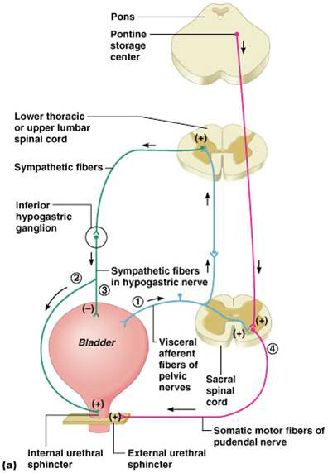

As mentioned earlier, the process of micturition is governed by both the nervous and muscular systems. Within the nervous system, the process is governed by the autonomous nervous system and the somatic system. Once the urinary bladder reaches its maximum capacity, the stretch receptors in the walls of the bladder send an impulse via the pelvic nerve to the brain via the spinal cord.
The micturition reflex is ultimately generated from the level of the spinal cord after it receives reflexes from the pontine region in the brain. Once the bladder and the urethra receive the signals to empty the bladder, the two sphincters relax and the detrusor muscle causes the contractions of the bladder.

Along with these muscles, the muscles of the abdomen also play a role by putting pressure on the bladder wall. This leads to complete emptying of the bladder.

3. JUXTAGLOMERULAR APPARATUS
The juxtaglomerular apparatus is a specialized structure formed by the distal convoluted tubule and the glomerular afferent arteriole. It is located near the vascular pole of the glomerulus and its main function is to regulate blood pressure and the filtration rate of the glomerulus.
The juxtaglomerular apparatus of the kidney serves as a intrarenal baroreceptor that is composed of four basic elements: the terminal portion of the afferent arteriole, the macula densa (a segment of the distal tubule), the extraglomerular mesangial region, and the efferent arteriole at the glomerulus. Because of its location in the nephron, it is highly sensitive to changes in volume as induced by various diuretic classes, and thus it is sensitive to changes in kidney perfusion pressure. The juxtaglomerular apparatus is also known to be adrenergically innervated, and has β-1 adrenoreceptors.
Sympathetic stimulation or decreases in volume or perfusion pressure can all stimulate the juxtaglomerular apparatus response to release renin into the afferent arteriole. Renin then converts angiotensinogen, which is formed in the liver, to angiotensin I .Angiotensin-converting enzyme converts angiotensin I to angiotensin II, which is a potent vasoconstrictor and stimulates secretion of aldosterone from the adrenal cortex.
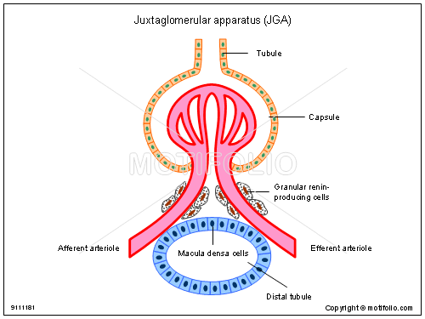
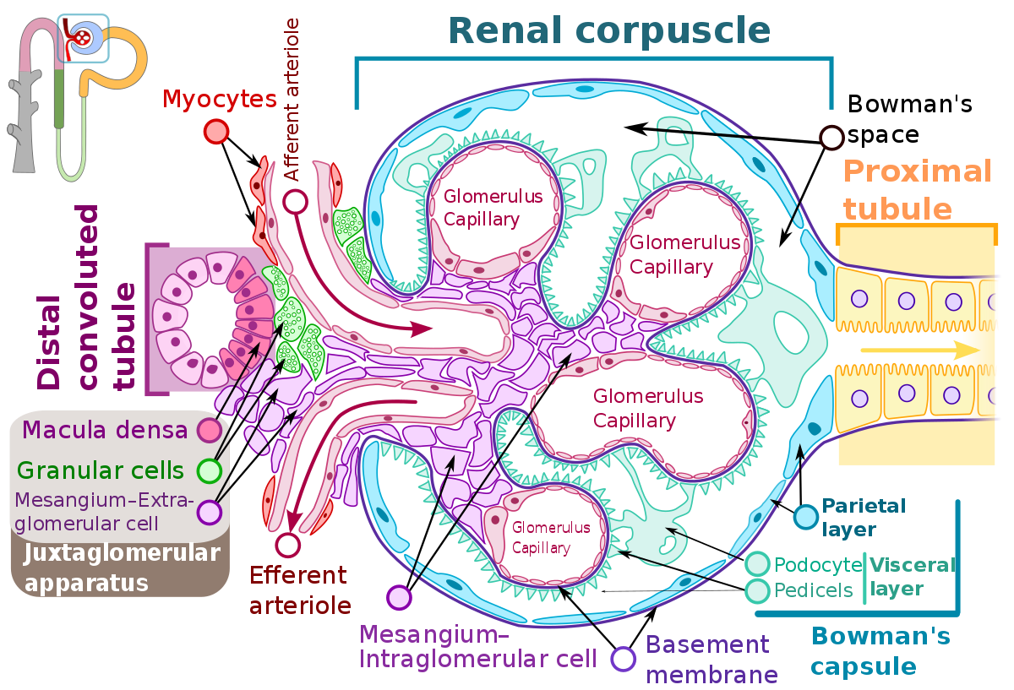

4. ROLE OF KIDNEY IN REGULATION OF BLOOD PRESSURE
The kidneys play a central role in the regulation of arterial blood pressure.

Mechanisms of blood pressure control by the kidneys
1. Intra-renal actions of the renin-angiotensin system in blood pressure control
The renin-angiotensin system (RAS) is a potent modulator of blood pressure, and dysregulation of the RAS results in hypertension. Pharmacological blockade of the RAS with renin inhibitors, angiotensin-converting enzyme (ACE) inhibitors, or angiotensin receptor blockers effectively lowers blood pressure in a substantial proportion of patients with hypertension, reflecting the important role for RAS activation as a cause of human hypertension. While in rodents, deletion of RAS genes lowers blood pressure, overexpression causes hypertension.
While The distal tubule cells (macula densa) sense the Na in the filtrate, and the arterial cells (juxtaglomerular cells) sense the blood pressure.
In order words, Due to osmosis, water follows where Na+ leads. Much of the water the kidneys recover from the forming urine follows the reabsorption of Na+. ADH stimulation of aquaporin channels allows for regulation of water recovery in the collecting ducts. Normally, all of the glucose is recovered, but loss of glucose control (diabetes mellitus) may result in an osmotic dieresis severe enough to produce severe dehydration and death. A loss of renal function means a loss of effective vascular volume control, leading to hypotension (low blood pressure) or hypertension (high blood pressure), which can lead to stroke, heart attack, and aneurysm formation.

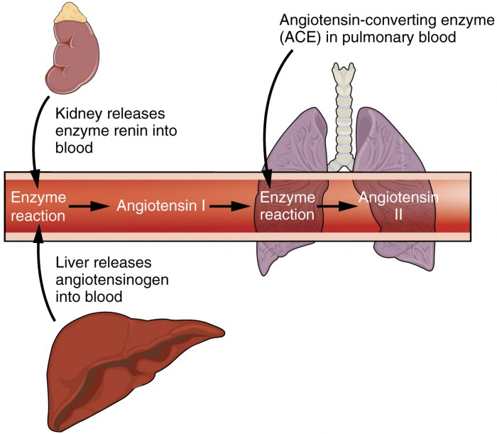
Figure 1. The Enzyme Renin Converts the Pro-enzyme Angiotensin
The kidneys cooperate with the lungs, liver, and adrenal cortex through the renin–angiotensin–aldosterone system. The liver synthesizes and secretes the inactive precursor angiotensinogen. When the blood pressure is low, the kidney synthesizes and releases renin. Renin converts angiotensinogen into angiotensin I, and ACE produced in the lung converts angiotensin I into biologically active angiotensin II. The immediate and short-term effect of angiotensin II is to raise blood pressure by causing widespread vasoconstriction. angiotensin II also stimulates the adrenal cortex to release the steroid hormone aldosterone, which results in renal reabsorption of Na+ and its associated osmotic recovery of water. The reabsorption of Na+ helps to raise and maintain blood pressure over a longer term.
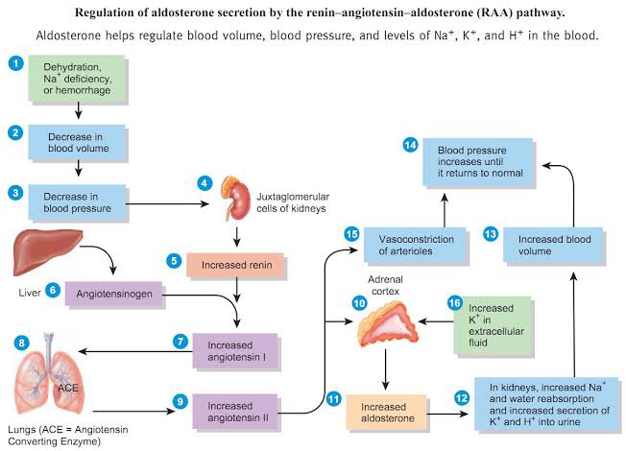

5. ROLE OF KIDNEY IN CALCIUM HOMEOSTASIS
Calcium is the most abundant mineral found in the body. The maintenance of calcium homeostasis is very important because calcium is the main component of bony skeleton and serves as the intracellular and extracellular messenger in numerous essential cellular events such as neuronal network, immune response, muscle contraction, and hormone secretion. About 99 percent of the calcium in the body is in bones and teeth. The remaining 1 percent is found in blood and soft tissues.
The kidney is critcally important in calcium homeostasis. Under normal blood calcium concentrations, almost all of the calcium that enters glomerular filtrate is reabsorbed from the tubular system back into blood, which preserves blood calcium levels. If tubular reabsorption of calcium decreases, calcium is lost by excretion into urine. Vitamin D and parathyroid hormone (PTH) help regulate how much calcium is absorbed and how much calcium the kidneys eliminate. Healthy kidneys turn vitamin D into an active hormone (calcitriol), which helps increase calcium absorption from the intestines into the blood.
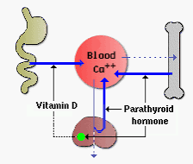
Schematic of the kidney’s role in calcium homeostasis.

