DIKONG BLESSING NDOH-FESE
19/SCI17/009
BIOTECHNOLOGY

1) Vitamins can be broadly classified into two categories based on their solubility:
i) Fat soluble vitamins e.g Vitamins A, D, E and K.
ii) Water soluble vitamins.e.g, Vitamins B1, B2, B3, B5, B6, B7 and B9.
Vitamins have diverse biochemical significance:
i) Vitamin A acts as a regulator of cell and tissue growth and differentiation.
ii) Vitamin D provides a hormone-like function, regulating mineral metabolism for bones and other organs.
iii) The B complex vitamins function as enzyme cofactors or the precursors of them.
iv) Vitamins C and E function as anti-oxidants.
v) Generally Vitamins are essential for normal growth and development of a multi-cellular organism, once growth and development are completed, vitamins remain essential for the healthy maintenance of cells, tissues and organs that make up a multi-cellular organism.
2) Vitamin B1(Thyamine)-Coenzyme Thyamine Pyrophospahte; Plays an important role in transmission of nerve impulses. It is also responsible for acetyl choline synthesis and ion translocation of neural tissue.
Vitamin B3(Niacin)-Coenzyme Nicotianamide Adenine Dinucleotide; It is involved in the synthesis of carbohydrate, lipid, protein, e.t.c.

3)
Base | Nucleoside | Nucleotide | Nucleic Acid
Purines:
Adenine | Adenosine Deoxyadenosine | Adenylate Deoxyadenylate | RNA  DNA
Guanine | Guanosine Deoxyguanosine | Guanylate Deoxyguanylate | RNA  DNA
Pyrimidines:
Cytosine | Cytidine Deoxycytidine | Cytidylate Deoxycytidylate | RNA  DNA
Thyamine | Deoxythyamine | Deoxythymidylate | DNA
Uracil | Uridine | Uridylate | RNA

4)
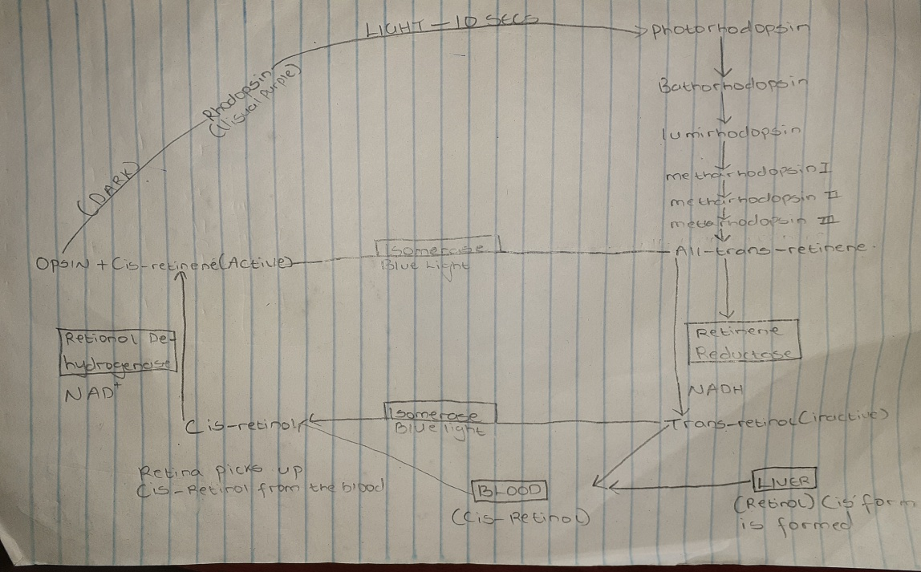
5) When a person shifts from bright light to dim light, rhodopsin stores are depleted and vision is impaired. However, after a few minutes called the “Dark Adaptation Time”, rhodopsin is resynthesized and vision is improved.
6) During the course of the cholesterol biosynthesis, 7-dehydro cholesterol is formed. On exposure to sunlight, 7-dehydrocholesterol is converted to cholecalciferol in the skin, Vitamin is referred to as the ‘Sunshine Vitamin’.
7) Acid hydrolysis cleaves susceptible purine N-glycosyl bonds in both RNA and DNA. When RNA is boiled in dilute acid, adenine and guanine are released, leaving an “apurinic acid” which maybe further hydrolyzed to a mixture of pyrimidine nucleotides. The pyrimidines are most resistant to acid hydrolysis.
Alkali hydrolysis of RNA produces a mixture of 2’ and 3’ nucleotides of Cyclic 2’, 3’ monophosphate dinucleotides.
8) The double helix structure of DNA was proposed by James Watson and Francis Crick. The structure of the DNA double helix is comparable to a twisted ladder. It consists of two polydeoxyribonucleotide chains twisted around each other. The two strands are anti-parallel with a width of 20Aº. The two polynucleotide strands are not identical but complementary to each other due to base pairing.
9)
 | RNA | DNA
Sugar Moiety | Ribose | Deoxyribose
Nitrogenous bases | Adenine, Guanine, Cytosine and Uracil. | Adenine, Guanine, Cytosine and thyamine.
Pairing | Adenine pairs with uracil | Adenine pairs with thyamine.
Strand | Single strand of RNA | Double helix strand of DNA
Reaction with Alkali | Hydrolysis occurs | No effect

10) Functions of Nucleotides:
- Nucleotides are activated precursors of RNA and DNA.
- They are required for the activation of intermediates in many biosynthetic pathways.
- Nucleotides of Adenine act as carriers of methyl group in the form of S-adenosylmethionine.
- ATP is a universal currency of energy in biological systems.
- Adenine nucleotides are components of three major coenzymes: NAD⁺, FAD⁺, CoA.
- Nucleotides are metabolic regulators. E.g; C-AMP and C-GMP.

