NAME: SHITTU RUKAYAT. A

MATRIC.NO: 17/SCI04/003
DEPARTENT: HUMAN BIOLOGY
COLLEGE: SCIENCES
COURSE: HMB 316

- Write a short note on the toxicological effect of food additives and preservatives:
The effect of food additives and preservatives may of immediate harm or harmful at a later time due to constant exposure. Food additives and preservatives have been of carcinogenic origin and effects, and other allergic reactions due to the presence of the chemicals used in making them. Excessive consumption of artificial additives and preservatives can weaken the heart tissues, which is very dangerous (especially for the aged), they could also contain BHA (found in baked goods, meat) and BHT (used in cereals) which could be carcinogenic, digestive disorders such as diarrhea, nervous disorders such as insomnia, respiratory problems such as asthma, reduce the body’s ability to absorb fat-soluble, cancer preventing carotenoids (e.g. beta-carotene and lycopene), skin problems such as itching, rashes, and swellings, anaphylactic shock. There are two major sources of dangerous additives:
A) The ones that are put as part of processing of food e.g. colorings, flavor enhancers, sweeteners, texture and processing agents.
B) The ones from packaging, storing.

- Describe various categories by which toxicity testing studies can be performed. Hence write on various tests for assessing the toxicity of any two major organs in the body:
Toxicity testing or safety assessment is the process by which the degree to which a substance negatively impacts the normal biological function of an organism, by certain exposure duration, route of exposure, and substance is determined. The following are the categories of toxicity testing:
- Acute Toxicity Studies: gives information on the likely adverse effects that may occur as a result of short-term exposure. Determination of oral, dermal, and inhalation toxicity is the first step in evaluating the toxicity of a substance.
- Sub Chronic Toxicity Studies: sub chronic exposures to substances do not draw out effects that have a long lasting latency period( e.g. carcinogenicity). But, they provide information on the adverse effects that may result from repeated exposures to a substance over a period of time.
- Chronic Toxicity Studies: is used for assessing potential adverse effects resulting from prolonged and repeated exposure to a substance over a very long period of time
- Developmental Toxicity Studies: help to assess the potential developmental effects in offspring arising from the mother’s exposure to the test substance during pregnancy. These effects can include the death of developing organism, structural abnormalities, altered growth, and functional deficiencies.
- Mutagenicity Studies: this test is required to assess the potential of each test chemical to affect genetic material.
- General Metabolism Studies: information from studies on the absorption, distribution, metabolism, excretion, and bioaccumulation of a toxicant may be meaningful in the evaluation of test results and more appropriate risk assessment.
- Neurotoxicity Studies: evaluate the potential of toxicants to adversely affect the structure or function of the nervous system.

B) Tests for assessing the toxicity of two major organs in the body;

ACUTE TOXICITY TESTING FOR INHALATION (LUNGS): is performed for aerosol-like toxicants. The animals are acclimatized to laboratory conditions temperature preferably within 22 degrees. They are maintained in airflow of 12-15 air changes per hour with adequate oxygen (19%h). The animal is exposed to the toxic substance for a minimum of 4 hours and then monitored for 14 days. Food and water may be withheld during the exposure period. During observation period, the animal is observed for convulsions, coma, tremors, salivation, etc. Mortality during exposure period is noted and dead animals are examined for histological and pathological changes. At the end of the study, the animals are sacrificed and pathological changes are evaluated.

CHRONIC ORAL TOXICITY TESTING: provides information about long-term effect of a test substance in animals. During the study period, the animals are observed for normal physiological functions, alterations in biochemical parameters. At the end of the study, tissues are collected from all parts of the animal and subjected to histological analyses. Hence, this test can be used for any organ.

Toxicity Test For The Heart
a) Current Cardiac Toxicity Testing: markers include an in vitro assay that measures the inhibition of a cardiac channel encoded by the human ether-a-go-go related gene ( hERG) and an in vivo ECG assay that measures prolongation of the QT interval in animals and humans.
b) Echocardiogram Test: uses sound waves to study the structure of the heart and how well the heart valves are working upon exposure to harmful toxicants.

Lung Function Tests: include a variety of tests that check how well the lungs work. The most basic test is spirometry. This test measures the amount of air the lungs can hold, and hoe forcefully once can empty air from the lungs.
b) Plethysmography Test: measures the volume of gas in the lungs( lung volume)
c) Diffusion Capacity Test: evaluates how well te small air sacs( alveoli) work.

- Discuss the various routes by which the body can be exposed to foreign substances:
There are four major routes of entry by which foreign substances can enter the body:
- Inhalation (breathing): substances in form of gas, vapor, or particulates use the nose (inhalation) as a route of entry into the body. Once inhaled, the substances can also be exhaled back or go in to the respiratory tract which can cause damage through direct contact with tissues, or can diffuse into the blood through the lung-blood interface.
- Skin (or eye) contact (absorption): dermal contact can cause effects that are harmless such as redness or mild dermatitis. More severe effects are destruction of skin tissue. Many toxicants can pass the skin barrier and be absorbed into the blood system. Once absorbed, they may cause systemic damage to internal organs. The eyes are sensitive, so even a short exposure can cause severe effects to the eyes or the substance can be absorbed through the eyes and move to other parts of the body.
- Ingestion: when substances get into the mouth and are swallowed, they do not harm the gastrointestinal tract unless they are corrosive. Substances that are insoluble in the GIT will be excreted. Others that are soluble are absorbed through the lining of the GIT, and transported by the blood into internal organs, where they may cause damage.
- Injection: substances can enter the body if the skin is punctured with contaminated object, or penetrated with the aim of injecting a substance into the body. Effects may occur as the substance is circulated in the blood and taken to organs.

- Bioavailability of toxicants is influenced majorly by lipid barrier, discuss:
The cell membrane is selective permeable, which means only certain substances can pass through it. The selective permeability however is determined by molecular size, lipid solubility, and electrical charge associated with the toxic molecule. The amount of toxic substances that is transported across these barriers is determined by the characteristics of the cell membrane transport and the physio-chemical components of the toxic substance. Most toxic substances move across the cell membrane by diffusion (passive diffusion), and diffusion is dependent on 3 factors
- Concentration gradient across the cell membrane
- Lipid solubility
- Electrical charge associated with the molecule.
Lipid solubility is important in determining the diffusion rate of a toxic substance since 75% of the cell membrane is made of lipid. Hence, why bioavailability of toxicants will be majorly influenced by lipid barrier, as the bioavailability of the toxicant will be high in the body if the toxicant is lipid soluble because lipid soluble substances will diffuse more rapidly than water-soluble.

- Explain the concept of molecular targets of toxicants:
Toxicants that can modify molecular or cellular processes can have consequences throughout an organism. These interconnections can be common to all cell types, or may reflect special or unique targets or bioactivation that are to be found in limited subpopulations of cells. The results of these modifications will or can produce different changes that can be characterized by measurements of transcription factor activity, gene expression at the RNA or protein level in the molecule of an organ. Many chemicals spread in the body and often affect only specific target organs. But however, other chemicals can damage any cell or tissue that they come in contact with. The target organs that are affected may vary depending on the dosage and route of exposure. For example, the Central nervous system might be the target organ for toxicity from a chemical after acute exposure, whereas the liver may be affected after chronic exposures. Also, the toxic action of a chemical is as a result of the physical/chemical interaction of the active form of that chemical with a molecular target in an organism examples of molecular targets are DNA, proteins.

6) Write on the toxicological effect of a named food additive:
VINEGAR: apple cider vinegar has been found to cause esophageal injury, and long term heavy ingestion can cause a possible case of hypokalemia, hyperreninemia, and osteoporosis.

- Carcinogenesis can result from toxicant exposure, discuss:
Carcinogens can be described as reproductive toxins and substances that possess high acute toxicity as particularly hazardous substances (PHS). Carcinogens can be chemical substances, medications, or radiations. Toxicity is defined as the degree to which a chemical can cause damage to the human cell of a body. Therefore, carcinogenesis occurs by the interaction of the body with toxic chemical substances capable of causing cancer i.e. carcinogenic substances. Exposure to substances such as asbestos, benzene, nickel, tobacco and so forth can pose a great risk for cancer. Hence, carcinogenesis and toxicant exposure have a strong relationship; therefore they work hand in hand. Toxicant exposure is the first stage to carcinogenesis.

- Describe the various excretory pathways of toxicants:
- Urinary Excretion: removal of substances by the kidneys into urine is the chief route of excretion of toxicants. The main function of the kidney is the excretion of wastes and harmful chemicals. The nephron is the functional unit of the kidney responsible for the excretion. The three processes involved in urinary excretion are: filtration which takes place in the glomerulus, the glomerulus filtrate is transported into the convoluted tubule where reabsorption of useful nutrients take place, which is the second process, then secretion which occurs in the proximal tubule of the nephron transports certain molecules out of the blood and into the urine. The urine is transported into the urethra and upon constriction, is released.
- Fecal Excretion: removal of toxicants in the feces occurs from two processes: excretion in bile, which enters the intestine, and direct excretion into the lumen of the gastrointestinal tract. The biliary route is an important mechanism for fecal excretion of xenobiotic and its metabolites. When a substance has been excreted by the liver into the bile, and into the intestinal tract, it can be removed from the body in the feces, or it may ne reabsorbed. Since most of the substances excreted in the bile are water-soluble, they are most likely not reabsorbed.
- Exhaled Air: the lungs are also an important route for the excretion of xenobiotic and its metabolites that are in gaseous forms in the blood.
- Other routes of excretion include milk, saliva, sweat, tears, and semen.
- With the aid of a schematic diagram, describe the toxicological process in mammal:
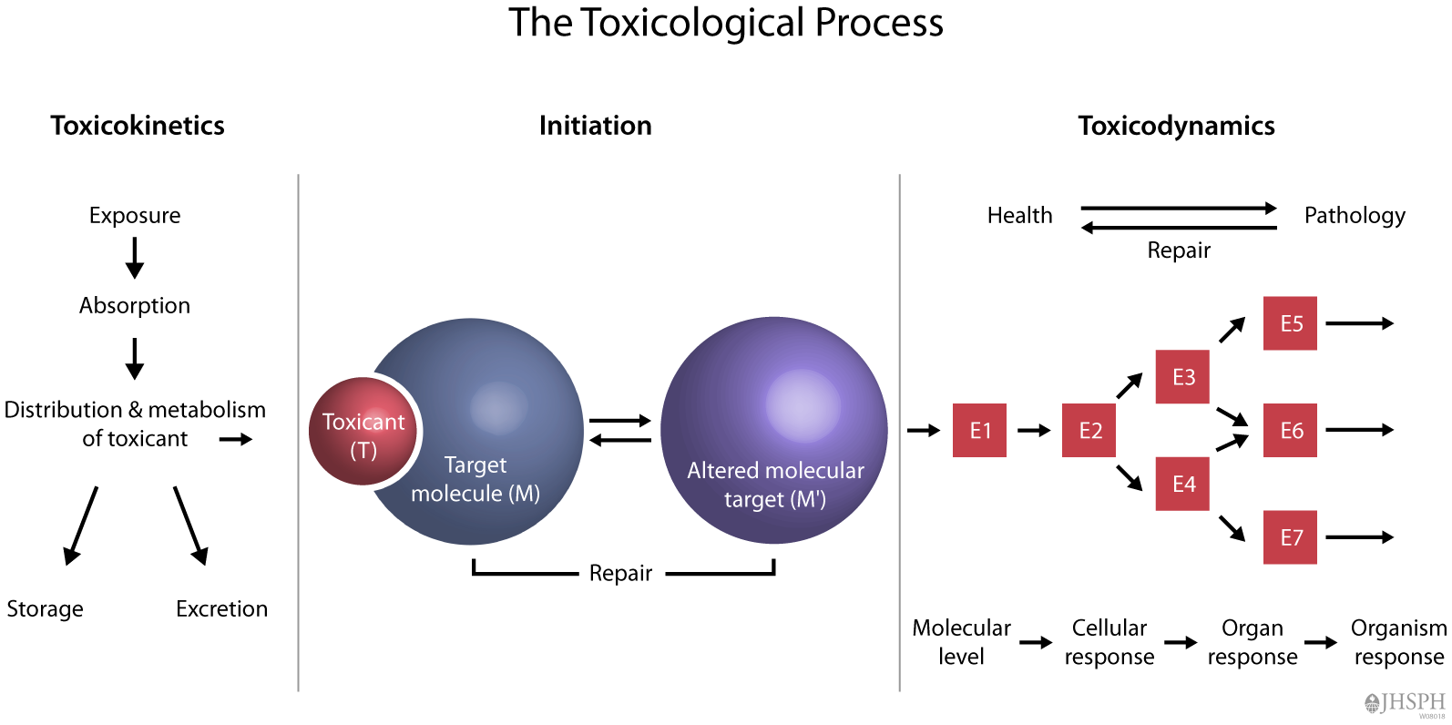

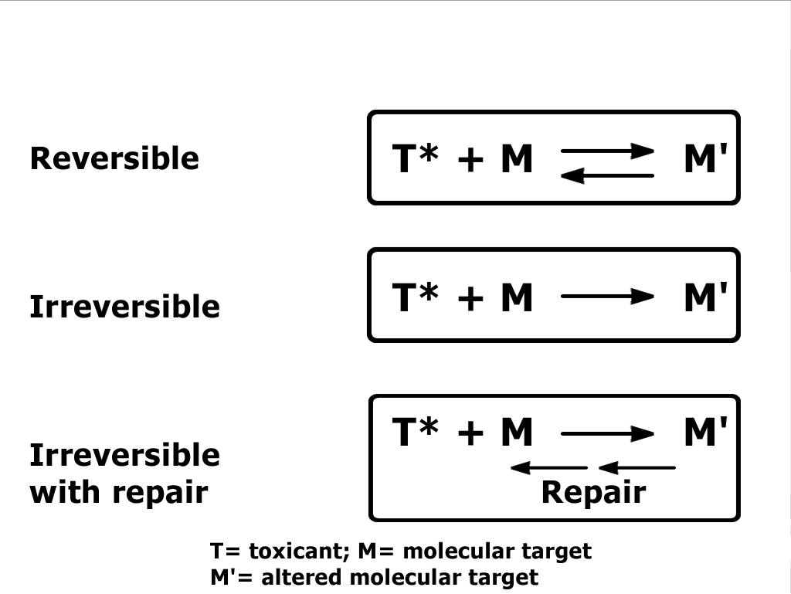

Absorption: intake of the toxicant via the various exposure routes i.e. inhalation, ingestion, and skin contact, injection. Absorption is the transfer of a toxicant from its site of administration into the blood. The rate and efficiency of absorption depends on the route of exposure or administration.
Distribution- is the process by which a toxicant reversibly leaves the bloodstream and enters extracellular fluid and cells of tissues. The volume of distribution is a hypothetical volume in which a toxicant is distributed.
Metabolism- or biotransformation is a process, which provides decreasing of toxicity and accelerates excreting of the molecule of toxicant after coming into the organism. Most hydrophilic drugs are less biotransformed and excreted unchanged. Metabolism protects the body from toxic metabolites.
Excretion- or elimination is the process by which toxicants can be excreted in forms of metabolites or unchanged forms through various ways: lungs, skin, kidney, liver, and mammary glands.
The toxicant binds with the target molecule, after biotransformstion to produce an altered molecule which can be repaired and goes back to the biotransformation stage again to be excreted or, it continues as an altered molecular target to the molecular, cellular, organ, organism levels to cause pathology, or the process can be reversed back to normal health.

- With the aid of an adequate pathway, discuss the phase 1 and 2 metabolism of ethanol and Aflatoxin B1

Phase I metabolism of aflatoxin B1
Phase I metabolism of AFB1 is carried out mainly by members of the CYP450 superfamily of enzymes. Collectively, CYP450 enzymes participate in a variety of oxidative reactions with lipophilic xenobiotic and endogenous substrates including hydroxylation of an aliphatic or aromatic carbon, epoxidation of a double bond, heteroatom (S-, N- and I-) oxygenation and N- hydroxylation, heteroatom (O-, S-, and N-) dealkylation, oxidative group transfer, cleavage of esters, and dehydrogenation .In regards to AFB1, CYP450s can hydroxylate, hydrate, O-demethylate, and epoxidate the molecule.
Phase II metabolism of aflatoxin B1
The most studied Phase II biotransformation reaction of any AFB1 metabolite is the nucleophilic trapping process in which GSH reacts with the electrophilic metabolite AFBO. Conjugation of AFBO with GSH is catalyzed by glutathione transferases (GST, 2.5.1.18), a superfamily of enzymes responsible for a wide range of reactions in which the GSH thiolate anion participates as a nucleophile. These intracellular proteins are found in most aerobic eukaryotes and prokaryotes, and protect cells against chemically-induced toxicity and stress by catalyzing the conjugation of the thiol group of GSH and an electrophilic moiety in the substrate.
Another conjugation reaction reported for AFB1 metabolites is the conjugation of AFP1 and its 9a-hydroxy metabolite (aflatoxin M1-P1) with glucuronic acid. This conjugation has only been reported in rats and mice and leads to the synthesis of detoxified products. Conjugation with glucuronic acid is catalyzed by enzymes known as UPD-glucuronosyltransferases, but the specific UGT involved in the conjugation of AFP1 and AFM1-P1 has not been described yet.
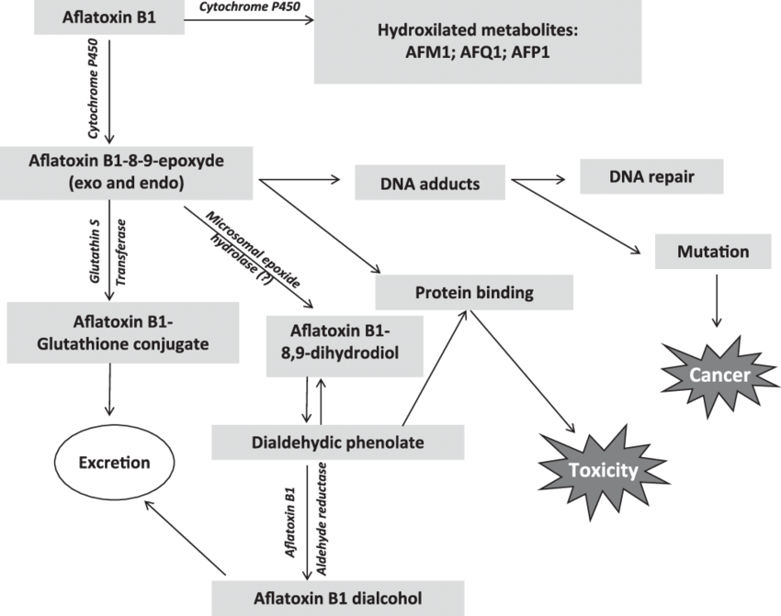

Ethanol Metabolism:
Ethanol is metabolized by oxidation to acetaldehyde by the enzyme ADH, by the CYP2E1-dependent MEOS, or by catalase and further to acetate by ALDH
Ethanol Metabolism via ADH
ADH is localized in the cytoplasm of all cells, but predominantly in hepatocytes.
ADH requires as cofactor NAD , which is reduced to NADH + H during the
metabolism of ethanol to acetaldehyde. ADH is a zinc-containing enzyme with a molecular weight of 80 000 and a predominant location around the central vein within the hepatic lobule. It is a dimer consisting of three polypeptide chains (α, β, and γ). ADH oxidizes ethanol first to acetaldehyde, which is then further oxidized to acetate. The reactions involve an intermediate carrier of electrons,
NAD , which is reduced to NADH. The electrons that originated in ethanol to produce NADH are ultimately transferred to oxygen via a number of other inter- mediate carriers in the mitochondrial electron transport chain and oxygen is reduced to water at the terminal enzyme (cytochrome oxidase). The final oxidation creates energy as ATP (1 g of ethanol equivalents 7.1 kcal). This intramitochondrial electron transport may generate ROS if not controlled adequately. A small portion of oxygen that is reduced in the mitochondria is released as the one-electron- reduced form–superoxide. Increased mitochondrial activity and NADH use generate more superoxide. As a protection against intramitochondrially generated ROS, the mitochondria possess manganese superoxide dismutase, which destroys superoxide.
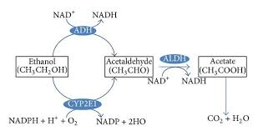

- Write on the following:
- Toxickinetics
- Toxicodynamics.

TOXICOKINETICS: is the quantitation of the time course of toxicants in the body during the processes of absorption, distribution, biotransformation, and excretion or clearance of toxicants. Hence, toxicokinetics is a study of how the body handles toxicants as indicated by the plasma concentration of that xenobiotic at various time points i.e. fate of administered drug. The end result of these toxicokinetic processes is a biologically effective dose of the toxicant.
TOXICODYNAMICS: refers to the molecular, biochemical, and physiological effects of toxicants or their metabolites in biological systems, Hence the effects of toxicants on the body.
These effects are result of the interaction of the biologically effective dose of the active form of the toxicant with a molecular target.

