NAME: Obiremi Ezekiel babawale
MATRIC NUMBER:17/MHS01/222
DEPARTMENT:MBBS
COURSE : PHYSIOLOGY
ASSIGNMENT
QUESTION 1
Discuss the role of kidney in glucose homeostasis?
The kidney plays an important role in glucose homeostasis via gluconeogenesis, glucose utilization, and glucose reabsorption from the renal glomerular filtrate. After an overnight fast, 20–25% of glucose released into the circulation originates from the kidneys through gluconeogenesis. In this post-absorptive state, the kidneys utilize about 10% of all glucose utilized by the body. After glucose ingestion, renal gluconeogenesis increases and accounts for approximately 60% of endogenous glucose release in the postprandial period. Each day, the kidneys filter approximately 180 g of glucose and virtually all of this is reabsorbed into the circulation. Hormones (most importantly insulin and catecholamines), substrates, enzymes, and glucose transporters are some of the various factors influencing the kidney’s role. Patients with type 2 diabetes have an increased renal glucose uptake and release in the fasting and the post-prandial states. Additionally, glucosuria in these patients does not occur at plasma glucose levels that would normally produce glucosuria in healthy individuals.
the kidneys contribute to glucose homeostasis by filtering and reabsorbing glucose. Under normal conditions, the kidneys retrieve as much glucose as possible, rendering the urine virtually glucose free. The glomeruli filter from plasma approximately 180 grams of D-glucose per day, all of which is reabsorbed through glucose transporter proteins that are present in cell membranes within the proximal tubules.If the capacity of these transporters is exceeded, glucose appears in the urine. This maximum capacity, known as the tubular maximum for glucose (TmG), ranges from 260 to 350 mg/min/1.73 m² in healthy adults and children, and corresponds to a plasma glucose level of approximately 200 mg/dL. Once the TmG (the threshold) is reached and transporters are unable to reabsorb all the glucose (as in T2DM), glucosuria ocurrs.The correlation between the degree of hyperglycemia and degree of glucosuria becomes linear when blood glucose concentrations have increased beyond a threshold. It should be noted that slight differences between individual nephrons and the imprecise nature of biological systems may alter this linear concentration/reabsorption curve, as indicated by a splay from the theoretical as the TmG is approached. As such, glucosuria may potentially develop before the expected TmG is reached. Glucosuria may also occur at lower plasma glucose concentrations in certain conditions of hyperfiltration (eg, pregnancy), but as a consequence of hyperfiltration rather than significant hyperglycemia.
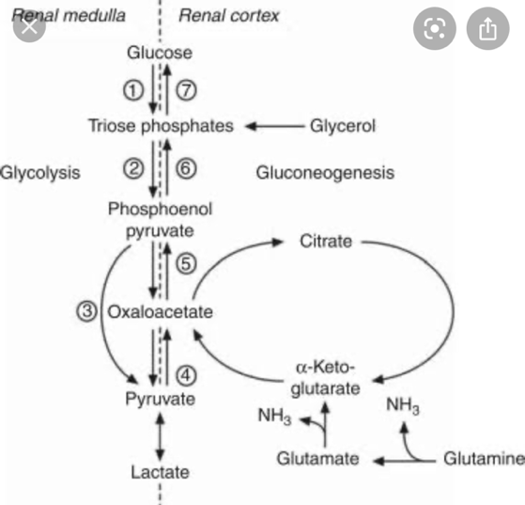

QUESTION 2
Discuss the process of micturition?

Micturition
Micturition or urination is the process of expelling urine from the bladder. This act is also known as voiding of the bladder. The excretory system in humans includes a pair of kidneys, two ureters, a urinary bladder and a urethra. The kidneys filter the urine and it is transported to the urinary bladder via the ureters where it is stored till its expulsion. The process of micturition is regulated by the nervous system and the muscles of the bladder and urethra. The urinary bladder can store around 350-400ml of urine before it expels it out.

Stages or process of Micturition

The urinary bladder has two distinct stages or phases:
- Resting or filling stage
- Voiding stage

Resting or Filling Stage
It is in this phase of the bladder that the urine is transported from the kidneys via the ureters into the bladder. The ureters are thin muscular tubes that arise from each of the kidneys and extend downwards where they enter the bladder obliquely.
The oblique placement of the ureters in the bladder wall serves a very important function. The opening of the ureter into the urinary bladder is not guarded by any sphincter or muscle. Therefore, this oblique natureof opening prevents the urine from re-entering the ureters. At the same time, the main muscle of the urinary bladder, the detrusor muscle, is relaxing allowing the bladder to distend and accommodate more urine.

Voiding Stage
During this stage, both the urinary bladder and the urethra come into play together. The detrusor muscle of the urinary bladder which was relaxing so far starts to contract once the bladder’s storage capacity is reached.
The urethra is controlled by two sets of muscles: The internal and external urethral sphincters. The internal sphincter is a smooth muscle whereas the external one is skeletal. Both these sphincters are in a contracted state during the filling stage.The process of micturition is regulated by both the nervous and muscular systems. Within the nervous system, the process is governed by the autonomous nervous system and the somatic system. Once the urinary bladder reaches its maximum capacity, the stretch receptors in the walls of the bladder send an impulse via the pelvic nerve to the brain via the spinal cord.
The micturition reflex is ultimately generated from the level of the spinal cord after it receives reflexes from the pontine region in the brain. Once the bladder and the urethra receive the signals to empty the bladder, the two sphincters relax and the detrusor muscle causes the contractions of the bladder.

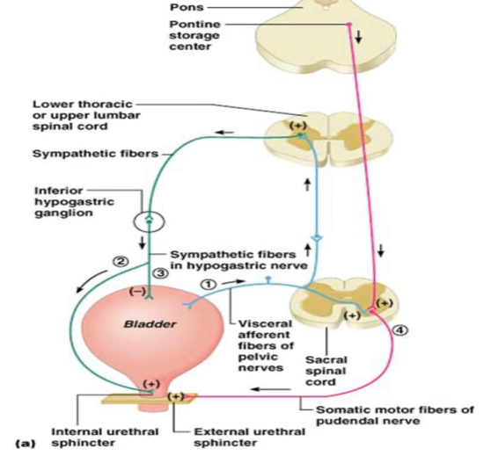
QUESTION 3?
Explain the juxaglomerular Apparatus
The juxtaglomerular apparatus (JGA) is located between the afferent arteriole and the returning distal convoluted tubule of the same nephron. It is responsible for regulating both intrarenal (tubuloglomerular feedback) and extrarenal (renin-angiotensin-aldosterone) mechanisms necessary to maintain both renal and entire body volume status.
The three components of the JGA are the following:
(1) the juxtaglomerular cells of the afferent arteriole, synthesize and store renin, which is secreted in response to specific stimuli (e.g., low blood flow, decreased NaCl delivery). The juxtaglomerular cells could be considered the “effector arm” of the renin-angiotensin-aldosterone axis.
(2) the macula densa, a region of the distal convoluted tubule characterized by tubular epithelial cells which are more densely-packed than in other regions of the nephron (and thereby leading to its characteristic appearance on light microscopy). The macula densa can be considered the “sensory arm” of the renin-angiotensin-aldosterone axis in that these are the cells which sense decreased Na Cl delivery which determines downstream function. They are also involved in the mechanism of tubuloglomerular feedback.
(3) mesangial cells, which form connections via actin and microtubules which allow for selective vasoconstriction/vasodilation of the renal afferent and efferent arterioles with mesangial cell contraction.
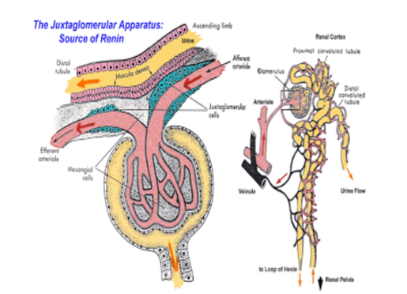
Question 4
Discuss the role of kidney in regulation of blood pressure?
The kidneys play a central role in the regulation of arterial blood pressure.The kidney influences blood pressure by:

• Causing the arteries and veins to constrict

• Increasing the circulating blood volume

Specialized cells called macula densa are located in a portion of the distal tubule located near and in the wall of the afferent arteriole. These cells sense the Na in the filtrate, while the arterial cells (juxtaglomerular cells) sense the blood pressure. When the blood pressure drops, the amount of filtered Na also drops. The arterial cells sense the drop in blood pressure, and the decrease in Na concentration is relayed to them by the macula densa cells. The juxtaglomerular cells then release an enzyme called renin.

Renin converts angiotensinogen (a peptide, or amino acid derivative) into angiotensin-1. Angiotensin-1 is thereafter converted to angiotensin-2 by an angiotensin-converting enzyme (ACE), found in the lungs. Angiotensin-2 causes blood vessels to contract -- the increased blood vessel constrictions elevate the blood pressure. When the volume of blood is low, arterial cells in the kidneys secrete renin directly into circulation. Plasma renin then carries out the conversion of angiotensinogen released by the liver to angiotensin-1. Angiotensin-1 is subsequently converted to angiotensin-2 by the enzyme angiotensin converting enzyme found in the lungs. Angiotensin-2m a potent vasoactive peptide causes blood vessels to constrict, resulting in increased blood pressure. Angiotensin-2 also stimulates the secretion of the hormone aldosterone from the adrenal cortex [9].

Aldosterone causes the tubules of the kidneys to increase the reabsorption of sodium and water into the blood. This increases the volume of fluid in the body, which also increases blood pressure. If the renin-angiotensin-aldosterone system is too active, blood pressure will be too high. Many drugs interrupt different steps in this system to lower blood pressure. These drugs are one of the main ways to control high blood pressure (hypertension), heart failure, kidney failure, and harmful effects of diabetes. It is believed that angiotensin-1 may have some minor activity, but angiotensin-2 is the major bioactive product. Angiotensin-2 has a variety of effects on the body: throughout the body, it is a potent vasoconstrictor of arterioles
Mechanisms of blood pressure control by the kidneys

1. Intra-renal actions of the renin-angiotensin system in blood pressure control

The renin-angiotensin system (RAS) is a potent modulator of blood pressure, and dysregulation of the RAS results in hypertension. Pharmacological blockade of the RAS with renin inhibitors, angiotensin-converting enzyme (ACE) inhibitors, or angiotensin receptor blockers effectively lowers blood pressure in a substantial proportion of patients with hypertension, reflecting the important role for RAS activation as a cause of human hypertension. While in rodents, deletion of RAS genes lowers blood pressure, overexpression causes hypertension.

While The distal tubule cells (macula densa) sense the Na in the filtrate, and the arterial cells (juxtaglomerular cells) sense the blood pressure. Studies have shown that chronic infusion of low doses of angiotensin II directly into the kidney caused hypertension with impaired natriuresis due to a shift of the pressure-natriuresis relationship .It is also believed that the existence of local and independent control of RAS activity within the kidney influencing sodium excretion and blood pressure regulation. In this hypothesis, increased circulating levels of angiotensin II are associated with accumulation of angiotensin peptides in the kidney, upregulated expression of angiotensinogen, the primary RAS substrate, in proximal tubule epithelium, and increased excretion of angiotensinogen and angiotensin peptides in urine. In this feed-forward pathway, angiotensin II acting via type 1 angiotensin (AT1) receptors in the kidney induces local activation of the RAS inside the kidney and increases generation of angiotensin II in the lumen of renal tubules, resulting in autocrine and paracrine stimulation of epithelial transporters

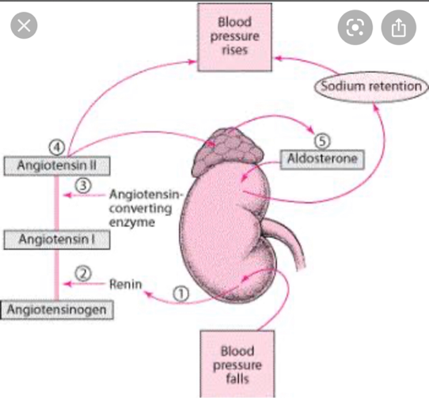
Question 5
Discuss the role of kidney in calcium homeostasis

The kidney plays a key role in this process by the fine regulation of calcium excretion. More than 95% of filtered calcium is reabsorbed along the renal tubules. In the proximal tubules, 60% of filtered calcium is reabsorbed by passive mechanisms. In the thick ascending limb, 15% of calcium is reabsorbed by paracellular diffusion through paracellin-1 (claudin-16). The calcium sensing receptor (CaSR) in the basolateral membrane of the thick ascending limb senses the change in iCa2+ and inhibits calcium reabsorption independent to PTH and 1,25(OH)2D3. The fine regulation of calcium excretion occurs in the distal convoluted tubules and connecting tubules despite the fact that only 10-15% of filtered calcium is reabsorbed there. Transient receptor potential vanilloid 5 (TRPV5) and 6 (TRPV6) in the apical membrane act as the main portal of entry, calbindin-D28K delivers Ca2+in the cytoplasm, and then Na2+/Ca2+ exchanger (NCX1) and plasma membrane Ca2+-ATPase in the basolateral membrane serve as an exit. In the cortical collecting duct, TRPV6 is expressed, but the role might be negligible. In addition to PTH and 1,25(OH)2D3, acid-base disturbance, diuretics, and estrogen affect on these calcium channels. Recently, klotho and fibroblast growth factor 23 (FGF23) are suggested as new players in the calcium metabolism. Klotho is exclusively expressed in the kidney and co-localized with TRPV5, NCX1, and calbindin-D28K. Klotho increases calcium reabsorption through trafficking of TRPV5 to the plasma membrane, and also converts FGF receptor to the specific FGF23 receptor. FGF23:klotho complex bound to FGF receptor inhibits 1α-hydroxylase of vitamin D, and contributes to calcium reabsorption and phosphate excretion in the kidney.

