NAME: AJAYI EMMANUEL OLUWASEGUN
MATRICULATION NUMBER: 17/MHS01/039
DEPARTMENT: MEDICINE AND SURGERY

THE ROLE OF THE KIDNEYS IN GLUCOSE HOMEOSTASIS
The kidneys play an important role in glucose homeostasis via gluconeogenesis, glucose utilization and glucose reabsorption from the renal glomerular filtrate. After an overnight fast, 20–25% of glucose released into the circulation originates from the kidneys through gluconeogenesis. In this post-absorptive state, the kidneys utilize about 10% of all glucose utilized by the body. After glucose ingestion, renal gluconeogenesis increases and accounts for approximately 60% of endogenous glucose release in the postprandial period. Hormones (most importantly insulin and catecholamines), substrates, enzymes and glucose transporters are some of the various factors influencing the kidneys’ role.
Under normal conditions, the kidneys filter and reabsorb 100% of glucose, rendering the urine virtually glucose free. The glomeruli filter from plasma approximately 180g (1 mole) of D-glucose per day, all of which is reabsorbed through glucose transporter proteins that are present in cell membranes within the proximal tubules. The glucose transporters expressed in the renal proximal tubule ensure that less than 0.5g/day (range 0.03-0.3 g/d) is excreted in the urine of healthy adults. More water than glucose is reabsorbed resulting in an increase in the glucose concentration in the urine along the tubule. Consequently, the affinity of the transporters for glucose along the tubule increases to allow for complete reabsorption of glucose from the urine.
If the capacity of these transporters is exceeded, glucose appears in the urine. This maximum capacity, known as the tubular maximum for glucose (TmG), ranges from above 260-350 mg/1.73m²/min and equates to a blood glucose concentration of approximately 200 mg/dL (threshold) in healthy individuals. Once the transport maximum is reached and transporters are unable to reabsorb all the glucose (as in T2DM), glycosuria occurs.
Gluconeogenesis in the kidneys exceeds renal glucose consumption. It is important in the prevention of hypoglycemia, and its inappropriate increase in diabetic patients contributes to the development of hyperglycemia.

THE PROCESS OF MICTURITION
Micturition or urination is the process of expelling urine from the bladder through the urethra. This act is also known medically as uresis, emiction, voiding of the bladder. The excretory system in humans includes a pair of kidneys, two ureters, a urinary bladder and a urethra. The kidneys filter the urine and it is transported to the urinary bladder via the ureters where it is stored till its expulsion. In humans, the process of urination is under voluntary control. In infants, some elderly individuals, and those with neurological injury, urination may occur as a reflex. The process is regulated by the nervous system and the muscles of the bladder and urethra. The urinary bladder can store around 350-400ml of urine before it expels it out.
The urinary bladder has two distinct stages or phases:
- Resting or filling stage
- Voiding stage
Resting or Filling Stage
It is in this phase of the bladder that the urine is transported from the kidneys via the ureters into the bladder. The ureters are thin muscular tubes that arise from each of the kidneys and extend downwards where they enter the bladder obliquely.
The oblique placement of the ureters in the bladder wall serves a very important function. The opening of the ureter into the urinary bladder is not guarded by any sphincter or muscle. Therefore, this oblique nature of opening prevents the urine from re-entering the ureters. At the same time, the main muscle of the urinary bladder, the detrusor muscle, is relaxing allowing the bladder to distend and accommodate more urine.
Voiding Stage
During this stage, both the urinary bladder and the urethra come into play together. The detrusor muscle of the urinary bladder which was relaxing so far starts to contract once the bladder’s storage capacity is reached.
The urethra is controlled by two sets of muscles - The internal and external urethral sphincters. The internal sphincter is a smooth muscle whereas the external one is skeletal. Both these sphincters are in a contracted state during the filling stage. The process of micturition is regulated by both the nervous and muscular systems. Within the nervous system, the process is governed by the autonomous nervous system and the somatic system. Once the urinary bladder reaches its maximum capacity, the stretch receptors in the walls of the bladder send an impulse via the pelvic nerve to the brain via the spinal cord.
The micturition reflex is ultimately generated from the level of the spinal cord after it receives reflexes from the pontine region in the brain. Once the bladder and the urethra receive the signals to empty the bladder, the two sphincters relax and the detrusor muscle causes the contractions of the bladder.

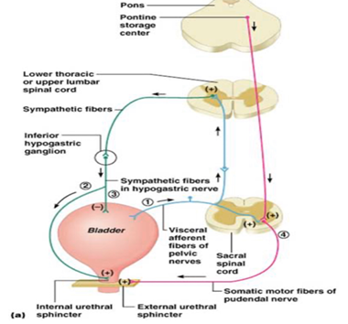

THE JUXTAGLOMERULAR APPARATUS
The Juxtaglomerular Apparatus (JGA) is a specialized structure formed by the glomerular afferent arteriole and the distal convoluted tubule. It is located near the vascular pole of the glomerulus and its main function is to regulate blood pressure and the filtration rate of the glomerulus to maintain both renal and entire body volume status.
The three components of the JGA are as follows:
- The juxtaglomerular cells, derived from smooth muscle cells, of the afferent arteriole synthesize and store renin, which is secreted in response to specific stimuli (e.g., low blood flow, decreased NaCl delivery). The juxtaglomerular cells could be considered the “effector arm” of the renin-angiotensin-aldosterone axis.
- The macula densa, a region of the distal convoluted tubule characterized by a collection of specialized tubular epithelial cells which are more densely-packed than in other regions of the nephron (and thereby leading to its characteristic appearance on light microscopy). The macula densa can be considered as the “sensory arm” of the renin-angiotensin-aldosterone axis in that these are the cells which detect sodium concentration of the fluid in the tubule. In response to elevated sodium, its cells trigger contraction of the afferent arteriole, reducing flow of blood to the glomerulus and the glomerular filtration rate.
- Lacis cells, also called extraglomerular mesengial cells, being flat and elongated cells located near the macula densa, form connections via actin and microtubules which allow for selective vasoconstriction/vasodilation of the renal afferent and efferent arterioles with mesangial cell contraction.
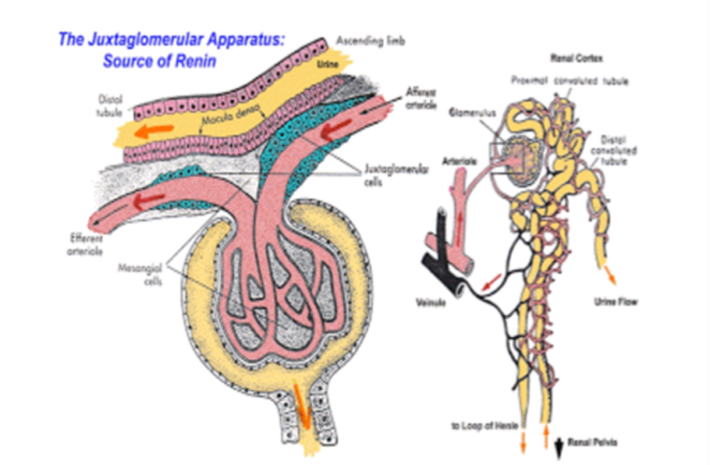
THE ROLE OF THE KIDNEYS IN REGULATION OF BLOOD PRESSURE
The kidneys play a central role in the regulation of arterial blood pressure. They influence blood pressure by:
• Causing the arteries and veins to constrict
• Increasing the circulating blood volume
Specialized cells called macula densa are located in a portion of the distal tubule located near and in the wall of the afferent arteriole. These cells sense the sodium (Na) in the filtrate, while the arterial cells (juxtaglomerular cells) sense the blood pressure. When the blood pressure drops, the amount of filtered sodium also drops. The arterial cells sense the drop in blood pressure, and the decrease in sodium concentration is relayed to them by the macula densa cells. The juxtaglomerular cells then release an enzyme called renin.
Renin converts angiotensinogen (a peptide, or amino acid derivative) into angiotensin-1. Angiotensin-1 is thereafter converted to angiotensin-2 by an angiotensin-converting enzyme (ACE), found in the lungs. Angiotensin-2 causes blood vessels to contract - the increased blood vessel constrictions elevate the blood pressure. When the volume of blood is low, arterial cells in the kidneys secrete renin directly into circulation. Plasma renin then carries out the conversion of angiotensinogen released by the liver to angiotensin-1. Angiotensin-1 is subsequently converted to angiotensin-2 by the enzyme angiotensin-converting enzyme found in the lungs. Angiotensin-2, a potent vasoactive peptide causes blood vessels to constrict, resulting in increased blood pressure. It also stimulates the secretion of the hormone aldosterone from the adrenal cortex.
Aldosterone causes the tubules of the kidneys to increase the reabsorption of sodium and water into the blood. This increases the volume of fluid in the body, which also increases blood pressure. If the renin-angiotensin-aldosterone system is too active, blood pressure will be too high. Many drugs interrupt different steps in this system to lower blood pressure.
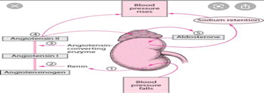
THE ROLE OF THE KIDNEYS IN CALCIUM HOMEOSTASIS
The kidney plays a key role in this process by the fine regulation of calcium excretion. More than 95% of filtered calcium is reabsorbed along the renal tubules. In the proximal tubules, 60% of filtered calcium is reabsorbed by passive mechanisms. In the thick ascending limb, 15% of calcium is reabsorbed by paracellular diffusion through paracellin-1 (claudin-16). The calcium sensing receptor (CaSR) in the basolateral membrane of the thick ascending limb senses the change in Ca²⁺ and inhibits calcium reabsorption independent to PTH and 1,25(OH)2D3.
The fine regulation of calcium excretion occurs in the distal convoluted tubules and connecting tubules despite the fact that only 10 - 15% of filtered calcium is reabsorbed there. Transient receptor potential vanilloid 5 (TRPV5) and 6 (TRPV6) in the apical membrane act as the main portal of entry, calbindin-D28K delivers Ca²⁺ in the cytoplasm, and then Na⁺/Ca²⁺ exchanger (NCX1) and plasma membrane Ca²⁺-ATPase in the basolateral membrane serve as an exit. In the cortical collecting duct, TRPV6 is expressed, but the role might be negligible. In addition to PTH and 1,25(OH)2D3, acid-base disturbance, diuretics, and estrogen effect on these calcium channels. Recently, klotho and fibroblast growth factor 23 (FGF23) are suggested as new players in the calcium metabolism. Klotho is exclusively expressed in the kidney and co-localized with TRPV5, NCX1, and calbindin-D28K.
Klotho increases calcium reabsorption through trafficking of TRPV5 to the plasma membrane, and also converts FGF receptor to specific FGF23 receptor to make it possible for the FGF23:Klotho complex to bind to the receptor, and then this complex inhibits 1α-hydroxylase of vitamin D and contributes to calcium reabsorption and phosphate excretion in the kidney.
