NAME: SELUWA TEMITOPE PETER
MATRIC NO.:17/MHS01/295
COLLEGE: MHS
LEVEL: 300
DEPT: MBBS

ASSIGNMENT
- Discuss the role of kidney in glucose homeostasis
- Discuss the process of micturition
- Explain juxtaglomerular apparatus
- Discuss the role of kidney in regulation of blood pressure
- Discuss the role of kidney in calcium homeostasis

- Discuss the role of kidney in glucose homeostasis
The primary function of the kidney is to maintain homeostasis, and this is accomplished by the formation of urine. During the formation of urine, kidneys regulate various activities in the body, which are concerned with homeostasis.
ROLE OF KIDNEY IN GLUCOSE HOMEOSTASIS
Nutritional substances in the blood, such as glucose, amino acids are freely filtered at the glomerular capillaries but are not excreted into the urine because approximately all the filtered substance is reabsorbed from the proximal tubules back into the blood. This allows these nutritional substances to be conserved in the body fluids.
- Reabsorption of Glucose
Glucose is completely reabsorbed in the proximal convoluted tubule. It is transported by secondary active transport (sodium co transport) mechanism.
Glucose and sodium bind to a common carrier protein in the luminal membrane of tubular epithelium and enter the cell. The carrier protein is called sodium-dependent glucose co transporter 2 (SGLT2). From tubular cell, glucose is transported, through the basolateral membrane through facilitated diffusion, into renal medullary interstitial fluid by another carrier protein called glucose transporter (GluT 1 and GluT2).
Tubular maximum for glucose (TmG)
In adult male, TmG is 375 mg/minute and in adult females it about 300 mg/minute.
Renal threshold for glucose
Renal threshold for glucose is 180 mg/dL in venous blood.
At low levels of plasma glucose, no glucose is filtered through the glomerular filtration. When the blood level reaches 180 mg/dL glucose is not reabsorbed completely and appears in urine.
Splay
Splay means deviation. With normal Glomerular Filtration Rate (GFR) of 125 mL/ minute and TmG of 375 mg/minute in an adult male the predicted (expected) renal threshold for glucose should be 300 mg/dL. But actually(reality) it is only 180 mg/dL.
When the renal threshold curves are drawn by using these values, the actual curve deviates from the ‘should be’ or predicted or ideal curve. This type of deviation is called splay.
Splay is because of the fact that all the nephrons do not have the same filtering and reabsorbing capacities and tubular maximum for glucose, TmG, therefore some nephrons may excrete before others.

- Glucose Synthesis
The kidneys synthesize glucose from amino acids and other precursors during prolonged fasting, a process referred to as gluconeogenesis. The kidneys' capacity to add glucose to the blood during prolonged periods of fasting rivals that of the liver. The glucose produced is used for covering the energy needs of the medulla.
Gluconeogenesis occurs mainly in the cytosol although some precursors are produced in the mitochondria. Liver is the major tissue for gluconeogenesis. During starvation, the kidney’s cortex is also capable of making glucose by gluconeogenesis. Certain enzymes required in gluconeogenesis are present only in these organs.

IN SUMMARY
- The kidneys freely filter glucose at the glomerular capillaries but are not excreted into the urine because approximately all the filtered substance is reabsorbed from the proximal tubules back into the blood. This allows for glucose to be conserved in the body fluids.
- At low levels of plasma glucose, no glucose is filtered through the glomerular filtration. When the blood level reaches 180 mg/dL glucose is not reabsorbed completely and appears in urine.
- Thus, by excreting extra amount of sugar in the urine during hyperglycemic state and reabsorbing sugar during the hypoglycemic state, the kidney helps in regulating the level of glucose in blood.
- During starvation, the kidney is also capable of making glucose by gluconeogenesis.
APPLIED PHYSIOLOGY
GLYCOSURIA
Normally, the urine contains about 0.05 gm% of sugar. Such a small quantity cannot be detected by Benedict’s test, but under certain circumstances, a considerable amount of glucose or other sugar may be excreted in the urine.
Excretion of detectable amount of sugar in urine is known as glycosuria. Glycosuria results from the rise of blood glucose above its renal threshold level (180 mg%).
Glycosuria may be due to various reasons on the basis of which it is classified into the following groups: Alimentary (lag storage) glycosuria, Renal glycosuria, Diabetic glycosuria

- Discuss the process of micturition
The process whereby urine is removed, emptied or voided from the urinary bladder is called micturition. It is the process by which the urinary bladder empties when it becomes filled.
URINART TRACT
Urine is continually produced but not continually released from the body. Certain structures for stirage and neurological imput allow for a tiely release. These structures are:
- Ureters: are long, narrow ducts, usually about 25 to 35cm long in adults, that carry urine from the kidneys to the bladder. They enter into the urinary bladder through the detrusor muscle in the trigone region of the bladder.
- Urinary bladder: a triangular, elastic muscular hollow organ located in the pelvic cavity (when empty) or lower abdomen (when full). It stores urine prior to disposal by micturition. Urine enters the bladder via the ureters and exits via the urethra.
- Urethra: a tube that coveys urine out of the body,and, in male penis, is also the tube through which semen is ejaculated. The male urethra is about 20cm long and the female urthra is about 3 to 4cm long.

There are two urethra spincter in the urinary tract:
- Internal urethral sphincter: located between the neck of the bladder and upper end of urethra. It is formed by the thickening of detrusor muscle (smooth muscle fibers interlaced with a large amount of elastic tissue). It is innervated by autonomic nerve fibers. It normally prevents emptying of the bladder until the pressure in the main parts of the bladder rises above a critical threshold and closes the urethra when bladder is emptied.
- Externaal urethral sphincter: it is located in the urogenital diaphragm. It is made up of volumtary, circular skeletal muscle fibres. It is innervated by somatic nerve fibres. It is used to consciously prevent urination even when involuntary controls are attempting to empty the bladder.

PROCESS OF MICTURITION
Micturition is a reflex process. However, in grown up children and adults, it can be controlled voluntarily to some extent. Although the micturition reflex is an autonomic spinal cord reflex, it can also be inhibited or facilitated by centers in the cerebral cortex or brain stem.
Micturition involves two main steps:
- First, the bladder fills progressively until the tension in its walls rises above a threshold level; this elicits the second step
- The second step is a nervous reflex called the micturition reflex that empties the bladder or, if this fails, at least causes a conscious desire to urinate.

STEP 1: FILLING OF URINARY BLADDER
Urine is continuously formed by nephrons and it flows into urinary bladder drop by drop through ureters.
When urine collects in the pelvis of ureter, the contraction sets up in pelvis. This contraction is transmitted through rest of the ureter in the form of peristaltic wave up to trigone of the urinary bladder. Peristaltic wave usually travels at a velocity of 3 cm/second. It develops at a frequency of 1 to 5 per minute. The peristaltic wave moves the urine into the bladder. After leaving the kidney, the direction of the ureter is initially downward and outward. Then, it turns horizontally before entering the bladder.
At the entrance of ureters into urinary bladder, a valvular arrangement is present. When peristaltic wave pushes the urine towards bladder, this valve opens towards the bladder. The position of ureter and the valvular arrangement at the end of ureter prevent the back flow of urine from bladder into the ureter when the detrusor muscle contracts. Thus, urine is collected in bladder drop by drop.
A reasonable volume of urine can be stored in urinary bladder without any discomfort and without much increase in pressure inside the bladder (intravesical pressure). It is due to the adaptation of detrusor muscle. This can be explained by cystometrogram. Cystometry is the technique used to study the relationship between intravesical pressure and volume of urine in the bladder.
Cystometrogram is the graphical registration (recording) of pressure changes in urinary bladder in relation to volume of urine collected in it.
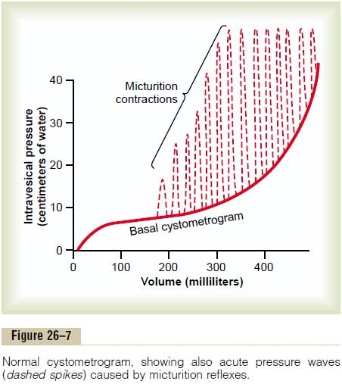

STEP 2: MICTURITION REFLEX
Micturition reflex is the reflex by which micturition occurs. This reflex is elicited by the stimulation of stretch receptors situated on the wall of urinary bladder and urethra. When about 300 to 400 mL of urine is collected in the bladder, intravesical pressure increases. This stretches the wall of bladder resulting in stimulation of stretch receptors and generation of sensory impulses.
The micturition reflex is a single complete cycle of
(1) progressive and rapid increase of pressure,
(2) a period of sustained pressure, and
(3) return of the pressure to the basal tone of the bladder.

- Pathway for Micturition Reflex
When about 300 to 400mL of urine is collected in the bladder, intravesical pressure increases. This stretches the wall of the bladder, resulting in stimulation of the sensory stretch receptors in the bladder wall and generation of sensory impulses.
The sensory (afferent) impulses from the bladder’s stretch receptors are conducted to the sacral segments of the cord through the sensory fires of the pelvic (parasympathetic) nerves. Motor (efferent) impulses produced in spinal cord, are then reflexively conducted to the bladder and internal sphincters through motor fibers of pelvic (parasympathetic) nerve.
Motor impulses cause contraction of detrusor muscle and relaxation of internal sphincter so that, urine enters the urethra from the bladder.
When the bladder is only partially filled, these micturition contractions usually relax spontaneously after a fraction of a minute, the detrusor muscles stop contracting, and pressure falls back to the baseline. As the bladder continues to fill, the micturition reflexes become more frequent and cause greater contractions of the detrusor muscle.
Once the micturition reflex becomes powerful enough and urine enters the urethra, it causes another reflex.
The stretch receptors in the urethra are stimulated and send afferent (sensory) impulses to spinal cord via pelvic nerve fibres. Then, the motor impulses generated form the spinal centres, passes through the pudendal nerves to the external sphincter to inhibit it (i.e causes the external sphincter to relax).
If this inhibition is more potent in the brain than the voluntary constrictor signals to the external sphincter, then the external sphincter would relax and urination will occur. If not, urination will not occur until the bladder fills still further and the micturition reflex becomes more powerful.
Once a micturition reflex begins, it is "self-regenerative". That is, initial contraction of the bladder activates the stretch receptors to cause still further increase in sensory impulses from the bladder and posterior urethra, which then causes a further increase in reflex contraction of the bladder. Thus, the cycle is repeated again and again until the bladder has reached a strong degree of contraction and urine is voided out completely. During micturition, the flow of urine is facilitated by the increase in the abdominal pressure due to the voluntary contraction of abdominal muscles.
Then, after a few seconds to more than a minute, the self-regenerative reflex begins to fatigue and the regenerative cycle of the micturition reflex ceases, permitting the bladder to relax.
It is important to note that once a micturition reflex has occurred but has not succeeded in emptying the bladder, the nervous elements of this reflex usually remain in an inhibited state for a few minutes to 1 hour or more before another micturition reflex occurs. As the bladder becomes more and more filled, micturition reflexes occur more and more often and more and more powerfully.

- Higher Centres for Micturition (Facilitation or Inhibition of Micturition by the Brain)
The micturition reflex is an autonomic spinal cord reflex, but is regulated by higher centres. The higher centers, which control micturition are of two types, inhibitory centers and facilitatory centers.
Inhibitory centers for micturition
- Strong inhibitory centers are located in the brain stem, mainly in the pons and mid-brain.
- Several centers located in the cerebral cortex are mainly inhibitory.
They inhibit micturition by suppressing spinal micturition centers.
Facilitatory centers for micturition
- Strong facilitative centers in the brain stem, located mainly in the pons.
- Some centres in the cerebral cortex.
The micturition reflex is the basic cause of micturition, but the higher centers normally exert final control of micturition as follows:
- The higher centers keep the micturition reflex partially inhibited, except when micturition is desired.
- The higher centers can prevent micturition, even if the micturition reflex occurs, by tonic contraction of the external bladder sphincter until a convenient time presents itself.
- When it is time to urinate, the cortical centers can facilitate the sacral micturition centers to help initiate a micturition reflex and at the same time inhibit the external urinary sphincter so that urination can occur.
Voluntary urination is usually initiated in the following way:
First, a person voluntarily contracts his or her abdominal muscles, which increases the pressure in the bladder and allows extra urine to enter the bladder neck and posterior urethra under pressure, thus stretching their walls. This stimulates the stretch receptors, which excites the micturition reflex and simultaneously inhibits the external urethral sphincter.
Ordinarily, all the urine will be emptied, with rarely more than 5 to 10 mL left in the bladder.
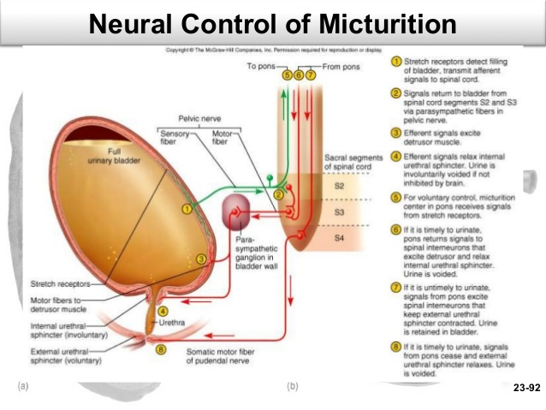

APPLIED PHYSIOLOGY
- Atonic Bladder and Incontinence Caused by Destruction of Sensory Nerve Fibers
Atonic bladder is the urinary bladder with loss of tone in detrusor muscle. It is also called flaccid neurogenic bladder or hypoactive neurogenic bladder. It is caused by destruction of sensory (pelvic) nerve fibers of urinary bladder.
Conditions/ causes of Destruction of Sensory Nerve Fibers are Injury to the sacral region of the spinal cord and Syphilis
Automatic bladder Caused by Spinal Cord Damage Above the Sacral Region
Automatic bladder is the urinary bladder characterized by hyperactive micturition reflex with loss of voluntary control. So, even a small amount of urine collected in the bladder elicits the micturition reflex resulting in emptying of bladder.
It is caused by spinal cord damage above the sacral region.

- Uninhibited neurogenic bladder Caused by Lack of Inhibitory Signals from the Brain
Another abnormality of micturition is the so-called uninhibited neurogenic bladder. Uninhibited neurogenic bladder is the urinary bladder with frequent and relatively uncontrolled micturition.
It is also called spastic neurogenic bladder or hyperactive neurogenic bladder.

- Nocturnal micturition
Nocturnal micturition is the involuntary voiding of urine during night. It is otherwise known as enuresis or bedwetting. It occurs due to the absence of voluntary control of micturition. It is a common and normal process in infants and children below 3 years. It is because of incomplete myelination of motor nerve fibers of the bladder.

- Explain juxtaglomerular apparatus
Juxtaglomerular apparatus is a specialized organ situated near the glomerulus of each nephron (juxta = near).
STRUCTURE OF JUXTAGLOMERULAR APPARATUS
Juxtaglomerular apparatus is formed by three different structures:
1. Macula densa
2. Extraglomerular mesangial cells
3. Juxtaglomerular cells.
- MACULA DENSA
Macula densa is the end portion of thick ascending segment before it opens into distal convoluted tubule. It is situated between afferent and efferent arterioles of the same nephron, but is very close to afferent arteriole. Macula densa is formed by tightly packed cuboidal epithelial cells and contains golgi apparatus.
- EXTRAGLOMERULAR MESANGIAL CELLS
Extraglomerular mesangial cells are situated in the triangular region bound by afferent arteriole, efferent arteriole and macula densa. These cells are also called agranular cells, lacis cells or Goormaghtigh cells.
Glomerular Mesangial Cells
Besides extraglomerular mesangial cells there is another type of mesangial cells situated in between glomerular capillaries called glomerular mesangial or intraglomerular mesangial cells
The glomerular mesangial cells support the glomerular capillary loops by surrounding the capillaries in the form of a cellular network.
These cells play an important role in regulating the glomerular filtration by their contractile property.
They are phagocytic in nature.
These cells also secrete glomerular interstitial matrix, prostaglandins and cytokines.

- JUXTAGLOMERULAR CELLS (JG cells)
Juxtaglomerular cells are specialized smooth muscle cells situated in the wall of afferent arteriole just before it enters the Bowman capsule. These smooth muscle cells are mostly present in tunica media and tunica adventitia of the wall of the afferent arteriole.
Juxtaglomerular cells are also called granular cells because of the presence of secretary granules (renin) in their cytoplasm.
Juxtaglomerular cells form a thick cuff called polar cushion or polkissen around the afferent arteriole before it enters the Bowman capsule.

FUNCTIONS OF JUXTAGLOMERULAR APPARATUS
- Secretion of hormones: Primary function of juxtaglomerular apparatus is the secretion of hormones.
- Regulation of glomerular blood flow and glomerular filtration rate (GFR): The JGA is also one of the components of the tubuloglomerular feedback mechanism that is involved in autoregulation of the glomerular blood flow and glomerular filtration rate.

- SECRETION OF HORMONES
Juxtaglomerular apparatus secretes two hormones:
1. Renin
2. Prostaglandin.

1. RENIN
Renin is a peptide with 340 amino acids. Along with angiotensin, it forms the Renin-Angiotensin System (RAS), a hormone system that plays an important role in the maintenance of blood pressure.
Renin is sercreted by Juxtaglomerular cells of the JGA.
Stimulants for renin secretion
Secretion of renin is stimulated by four factors:
- Fall in arterial blood pressure: This is directly sensed mechanically by the juxtaglomerular cells.
- Reduction in the ECF volume
- Increased sympathetic activity: Nerves lie on the tunica externa of the blood vessels. These sympathetic nerves have their nerve endings on the juxtaglomerular cells. Their stimulation causes these cells to release renin.
- Decreased load of sodium and chloride in macula densa.: the macula densa cells senses low sodium and chloride ions in the distal convoluted tubules and interprete it as low blood pressure in the glomerulus and in the circulatory system. Hence, they send signals to the JG cells to release renin.

Renin-angiotensin system (RAS)
The renin-angitensin system is a powerful mechanism for controlling arterial pressure.
When renin is released into the blood, it acts on a specific plasma protein called angiotensinogen or renin substrate. Angiotensinogen is an alpha-2 globulin and has 452 amimo acids. By the activity of renin, the angiotensinogen is converted into a 10-amino acid peptide, angiotensin-I. Angiotensin I is converted into angiotensin II, an 8-amino acid peptide, by the activity of angiotensin-converting enzyme (ACE) secreted from lungs. Most of the conversion of angiotensin I into angiotensin II takes place in lungs. Other tissues that have ACE are kidneys and blood vessels.
Angiotensin II is an extremely powerful vasoconstrictor. It has a short half-life of about 1 to 2 minutes. Then it is rapidly degraded into a 7-amino acid peptide called angiotensin III by angiotensinases, which are present in RBCs and vascular beds in many tissues. Angiotensin III is converted into angiotensin IV, which is a 6-amino acid peptide.
2.PROSTAGLANDIN
Extraglomerular mesangial cells of juxtaglomerular apparatus secrete prostaglandin.
Prostaglandin is also secreted by interstitial cells of medulla called type I medullary interstitial cells.

- REGULATION OF GLOMERULAR BLOOD FLOW AND GLOMERULAR FILTRATION RATE
Macula densa of juxtaglomerular apparatus plays an important role in the feedback mechanism called tubuloglomerular feedback mechanism, which regulates the renal blood flow and glomerular filtration rate.
- Discuss the role of kidney in regulation of blood pressure
Arterial blood pressure varies even under physiological conditions. However, immediately it is brought back to normal level because of the presence of well organized regulatory mechanisms in the body.
These regulatory mechanisms are:
- Nervous mechanism or short­term regulatory mechanism
- Renal mechanism or long­term regulatory mechanism
- Hormonal mechanism
- Local mechanism

RENAL MECHANISM FOR REGULATION OF BLOOD PRESSURE – LONG-TERM REGULATION
Kidneys play an important role in the long­term regulation of arterial blood pressure.
When blood pressure alters slowly in several days/months/years, the nervous mechanism adapts to the altered pressure and loses the sensitivity for the changes. It cannot regulate the pressure any more.In such conditions, the renal mechanism operates efficiently to regulate the blood pressure. Therefore, it is called long­term regulation.
Kidneys regulate arterial blood pressure by two ways:
1. By regulation of ECF volume
2. Through renin­angiotensin mechanism.

- BY REGULATION OF EXTRACELLULAR FLUID VOLUME (Renal-Body Fluid System for Arterial Pressure Control)
The renal-body fluid system for arterial pressure control acts slowly but powerfully as follows:
- Increase in extracellular fluid (ECF) volume, due to excess intake of water and salt or excess intake of salt and increase of water osmotically, would result in increase in blood volume. If blood volume increases and vascular capacitance is not altered, arterial pressure will also increase. The increase in pressure would in turn cause the kidneys to excrete the excess volume, i.e. excrete large amounts of water and salt, particularly sodium, by means of pressure diuresis and pressure natriuresis.
Pressure diuresis is the excretion of large quantity of water in urine because of increased blood pressure. Even a slight increase in blood pressure in humans of only a few mm Hg can double renal output of water i.e. doubles the water excretion. Pressure natriuresis is the excretion of large quantity of sodium in urine. A slight increase in blood pressure can also double the output of salt.
Because of diuresis and natriuresis, there is a decrease in ECF volume and blood volume, which in turn brings the arterial blood pressure back to normal level.
- When blood pressure decreases, the reabsorption of water from renal tubules is increased. This in turn, increases ECF volume, blood volume and cardiac output, resulting in restoration of blood pressure.

It is important to note that: Raising salt intake in the absence of impaired kidney function or excessive formation of antinatriuretic hormones usually does not increase arterial pressure much because the kidneys rapidly eliminate the excess salt and blood volume is hardly altered.
- THROUGH RENIN-ANGIOTENSIN MECHANISM
Another powerful mechanism for controlling pressure Is the renin-angiotensin system (RAS).
Components of the Renin-Angiotensin System
- Renin
- Angiotensin
The renin-angitensin system is a powerful mechanism for controlling arterial pressure.
When renin is released into the blood, it acts on a specific plasma protein called angiotensinogen or renin substrate. Angiotensinogen is an alpha-2 globulin and has 452 amimo acids. By the activity of renin, the angiotensinogen is converted into a 10-amino acid peptide, angiotensin-I. Angiotensin I is converted into angiotensin II, an 8-amino acid peptide, by the activity of angiotensin-converting enzyme (ACE) secreted from lungs. Most of the conversion of angiotensin I into angiotensin II takes place in lungs. Other tissues that have ACE are kidneys and blood vessels.
Angiotensin II is an extremely powerful vasoconstrictor. It has a short half-life of about 1 to 2 minutes. Then it is rapidly degraded into a 7-amino acid peptide called angiotensin III by angiotensinases, which are present in RBCs and vascular beds in many tissues. Angiotensin III is converted into angiotensin IV, which is a 6-amino acid peptide
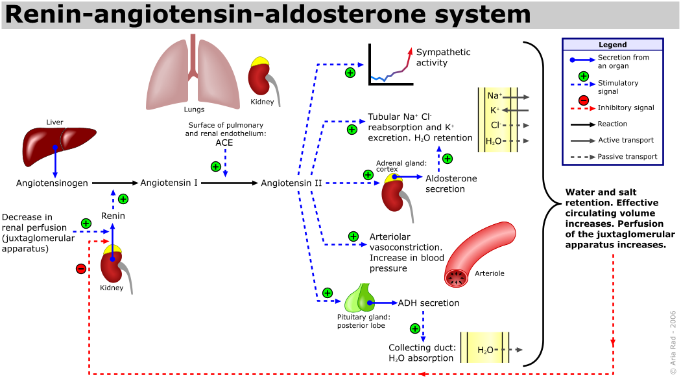

APPLIED PHYSIOLOGY
- Hemorrhage:
The renin-angiotensin system is powerful enough to return the arterial pressure at least halfway back to normal within a few minutes after severe hemorrhage. Therefore, sometimes it can be of lifesaving service to the body, especially in circulatory shock.

- Role of the Renin-Angiotensin System in Maintaining a Normal Arterial Pressure Despite Large Variations in Salt Intake
One of the most important functions of the renin-angiotensin system is to allow a person to eat either very small or very large amounts of salt without causing great changes in either extracellular fluid volume or arterial pressure.
- Chronic Hypertension (High Blood Pressure) Is Caused by Impaired Renal Fluid Excretion
When a person is said to have chronic hypertension (or "high blood pressure"), it is meant that his or her mean arterial pressure is greater than the upper range of the accepted normal measure.
A mean arterial pressure greater than 110 mm Hg (normal is about 90 mm Hg) is considered to be hypertensive. (This level of mean pressure occurs when the diastolic blood pressure is greater than about 90 mm Hg and the systolic pressure is greater than about 135 mm Hg). In severe hypertension, the mean arterial pressure can rise to 150 to 170 mm Hg, with diastolic pressure as high as 130 mm Hg and systolic pressure occasionally as high as 250 mm Hg. Even moderate elevation of arterial pressure leads to shortened life expectancy. At severely high pressures (mean arterial pressures 50 percent or more above normal) a person can expect to live no more than a few more years unless appropriately treated.
Chronic Hypertension (High Blood Pressure) can be said to be Caused by Impaired Renal Fluid Excretion. Hypertension caused by excess accumulation of extracellular fluid in the body is called “Volume-loading hypertension”
The lethal effects of hypertension are caused mainly in three ways:
1. Excess workload on the heart leads to early heart failure and coronary heart disease, often causing death as a result of a heart attack.
2. The high pressure frequently damages a major blood vessel in the brain, followed by death of major portions of the brain; this is a cerebral infarct. Clinically it is called a "stroke." Depending on which part of the brain is involved, a stroke can cause paralysis, dementia, blindness, or multiple other serious brain disorders.
3. High pressure almost always causes injury in the kidneys, producing many areas of renal destruction and, eventually, kidney failure, uremia, and death.
4. Hypertension Caused by a Renin-Secreting Tumor or by Infusion of Angiotensin II :
Occasionally a tumor of the renin-secreting juxtaglomerular cells (the JG cells) occurs and secretes tremendous quantities of renin; in turn, equally large quantities of angiotensin II are formed. This results in development of severe hypertension.

- Discuss the role of kidney in calcium homeostasis
Calcium is both filtered and reabsorbed in the kidneys but not secreted. Therefore, the rate of renal calcium excretion is calculated thus:
Renal calcium excretion = calcium filtered – calcium reabsorbed
Only about 50 percent of the plasma calcium is ionized, with the remainder being bound to the plasma proteins or complexed with anions such as phosphate. Therefore, only about 50 percent of the plasma calcium can be filtered at the glomerulus.
Normally, about 99 percent of the filtered calcium is reabsorbed by the tubules, with only about 1 percent of the filtered calcium being excreted.
- About 65% of the filtered calcium is reabsorbed in the proximal tubule,
- 25 to 30% is reabsorbed in the loop of Henle, and
- 4 to 9% is reabsorbed in the distal and collecting tubules.

As is true with the other ions, calcium excretion is adjusted to meet the body's needs. With an increase in calcium intake, there is also increased renal calcium excretion, although much of the increase of calcium intake is eliminated in the feces. With calcium depletion, calcium excretion by the kidneys decreases as a result of enhanced tubular reabsorption.

- Proximal Tubular Calcium Reabsorption
Most of the calcium reabsorption in the proximal tubule occurs through the paracellular pathway, dissolved in water and carried with the reabsorbed fluid as it flows between the cells.
Only about 20% of proximal tubular calcium reabsorption occurs through the transcellular pathway in two steps:
Step 1: Calcium diffuses from the tubular lumen, through the calcium channels, into the cell down an electrochemical gradient due to the much higher concentration of calcium in the tubular lumen, compared with the epithelial cell cytoplasm, and because the cell interior has a negative relative to the tubular lumen.
Step 2: Calcium exits the cell across the basolateral membrane by a calcium-ATPase pump and by sodium-calcium counter-transporter.
-

- Loop of Henle Calcium Reabsorption
In the loop of Henle, calcium reabsorption is restricted to the thick ascending limb. Approximately 50% of calcium reabsorption in the thick ascending limb occurs through the paracellular route by passive diffusion due to the slight positive charge of the tubular lumen relative to the interstitial fluid. The remaining 50% of calcium reabsorption in the thick ascending limb occurs through the transcellular pathway, a process that is stimulated by parathyroid hormone (PTH).

- Distal Convoluted Tubule Calcium Reabsorption
In the distal tubule, calcium reabsorption occurs almost entirely by active transport through the cell membrane.
The mechanism for this active transport is similar to that in the proximal tubule and thick ascending limb. It involves:
- Diffusion across the luminal membrane through calcium channels and
- Exits across the basolateral membrane by a calcium-ATPase pump, as well as a sodium-calcium counter transport mechanism.
In the distal tubule, as well as in the loops of Henle, PTH stimulates calcium reabsorption. Vitamin D (Calcitrol) and calcitonin also stimulate calcium reabsorption in the thick ascending limb of Henle's loop and in the distal tubule, although these hormones are not as important quantitatively as PTH in reducing renal calcium excretion.

FACTORS THAT REGULATE TUBULAR CALCIUM REABSORPTION
One of the primary controllers of renal tubular calcium reabsorption is PTH.
- Increased levels of PTH stimulate calcium reabsorption in the thick ascending loops of Henle and distal tubules, which reduces urinary excretion of calcium.
- Conversely, reduction of PTH promotes calcium excretion by decreasing reabsorption in the loops of Henle and distal tubules.
In the proximal tubule, calcium reabsorption usually parallels sodium and water reabsorption and is independent of PTH.
- Therefore, in instances of extracellular volume expansion or increased arterial pressure (both of which decrease proximal sodium and water reabsorption) there is also reduction in calcium reabsorption and, consequently, increased urinary excretion of calcium.
- Conversely, with extracellular volume contraction or decreased blood pressure, calcium excretion decreases primarily because of increased proximal tubular reabsorption.
Another factor that influences calcium reabsorption is the plasma concentration of phosphate.
- Increased plasma phosphate stimulates PTH, which increases calcium reabsorption by the renal tubules, thereby reducing calcium excretion.
- The opposite occurs with reduction in plasma phosphate concentration.
Calcium reabsorption is also stimulated by metabolic acidosis and inhibited by metabolic alkalosis.
- Most of the effect of hydrogen ion concentration on calcium excretion results from changes in calcium reabsorption in the distal tubule.
APPLIED PHYSIOLOGY
- Hypercalcemia (increased calcium concentration) depresses neuromuscular excitability and can lead to cardiac arrhythmias.
- Hypocalcemia When calcium ion concentration falls to low levels (hypocalcemia), the excitability of nerve and muscle cells increases markedly and can in extreme cases result in hypocalcemic tetany. This is characterized by spastic skeletal muscle contractions.

