Name: Adeyemo Sinmiloluwa
Course: Renal physiology
Matric no: 17/MHS01/025
Department: Medicine and Surgery

QUESTION 1
The role of the kidney in glucose homeostasis
This kidney has a vital role in absorbing the entire quantity of the filtered glucose. Having a glomerular filtration rate of 180 liters per day, it filters approximately 180 grams of glucose per day, bringing its contribution in maintaining normal fasting plasma glucose (FPG) level. The reabsorption of glucose is ensured by the sodium-glucose cotransporter (SGLT) 2, responsible for the reabsorption of 90% of glucose, and SGLT1, that reabsorbs the remaining. The kidneys maintain glucose homeostasis through 3 mechanisms:
- release of glucose into the circulation via gluconeogenesis,
- uptake of glucose from the circulation to satisfy their energy needs,
- reabsorption of glucose at the level of the proximal tubule.
Glycogenolysis and Gluconeogenesis
Renal release of glucose into the circulation is the result of glycogenolysis and gluconeogenesis. Glycogenolysis involves the breakdown of glycogen to glucose-6-phosphate from precursors (e.g., lactate, glycerol, amino acids) and its subsequent hydrolysis (via glucose-6-phosphatase) to free glucose. Conversely, gluconeogenesis involves formation of glucose-6-phosphate from those same precursors and subsequent conversion to free glucose.
With regard to glucose utilization, the kidney may be perceived as 2 separate organs, with glucose utilization occurring predominantly in the renal medulla and glucose release limited to the renal cortex. These activities are separated as a result of differences in the distribution of various enzymes along the nephron.
The cells in the renal medulla can use only glucose for their needs (like the brain) and they have enzymes capable of glucose-phosphorylation and glycolysis. They can therefore phosphorylate important amounts of glucose and accumulate glycogen but, because these cells do not have glucose-6-phosphatase or any other gluconeogenic enzymes, they are unable to release glucose into the bloodstream. Moreover, the cells in the renal cortex have gluconeogenic enzymes and they can produce and release glucose into the circulation. However these cells cannot synthesize glycogen because they have little phosphorylating capacity.
Glucose reabsorption
Apart from the important role in gluconeogenesis and the role of renal cortex in glucose uptake, the kidneys contribute to glucose homeostasis by filtering and reabsorbing glucose. In normal conditions, the kidneys can reabsorb as much glucose as possible, the result being a virtually glucose free urine. Approximately 180 grams of glucose are filtered by the glomeruli from plasma, daily but all of this quantity is reabsorbed through glucose transporters that are present in cell membranes located in the proximal tubules.

QUESTION 2
Micturition
Micturition or urination is the process of expelling urine from the bladder. This act is also known as voiding of the bladder. The excretory system in humans includes a pair of kidneys, two ureters, a urinary bladder and a urethra. The kidneys filter the urine and it is transported to the urinary bladder via the ureters where it is stored till its expulsion. The process of micturition is regulated by the nervous system and the muscles of the bladder and urethra. The urinary bladder can store around 350-400ml of urine before it expels it out.
Stages of Micturition
The urinary bladder has two distinct stages or phases:
- Resting or filling stage
- Voiding stage
Resting or Filling Stage
It is in this phase of the bladder that the urine is transported from the kidneys via the ureters into the bladder. The ureters are thin muscular tubes that arise from each of the kidneys and extend downwards where they enter the bladder obliquely.
The oblique placement of the ureters in the bladder wall serves a very important function. The opening of the ureter into the urinary bladder is not guarded by any sphincter or muscle. Therefore, this oblique nature of opening prevents the urine from re-entering the ureters. At the same time, the main muscle of the urinary bladder, the detrusor muscle, is relaxing allowing the bladder to distend and accommodate more urine.
Voiding Stage
During this stage, both the urinary bladder and the urethra come into play together. The detrusor muscle of the urinary bladder which was relaxing so far starts to contract once the bladder’s storage capacity is reached.
The urethra is controlled by two sets of muscles: The internal and external urethral sphincters. The internal sphincter is a smooth muscle whereas the external one is skeletal. Both these sphincters are in a contracted state during the filling stage.

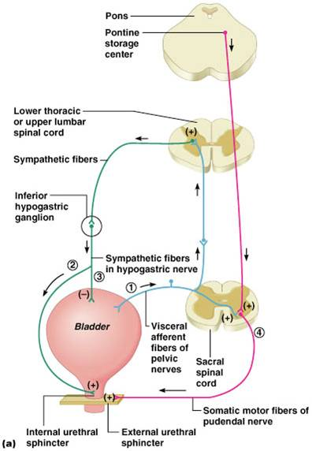
Diagram showing process of micturition
The process of micturition is governed by both the nervous and muscular systems. Within the nervous system, the process is governed by the autonomous nervous system and the somatic system. Once the urinary bladder reaches its maximum capacity, the stretch receptors in the walls of the bladder send an impulse via the pelvic nerve to the brain via the spinal cord.
The micturition reflex is ultimately generated from the level of the spinal cord after it receives reflexes from the pontine region in the brain. Once the bladder and the urethra receive the signals to empty the bladder, the two sphincters relax and the detrusor muscle causes the contractions of the bladder.
Along with these muscles, the muscles of the abdomen also play a role by putting pressure on the bladder wall. This leads to complete emptying of the bladder.
QUESTION 3
Juxtaglomerular Apparatus
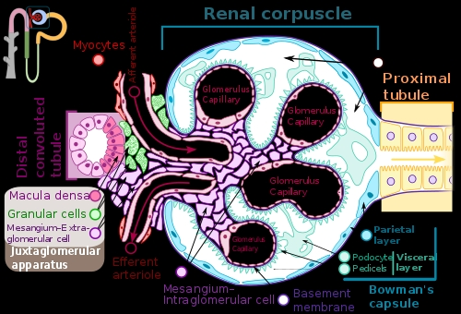

Diagram showing the Juxtaglomerular apparatus
The juxtaglomerular apparatus is a specialized structure formed by the distal convoluted tubule and the glomerular afferent arteriole. It is located near the vascular pole of the glomerulus and its main function is to regulate blood pressure and the filtration rate of the glomerulus.
The juxtaglomerular apparatus consists of three types of cells:
- the macula densa, a part of the distal convoluted tubule of the same nephron
- juxtaglomerular cells, (also known as granular cells) which secrete renin
- extraglomerular mesangial cells
The macula densa At the point where the afferent arterioles enter the glomerulus and the efferent arteriole leaves it, the tubule of the nephron touches the arterioles of the glomerulus from which it rose. At this location, in the wall of the distal convoluted tubule, there is a modified region of tubular epithelium called the macula densa. I n response to elevated sodium, the macula densa cells trigger contraction of the afferent arteriole, reducing flow of blood to the glomerulus and the glomerular filtration rate.
The juxtaglomerular cells, derived from smooth muscle cells, of the afferent arteriole. They are similar to epithelium and are located in the tunica media of the afferent arterioles as they enter the glomeruli. Juxtaglomerular cells secrete renin when blood pressure in the arteriole falls. Renin increases blood pressure via the renin-angiotensin-aldosterone system. Juxtaglomerular cells secrete renin in response to:
- Stimulation of the beta-1 adrenergic receptor
- Decrease in renal perfusion pressure (detected directly by the granular cells)
- Decrease in NaCl concentration at the macula densa, often due to a decrease in glomerular filtration rate
Extraglomerular mesangial cells
Extraglomerular mesangial cells are located in the junction between the afferent and efferent arterioles. These cells have a contractile property similar to vascular smooth muscles and thus play a role in “regulating glomerular filtration rate” by altering the vessel diameter. Renin is also found in these cells.

QUESTION 4
Role of kidneys in regulating blood pressure
The kidneys play a central role in the regulation of arterial blood pressure. A large body of experimental and physiological evidence indicates that renal control of extracellular volume and renal perfusion pressure are closely involved in maintaining the arterial circulation and blood pressure. Renal artery perfusion pressure directly regulates sodium excretion; a process known as pressure natriuresis, and influences the activity of various vasoactive systems such as the renin–angiotensin–aldosterone (RAS) system. Along with vessel morphology, blood viscosity is one of the key factors influencing resistance and hence blood pressure. A key modulator of blood viscosity is the renin-angiotensin system (RAS) or the renin-angiotensin-aldosterone system (RAAS), a hormone system that regulates blood pressure and water balance.
The blood pressure in the body depends upon:
- The force by which the heart pumps out blood from the ventricles of the heart - and this is dependent on how much the heart muscle gets stretched by the inflowing blood into the ventricles.
- The degree to which the arteries and arterioles constrict-- increases the resistance to blood flow, thus requiring a higher blood pressure.
- The volume of blood circulating round the body; if the volume is high, the ventricles get more filled, and the heart muscle gets more stretched.
The kidney influences blood pressure by:
- Causing the arteries and veins to constrict
- Increasing the circulating blood volume
Specialized cells called macula densa are located in a portion of the distal tubule located near and in the wall of the afferent arteriole. These cells sense the sodium in the filtrate, while the arterial cells (juxtaglomerular cells) sense the blood pressure. When the blood pressure drops, the amount of filtered Na also drops. The arterial cells sense the drop in blood pressure, and the decrease in Na concentration is relayed to them by the macula densa cells. The juxtaglomerular cells then release an enzyme called renin.
Renin converts angiotensinogen (a peptide, or amino acid derivative) into angiotensin-1. Angiotensin-1 is thereafter converted to angiotensin-2 by an angiotensin-converting enzyme (ACE), found in the lungs. Angiotensin-2 causes blood vessels to contract, the increased blood vessel constrictions elevate the blood pressure. When the volume of blood is low, arterial cells in the kidneys secrete renin directly into circulation. Plasma renin then carries out the conversion of angiotensinogen released by the liver to angiotensin-1. Angiotensin-1 is subsequently converted to angiotensin-2 by the enzyme angiotensin converting enzyme found in the lungs. Angiotensin-2m a potent vasoactive peptide causes blood vessels to constrict, resulting in increased blood pressure. Angiotensin-2 also stimulates the secretion of the hormone aldosterone from the adrenal cortex.
Aldosterone causes the tubules of the kidneys to increase the reabsorption of sodium and water into the blood. This increases the volume of fluid in the body, which also increases blood pressure. If the renin-angiotensin-aldosterone system is too active, blood pressure will be too high. Many drugs interrupt different steps in this system to lower blood pressure. These drugs are one of the main ways to control high blood pressure (hypertension), heart failure, kidney failure, and harmful effects of diabetes. It is believed that angiotensin-1 may have some minor activity, but angiotensin-2 is the major bioactive product. Angiotensin-2 has a variety of effects on the body: throughout the body, it is a potent vasoconstrictor of arterioles.

QUESTION 5
Role of kidney in calcium homeostasis
The amount of calcium excreted in the urine usually ranges from 100 to 200 mg per 24 hours; hence, 98%–99% of the filtered load of calcium is reabsorbed by the renal tubules. Approximately 60%–70% of the filtered calcium is reabsorbed in the proximal convoluted tubule, 20% in the loop of Henle, 10% by the distal convoluted tubule, and 5% by the collecting duct. The terminal nephron, although responsible for the reabsorption of only 5%–10% of the filtered calcium load, is the major site for regulation of calcium excretion.
The reabsorption of calcium in the proximal convoluted tubule parallels that of sodium and water. Proximal tubular calcium reabsorption is thought to occur mainly by passive diffusion and solvent drag. This is based on the observation that the ratio of calcium in the proximal tubule fluid to that in the glomerular filtrate is 1:1.2. The passive paracellular pathways account for approximately 80% of calcium reabsorption in this segment of the nephron. A small but significant component of active calcium transport is observed in the proximal tubules. The active transport of calcium proceeds in a two-step process, with calcium entry from the tubular fluid across the apical membrane and exit though the basolateral membrane. This active transport is generally considered to constitute 10%–15% of total proximal tubule calcium reabsorption and it is mainly regulated by parathyroid hormone (PTH) and calcitonin.
No reabsorption of calcium occurs within the thin segment of the loop of Henle. In the thick ascending limb of the loop of Henle, 20% of the filtered calcium is reabsorbed largely by the cortical thick ascending limb, through both trans cellular and paracellular routes. In the thick ascending limb, the bulk of calcium reabsorption proceeds through the paracellular pathway and is proportional to the trans tubular electrochemical driving force.

