Olisaemeka Gerald Okolo
15/mhs05/015
PHYSIOLOGY ASSIGNMENT

QUESTION 1 - the role of the kidney in glucose homeostasis

Mechanism of tubular reabsorption.
All the filtered glucose is completely reabsorbed into the proximal tubule by an active transport mechanism as shown below.
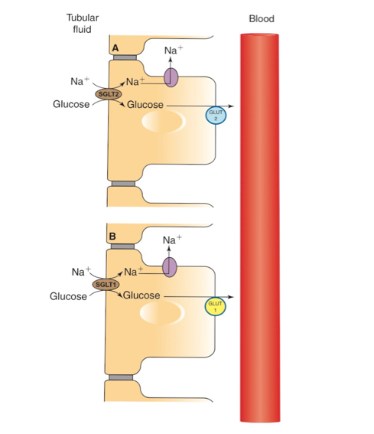

MECHANISM OF GLUCOSE REABSORPTION IN; A; EARLY PROXIMAL TUBULE
B; LATE PROXIMAL TUBULE
Carrier mediated Na+-glucose co-transport. Carrier protein located at the apical membrane in the proximal tubule reabsorbs glucose from tubular fluid into the blood.

- The carrier protein for glucose in early and late proximal tubule is called SGLT-2 and SGLT-1, respectively. ( sodium dependent glucose transporter)
- The carrier is driven by the Na+ concentration gradient which exists between the high tubular (Na+) concentration and the low intercellular (Na+) gradient produced by the pumping out of Na+ through the basolateral surface.
Facilitated diffusion moves the glucose out of the cell through the basolateral membrane. The carrier for facilitated diffusion across the basolateral membrane in early and late proximal tubule is called GLUT-2 and GLUT-1, respectively (GLUT = glucose transporter).

CHARACTERISTICS OF GLUCOSE TRANSPORT AND GLUCOSE EXCRETION
Glucose is reabsorbed by a transport maximum process that is there are limited number of Na+-glucose carriers. The characteristics of glucose transport and glucose excretion can be elicited from the glucose titration curve, which is constructed by plotting the following variables;
- The filtered load against plasma -LASUMSA glucose concentration
- The excretion rate against plasma glucose concentration
- The difference between the filtered load and excretion rate (I.e maximum tubular reabsorption capacity, Tr) against plasma concentration.
Glucose titration curve depicts that
Filtered load increases with the plasma glucose concentration (Pg).

Renal threshold, I.e the plasma glucose concentration at which glucose first appears in the urine (glycosuria) is about 180-200 mg/dL. At plasma levels below renal threshold, the reabsorption of glucose is complete (100%), i.e all of the filtered glucose can be reabsorbed because plenty of carriers are available and hence no glucose is excreted in urine. In this region, the line of reabsorption is the same as that of filtration.

Transport maximum (Tm) refers t the plasma concentration at which carriers are fully saturated. As shown below , beyond plasma glucose concentration of 350mg/dL (TmG) the reabsorption rate does not increase, I,e. Becomes constant and is independent of Pg.
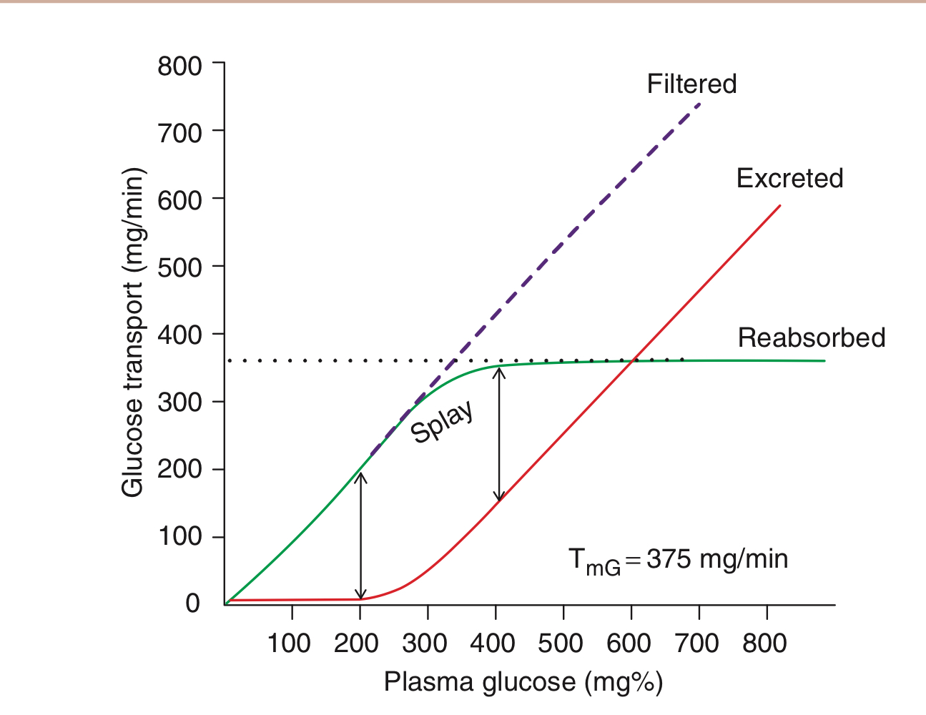Therefore, as the TmG is reached, the urinary excretion rate increases linear’ly with increase in plasma glucose concentration.

Spray refers to the region of the glucose curve between threshold and TmG, I.e between Pg 180 and 350 mg/dL. It represents the excretion of glucose in urine before the TmG is fully achieved. Note in the region of splay, the reabsorption curve is rounded indicating that though the reabsorption rate is increasing with increase in Pg, but reabsorption is less than filtration. Similarly, the excretion curve is also rounded in the region of splay, indicating that though the urinary excretion is increasing with increase in Pg, but there is no linear relation.
Causes of splay are;
- Heterogeneity in glomerular size,proximal tubular length and number of carrier proteins for glucose reabsorption.
- Variability in TmG of the nephron.

For example, there is variability in the number of glucose carrier, the transport rate of the carriers and the binding affinity of the Na+ glucose carriers.

QUESTION 2 - Discuss the process of micturition

Micturition is the process by which the urinary bladder empties when it gets filled. The main physiological events involved in the process of micturition include :
- Filling of the urinary bladder
- Emptying of the urinary bladder

FILLING OF THE URINARY BLADDER
transport of urine into the urinary bladder through ureters
As urine collects in the renal pelvis, the pressure in the pelvis increases and initiates a peristaltic contraction beginning in the pelvis and spreading along the ureter to force urine towards the bladder.
Urine is continuously formed by nephrons and it flows into urinary bladder drop by drop through ureters. When urine collects in the renal pelvis, the contraction sets up in the pelvis. This contraction is transmitted through rest of the ureter in the form of peristaltic wave up to trigone of the urinary bladder. Peristaltic wave usually travels at a velocity of 3cm/second. It develops at a frequency of 1 to 5 per minute. The peristaltic wave moves the urine into the bladder.
After leaving the kidney, the direction of the ureter Is initially downward and outward. Then, it turns horizontally before entering the bladder. At the entrance of the ureters into the urinary bladder, a valvular arrangement is present . When peristaltic wave pushes urine towards the bladder , this valve opens towards the bladder.

Capacity of the bladder
Physiological capacity of the bladder varies with age, being 20-50ml at birth, about 200ml at 1 year, and can be as high as 600ml in young adult males. In all cases, the physiological capacity is about twice that at which the first desire to void is felt.

Volume and pressure changes in bladder during filling
The normal bladder is completely empty at the end of micturition and the intravesical pressure is equal to the intra-abdominal pressure. As the bladder is filled up, it adjusts its tone and a fairly large volume of urine can be accommodated with minimal alterations in the intravesical pressure. This is possible because of the phenomenon of adaptation. The adaptation occurs because of the inherent property of plasticity, the smooth ,uncles of detrusor and because of law of Laplace.

EMPTYING OF THE URINARY BLADDER ; MICTURITION REFLEX
Emptying of the bladder is basically a reflex action called the micturition reflex, which is controlled by Supra spinal centers assisted by contraction of perineal and abdominal muscles. Therefore, emptying of the urinary bladder focuses on:
- Micturition reflex
- Voluntary control of micturition
- Role of perineal and abdominal muscles in micturition

Pathway for the micturition reflex

Sensory (afferent) impulses from the receptors reach the segments of the spinal cord via the sensory fibers of the pelvic (parasympathetic) nerve. Motor (efferent) impulses produced in the spinal cord, travel through motor fibers of the pelvic nerve towards bladder and internal sphincter. Motor impulses cause contraction of the detrusor muscle and relaxation of the internal sphincter so that, urine enters the urethra from the bladder.
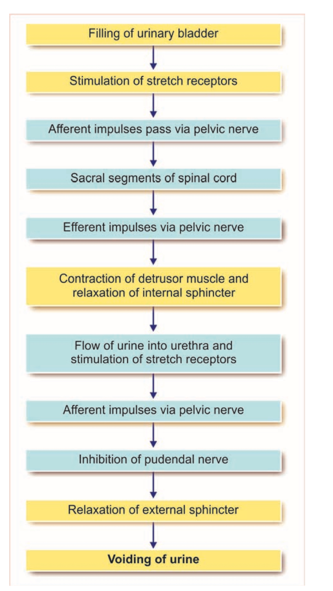
Micturition reflex pathway
Once urine enters the urethra, the stretch receptors in the urethra are stimulated and send afferent impulses to spinal cord via pelvic nerve fibers. Now the impulses generated from the spinal centers inhibit the pudendal nerve. So, the external sphincter relaxes and micturition occurs.
Once the reflex begins, it is self-regenerative (positive feedback). The initial contraction of bladder further activated the receptors to cause still further increase in reflex contraction of the bladder. The cycle continues repeatedly until the force if contraction of the bladder reaches the maximum and the tribe is voided out completely.
During micturition, the flow of Irvine is facilitated by the increase in abdominal pressure due to the voluntary contraction of the abdominal muscles.

Higher centers for micturition
Spinal centers for micturition are present in sacral and lumbar segments. But, these spinal centers are regulated by higher centers. The higher centers, which control micturition are of two types, inhibitor and facilitator centers.
Inhibitory centers for micturition centers in the midbrain and cerebral cortex inhibit the micturition by suppressing spinal micturition centers.
Facilitatory centers for micturition centers in pons facilitate micturition via spinal centers. Some centers in cerebral cortex also facilitate micturition.

QUESTION 3 - explain the juxtaglomerular apparatus
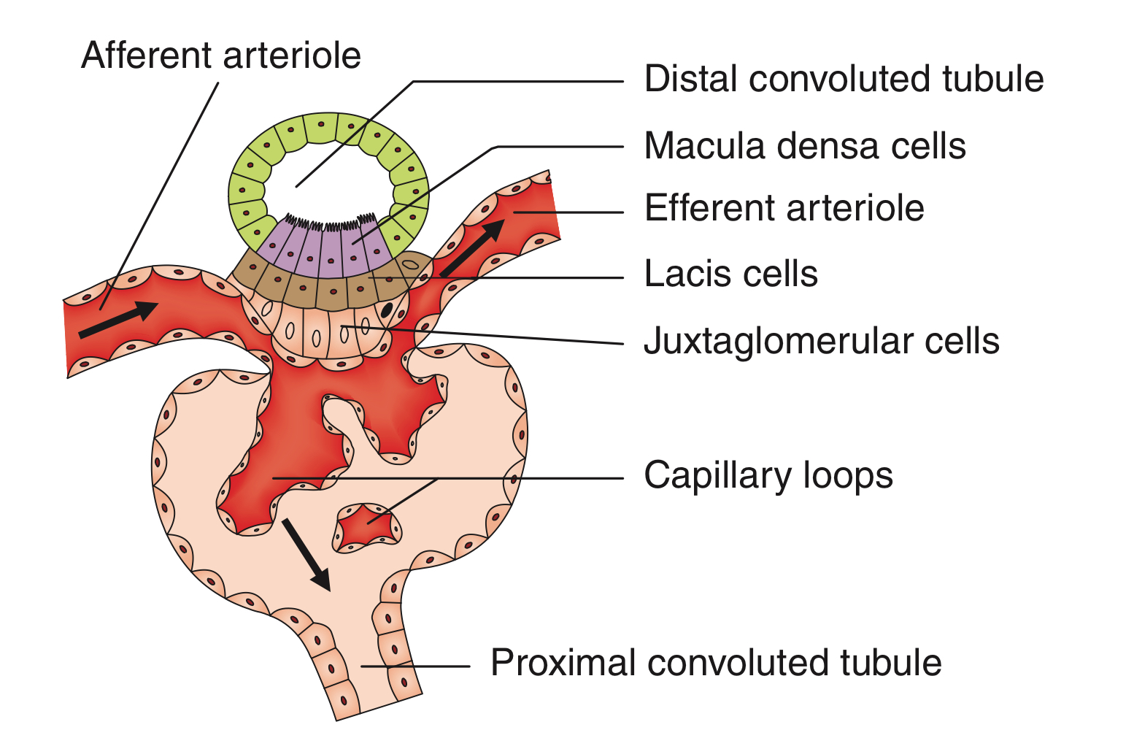
Juxtaglomerular apparatus

Juxtaglomerular (JG) apparatus as the name indicates (juxtanear) refers to the collection of specialized cells located very near to the glomerulus. It forms the major component of renin-angiotensin-aldosterone system. The juxtaglomerular apparatus consists of three types of cells:
- Juxtaglomerular cells
- Macula densa cells
- Mesangial cells

1. Juxtaglomerular cells. Specialized myoepthelial (modified vascular smooth muscle) cells located in the media of the afferent arteries in the region of the juxtaglomerular apparatus.
Characteristic features of juxtaglomerular cells are:
- They have well-developed Golgi apparatus and endoplasmic reticulum, abundant mitochondria and ribosomes.
- They synthesize, store and release an enzyme called renin. Renin is stored in the secretory granules of juxtaglomerular cells and, therefore, these are also called granular cells.
- They act as baroreceptors (tension receptors) and respond to changes in the transmural pressure gradient between the afferent arterioles and the interstitium.
- They are densely innervated by the sympathetic nerve fibers and release their renin content in response to the sympathetic discharge.
- As these cells act as vascular volume receptors, they monitor renal perfusion pressure and are stimulated by hypovolemia or decreased renal perfusion pressure.
2. Macula densa cells. Macula densa cells refer to the specialized renal tubular epithelial cellsof a short segment of the thick ascending limb of loop of Henle which passes between the afferent and efferent arterioles supplying its glomerulus of origin.
Characteristic features of macula densa cells are:
- They are not well adapted for reabsorption.
- They are not innervated.
- These cells are in direct contact with the mesangial cells and in close contact with the juxtaglomerular cells.
- They act as chemoreceptors and are stimulated by decreased NaCl concentration and thereby causing increased renin release.
3. Mesangial cells or lacis cells are the interstitial cells of the juxtaglomerular apparatus.
Characteristic features of mesangial cells are:
- They are in contact with both the macula densa cells (on one side) and juxtaglomerular cells (on the other side).
- Functionally, these cells possibly relay the signals from macula densa to the granular cells after modulating the signals. In this way, a decreased intraluminal Na+ load, Cl- load, or both in the region of macula densa stimulates the JG cells to secrete renin.
- They also show granulation to secrete renin in conditions of extreme hyperactivity.
- They also secrete various substances and take up immune complexes.

QUESTION 4 - discuss the role of the kidney in regulation of blood pressure

Kidneys play an important role in the long-term regulation of arterial blood pressure. When blood pressure alters slowly in several days/ months/ years, the nervous mechanism adapts to the altered pressure and loses the sensitivity for the changes. It cannot regulate the pressure any more. In such conditions, the renal mechanism operates efficiently to regulate the blood pressure. Therefore, it is called long-term regulation.
Kidneys regulate arterial blood pressure by two ways :
1. By regulation of extracellular fluid volume.
2. Through renin-angiotensin mechanism.

- By regulation of extracellular fluid volume
When the blood pressure increases, kidneys excrete large amounts of water and salt, particularly sodium, by means of pressure diuretics and pressure natriuresis. Pressure diuretics is the excretion of large quantity of water in urine because of increased blood pressure. Even a slight increase in blood pressure doubles the water excretion. Pressure natriuresis is the excretion of large quantities of sodium in urine.
Because of diuresis and natriuresis, there is a decrease in ECF volume and blood volume, which in turn brings the arterial blood pressure back to normal level.
When blood pressure decreases, the reabsorption of water from renal tubules is increased. This in turn, increases ECF volume, blood volume and cardiac output, resulting in restoration of blood pressure.

- Through renin-angiotensin mechanism
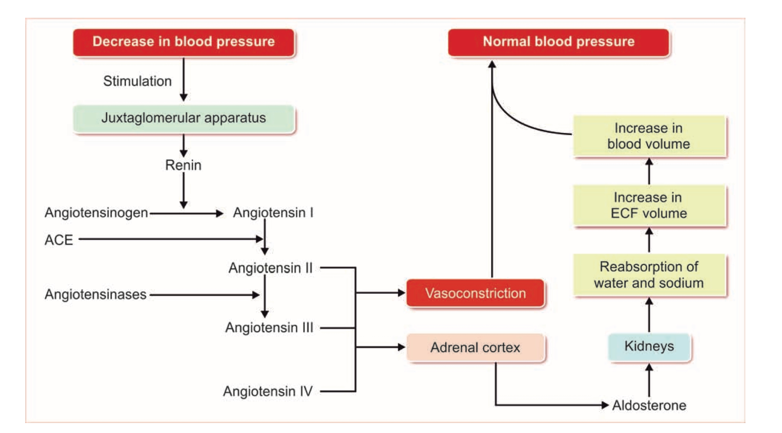
Regulation of blood pressure by renin-angiotensin mechanism.
ACE = angiotensin-converting enzyme

Actions of angiotensin II
When blood pressure and ECF volume decrease, renin secretion from kidneys is increased. It converts angiotensinogen to angiotensin I. This is converted into angiotensin II by ACE (angiotensin-converting enzyme).
Angiotensin II acts in two ways to restore the blood pressure:
- It causes constriction of arterioles in the body so that the peripheral resistance is increased and blood pressure rises. In addition, angiotensin II causes constriction of afferent arterioles in kidneys, so that glomerular filtration reduces. This results in retention of water and salts, increases ECF volume to normal level. This in turn increases the blood pressure to normal level.
- Simultaneously, angiotensin II stimulates the adrenal Cortex to secrete aldosterone. This hormone increases reabsorption of sodium from renal tubules. Sodium reabsorption is followed by water reabsorption, resulting in increased ECF volume and blood volume. It increases the blood pressure to normal level.

- Actions of angiotensin III and IV
Like angiotensin II, the angiotensins III and IV also increase the blood pressure and stimulate adrenal cortex to secrete aldosterone.

QUESTION 5 - discuss the role of the kidney in calcium homeostasis

Three principal hormones are involved in calcium homeostasis,. These 3 hormones act on the kidneys to maintain calcium homeostasis in the following ways:

1. Vitamin D
Vitamin D is a group of closely related sterols produced by the action of ultraviolet light. Vitamin D3 (cholecalciferol) is produced by the action of sunlight and is converted to 25-hydroxycholecalciferol in the liver.

-Facilitates calcium absorption in the kidney

2. Parathyroid hormone (PTH)
Parathyroid hormone is a linear polypeptide containing 84 amino acid residues. It is secreted by the chief cells in the four parathyroid glands. Plasma ionized calcium acts directly on the parathyroid glands in a feedback manner to regulate the secretion of PTH.

- Increases renal calcium reabsorption by the distal renal tubules
- Increases renal phosphate excretion by decreasing tubule phosphate reabsorption
- Increases the formation of 1,25-dihydrocholecalciferol by increasing the activity of alpha-hydroxyls in the kidney

A large amount of calcium is filtered in the kidneys, but 99% of the filtered calcium is reabsorbed. About 60% is reabsorbed in the proximal tubules and the remainder in the ascending limb of the loop of Henle and the distal tubule. Distal tubule absorption is regulated by parathyroid hormone

3. Calcitonin
Calcitonin is a 32 amino acid polypeptide secreted by the parafollicular cells in the thyroid gland. It tends to decrease serum calcium concentration and, in general, has effects opposite to those of PTH. The actions of calcitonin are as follows:

- Increases renal calcium excretion by inhibiting reabsorption from the renal tubules.

4. Other hormones

Growth hormone increases calcium excretion in the urine, but it also increases intestinal absorption of calcium, and this effect may be greater than the effect on excretion, with a resultant positive calcium balance.
Glucocorticoids increase renal excretion of calcium.

