Okerewa Alice
Bch306
Study questions
17/sci03/007

Questions :

- Write short note on the toxicological effect of food additives and preservatives.
- Describe various categories by which toxicity testing studies can be performed. Hence write on various tests for assessing the toxicity of any two major organ in the body.
- Discuss the various routes by which the body can be exposed to foreign substances
- of any toxicant is influenced majorly by lipid barrier, discuss.
- Explain the concept of molecular targets of toxicants.
- Write on the toxicological effect of a named food preservative.
- Carcinogenesis could result from toxicant exposure, discuss.
- Describe the various excretory pathways of toxicants.
- With the aid of schematic diagram, describe the toxicological process in mammal.
- With the aid of an adequate pathway, discuss phase I and II metabolism of any two of the following compounds:
i. Benz[a]pyrene

ii. Carbon tetrachloride

iii. Ethanol

iv. Aflatoxin B1
11. Write on the following:

i. Toxicokinetics

ii. Toxicodynamics

Answers:
- Toxicological effect of food additives and preservative : Chemicals have been used to preserve food and to add color and taste to food for centuries. Following the considerable increase in the use of food additives in processed foods from the mid-twentieth century, safety assessment of food additives has been conducted on a formal basis at national and international levels. Production of food and its preservation for long time may involve addition of chemicals.Majority of the additives in the food may lead to headache, nausea, weakness and difficulty in breathing. The research on nerve cells has shown these chemicals to cause toxic effect on nerve cells.

2. Ways in which toxicity testing studies can be performed :
- Single or multiple dose (acute) exposure : Acute toxicity of chemical can be viewed from two perspectives . The experiment for acute can take up to 14 days , repeated exposure can take within 24hours to years by this definition two component comprise acute toxicity : acute exposure and acute effect .

- Repeated dose : sub-acute and sub-chronic toxicity studies involve investigating the effect of repeated exposure to substances (3-4doses) in animals for 14-28, and 90days respectively. Sub -acute toxicity:28days, sub-chronic toxicity: 90days and cornice testing :more than 90days

B. Various test for assessing the toxicity of any two major organ in the
Body: organs like livers and kidney can be tested by the following :

- Alanine transferees
- LDH – lactate dehydrogenase
- Glutamates dehydrogenase
- Tissues histology

- Glutamates dehydrogenase; is a liver damage marker we can use it to study the damage the liver using GGT and ALP .

3. The various routes by which the body can be exposed to foreign substances includes :
- The tropical application
- Parenteral routes
- Enteral routes
- Tropical application : it is the most direct and easiest mode of drug application examples are eye drop , sprays , and lotions for use . Absorption of this drug is based on their solubility , therefore drugs that are not soluble depends on oily vehicles to enhances solubility so that it can be absorbed by the body

- Parental administration : also known as injection it includes;

- Subcutaneous injection : it is mainly use for non -irritating drugs , it is slow to absorb therefore epinephrine can be added to the drug solution to decrease the rate of absorption . This route of administration is painful because of tissue distinction
- Intramuscular injection: it ensures rapid delivery of the desired blood conversion of the drug to be obtained accurately and immediately it is used in emergency situations , irritating drug can be administered through this route . It also ensures rapid absorption of the drug in aqueous solution. It is slow and painful to absorb .

- Enteral routes : this route is preferred when the oral route is not unsuitable due to irritation. Absorption of this drug is irregular and incomplete , formulations such as enemas are applied through rectal routes
- Oral administration: the drugs administered orally are absorbed at the GIT . The drugs may not be well absorbed at the GIT because irritating drugs may cause side effects therefore may not reach the circulation after administration.

4 . Of any toxic ant is influenced majorly by lipid barrier Discuss: This talks the mechanism of absorption of toxic ant across the membranes , in order for drugs to cross the biological membrane into systemic circulation and
Reach the site of action . The cell membrane restrict drug transport across the intestine and into the brain because, the cell membrane has a phospholipid bi-layer with interspersed integral and peripheral proteins which behaves like
molecular gates or pumps . They are highly specific and require energy for molecular transports .they are means through which drugs or toxicant can cut across the membrane to reach their intended target site they include Active transport and passive transport .

5. Molecular target concept : the toxic action of chemical is a consequence of the physical or chemical interaction of the active form of that chemical with a molecular target within the living organisms. Examples of molecular targets are ; lipids – carbon tetrachloride , DNA – Aflatoxin , proteins etc

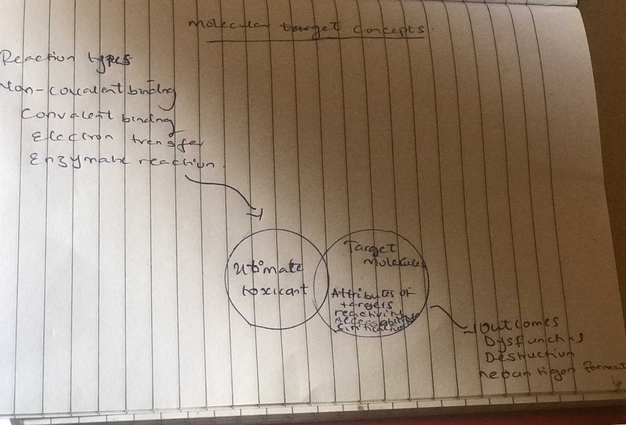
The molecular target concept

6. Toxicological effect of a named food preservative
Aspartame : is a food preservative metabolized by the action of pancreatic alpha- chymotrypsin and esterase to yield and L- aspartyl -L-phenylalanine within the guy wall, L-aspartyl-L-phenylalanine is cleared by an amides to yield free phenylalanine which is transport to the portal circulation . Since elevated plasma phenylalanine conceration are associated with metal retardation , it’s metabolism is primary concern .

7. Carcinogenesis could result from toxicant exposure : cancer is highly complex, multifactorial disease caused partly by metabolic or other imbalances associated with age or genetic makeup and xenobiotics . Common examples of toxicants that can lead to cancer are nitrosamines , aminofluorenes, inhaled asbestos and radioactive compounds that emit ionizing radiation .Also Aflatoxin B1 produced by fungus Aspergillum flavus growing on stored grains nuts and peanuts is a powerful naturally occurring carcinogen . So exposure to this Aflatoxin B1 can lead to cancer.

8. The various excretory pathways ;
- Respiratory excretion : one of the major defense mechanism of the lungs in which mucus and potentially harmful foreign substances contained in it are moved out of the lungs , it is also referred to as the waste disposal system .
- Gastrointestinal excretion : it is divided into biliary excretion and enterohepatic circulation . Biliary excretion involves active secretion of drugs molecules or their metabolites from hepatocytes into the bile, the bile then transport the drug to the gut where the drugs are excreted . While the Enterohepatic circulation refers to substances that are metabolized by the liver , excreted into the bile and passed into the intestinal lumen and returned to the liver through portal circulation .
- Urinary excretion : it is divided into Glomerular filtration and Trans-tubular secretion . Glomerular filtration is a process whereby a clear fluid is produced from the blood perfusing the Glomerular at the beginning of each nephron . While the trans – tubular secretion plays an important role in the excretion of several drugs including penicillin and a number of diuretics .

9. The toxicological process in mammals : it has to do with Absorption, distribution, metabolism and excretion of administered substances in an organism or human body and how it affects pharmacokinetic concentration profiles of the human body or organisms .
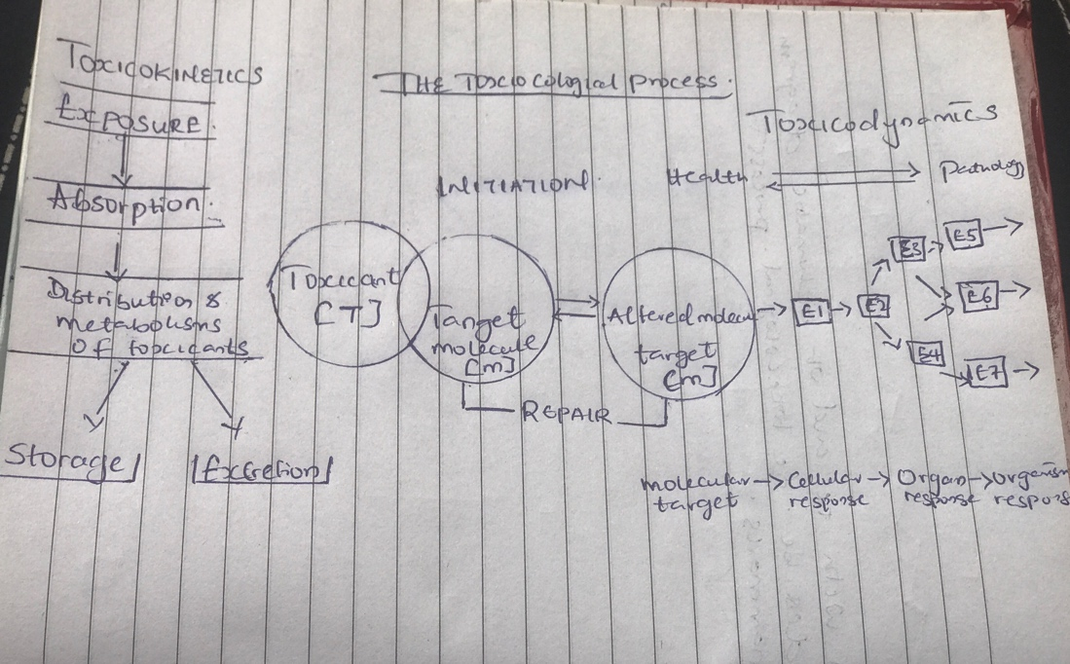
The toxicological process

10 . Aflatoxin B1:
Aflatoxin B1 is an aflatoxin produced by Aspergillus flavus and A. parasiticus. It is a very potent carcinogen with a TD50 3.2 μg/kg/day in rats. This carcinogenic potency varies across species with some, such as rats and monkeys, seemingly much more susceptible than others.Aflatoxin B1 is a common contaminant in a variety of foods including peanuts, cottonseed meal, corn, and other grains; as well as animal feeds.Aflatoxin B1 is considered the most toxic aflatoxin and it is highly implicated in hepatocellular carcinoma (HCC) in humans
Phase 1: Aflatoxin B1 must first be metabolized into its reactive electriphilic form, aflatoxin B1-8,9-exo-epoxide by cytochrome p450.This active form then intercalates between DNA base residues and forms adducts with guanine residues, most commonly aflatoxin B1-N7-Gua. These adducts may then rearrange or become removed from the backbone all-together, forming an apurinic site.
Phase 2: glutathione conjugation takes place with a wide range of organic compounds such as alkyl halides and epoxies get conjugated with cysteine of glutathione.in order to make AFB1 soluble so that it can be excreted in urine or feces .

Benz(a)pyrene :
Benzo[a]pyrene is a polycyclic aromatic hydrocarbon and the result of incomplete combustion of organic matter at temperatures between 300 °C (572 °F) and 600 °C (1,112 °F). The ubiquitous compound can lead be found in coal tar, tobacco smoke and many foods, especially grilled meats. The substance with the formula C20H12 is one of the benzopyrenes
, formed by a benzene ring fused to pyrene.

Phase 1: benz(a) pyrene undergoes oxidation through expoxidation of benz(a)pyrene to 4-5 epoxylbenz(a) pyrene Benzo[a]pyrene is first oxidized by cytochrome P450 1A1 to form a variety of products, including (+)benzo[a]pyrene-7,8-epoxide.[30]
This product is metabolized by epoxide hydrolase, opening up the epoxide ring to yield (−)benzo[a]pyrene-7,8-dihydrodiol.
The ultimate carcinogen is formed after another reaction with cytochrome P450 1A1 to yield the (+)benzo[a]pyrene-7,8-dihydrodiol-9,10-epoxide. It is this diol epoxide that covalently binds to DNA.

Phase2: glutathione conjugation takes place with a wide range of organic compounds such as alkyl halides and epoxies get conjugated with cysteine of glutathione.in order to make Benz(a)pyrene soluble so that it can be excreted in urine or feces .

- Toxicokinetics : is a quantitation of the time of toxic ants in the body during the process of absorption , distribution , bio transformation and excretion of toxicants . The end result of toxicokinetics processes is a biologically effect dose of the toxicants

Toxicodynmics: this refers to the molecular , biochemical and psychological effect of toxicant or their metabolites in biological systems .

