1. Importance of cholesterol.
- It builds the structure of cell membranes
- It makes hormones like oestrogen, testosterone and adrenal hormones
- It helps your metabolism work efficiently, for example, cholesterol is essential for your body to produce vitamin D
- It produces bile acids, which help the body digest fat and absorb important nutrients.

2. Differences between globosides and gangliosides.
A globoside is a type of glycosphingolipid with more than one sugar as the side chain (or R group) of ceramide. The sugars are usually a combination of N-acetylgalactosamine, D-glucose or D-galactose. A glycosphingolipid that has only one sugar as the side chain is called a cerebroside. While, A ganglioside is a molecule composed of a glycosphingolipid (ceramide and oligosaccharide) with one or more sialic acids (e.g. n-acetylneuraminic acid, NANA) linked on the sugar chain. NeuNAc, an acetylated derivative of the carbohydrate sialic acid, makes the head groups of gangliosides anionic at pH 7, which distinguishes them from globosides.
3. Methylated form of phosphatydil ethanolamine is phosphatidylcholine.
4. The double bond is in the 2nd ring
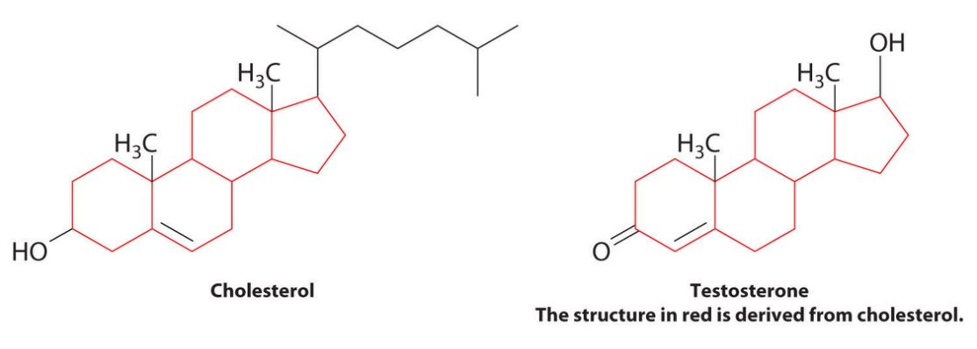

5. Properties of phosphoglycerides.
- phosphoglycerides are amphiphilic, as they have both hydrophobic (fears water) and hydrophilic (loves water) parts.
- The two fatty acid chains attached to the molecule of glycerol are nonpolar hence hydrophobic while the polar heads which mainly consists of the phosphate group attached to the third carbon of the glycerol molecule is hydrophilic.
- They are usually organized into a bilayer in membranes with the polar hydrophillic heads sticking outwards to the aqueous environment and the non polar hydrophobic tails pointing inwards.

6. Differences between triacylglycerol and phosphosglyceride. Examples and with schematic structures.
TRIACYLGLYCEROL | PHOSPHOGLYCERIDES
They are the major class of naturally occurring neutral lipids. | They are not neutral lipids
They are composed of a molecule of glycerol that has been esterified with three molecules of fatty acids | Phosphoglycerides have three parts: a three-carbon backbone of glycerol, two long-chain fatty acids esterified (or attached via an ether link in Archaea) to hydroxyl groups on carbons 1 and 2 (C₁ and C₂) of the glycerol, and phosphoric acid esterified to the C₃hydroxyl group of glycerol
Triacylglycerol serve several functions in the body. First, they help maintain the structure of cell membranes by forming a lipid bilayer. | Phosphoglycerides have a more rigid chemical structure than triglycerides do, so they make cell membranes tougher and help them to hold their shape better than triglycerides alone could
They are not component of membrane bilayers | They are the main constituents of membrane bilayers
Triacylglycerol, like all fats, also store energy. | Phosphoglycerides help break down fats during the digestive process.
Examples are; Tristearin, Triolein, Tripalmitin | Examples are; Plasmalogen, Phosphatidates, Phosphatidylcholine

Examples of Phosphoglyceride i
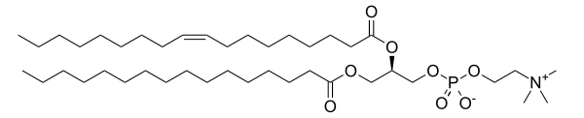

Palmitoyl-oleyl-sn-phosphatidylcholine, a phosphatidylcholine.

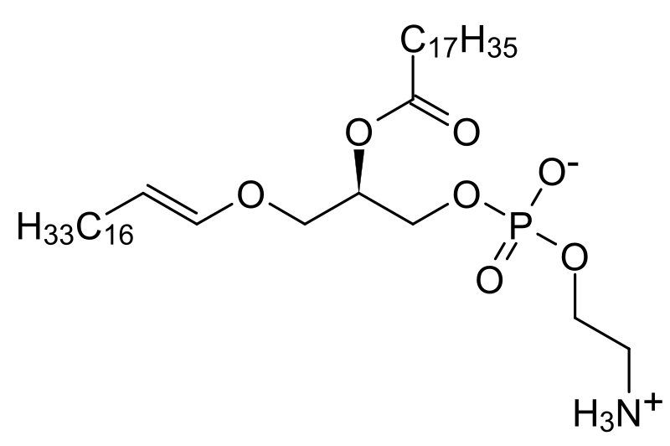

General chemical structure of phosphatidic acids

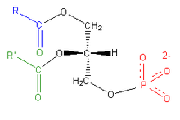
Plasmalogen

Examples of Triglycerol

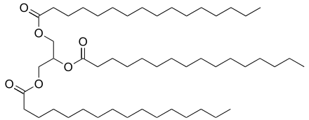
Tripalmitin

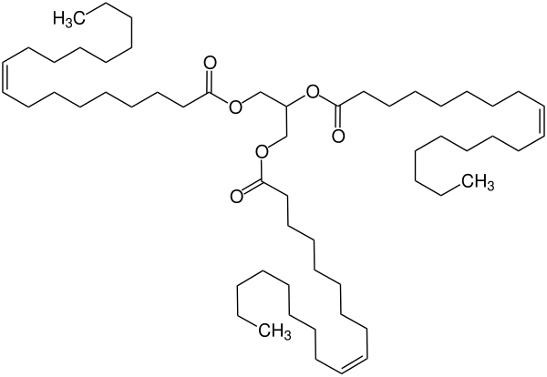

Tristearin

