NAME: EHIE GREAT CHIMSOM
MARTIC NUMBER: 17/SCI03/003
DEPARTMENT: BIOCHEMISRTY
COURSE CODE: BCH 306
- Toxicological Effects of Food additives and Preservatives
Food additive and preservatives help food taste, smell and look like something it is not. They enable food to stay for a long period of time without going bad. Food additives and preservatives can put our health and wellbeing at risk because they sometimes place a burden on our body’s detoxification mechanism which must attempt to get rid of these chemicals from our bodies. They can cause other severe damage to the system allowing asthma attacks, rashes, migraines, hyperactivity, insomnia diarrhea and more.
- a. Toxicological testing studies can be performed in various categories. They are
- Acute toxicity test
- Sub-acute toxicity test
- Sub-chronic toxicity
- Acute toxicity is an effect that is manifested within a short period of time (ranging from almost immediately to several days) after a single or multiple exposure of a substance within 24 hours. Acute toxicity study is the investigation of the effect/ mortality rate of a substance within 24 days of administering the substance to an organism.
- Sub-acute toxicity studies is the investigation of the adverse effect of repeated exposure of a substance in an organism for 14-28 days.
- Sub-chronic toxicity studies is the study of investigating the effect of repeated exposure of a substance in animals for 90 days.

2 b. i. Test For Assessing The Toxicity Of The Liver
Liver Function Test: Liver function test is used to:
- Screen for liver infections, such as hepatitis
- Monitor the progression of a diseases, such as viral or alcoholic hepatitis, and determine how well a treatment is working
- Monitor possible side effects of medications
Some common liver function tests are
- Alanine transaminase (ALT): ALT is an enzyme found in the liver that helps convert proteins into energy for the liver cells. When the liver is damaged, ALT is released into the bloodstream and the levels increase.
- Aspartate transaminase AST): AST is an enzyme that helps metabolize amino acids. AST is present in the blood at low levels just like ALT. An increase in AST levels may indicate liver damage, disease or muscle damage.
- Alkaline phosphate (ALP): ALP is an enzyme found in the liver and bone and is important for breaking down proteins. High levels of ALP may indicate liver damage or diseases such as a blocked bile duct or certain bone diseases.
Gamma-glutamyltransferase(GGT), Bilirubin, Albumin and total protein tests are other effective liver function tests.
2 b. ii. Test For Assessing The Toxicity Of The Kidney
Nephrotoxicity (renal toxicity): Nephrotoxicity is a common kidney problem and occurs when the body is exposed to a drug or toxin that causes damage to the kidneys. When the kidney is damaged, it is difficult or impossible to get rid of excess urine and waste in the body. Nephrotoxicity can also be referred to as ‘renal toxicity’.
Various tests for nephrotoxicity:
- Blood Urea Nitrogen (BUN): The BUN reflects the amount of Nitrogen that is present in the body in the form of a waste product called urea. BUN is used to determine if there is extra Nitrogenous waste in the blood stream which should have been filtered out of the kidneys. One of the symptoms of kidneys problems is the failure to filter as much as is necessary. An excess of Nitrogen compounds in the blood may lead to uremia
- Creatinine: The serum creatinine present after creatinine is broken down by the body in order to make energy for your muscles. The kidneys are normally able to filter out large amounts of creatinine on a daily basis, so when kidney problems are present, the ceratinine levels will increase, reflecting less creatine being filtered out through the kidneys

- The body can be exposed to foreign substances through various routes. Namely;
- Topical application
- Parenteral routes
- Enteral routes
- Topical application: This is the easiest and most direct mode of drug administration which involves local application of a drug to the site of action e.g eye drop solutions, sprays for oral, rectal, vaginal and urethral uses
-Oral administration: The drugs administered using this route are absorbed at different sites along the gastrointestinal tracts
-Rectal administration: When the oral route is not suitable for administration because of taste or odour, this route can come into play.
- Parenteral administration: This route of administration is also known as injection. It is more rapid and it enables more accurate dose selection and predicative absorption. Some parenteral routes are
-Subcutaneous injections: This is used for non-irritating drugs. It produces sustained drug effects because of even and slow absorption.
-Intravascular injection: This route ensures more rapid absorption of the drug in aqueous solutions
-Intravenous administration: This ensures rapidly delivery of the desired blood concentration of the drug to be obtained accurately and immediately and immediately. It is the preferred route of delivery in emerging situations. This mode of administration is used because the veins have low sensitivity to pain. It is also important because of the avoidance of the hepatic and pulmonary first pass effect
- Enteral administration: This is food or drug administration via the human gastrointestinal tract, which is in contract to the parenteral administration which occurs from routes outside the G.I tract
Enteral administration involves the esophagus, stomach, small and large intestines.
Some methods of administration are oral, sublingual and rectal.

- For a xenobiotic to enter the bod, it must pass across cell membranes. Cell membranes are formidable barriers and a major body defense that prevents foreign invaders or substances from gaining entry into the body tissues. Normally, cells in solid tissues (such as skin or mucous membranes of the lung or intestine) are so tightly compacted that substances cannot pass between them. This requires that the xenobiotic have the ability to penetrate cell membranes. It must cross several membranes to go from one area of the body to another. For a substance to move through one cell, it requires that it first move across the cell membrane into the cell, pass across the cell and then cross the cell membrane again to leave the cell.

- Molecular targets are cellular or tissues structures that are intended to be visualized by means of molecular imaging. Different biological structures can serve as imaging targets, ranging from proteins to DNA and RNA

- Toxicological effects of anti-caking agents: Anti-caking agents are compounds used to prevent clumping and sticking in packaged products. Some common anti-caking agents are silicon dioxide, calcium silicate, iron ammonium citrate, and yellow prussiate of soda. Sodium potassium ferrocyanide are feared because the chemical compound contains cyanide, a known toxin. Aluminum used in anti-caking agents is another concern. However, in healthy individuals, only 0.3% of orally ingested aluminum is absorbed in the G.I tract. In individuals with impaired renal function, ingested aluminum is cause for concern.
Improper excretion of aluminum can lead to deposits in the brain, bone, liver, head, spleen and muscle.
Additionally, aluminum absorbed intravenously has the potential to remain in the body. Excess aluminum has been linked to neurological conditions, certain types of anemia, kidney failure and softening of the bones
- Exposure to some chemicals/ harzadous substances or toxicants can increase the risk of cancer in an organism/ animal.
Carcinogenesis is any substance or radiation that promotes carcinogenesis, the formation of cancer. A few well known carcinogenesis are asbestos, nickel, cadmium, radon, vinyl chloride, benzidene and benzene.
Alcohol drinking and tobacco smoking can also put an individual at risk of cancer. Long term misuse of alcohol may cause cancers of the mouth, throat, liver and breast. Smoking or chewing of tobacco, cigarette smoking can cause cancers of the lungs, mouth, throat, kidney and bladder, etc.
- Excretion is a process by which metabolic waste is eliminated from and organism. In vertebrates, it is primarily carried out by lungs, kidney and skin
There are various excretion pathways. Namely;
- Respiratory excretion
-Mucocilliary clearance
- Gastrointestinal excretion
-Biliary excretion
-Entero-hepatic circulation
- Urinary excretion
-Glomerular filtration
-Trans-tubular secretion

- Respiratory excretion
- Mucocilliary clearance: It is a major defense mechanism of the lungs in which mucus and potentially harmful foreign substances contained in it are moved out of the lung. It is the physical undirected movement and removal of deposited particles and gases dissolved in the mucus from the respiratory tract
- Gastrointestinal excretion
- Biliary excretion: This has to do with secretion of drug molecules or their metabolites from hepatocytes into the bile. The bile afterwards transports the drugs to the gut where the drugs are excretion,.
- Entero-hepatic circulation: This involves substances that are metabolized in the liver, excreted into the bile and passed into the intestinal lumen, then they are released across the intestinal mucosa and returned to the liver via portal circulation.
- Urinary excretion
- Glomerular filtration: Here a fluid is produced from the blood perfusing the glomerulus at the beginning of each nephron
- Trans-tubular secretion: Renal tubular secretion plays a role in the excretion of several drugs.

- The Toxicological Process
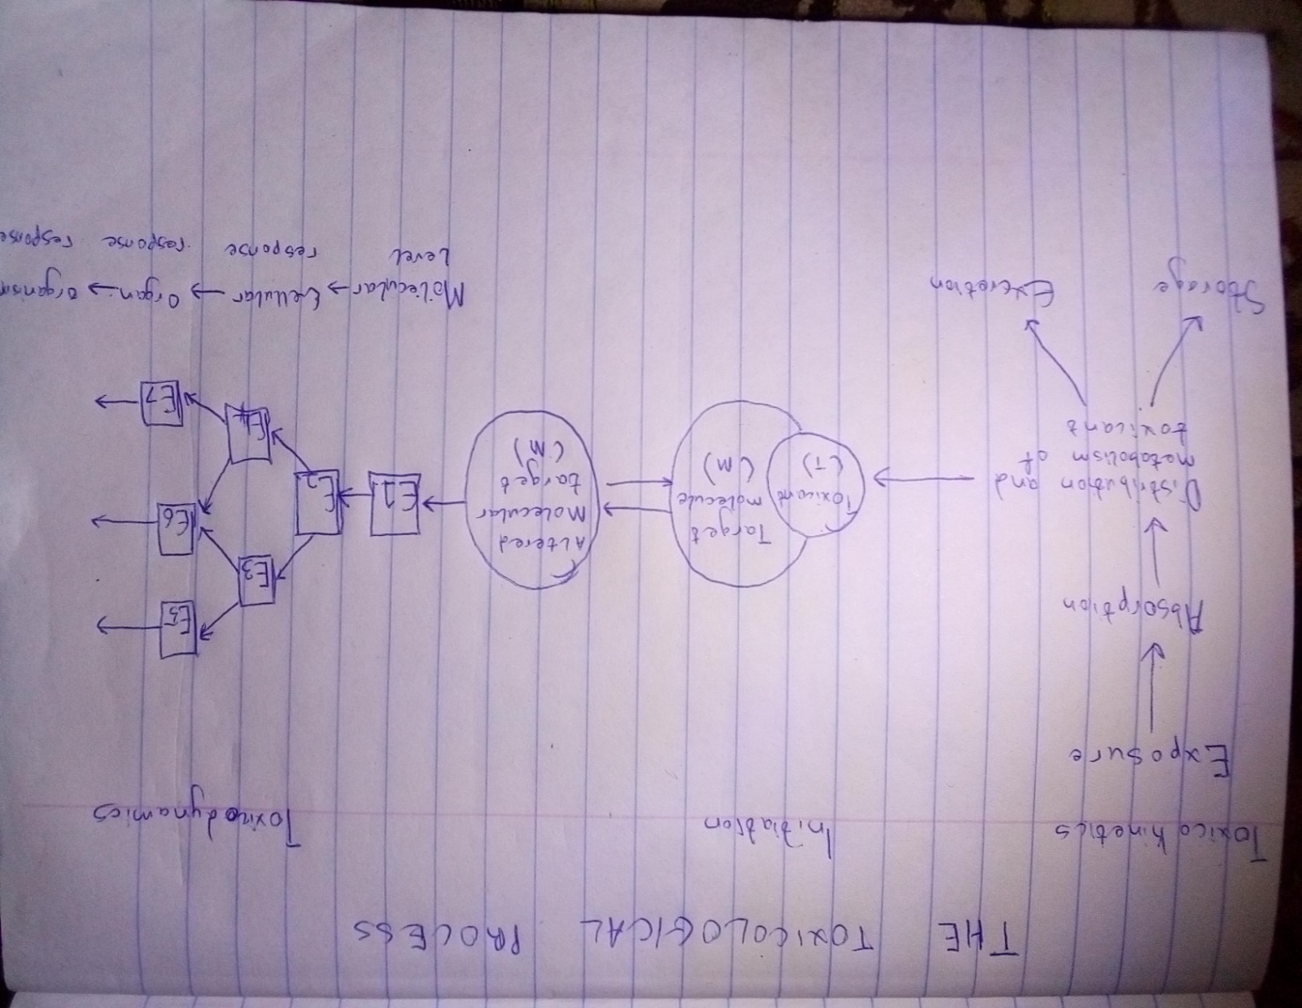

- Ethanol Metabolism:
Ethanol is metabolized into acetaldehyde by alcohol dehydrogenase (ADH) and the microsomal enzyme cytochrome P450 2E1. The ADH enzyme reaction is the main ethanol metabolic pathway involving an intermediate carrier of electrons, namely; nicotinamide adenine dinucleotiden(NAD+)
Acetaldehyde is rapidly metabolized by aldehyde dehydrogenasen(ALDH) in the muscle to Carbon dioxide and water
Ethanol promotes the traslocation of lipopolysaccharide form of gastrointestinal lumen to the portal vein, where it binds to the lipopolysaccharide-binding protein. In kupffer cells, lipopolysaccharide binds to CD14 which combines with TLR4 activating multiple cytokine genes. TLR4 are activated by MyD88 dependent or independent manner, leading to secretion of TNF-alpha or IFN-beta

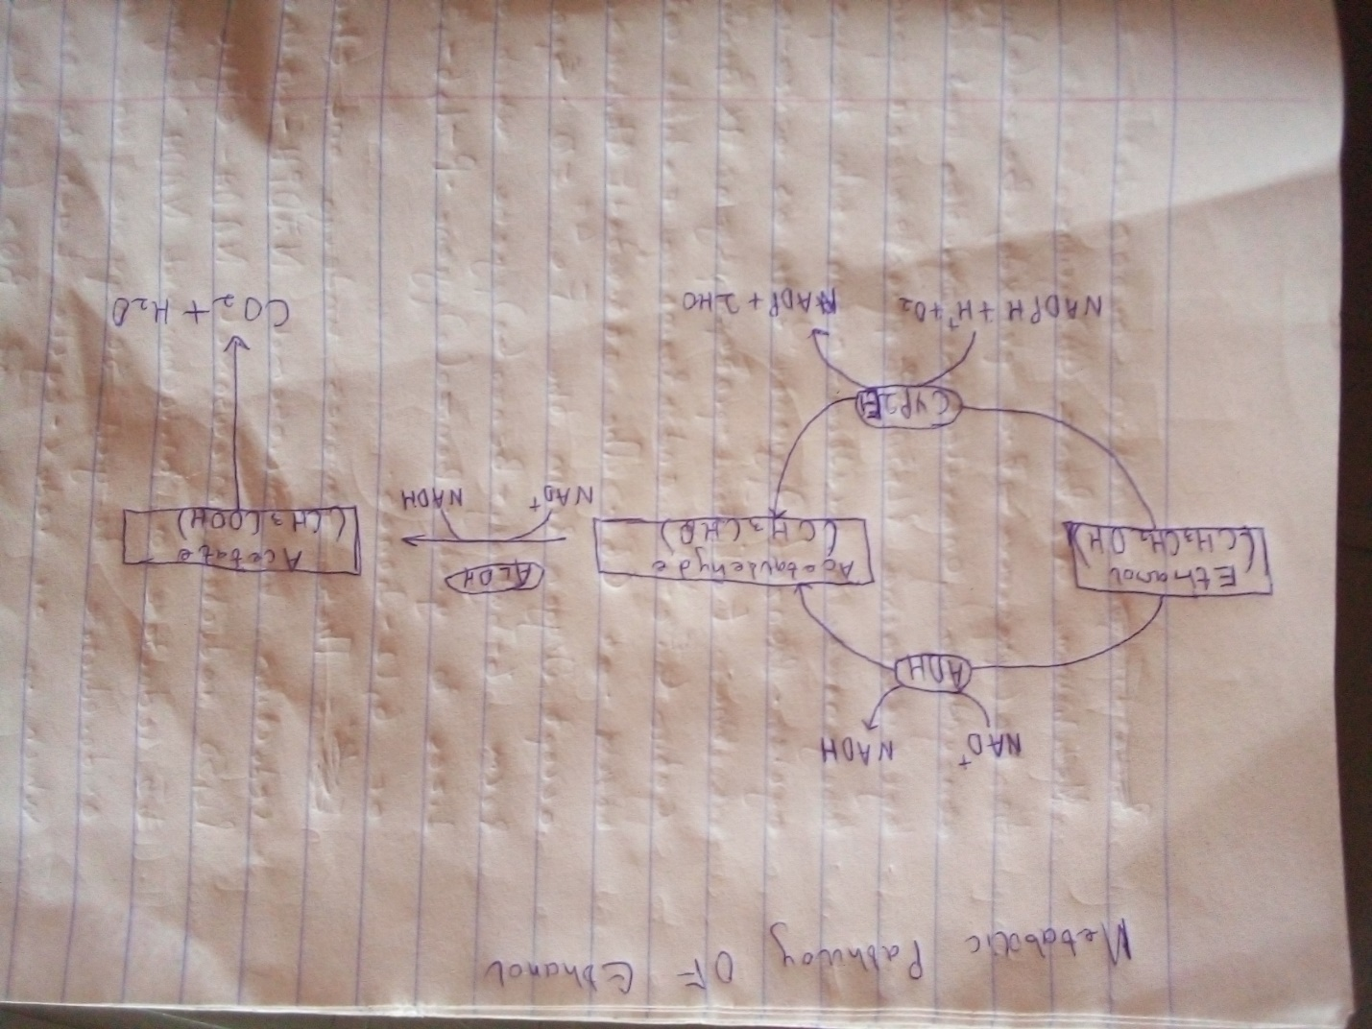

METABOLIC PATHWAY OF ETHANOL

Metabolism Of Benzo(a)pyrene
In the presence of a peroxide, benzo(a)pyrene can undergo one-electron oxidation at Carbon-6 by cytochrome P450 peroxidase or peroxidases to generate a radial cation. In the peroxidase cycle, Benzo(a)pyrene acts as a co-reductant of the Fe4+ protoporphyrin ix radical cation and forms a radical cation itself at Carbon-6. The activated Carbon can accept Oxygen from the Fe4+=0 species to form –hydroxy-benzo(a)pyrene which auto oxidizes to yield benzo(a)pyrene P-1, 6-3, 6- or 6, 12- diones
The quinones undergo one electron reduction by microsomal NADP-cytochrome P450 reductase, microsomal NADH- cytochrome b5 reductase, or microsomal NADH ubliquinone oxidoreductase to yield semiquinone anion radicals which in air redox-cycle back to the diones with the generation of ROS superoxide anion and hydroxyl radical
Benzo(a)pyrene can also undergo mono-oxygenation catalyzed by the microsomal NADPH- dependent P450 isoforms to yield a series of arene oxides which can either arrange to yield 3,7 or 9-hydroxyl-benzo(a)pyrene or be hydrated by microsomal epoxide hydrolase to yield the correspomding benzo(a)pyrene 7,8 or 9, 10-trans-dihydroils.
The non-k-region benzo(a)pyrene 7,8-dihydroil is further mono-oxygenagated by P4501A1/1B1 to yield the reactive anti-benzo(a)pyrene, 8-diol-9, 10-epoxide [anti-benzo(a)pyrene PDE] which is a rodent lung carcinogen. Formation of the diol-epoxide thus requires the combined action of P450 isoforms and E.H
Benzo(a)pyrene-7,8-dihydroil is also oxidized by human aldo-keto reductase (AKR1A1, 1 C1-1C4) to form a ketol which spontaneously rearranges to form a catechol
The catechol is unstable and undergoes a one-electron auto oxidation in air to form an o-semiquinone anion radical followed by a second one electron auto oxidation to generate a reactive Micheal acceptor, benzo(a)pyrene-7,8-dione can be reduced enzymatically or non-enzymatically back to the catechol establishing futile redox-cycles that result in the generation and amplification of ROS until cellular reducing equivalents are depleted. Formation of benzo(a)pyrene-7, 8-dione thus requires the combined action of P450 isoforms, EH and AKRs

- Toxicokinetics: This is essentially the study of how a substance gets into the body and what happens to it in the body. Before this term was used, the study of the kimetics(movement) of chemicals was originally conducted with pharmaceuticals and the term was ‘pharmacokinetics’ becomes commonly used. Toxicokinetics deals with what the body does with a drug when givem a relatively high dose relative to the therapeutic dose. There are four processes in toxicokinetics. They are;
- Absorption: The substance enters the body
- Distribution : The substance move from the site of entry to other areas of the body
- Biotransformation: The body changes the substance and new chemicals (metabolites)
- Excretion: The substance or its metabolites leave the body

Toxicodynamics: This is also called pharmacodynamics in pharmacology describes the dynamic interactions of a toxicant with a biological target and its biological effect.
While toxicokinetics describes the changes in the concentrations of a toxicant over time, due to the uptake, biotransformation, distribution and elimination of toxicants with a biological target, toxicodynamics involves the interactions of toxicants with a biological target and the functional or structural alterations in a cell that can eventually lead to a toxic effect

