1. What are plasmalogen
Plasmalogens are a unique class of membrane glycerophospholipids containing a fatty alcohol with a vinyl-ether bond at the sn-1 position, and enriched in polyunsaturated fatty acids at the sn-2 position of the glycerol backbone. These two features provide novel properties to these compounds. Although plasmalogens represent up to 20% of the total phospholipid mass in humans their physiological roles have been challenging to identify, and are likely to be particular to different tissues, metabolic processes and developmental stages. Their biosynthesis starts in peroxisomes, and defects at these steps cause the malformation syndrome, Rhizomelic Chondrodysplasia Punctata (RCDP). The RCDP phenotype predicts developmental roles for plasmalogens in bone, brain, lens, lung, kidney and heart.
2. Examples of plasmalogen
- Phosphatidylcholine plasmalogen
- Phosphatidylethanolamine plasmalogen
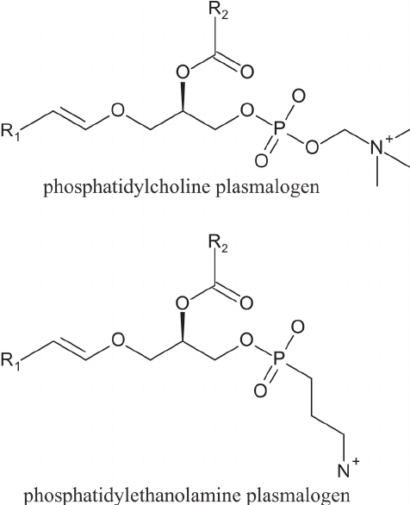

3. Differences between plasmalogen and Phosphoglyceride
Plasmalogen | Phosphoglyceride
Plasmalogen have an alkyl group attached to the first carbon of glycerol. The alkyl group is attached via an ether linkage to the glycerol. | These are the phospholipids that contain glycerol as an alcohol in their backbone.
No fatty acid is present | Fatty acid is present

