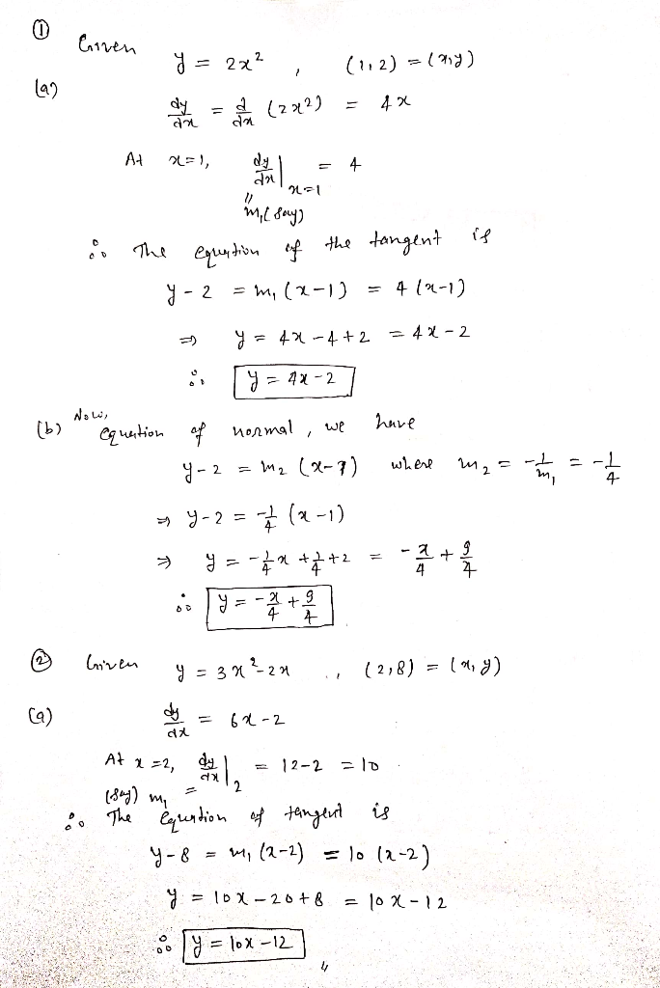
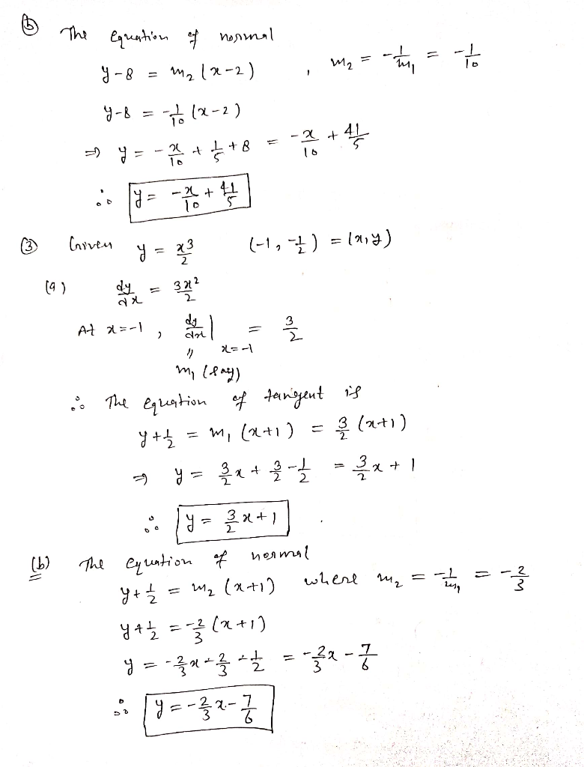

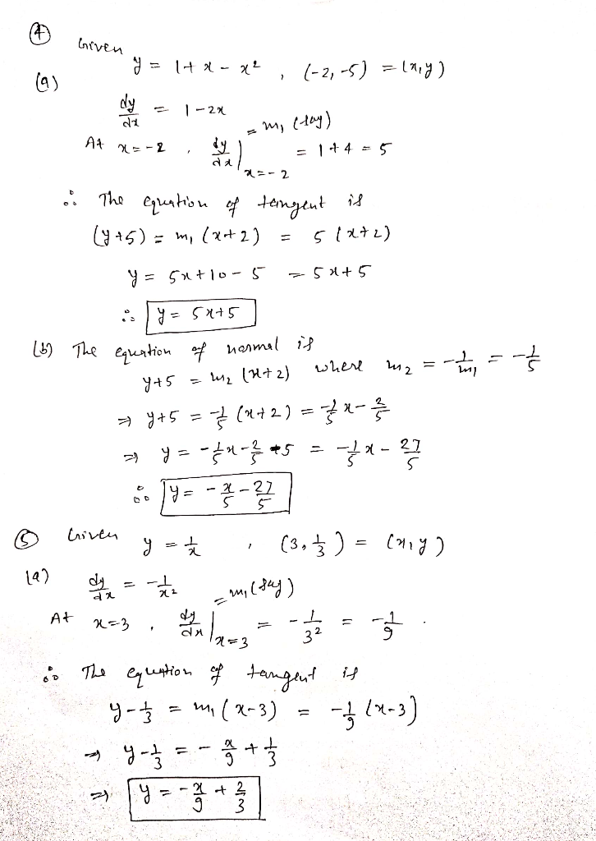
Matric Number: 19/MHS01/309
Student's Name: Okam Emmanuel Chijioke
Department: Medicine and Surgery
Level: 100

Assignment Title: Equation of tangent and normal. FOR MEDICINE STUDENT
Course Title: General Mathematics III
Course Code: MAT 104
Question
For the curves in Problem 1 to 5, at the points given, find (a) the equation of the tangent, and (b) the equation of the normal.
1. y = 2x² at the point (1,2)
2. y = 3x²- 2x at the point (2,8)
3. y = x³/2 at the point (-1,-1/2)
4. y = 1 + x - x² at the point (-2,-5)
5. y = 1/x at the point (3,1/3)

