NAME; NDIE OGOCHUKWU
MATRIC NUMBER : 17/MHS02/055
ASSIGNMENT TITLE: ASSIGNMENT 1
COURSE TITLE : CELLULAR PATHOLOGY
COURSE CODE : NSC 306
- Radiography is an imaging technique using X-RAYS, Gamma rays , or similar ionizing radiation and non-ionizing radiation to view the internal form of an object. Applications of radiography include medical radiography (there are two types "diagnostic" and "therapeutic") and industrial radiography similar techniques are used in airport security (where "body scanners" generally use backscatter X-rays). To create an image in conventional radiography, a beam of X-rays is produced by an X-ray generator and is projected toward the object. A certain amount of the X-rays or other radiation is absorbed by the object, dependent on the object's density and structural composition. The X-rays that pass through the object are captured behind the object by a detector (either photographic film or a digital detector). The generation of flat two dimensional images by this technique is called projectional radiography. In computed tomography (CT scanning) an X-ray source and its associated detectors rotate around the subject which itself moves through the conical X-ray beam produced. Any given point within the subject is crossed from many directions by many different beams at different times. Information regarding attenuation of these beams is collated and subjected to computation to generate two dimensional images in three planes (axial, coronal, and sagittal) which can be further processed to produce a three dimensional image.
Significant tests: screening tests, X-ray, CT, MRI, PET, bone scan, ultrasonography, mammography, fluoroscopy.
Significant diseases:
- Cancer.
- Trauma.
- General medical/surgical conditions.
- Cardiovascular disease.
- Musculoskeletal disease.
- Breast disease (benign and malignant)
- Medical and surgical subspecialties (includes GI, endocrine, rheumatologic, renal & pulmonary)
- Neurological disease including stroke.

Subdivisions
- Body Imaging.
- Breast Imaging.
- Cardiovascular and Thoracic Imaging.
- Interventional Neuroradiology.
- Musculoskeletal Radiology.
- Neuroradiology.
- Nuclear Medicine and PET Center.
- Pediatric Radiology.
- Nuclear medicine PET center .

Radiology specialists play an important role in the medical field. Their main task is to operate diagnostic equipment to produce radiographs. As a radiology specialist, your job is to supervise radiation procedures; you might use x-ray, computed tomography (CT), and/or magnetic resonance imaging (MRI) machines.

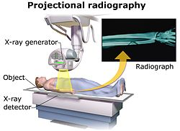

- URINALYSIS
Clinical urine tests are various tests of urine for diagnostic purposes. A urinalysis (UA) is one of the most common methods of medical diagnosis. The word is a portmanteau of the words urine and analysis. Other tests are urine culture (a microbiological culture of urine) and urine electrolyte levels.
There are three basic components to urinalysis: gross examination, chemical evaluation, and microscopic examination.
Gross examination targets parameters that can be measured or quantified with the naked eye (or other senses), including volume, color, transparency, odor, and specific gravity.
A part of a urinalysis can be performed by using urine test strips, in which the test results can be read as color changes. Another method is light microscopy of urine samples.

Types
When we refer to a urinalysis, we typically assume that to mean peeing in a cup at your doctor's office. In truth, that is just one of the ways urinalysis is performed in clinical practice.
A urinalysis may refer to:
- A complete urinalysis performed in a lab to assess the physical, chemical, and microscopic characteristics of your urine³﻿
- A rapid urinalysis performed at your doctor's office using test strips to routinely check for common renal abnormalities
- A 24-hour urine collection in which urine is collected over 24 hours to provide your doctor a clearer picture of your overall renal function, including output and composition⁴﻿
While a urine culture (in which a urine sample is placed in a growth medium to check for bacteria or fungi) is not technically a form of urinalysis, it may be an extension of the test if a UTI is suspected. It can even be performed using the same urine sample.

Purpose of Test
The urinary tract is composed of the kidneys, ureter, bladder, and urethra. Its primary role is to filter waste and regulate the balance of water, electrolytes, proteins, acids, and other substances in the body.
If any part of this system is damaged or impaired, it will alter the chemical composition and/or volume of urine. The urinalysis is a direct means of assessing these changes.
Methods urinalysis
There is either a routine urinalysis or a routine and microscopy (R&M) urinalysis, with the difference being a routine urinalysis does not include microscopy or culture.

Risks and Contraindications
A urinalysis is considered a safe and non-invasive form of testing. The only risk it may pose is for those who require catheterization to obtain a urine sample. A Foley catheter, a flexible tube inserted into the urethra to drain the bladder, is the most common type used in people with urinary retention, urinary incontinence, or other conditions that interfere with normal urination. The risks of urinary catheterization include infection, bleeding, pain, and bladder damage. 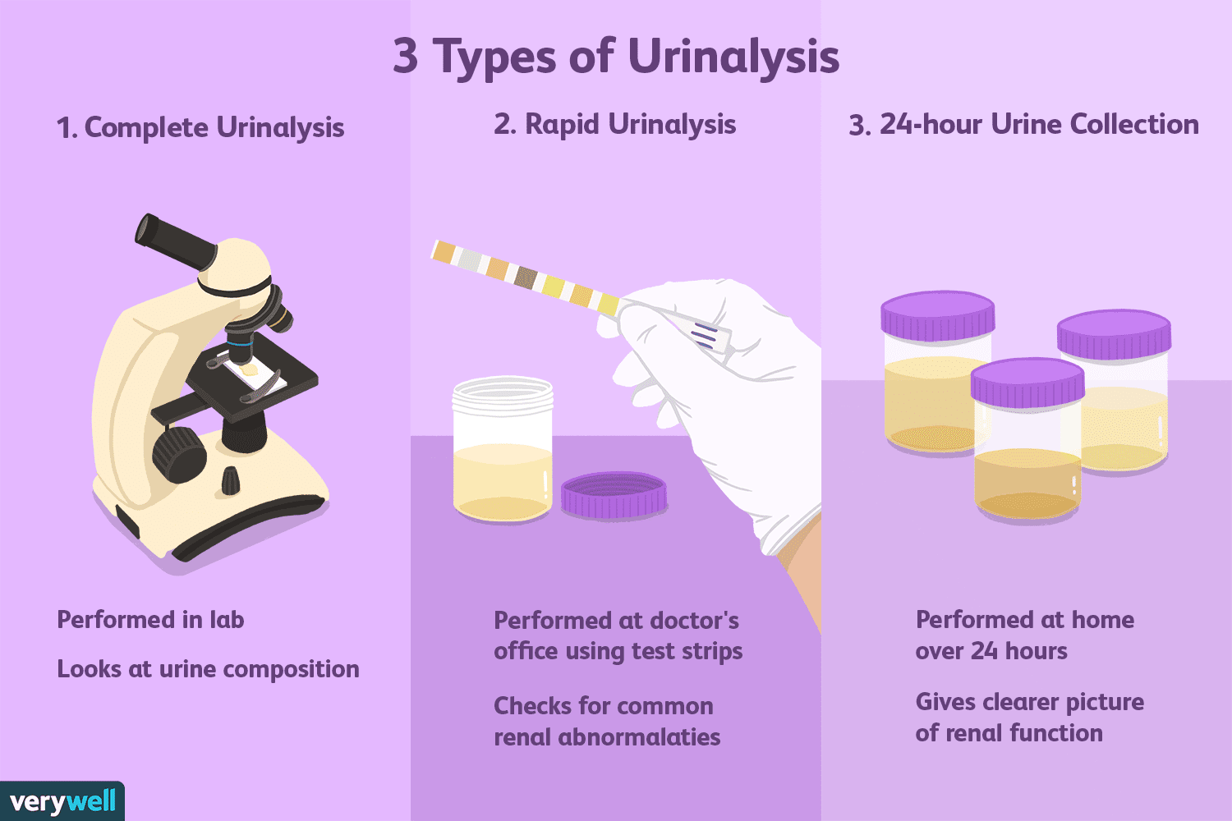

- MICROSCOPIC EXAMINATION OF TISSUES
Histopathology refers to the Microscopic examination of tissue in order to study the manifestations of disease. Specifically, in clinical medicine, histopathology refers to the examination of a biopsy or surgical specimen by pathology, after the specimen has been processed and histological sections have been placed onto glass slides. In contrast, cytopathology examines free cells or tissue micro-fragments (as "cell blocks").

COLLECTION OF TISSUES Histopathological examination of tissues starts with Surgery, biopsy, or autopsy. The tissue is removed from the body or plant, and then...often following expert dissection in the fresh state...placed in a fixative which stabilizes the tissues to prevent decay. The most common fixative is formalin (10% neutral buffered formaldehyde in water).

PREPARATION OF HISTOLOGY
The tissue is then prepared for viewing under a microscope using either chemical fixation or frozen section.
If a large sample is provided e.g. from a surgical procedure then a pathologist looks at the tissue sample and selects the part most likely to yield a useful and accurate diagnosis - this part is removed for examination in a process commonly known as grossing or cut up. Larger samples are cut to correctly situate their anatomical structures in the cassette. Certain specimens (especially biopsies) can undergo agar pre-embedding to assure correct tissue orientation in cassette & then in the block & then on the diagnostic microscopy slide. This is then placed into a plastic cassette for most of the rest of the process.
Chemical fixation
In addition to formalin, other chemical fixatives have been used. But, with the advent of Immunohistochemistry (IHC) staining and diagnostic molecular pathology testing on these specimen samples, formalin has become the standard chemical fixative in human diagnostic histopathology. Fixation times for very small specimens are shorter, and standards exist in human diagnostic histopathology
Processing
Water is removed from the sample in successive stages by the use of increasing concentrations of alcohol Xylene is used in the last dehydration phase instead of alcohol - this is because the wax used in the next stage is soluble in xylene where it is not in alcohol allowing wax to permeate (infiltrate) the specimen. This process is generally automated and done overnight. The wax infiltrated specimen is then transferred to an individual specimen embedding (usually metal) container. Finally, molten wax is introduced around the specimen in the container and cooled to solidification so as to embed it in the wax block. This process is needed to provide a properly oriented sample sturdy enough for obtaining a thin microtome section(s) for the slide.
Once the wax embedded block is finished, sections will be cut from it and usually placed to float on a waterbath surface which spreads the section out. This is usually done by hand and is a skilled job (histotechnologist) with the lab personnel making choices about which parts of the specimen microtome wax ribbon to place on slides. A number of slides will usually be prepared from different levels throughout the block. After this the thin section mounted slide is stained and a protective cover slip is mounted on it. For common stains, an automatic process is normally used; but rarely used stains are often done by hand.
Frozen section processing
The second method of histology processing is called frozen section processing. This is a highly technical scientific method performed by a trained histoscientist. In this method, the tissue is frozen and sliced thinly using a microtome mounted in a below-freezing refrigeration device called the cryostat. The thin frozen sections are mounted on a glass slide, fixed immediately & briefly in liquid fixative and stained using the similar staining techniques as traditional wax embedded sections. The advantages of this method are rapid processing time, less equipment requirement, and less need for ventilation in the laboratory. The disadvantage is the poor quality of the final slide. It is used in intra-operative pathology for determinations that might help in choosing the next step in surgery during that surgical session (for example, to preliminarily determine clearness of the resection margin of a tumor during surgery).

STAINING OF PROCESSED HISTOLOGY SLIDES
This can be done to slides processed by the chemical fixation or frozen section slides. To see the tissue under a microscope, the sections are stained with one or more pigments. The aim of staining is to reveal cellular components; counterstains are used to provide contrast.
The most commonly used stain in histopathology is a combination of hematoxylin and eosin (often abbreviated H&E). Hematoxylin is used to stain nuclei blue, while eosin stains cytoplasm and the extracellular connective tissue matrix pink. There are hundreds of various other techniques which have been used to selectively stain cells. Other compounds used to color tissue sections include safranin, oil red O, Congo red, silver salts and artificial dyes. Histochemistry refers to the science of using chemical reactions between laboratory chemicals and components within tissue. A commonly performed histochemical technique is the perls’ Prussian blue reaction, used to demonstrate iron deposits in diseases like Hemochromatosis.
Recently, antibodies have been used to stain particular proteins, lipids and carbohydrates. Called immunohistochemistry, this technique has greatly increased the ability to specifically identify categories of cells under a microscope. Other advanced techniques include in situ hybridization to identify specific DNA or RNA molecules. These antibody staining methods often require the use of frozen section histology. These procedures above are also carried out in the laboratory under scrutiny and precision by a trained specialist medical laboratory scientist (a histoscientist). Digital cameras are increasingly used to capture histopathological images.

INTERPRETATION
The histological slides are examined under a microscope by a Pathologist, a medically qualified specialist who has completed a recognized training program. This medical diagnosis is formulated as a pathology report describing the histological findings and the opinion of the pathologist. In the case of cancer, this represents the tissue diagnosis required for most treatment protocols. In the removal of cancer, the pathologist will indicate whether the surgical margine is cleared, or is involved (residual cancer is left behind). This is done using either the bread loafing or CCPDMA method of processing. Microscopic visual artifacts can potentially cause misdiagnosis of samples.
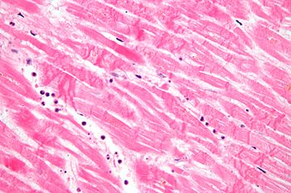
MICROGRAPH SHOWING CONTRACTION BAND NECROSIS A HISTOPATHOLOGIC FINDING MYOCARDIAL INFARCTION (HEART ATTACK).
- HAEMATOLOGICAL TESTS
Hematology is the study of blood and blood disorders. Hematologists and hematopathologists are highly trained healthcare providers who specialize in diseases of the blood and blood components. These include blood and bone marrow cells. Hematological tests can help diagnose anemia, infection, hemophilia, blood-clotting disorders, and leukemia.
HEMATOLOGY (hema- is from the Greek word for 'blood') is the study of blood in regards to a person's health or disease. It includes blood, blood-forming organs, and the proteins involved in bleeding and clotting.
Hematological tests can evaluate numerous conditions involving blood and its components. They can also be used to diagnose inflammation, anemia, infection, hemophilia, blood-clotting disorders, leukemia, and response to chemotherapy, among many other things. Let's take a look at some of these tests.
Common hematology tests
- White blood cell count (WBC)
- Red blood cell count (RBC)
- Platelet count.
- Hematocrit red blood cell volume (HCT)
- Hemoglobin concentration (HB). This is the oxygen-carrying protein in red blood cells.
- Differential white blood count.
- Red blood cell indices (measurements)
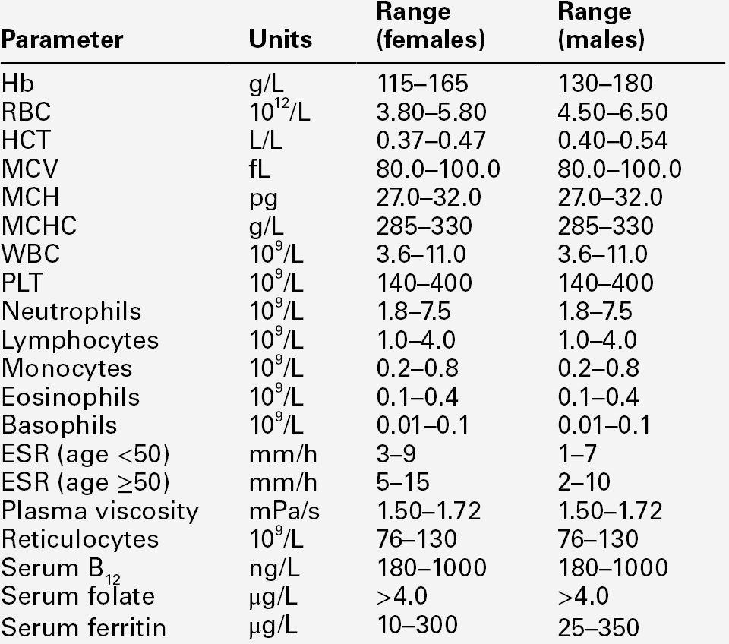

1. ANATOMICAL PATHOLOGY

Anatomical pathology or Anatomic pathology is a clinical claim to fame that is worried about the determination of sickness dependent on the plainly visible, tiny, biochemical, immunologic and atomic assessment of organs and tissues. In the course of the only remaining century, careful pathology has advanced hugely: from chronicled assessment of entire bodies (dissection) to an increasingly modernized practice, fixated on the determination and forecast of malignancy to direct treatment dynamic in oncology. Its cutting edge organizer was the Italian researcher Giovan Battista Morgagni from Forlì.

Anatomical pathology is one of two parts of pathology, the other being clinical pathology, the finding of ailment through the research center examination of natural liquids or tissues. Frequently, pathologists practice both anatomical and clinical pathology, a blend known as general pathology. Comparative fortes exist in veterinary pathology.

CONTRAST BETWEEN ANATOMICAL PATHOLOGY AND CLINICAL PATHOLOGY.

Anatomic pathology identifies with the preparing, assessment, and finding of careful examples by a doctor prepared in neurotic conclusion. Clinical pathology is the division that forms the test demands progressively recognizable to the overall population, for example, platelet checks, coagulation examines, urinalysis, blood glucose level conclusions and throat societies. Its subsections incorporate science, hematology, microbiology, immunology, urinalysis and blood donation center.

Anatomical pathology is itself partitioned in subspecialties, the principle ones being careful pathology (bosom, gynecological, endocrine, gastrointestinal, genitourinary, delicate tissue, head and neck, dermatopathology), neuropathology, hematopathology cytopathology, and legal pathology. To be authorized to rehearse pathology, one needs to finish clinical school and secure a permit to rehearse medication.

The procedures used in anatomic pathology include:

Gross examination – the examination of diseased tissues with the naked eye. This is important especially for large tissue fragments, because the disease can often be visually identified. It is also at this step that the pathologist selects areas that will be processed for histopathology. The eye can sometimes be aided with a magnifying glass or a stereo microscope, especially when examining parasitic organisms.
Histopathology – the microscopic examination of stained tissue sections using histological techniques. The standard stains are haematoxylin and eosin, but many others exist. The use of haematoxylin and eosin-stained slides to provide specific diagnoses based on morphology is considered to be the core skill of anatomic pathology. The science of staining tissues sections is called histochemistry.
Immunohistochemistry – the use of antibodies to detect the presence, abundance, and localization of specific proteins. This technique is critical to distinguishing between disorders with similar morphology, as well as characterizing the molecular properties of certain cancers.
In situ hybridization – Specific DNA and RNA molecules can be identified on sections using this technique. When the probe is labeled with fluorescent dye, the technique is called FISH.
Cytopathology – the examination of loose cells spread and stained on glass slides using cytology techniques
Electron microscopy – the examination of tissue with an electron microscope, which allows much greater magnification, enabling the visualization of organelles within the cells. Its use has been largely supplanted by immunohistochemistry, but it is still in common use for certain tasks, including the diagnosis of kidney disease and the identification of immotile cilia syndrome.
Tissue cytogenetics – the visualization of chromosomes to identify genetic defects such as chromosomal translocation
Flow immunophenotyping – the determination of the immunophenotype of cells using flow cytometry techniques. It is very useful to diagnose the different types of leukemia and lymphoma.

