NAME: AKINOLA MARVELLOUS OLUWANIFEMI
MATRIC NUMBER: 17/MHS02/016
DEPARTMENT: NURSING
COUSRE TITLE: CELLULAR PATHOLOGY
COURSE CODE: NSC 308

- Immunohistochemistry
Immunohistochemistry (IHC), the utilization of monoclonal and polyclonal antibodies for the detection of specific antigens in tissue sections, is an extraordinarily powerful tool in the armamentarium of the diagnostic surgical pathologist. IHC is an important application of monoclonal as well as polyclonal antibodies to determine the tissue distribution of an antigen of interest in health and disease. It is widely used for diagnosis of cancers because specific tumor antigens are expressed de novo or up-regulated in certain cancers. IHC plays an important role in pathology, particularly in the subspecialties of oncologic pathology, neuropathology, and hematopathology. Utilization studies are rare,[ but several authors have reviewed the diagnostic utility of IHC in surgical pathology. In autopsy pathology while basic histologic examination of tissue is considered a useful and necessary component IHC may provide a greater insight.
IHC requires the availability of biopsies; these are processed into sections with a microtome and then the sections are incubated with an appropriate antibody. The site of antibody binding is visualized under an ordinary or fluorescent microscope by a marker such as fluorescent dye, enzyme, radioactive element, or colloidal gold, which is directly linked to the primary antibody or to an appropriate secondary antibody.
Applications
Since IHC involves specific antigen–antibody reactions, it has apparent advantage over traditionally used special enzyme staining techniques that identify only a limited number of proteins, enzymes, and tissue structures. Therefore, IHC has become a crucial technique and is widely used in many medical research laboratories as well as clinical diagnostics.
- Flow cystometry
Flow cystometry is a laboratory method used to detect, identify, and count specific cells. This method can also identify particular components within cells. This information is based on physical characteristics and/or markers called antigens on the cell surface or within cells that are unique to that cell type. This method may be used to evaluate cells from blood ,bone marrow, body fluids such as cerebrospinal fluid(csf), or tumors.
How is it performed?
Flow cystometry involves several steps:
- A sample of cells is suspended in a fluid.
- Prior to testing and depending on the cells being analyzed, the sample may be treated with special dyes to further define cell sub-types. The dyes fluorochromes that are used are attached to monoclonal antibodies that bind to particular cells or key components of cells.
- The sample containing the cells passes through an instrument called a flow cytometer.
- In the instrument, the fluid in which the cells are suspended passes through very narrow channels so that the cells are organized in a single file as they pass the detector(s). This is accomplished at a high rate of speed (hundreds to thousands of cells per second.)
- The flow cystometer contains one or more lasers and a series of photo detectors that are able to identify certain characteristics unique to various cell types. The single-cell suspension creates unique light-scattering events that occur when each cell passes through the laser light. These initial events are characteristic of the size and shape of the cell, as well as the intensity of the signal that is generated by the specific dyes, thus creating patterns that reflect cell type.
- The signals from the detectors are amplified and sent to a computer. They are converted to digital read-outs displayed on a computer screen or in a printout.
- The data are usually displayed as graphs.

- Immunocytochemistry (ICC)
Immunocytochemistry (ICC) is a common laboratory technique that is used to anatomically visualize the localization of a specific protein or antigen in cells by use of a specific primary antibody that binds to it. The primary antibody allows visualization of the protein under a fluorescence microscope when it is bound by a secondary antibody that has a conjugated fluorophore. ICC allows researchers to evaluate whether or not cells in a particular sample express the antigen . In cases where an immunopositive signal is found, ICC also allows researchers to determine which sub-cellular compartments are expressing the antigen
- Electron microscope
Electron microscopy (EM) studies are conducted on cell cultures, tissues and body fluids. Both thin section and negative stain EM are available to assist in the diagnosis and characterization of pathogens. EM examination is conducted on glutaraldehyde fixed tissues or bodily fluids, formalin-fixed paraffin-embedded tissue blocks, prepared EM sections, images and grids.
Electron microscopes use shaped magnetic fields to form electron optical lens systems that are analogous to the glass lenses of an optical light microscope .
Electron microscopes are used to investigate the ultrastruture of a wide range of biological and inorganic specimens including microorganisms, cells, large molecules, biopsy samples, metals, and crystals. Industrially, electron microscopes are often used for quality control and failure analysis. Modern electron microscopes produce electron micrographs using specialized digital cameras and frame grabbers to capture the images.
Generally it can be stated that EM is of high value in the investigation of clinical specimens related to renal diseases (see above), tumor processes (especially for questions concerning the grade of differentiation of tumor cells), storage disorders and the identification of infectious agents
- Enzyme histochemistry
Enzyme histochemistry can be used in pathohistological routine diagnosis as it has simple technical requirements. Enzyme histotopochemical demonstration of acetyl cholinesterase activity in frozen colon mucosal biopsies has proven a reliable tool and is the current gold standard in the diagnosis of Hirschsprung disease today. In particular, in the diagnosis of ultrashort Hirschsprung disease and aganglionosis limited to the internal sphincter, the so-called sphincter achalasia, the acetyl cholinesterase reaction is the choice technique. Another attractive application of enzyme histochemistry is the verification of a per acute myocardial infarction during autopsy
Enzyme histochemistry serves as a link between biochemistry and morphology. It is based on metabolization of a substrate provided to a tissue enzyme in its orthotopic localization. Visualization is accomplished with an insoluble dye product. It is a sensitive dynamic technique that mirrors even early metabolic imbalance of a pathological tissue lesion, combined with the advantage of histotopographic enzyme localization

Question 2
The Normal Cell
Components of Normal Cells and Their Vulnerabilities

Cell Membranes
Cell membranes are a fluid phospholipids’ bilayer penetrated by numerous specific proteins . The two main biologic functions of these membranes are (l) to serve as selective barriers and (2) to form a structural base for the enzymes and receptors that determine cell function. Cell membranes form the boundaries of many organelles and separate them from the cytosol.
The plasma membrane is the cell’s first contact with injurious agents. Microvilli and cilia are specialized areas of the plasma membrane and are often specifically altered in disease . Plasma membranes separate the interior of the cell from external surfaces, neighboring cells, or surrounding matrix. Surface proteins, such as fibronectin, play a role in cell-to-cell and cell-to-ECM interactions. Transmembrane proteins embedded in the phospholipids bilayer serve in a variety of structural, transport, and enzymatic functions essential to cell viability . It is these transmembrane proteins that are often used by infectious microbes to enter or use cell systems during their life cycles, thus initiating a process that often results in injury to the host cell.
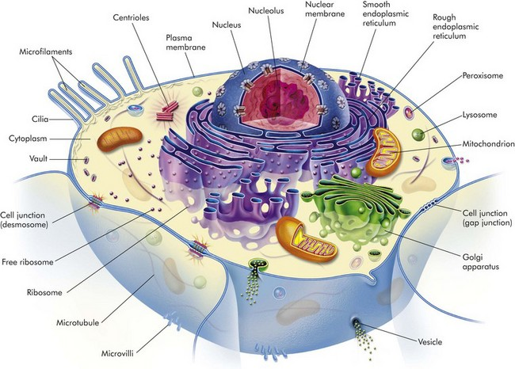
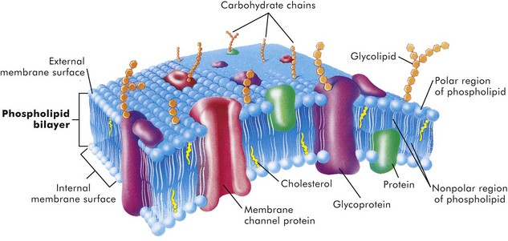
Cytosol
The cytosol is the watery gel in which the cell’s organelles and inclusions are dispersed. Many chemical reactions occur in the cytosol mediated by “free” enzymes or macromolecular complexes such as proteasomes. The cytosol is a highly organized microtrabecular network.
Mitochondria
Mitochondria (singular = mitochondrion) are the “powerhouses” of highly specialized eukaryotic cells. They are the site of fatty acid oxidation, the citric acid cycle, and oxidative phosphorylation. Transfer of electrons from reduced cytochrome oxidase to molecular oxygen is the final and critical step culminating in these catabolic pathways. Important structural components of a mitochondrion are the outer membrane, outer compartment, inner membrane, inner compartment (matrix), cristae, and mitochondrial DNA. Damage to mitochondria results in diminished adenosine triphosphate (ATP) production and if damage is unchecked, cell death .
Nucleus
The nucleus is that portion of the cell responsible for storage and transmission of genetic information . Chains of DNA, complexed to protein, are chromatin. Areas of uncoiled chromatin (euchromatin) are active in the generation of messenger RNA (mRNA) for protein synthesis. Highly coiled chromatin (heterochromatin) is inactive in transcription. The outer nuclear membrane is continuous with that of the rough endoplasmic reticulum (RER).
Nucleolus
The nucleolus is a basic organelle of the nucleus and is composed of RNA, nucleolus-associated chromatin, and protein . It functions in the synthesis of ribosomal RNA (rRNA), essential in protein synthesis. The nucleolus can be basophilic or eosinophilic, and its prominence is a subjective measure of the cell’s synthetic activity.
Rough Endoplasmic Reticulum
The RER is a network of intracellular membranes studded with ribosomes. RER is prominent in cells producing large amounts of extracellular protein (e.g., reactive fibroblasts, hepatocytes, plasma cells, and pancreatic acinar cells). The RER is responsible for the basophilia of the cytoplasm because of the numerous ribosomes, which contain acid (i.e., RNA).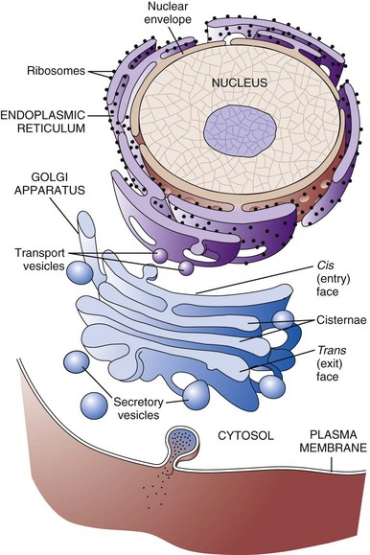
Smooth Endoplasmic Reticulum
Smooth endoplasmic reticulum (SER) is a tubular or vesicular form of cell membrane that lacks ribosome. SER is the locus of enzymes that metabolize steroids, drugs, lipids, and glycogen. It gives the cytoplasm a pale, finely vacuolated appearance as viewed in the light microscope.
Golgi Complex
The Golgi complex consists of several lamellar stacks or flattened sacs of membranes, vesicles, and vacuoles. It functions in the synthesis of complex proteins by the addition of carbohydrate molecules and in the production of secretory vesicles and lysosomes.
Lysosomes
Lysosomes are small membrane-bound vesicles laden with hydrolytic enzymes essential for intracellular digestion. They are discussed more completely as components of phagocytic cells. Peroxisomes are similar to lysosomes but also play a role in energy metabolism.
Microfilaments, Intermediate Filaments, and Microtubules
These structures are composed of protein subunits and function in the cytoskeleton and in cell movement. They have a prominent role in the mitotic spindle, cilia, microvilli, neurons, myocytes, and phagocytic cells. Many cell types besides muscles, for example, contain actin microfilaments.
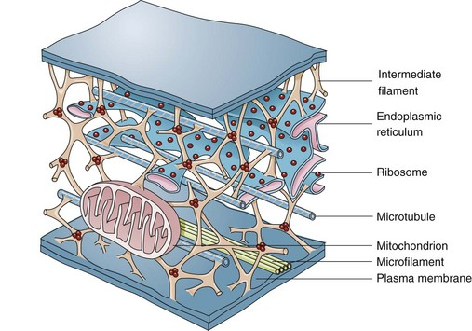

Intermediate filaments are about 10 nm in diameter and are important in cell shape and movement. Different cell types have different intermediate filaments; for example, cytokeratins are found in epithelial cells, desmin in muscle cells, and vimentin in cells of mesenchymal origin such as fibroblasts. Intermediate filaments can be useful markers for classifying undifferentiated neoplasms.
Cellular Inclusions
Inclusions include glycogen granules, proteinaceous vacuoles, lipid debris, hemosiderin, viral particles, and calcium granules. Some of these are normal, whereas others are the result of cell injury
Extracellular Matrix
Although not part of the cell itself, the ECM and its integrity influences cell health and function. ECM includes basement membranes and interstitial matrices composed of various collagens, proteoglycans, and adhesive glycoproteins among a variety of other molecules that interact with cells by means of various integrin molecules. Basement membrane integrity, for example, is essential for the proper structure and functioning of epithelial cells. Other components of the ECM influence how cells grow and differentiate.
Causes of Cell Injury
Causes of cell injury are numerous and can be classified in a variety of ways. Some causes, such as physical trauma, viruses, and toxins, are clearly extrinsic, whereas others, such as spontaneous genetic mutations, are clearly intrinsic. Others, such as workload imbalance, nutritional abnormalities, and immunologic dysfunctions, can have components of both extrinsic and intrinsic mechanisms. General mechanisms of injury include ATP depletion (often caused by hypoxia), membrane damage (a result of a myriad of causes, including oxygen-derived free radicals), disturbances of cellular metabolism, and genetic damage
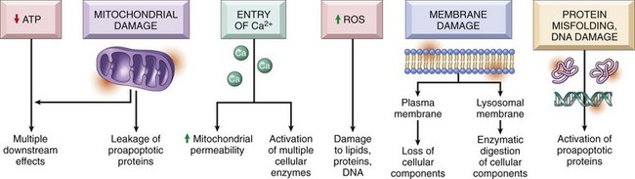

Understanding disease starts with understanding the cell. Until the nineteenth century, the dominant theory of disease in western societies was humoral pathology, wherein disease was attributed to a maldistribution of body fluids or “humors.” In the mid-1800s, Rudolph Virchow, a German pathologist now considered to be the founder of modern pathology, redefined pathology and medical science with his idea of the body as an organization of cells, each suited for specific functions. He taught that disease resulted from injury to, or dysfunction of, specific populations of cells. The recent rapid advancement in medical science is owed to a great extent to Virchow’s original emphasis on cellular pathology and more recently on molecular pathology.
Cells can be injured through a large number of causes (etiologic agents). Fortunately, the types of responses of the cell to injury are not as large. The responses to injury depend on many factors, including the type of agent, the extent of injury, the duration of injury, and the cell type affected. Renal tubular cells deprived of adequate blood supply, for example, may exhibit only cell swelling, if oxygen is soon restored. Prolonged lack of adequate blood supply (ischemia) can lead to cell death. Diminished but sublethal reduction in blood supply may result in cells adapting by decreasing their metabolic rates, which could lead to recovery or if adaptation is inadequate, eventually death. Cells respond to stimuli and stressors in a variety of ways to maintain homeostasis.
Cell injury takes place when a cell can no longer maintain a steady state. Some types of cell injury, such as cell swelling, can be reversible if the extent and duration of injury are not excessive. But if the injury exceeds certain limits, cell death and irreversible change occur. Not all cell injury results in cell death. Cell injury may be sublethal and result in a variety of types of cell degenerations or accumulations and/or adaptations by the cell to the injury. In essence, cells or tissues respond to injury (or stress) in three important ways: (l) adaptation, (2) degeneration or intracellular or extracellular accumulations, and (3) death
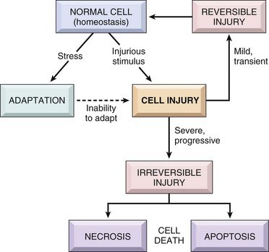
Pathologically, reversible cell injury is injury from which the cell can adapt or recover and thus return to normal or nearly normal function. Irreversible cell injury results in a dead cell. This distinction seems clear-cut, but the point at which a cell transitions from reversible cell injury to irreversible cell injury (i.e., “the point of no return”) has been a major research challenge for the past few decades and remains so today. The lesions of reversible and irreversible cell injury are discussed in greater detail in subsequent sections; however, in summary, the cytomorphologic changes characteristic of irreversible cell injury include the following:
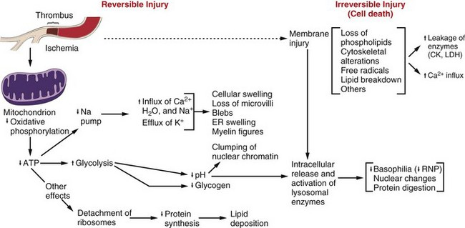
• Plasma membrane damage
• Calcium entry into the cell
• Mitochondrial swelling and vacuolization
• Amorphous densities (likely calcium) in the mitochondria
• Lysosomal swelling
The causes of reversible and irreversible cell injury resulting in cell death, cell adaptation and degeneration, and finally cellular accumulations are now discussed.
Oxygen Deficiency
Hypoxia is one of the most common and important causes of cell injury and death. Hypoxia is a partial reduction in the O2 concentration supplied to cells or tissue; a complete reduction is referred to as anoxia. Oxygen is critically important for oxidative phosphorylation, especially in highly specialized cells such as neurons, hepatocytes, cardiac myocytes, and renal tubule cells. Hypoxia can result from inadequate oxygenation of blood as a result of heart failure or respiratory failure, loss or reduction of blood supply (ischemia), reduced transport of O2 in blood (e.g., anemia or carbon monoxide toxicity), and blockage of cell respiratory enzymes (cyanide toxicosis).
Physical Agents
Trauma, extremes of heat and cold, radiation, and electrical energy may seriously injure cells. Trauma may cause direct rupture and death of large numbers of cells, or it may damage the blood supply to cells. Extreme cold impairs the blood flow, and intracellular ice crystals rupture cell membranes. Extreme heat denatures essential cell enzymes and other proteins. Excessive heat can increase the rate of metabolic reactions so that substrates, water, and pH changes reach lethal levels. Electricity generates great heat as it passes through tissue. It also alters conduction of nerves and muscle. Ionizing radiation causes ionization of cellular water with production of highly reactive “free radicals” that injure cell components. Many forms of radiation may damage genetic material, resulting in reproductive death of cells by apoptosis, genetic defects from mutations, and neoplasia.
Infectious Agents
Viruses are obligate intracellular parasites that redirect host cell enzyme systems toward synthesis of viral proteins and genetic materials to the detriment of host cells. Cell changes induced by viral agents vary from little effect to cell death or neoplastic transformation.
Injury caused by bacterial infection varies and can result from the action of potent toxins on specific host cells (clostridial infections, enterotoxigenic Escherichia coli infection) or from an overwhelming or ineffective inflammatory response to uncontrolled bacterial replication in tissue. Some bacteria, such as Lawsonia intracellularis, can result in excessive intestinal epithelial cell replication. Mycotic agents resist destruction by the body that can lead to progressive, chronic inflammatory disease with loss of normal host tissues. Protozoal agents replicate in specific host cells, often resulting in destruction of infected cells. Metazoan parasites cause inflammation, distort tissue, and use host nutrients.
Nutritional Deficiencies and Imbalances
Dietary protein-calorie deficiencies are seen sporadically in animals and humans (known as kwashiorkor). These deficiencies require metabolic adaptation by large populations of cells. Lipolysis, catabolism of muscle protein, and glycogenolysis enable short-term survival. Calorie excess, as seen in many pets and people of affluent societies, is implicated in cardiovascular disease and several other diseases. Vitamin and mineral imbalances are common due to errors in formulating rations and hypersupplementation by well-meaning animal owners.
Genetic Derangement
A normal genetic apparatus is essential for cell homeostasis. Mutations, whatever their origin, may cause no disease, may deprive a cell of a protein (enzyme) critical for normal function, may result in neoplasia, or may be incompatible with cell survival. A few examples of genetic diseases are defects of
clotting factors (hemophilia), lysosomal storage disease (mannosidosis), combined immunodeficiency of Arabian foals, and defects of collagen synthesis (dermatosparaxis). Besides causing overt disease, some genotypes cause the host to be more prone to certain types of extrinsic or intrinsic disease, a condition often termed genetic predisposition.
Workload Imbalance
Cells that are overworked may adapt to the demand or eventually become exhausted and die. Conversely, cells that are no longer stimulated to work may shrink in size and waste away. An example is the way endocrine tissues react to the presence or absence of specific trophic hormones. Muscle fibers deprived of work or their nerve supply will atrophy and ultimately disappear, leaving a fibrous stroma.
Chemicals, Drugs, and Toxins
Chemicals, drugs, and toxins influence cells by a multitude of mechanisms. Drugs produce their therapeutic effects by modifying the function (and morphology) of specific populations of cells. Most drugs cause these cells to adapt within a tolerable range of homeostasis. Chemicals, including drugs and toxins, can block or stimulate cell membrane receptors, alter specific enzyme systems, produce toxic free radicals, alter cell permeability, damage chromosomes, modify metabolic pathways, and damage structural components of cells.
Immunologic Dysfunction
The immune system may fail to respond to infectious agents and other antigens as a result of congenital or acquired defects of lymphoid tissue or their products. Examples of congenital defects are thymic aplasia of nude mice and combined immunodeficiency of Arabian foals. Affected animals may die at an early age from infection by opportunistic microorganisms. Acquired immunodeficiency disease may be transient and results from damage to lymphoid tissue by viral infection, chemicals, and drugs.
The immune response directed toward foreign antigens (pathogenic organisms) is usually beneficial to the host, but sometimes the response is misdirected against antigens of host cells. This large group of diseases is referred to as autoimmune disease. An inappropriate or exaggerated response to certain antigens results in immunologic disease referred to as hypersensitivity (allergy). Some examples are anaphylaxis, feline asthma, and flea allergy dermatitis. The activity of the immune system is greatly amplified by its effect on serum complement and inflammation. These reactions often lead to serious injury to the kidney, skin, and joints.
Aging
The diminished capacity of aged cells and tissue to carry out their normal functions can hardly be disputed. One can argue that aging is simply the culmination of life’s injuries inflicted by chemicals, infectious agents, work imbalances, or poor nutrition. We use the aging category for those lesions commonly found in aged animals; lesions for which we have no other defensible mechanistic explanation. Some of the lesions commonly found in older animals include nodular hyperplasia of parenchymal cells in the liver, pancreas, adrenal, spleen, and thyroid. There appear to be defects in growth control of these cell populations, but the cause is unclear. Aged cells may suffer a lifetime of damage to their DNA, or there may be accumulation of cellular debris that interferes with normal cell functions. One could argue that many cancers are caused by old age, rather than by exposure to specific chemicals, foods, viruses, or other insults.

