NAME: ADEJARE OLASUBOMI SOPHIA
MATRIC NO: 17\ MHS02\005

5 diagnostic techniques used in pathology, relevant illustrations and examples required.
1. HISTOPATHOLOGY
Histopathological examination of tissues starts with surgery, biopsy, or autopsy. The tissue is removed from the body or plant, and then...often following expert dissection in the fresh state...placed in a fixative which stabilizes the tissues to prevent decay. The most common fixative is formalin (10% neutral buffered formaldehyde in water).
Preparation of histology
The tissue is then prepared for viewing under a microscope using either chemical fixation or frozen section.
If a large sample is provided e.g. from a surgical procedure then a pathologist looks at the tissue sample and selects the part most likely to yield a useful and accurate diagnosis - this part is removed for examination in a process commonly known as grossing or cut up. Larger samples are cut to correctly situate their anatomical structures in the cassette. Certain specimens (especially biopsies) can undergo agar pre-embedding to assure correct tissue orientation in cassette & then in the block & then on the diagnostic microscopy slide. This is then placed into a plastic cassette for most of the rest of the process.
PROCESSING:

Water is removed from the sample in successive stages by the use of increasing concentrations of alcohol. Xylene is used in the last dehydration phase instead of alcohol - this is because the wax used in the next stage is soluble in xylene where it is not in alcohol allowing wax to permeate (infiltrate) the specimen. This process is generally automated and done overnight. The wax infiltrated specimen is then transferred to an individual specimen embedding (usually metal) container. Finally, molten wax is introduced around the specimen in the container and cooled to solidification so as to embed it in the wax block. This process is needed to provide a properly oriented sample sturdy enough for obtaining a thin microtome section(s) for the slide.
Once the wax embedded block is finished, sections will be cut from it and usually placed to float on a waterbath surface which spreads the section out. This is usually done by hand and is a skilled job (histotechnologist) with the lab personnel making choices about which parts of the specimen microtome wax ribbon to place on slides. A number of slides will usually be prepared from different levels throughout the block. After this the thin section mounted slide is stained and a protective cover slip is mounted on it. For common stains, an automatic process is normally used; but rarely used stains are often done by hand.
Examples: Study of human tissues.

2. IMMUNOHISTOCHEMISTRY
Immunohistochemistry (IHC) is the most common application of immunostaining. It involves the process of selectively identifying antigen (proteins) in cells of a tissue section by exploiting the principle of antibodies binding specifically to antigens in biological tissues. IHC takes its name from the roots "immuno", in reference to antibodies used in the procedure, and "histo", meaning tissue (compare to immunocytochemistry). Albert Coons conceptualized and first implemented the procedure in 1941.
Visualising an antibody-antigen interaction can be accomplished in a number of ways, mainly either of the following:
- Chromogenic immunohistochemistry (CIH), wherein an antibody is conjugated to an enzyme, such as peroxidase (the combination being termed immunoperoxidase), that can catalyse a colour-producing reaction.
- Immunofluorescence, where the antibody is tagged to a fluorophore, such as fluorescein or rhodamine.
Example: BrdU , cytokeratins
3. MOLECULAR AUTOPSY
Molecular autopsy or postmortem molecular testing is a set of molecular techniques used in forensic medicine to attempt to determine the cause of death in unexplained cases, in particular sudden unexplained deaths (for example sudden cardiac death). About 30% of sudden cardiac deaths in young people are not explained after full conventional autopsy, and are classified as sudden unexplained deaths. The use of a panel of genetic markers for long QT syndrome, catecholaminergic polymorphic ventricular tachycardia and cardiac channel miopathies elucidated around 40 to 45% of the cases
METHODS: When a traditional medical autopsy is not able to determine the sudden cause of death, molecular autopsy may help provide an alternative insight through the use of Deoxyribonucleic acid (DNA) sequencing. It looks at things from a cellular level instead of only what the human eye can see.
The first step in performing a molecular autopsy is to obtain a sample of blood or tissue from the individual after death has occurred. DNA is then extracted from the blood sample in order to undergo a process of genetic sequencing. Then, the DNA sequence is carefully analyzed to detect any gene mutations that may be a cause of sudden death. Initially, molecular autopsy focused on the direct DNA sequencing of four genes. However, recent advancements in sequencing technologies have made it possible to screen a large number of genes at once from a small sample of DNA through whole-exome sequencing (WES) in which the coding regions of all 22,000 genes are sequenced. This potentially allows the detection of genetic variants of genes related to all major diseases

4. MICROBIOLOGICAL EXAM
Microbiological examination plays an important role in the diagnosis and control of infectious disease. As such examination identifies micro-organisms likely to be involved in the disease and their susceptibility to chemotherapeutic agents, case-specific antimicrobial regimens can be made based on the results. However, results obtained with improper collection, poor technique, inappropriate transport and inadequate management of the specimen may contribute to misdiagnosis and inappropriate antimicrobial therapy.
Collection of Specimen
Clinical material for microbiological testing should be collected from a site representative of the active disease process. Sites of inflammation that are free of contaminating micro-flora are optimal. Since large numbers of micro-organisms reside in the human body, specimens often may be contaminated with indigenous micro-organisms that are not involved in the infection. To reduce this risk, any contact with surrounding tissues and fluids during collection must be avoided or minimized . In addition, avoid contamination of specimens with any micro-organisms colonizing the hospital environment and associated healthcare workers.
EXAMPLE: A homogenized sample of food

CELL ADAPTATION PRECEDES CELL DEATH
The early pathologists Morgagni and Bichat emphasized the importance of organs and tissues as the seat of disease. Virchow later focused on individual cells as the primary cause of abnormal function and structure associated with diseases. Before we can interpret lesions of sick cells, it is essential that we understand normal cell structure and function. The cell can be visualized simplistically as a membrane-enclosed compartment, subdivided into numerous smaller compartments (organelles) by membranes (Fig. 1-1). This vast interconnecting system of membrane-bound spaces is termed the cytocavitary network. The function of these organelles is largely determined by the type and quantity of specific enzymes associated with each membrane and in the cytoplasmic matrix.
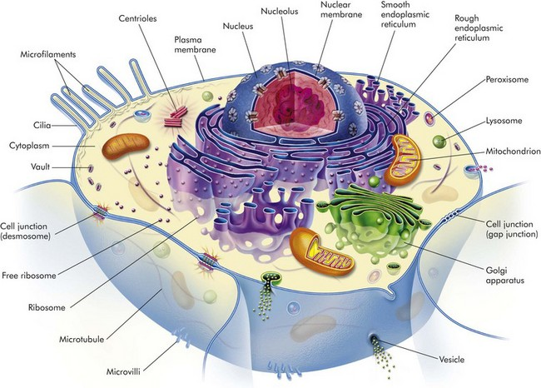
Fig. 1-1 Cell structure and the organization of organelles, cytoskeleton, and membrane enhancements. (From McCance K, Huether S: Pathophysiology: the biologic basis for disease in adults and children, ed 5, St Louis, 2006, Mosby.)
It is essential to have a clear understanding of the structure and function of the components of normal cells and how they are interrelated in a normally functioning cell. Cell membranes and organelles serve as targets for injury by microbes, harmful environmental agents, and a variety of genetic, metabolic, and toxicologic diseases discussed in greater detail in the Pathology of Organ Systems chapters of this book.
Cell Membranes
Cell membranes are a fluid phospholipid bilayer penetrated by numerous specific proteins (Fig. 1-2). The two main biologic functions of these membranes are (l) to serve as selective barriers and (2) to form a structural base for the enzymes and receptors that determine cell function. Cell membranes form the boundaries of many organelles and separate them from the cytosol.
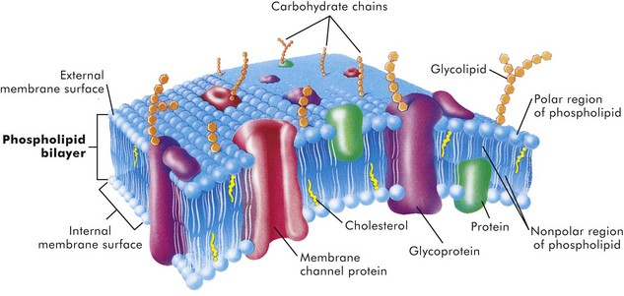
Fig. 1-2 Fluid mosaic model of cell membrane structure.The lipid bilayer provides the basic structure and serves as a relatively impermeable barrier to most water-soluble molecules. (From McCance K, Huether S: Pathophysiology: the biologic basis for disease in adults and children, ed 4, St Louis, 2002, Mosby.)
The plasma membrane is the cell’s first contact with injurious agents. Microvilli and cilia are specialized areas of the plasma membrane and are often specifically altered in disease (see Fig. 1-1). Plasma membranes separate the interior of the cell from external surfaces, neighboring cells, or surrounding matrix. Surface proteins, such as fibronectin, play a role in cell-to-cell and cell-to-ECM interactions. Transmembrane proteins embedded in the phospholipid bilayer serve in a variety of structural, transport, and enzymatic functions essential to cell viability (Fig. 1-3). It is these transmembrane proteins that are often used by infectious microbes to enter or use cell systems during their life cycles, thus initiating a process that often results in injury to the host cell.
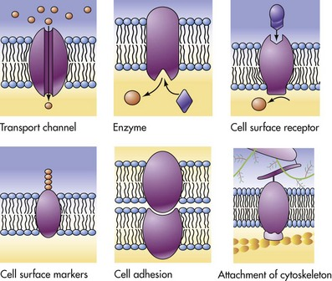
Fig. 1-3 Functions of transmembrane proteins.A variety of functions are performed by different types of cell membranes as shown. (From McCance K, Huether S: Pathophysiology: the biologic basis for disease in adults and children, ed 5, St Louis, 2006, Mosby.)
Cytosol
The cytosol is the watery gel in which the cell’s organelles and inclusions are dispersed. Many chemical reactions occur in the cytosol mediated by “free” enzymes or macromolecular complexes such as proteasomes. The cytosol is a highly organized microtrabecular network.
Mitochondria
Mitochondria (singular = mitochondrion) are the “powerhouses” of highly specialized eukaryotic cells. They are the site of fatty acid oxidation, the citric acid cycle, and oxidative phosphorylation. Transfer of electrons from reduced cytochrome oxidase to molecular oxygen is the final and critical step culminating in these catabolic pathways. Important structural components of a mitochondrion are the outer membrane, outer compartment, inner membrane, inner compartment (matrix), cristae, and mitochondrial DNA. Damage to mitochondria results in diminished adenosine triphosphate (ATP) production and if damage is unchecked, cell death (see Fig. 1-6).
Nucleus
The nucleus is that portion of the cell responsible for storage and transmission of genetic information (see Fig. 1-1). Chains of DNA, complexed to protein, are chromatin. Areas of uncoiled chromatin (euchromatin) are active in the generation of messenger RNA (mRNA) for protein synthesis. Highly coiled chromatin (heterochromatin) is inactive in transcription. The outer nuclear membrane is continuous with that of the rough endoplasmic reticulum (RER).
Nucleolus
The nucleolus is a basic organelle of the nucleus and is composed of RNA, nucleolus-associated chromatin, and protein (see Fig. 1-1). It functions in the synthesis of ribosomal RNA (rRNA), essential in protein synthesis. The nucleolus can be basophilic or eosinophilic, and its prominence is a subjective measure of the cell’s synthetic activity.
Rough Endoplasmic Reticulum
The RER is a network of intracellular membranes studded with ribosomes (Fig. 1-4). RER is prominent in cells producing large amounts of extracellular protein (e.g., reactive fibroblasts, hepatocytes, plasma cells, and pancreatic acinar cells). The RER is responsible for the basophilia of the cytoplasm because of the numerous ribosomes, which contain acid (i.e., RNA).
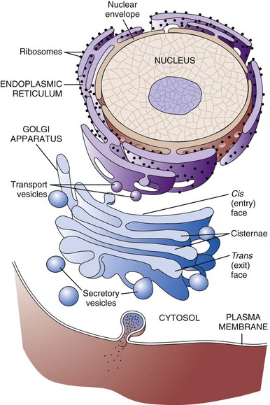
Fig. 1-4 Membrane systems.The rough endoplasmic reticulum and Golgi apparatus are important organelles in cellular biosynthesis of proteins and glycoproteins inserted into cell membranes and used in and secreted from cells. Transcription, translation, assembly, modification, and packaging of these molecules occur in an orderly sequence from the nucleus to the cell membrane as shown. Alterations in one or more of these steps can result in cell injury and serve as the underlying pathogenesis of a disease process. (From Copstead L, Banasik J: Pathophysiology, ed 4, St Louis, 2010, Mosby.)
Smooth Endoplasmic Reticulum
Smooth endoplasmic reticulum (SER) is a tubular or vesicular form of cell membrane that lacks ribosomes (see Fig. 1-1). SER is the locus of enzymes that metabolize steroids, drugs, lipids, and glycogen. It gives the cytoplasm a pale, finely vacuolated appearance as viewed in the light microscope.
Golgi Complex
The Golgi complex consists of several lamellar stacks or flattened sacs of membranes, vesicles, and vacuoles (see Fig. 1-4). It functions in the synthesis of complex proteins by the addition of carbohydrate molecules and in the production of secretory vesicles and lysosomes.
Lysosomes
Lysosomes are small membrane-bound vesicles laden with hydrolytic enzymes essential for intracellular digestion (see Fig. 1-1). They are discussed more completely as components of phagocytic cells. Peroxisomes are similar to lysosomes but also play a role in energy metabolism.
Microfilaments, Intermediate Filaments, and Microtubules
These structures are composed of protein subunits and function in the cytoskeleton and in cell movement (Fig. 1-5). They have a prominent role in the mitotic spindle, cilia, microvilli, neurons, myocytes, and phagocytic cells. Many cell types besides muscles, for example, contain actin microfilaments.
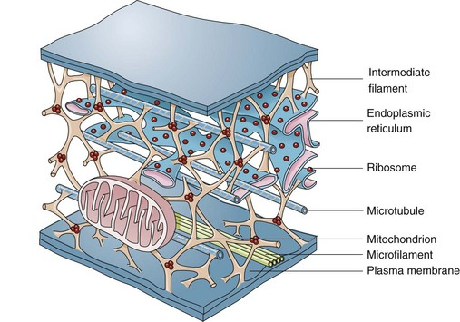
Fig. 1-5 Cytoskeleton.The complexity of and interrelations between intermediate filaments, microtubules, endoplasmic reticulum, and other cytoplasmic organelles that can be involved in the pathogenesis of diseases are shown. (From McCance KL, Huether SE: Pathophysiology: the biologic basis for disease in adults and children, ed 5, St Louis, 2006, Mosby.)
Intermediate filaments are about 10 nm in diameter and are important in cell shape and movement. Different cell types have different intermediate filaments; for example, cytokeratins are found in epithelial cells, desmin in muscle cells, and vimentin in cells of mesenchymal origin such as fibroblasts. Intermediate filaments can be useful markers for classifying undifferentiated neoplasms.
Cellular Inclusions
Inclusions include glycogen granules, proteinaceous vacuoles, lipid debris, hemosiderin, viral particles, and calcium granules (discussed in greater detail later in this chapter). Some of these are normal, whereas others are the result of cell injury and are discussed later in this chapter in the section dealing with intracellular and extracellular accumulations.
Extracellular Matrix
Although not part of the cell itself, the ECM and its integrity influences cell health and function (see Chapter 3 and Web Figs. 3-23 and 3-24). ECM includes basement membranes and interstitial matrices composed of various collagens, proteoglycans, and adhesive glycoproteins among a variety of other molecules that interact with cells by means of various integrin molecules. Basement membrane integrity, for example, is essential for the proper structure and functioning of epithelial cells. Other components of the ECM influence how cells grow and differentiate.
Causes of Cell Injury
Causes of cell injury are numerous and can be classified in a variety of ways. Some causes, such as physical trauma, viruses, and toxins, are clearly extrinsic, whereas others, such as spontaneous genetic mutations, are clearly intrinsic. Others, such as workload imbalance, nutritional abnormalities, and immunologic dysfunctions, can have components of both extrinsic and intrinsic mechanisms. General mechanisms of injury include ATP depletion (often caused by hypoxia), membrane damage (a result of a myriad of causes, including oxygen-derived free radicals), disturbances of cellular metabolism, and genetic damage (Fig. 1-6).
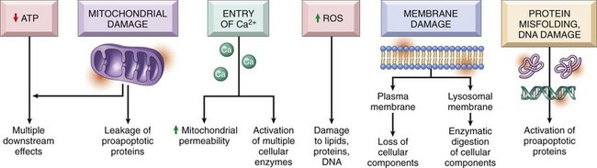
Fig. 1-6 Cellular and biochemical sites of damage in cell injury.ATP, Adenosine triphosphate; ROS, reactive oxygen species. (From Kumar V, Abbas A, Fausto N, et al: Robbins & Cotran pathologic basis of disease, ed 8, Philadelphia, 2009, Saunders.)
Understanding disease starts with understanding the cell. Until the nineteenth century, the dominant theory of disease in western societies was humoral pathology, wherein disease was attributed to a maldistribution of body fluids or “humors.” In the mid-1800s, Rudolph Virchow, a German pathologist now considered to be the founder of modern pathology, redefined pathology and medical science with his idea of the body as an organization of cells, each suited for specific functions. He taught that disease resulted from injury to, or dysfunction of, specific populations of cells. The recent rapid advancement in medical science is owed to a great extent to Virchow’s original emphasis on cellular pathology and more recently on molecular pathology.
Cells can be injured through a large number of causes (etiologic agents). Fortunately, the types of responses of the cell to injury are not as large. The responses to injury depend on many factors, including the type of agent, the extent of injury, the duration of injury, and the cell type affected. Renal tubular cells deprived of adequate blood supply, for example, may exhibit only cell swelling, if oxygen is soon restored. Prolonged lack of adequate blood supply (ischemia) can lead to cell death. Diminished but sublethal reduction in blood supply may result in cells adapting by decreasing their metabolic rates, which could lead to recovery or if adaptation is inadequate, eventually death.
Cells respond to stimuli and stressors in a variety of ways to maintain homeostasis. Cell injury takes place when a cell can no longer maintain a steady state. Some types of cell injury, such as cell swelling, can be reversible if the extent and duration of injury are not excessive. But if the injury exceeds certain limits, cell death and irreversible change occur. Not all cell injury results in cell death. Cell injury may be sublethal and result in a variety of types of cell degenerations or accumulations and/or adaptations by the cell to the injury. In essence, cells or tissues respond to injury (or stress) in three important ways: (l) adaptation, (2) degeneration or intracellular or extracellular accumulations, and (3) death (Fig. 1-7).
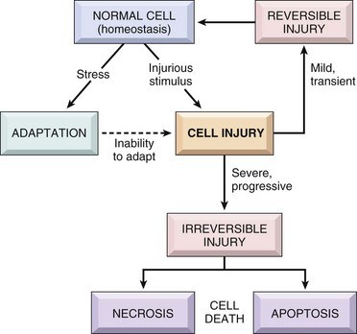
Fig. 1-7 Stages in the cellular response to stress and injurious stimuli. (From Kumar V, Abbas A, Fausto N, et al: Robbins & Cotran pathologic basis of disease, ed 8, Philadelphia, 2009, Saunders.)
Pathologically, reversible cell injury is injury from which the cell can adapt or recover and thus return to normal or nearly normal function. Irreversible cell injury results in a dead cell. This distinction seems clear-cut, but the point at which a cell transitions from reversible cell injury to irreversible cell injury (i.e., “the point of no return”) has been a major research challenge for the past few decades and remains so today (Fig. 1-8). The lesions of reversible and irreversible cell injury are discussed in greater detail in subsequent sections; however, in summary, the cytomorphologic changes characteristic of irreversible cell injury include the following:
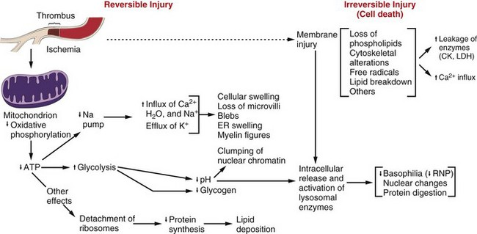
Fig. 1-8 Postulated sequence of events in reversible and irreversible ischemic cell injury.Note that although reduced oxidative phosphorylation and adenosine triphosphate (ATP) levels have a central role, ischemia can cause direct membrane damage. ER, Endoplasmic reticulum; CK, creatine kinase; LDH, lactate dehydrogenase; RNP, ribonucleoprotein. (From Kumar V, Abbas A, Fausto N: Robbins & Cotran pathologic basis of disease, ed 7, Philadelphia, 2005, Saunders.)
• Plasma membrane damage
• Calcium entry into the cell
• Mitochondrial swelling and vacuolization
• Amorphous densities (likely calcium) in the mitochondria
• Lysosomal swelling
The causes of reversible and irreversible cell injury resulting in cell death, cell adaptation and degeneration, and finally cellular accumulations are now discussed.
Oxygen Deficiency
Hypoxia is one of the most common and important causes of cell injury and death (see Fig. 1-8). Hypoxia is a partial reduction in the O₂ concentration supplied to cells or tissue; a complete reduction is referred to as anoxia. Oxygen is critically important for oxidative phosphorylation, especially in highly specialized cells such as neurons, hepatocytes, cardiac myocytes, and renal tubule cells. Hypoxia can result from inadequate oxygenation of blood as a result of heart failure or respiratory failure, loss or reduction of blood supply (ischemia), reduced transport of O₂ in blood (e.g., anemia or carbon monoxide toxicity), and blockage of cell respiratory enzymes (cyanide toxicosis).
Physical Agents
Trauma, extremes of heat and cold, radiation, and electrical energy may seriously injure cells. Trauma may cause direct rupture and death of large numbers of cells, or it may damage the blood supply to cells. Extreme cold impairs the blood flow, and intracellular ice crystals rupture cell membranes. Extreme heat denatures essential cell enzymes and other proteins. Excessive heat can increase the rate of metabolic reactions so that substrates, water, and pH changes reach lethal levels. Electricity generates great heat as it passes through tissue. It also alters conduction of nerves and muscle. Ionizing radiation causes ionization of cellular water with production of highly reactive “free radicals” that injure cell components. Many forms of radiation may damage genetic material, resulting in reproductive death of cells by apoptosis, genetic defects from mutations, and neoplasia.
Infectious Agents
Viruses are obligate intracellular parasites that redirect host cell enzyme systems toward synthesis of viral proteins and genetic materials to the detriment of host cells. Cell changes induced by viral agents vary from little effect to cell death or neoplastic transformation.
Injury caused by bacterial infection varies and can result from the action of potent toxins on specific host cells (clostridial infections, enterotoxigenic Escherichia coli infection) or from an overwhelming or ineffective inflammatory response to uncontrolled bacterial replication in tissue. Some bacteria, such as Lawsonia intracellularis, can result in excessive intestinal epithelial cell replication.
Mycotic agents resist destruction by the body that can lead to progressive, chronic inflammatory disease with loss of normal host tissues. Protozoal agents replicate in specific host cells, often resulting in destruction of infected cells. Metazoan parasites cause inflammation, distort tissue, and use host nutrient

Cells that are overworked may adapt to the demand or eventually become exhausted and die. Conversely, cells that are no longer stimulated to work may shrink in size and waste away. An example is the way endocrine tissues react to the presence or absence of specific trophic hormones. Muscle fibers, deprived of work or their nerve supply, will atrophy and ultimately disappear, leaving a fibrous stroma.
Chemicals, Drugs, and Toxins
Chemicals, drugs, and toxins influence cells by a multitude of mechanisms. Drugs produce their therapeutic effects by modifying the function (and morphology) of specific populations of cells. Most drugs cause these cells to adapt within a tolerable range of homeostasis. Chemicals, including drugs and toxins, can block or stimulate cell membrane receptors, alter specific enzyme systems, produce toxic free radicals, alter cell permeability, damage chromosomes, modify metabolic pathways, and damage structural components of cells.
Immunologic Dysfunction
The immune system may fail to respond to infectious agents and other antigens as a result of congenital or acquired defects of lymphoid tissue or their products (see Chapter 5). Examples of congenital defects are thymic aplasia of nude mice and combined immunodeficiency of Arabian foals. Affected animals may die at an early age from infection by opportunistic microorganisms. Acquired immunodeficiency disease may be transient and results from damage to lymphoid tissue by viral infection, chemicals, and drugs.
The immune response directed toward foreign antigens (pathogenic organisms) is usually beneficial to the host, but sometimes the response is misdirected against antigens of host cells. This large group of diseases is referred to as autoimmune disease. An inappropriate or exaggerated response to certain antigens results in immunologic disease referred to as hypersensitivity (allergy). Some examples are anaphylaxis, feline asthma, and flea allergy dermatitis. The activity of the immune system is greatly amplified by its effect on serum complement and inflammation. These reactions often lead to serious injury to the kidney, skin, and joints.
Aging
The diminished capacity of aged cells and tissue to carry out their normal functions can hardly be disputed. One can argue that aging is simply the culmination of life’s injuries inflicted by chemicals, infectious agents, work imbalances, or poor nutrition. We use the aging category for those lesions commonly found in aged animals; lesions for which we have no other defensible mechanistic explanation. Some of the lesions commonly found in older animals include nodular hyperplasia of parenchymal cells in the liver, pancreas, adrenal, spleen, and thyroid. There appear to be defects in growth control of these cell populations, but the cause is unclear. Aged cells may suffer a lifetime of damage to their DNA, or there may be accumulation of cellular debris that interferes with normal cell functions. One could argue that many cancers are caused by old age, rather than by exposure to specific chemicals, foods, viruses, or other insults.

