MGBEZE EMMANUEL CHUKWUWEIKE
15/ENG05/013

1. Single Phase Half Wave Controlled Rectifier
In a Single-Phase Half Wave Controlled Rectifier, the primary of transformer is connected to AC mains supply with which SCR becomes forward bias in positive half cycle. T is triggered at ana angle and conducts then voltage is applied across R. Single Phase Half Wave Controlled Rectifier, as the name suggests, is a rectifier circuit which converts AC input into DC output only for positive half cycle of the AC input supply. The word “controlled” means that, we can change the starting point of load current by controlling the firing angle of SCR. These words might seem a lot technical. But firing of SCR simply means, the SCR turn ON at certain point of time when it is forward biased.
A Single-Phase Half Wave Controlled Rectifier circuit consists of SCR / thyristor, an AC voltage source and load. The load may be purely resistive, Inductive or a combination of resistance and inductance. For simplicity, we will consider a resistive load. A simple circuit diagram of Single-Phase Half Wave Controlled Rectifier is shown in figure below.
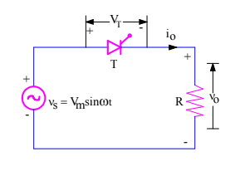
v₀ = Load output voltage
i₀ = Load current
V_{T} = Voltage across the thyristor T
I_{o}=V_{o}/R
As t conducts only in positive half cycle as it is reverse bias in negative cycle, the ripple frequency of the output voltage is friplle =50 Hz(supply frequency)
Average output voltage is given as V_{o}(Avg)=1/Tʃ^{T}_{o} V_{o} (wt) dwt

2. Single phase Full Wave controlled Rectifier using a center tapped transformer
The single phase fully controlled rectifier allows conversion of single-phase AC into DC. Normally this is used in various applications such as battery charging, speed control of DC motors and front end of UPS (Uninterruptible Power Supply) and SMPS (Switched Mode Power Supply).
• All four devices used are thyristors. The turn-on instants of these devices are dependent on the firing signals that are given. Turn-off happens when the current through the device reaches zero and it is reverse biased at least for duration equal to the turn-off time of the device specified in the data sheet.

When an additional wire is connected across the exact middle of the secondary winding of a transformer, it is known as a center tapped transformer. The full-wave rectifier circuit using two diodes and a centre-tapped transformer shown in Figure 1-1. The center-tap is usually taken as the ground or zero voltage reference point.
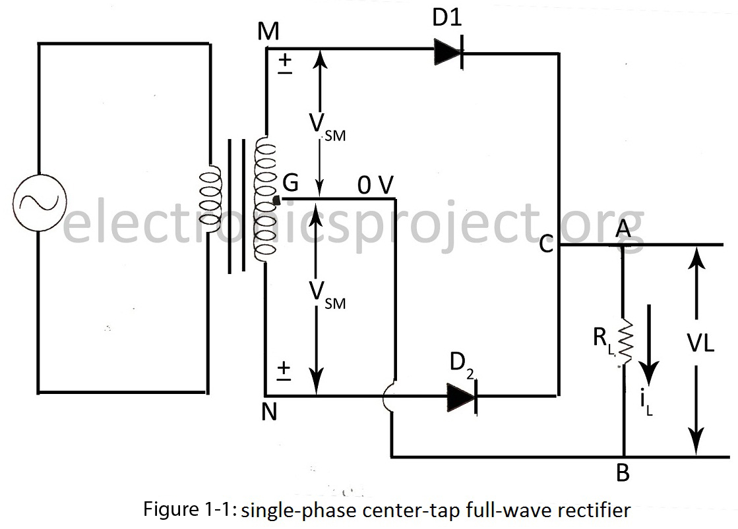
When input ac supply is switched on, the ends M and N of the transformer secondary become +ve and -ve alternately. During the positive half-cycle of the ac input, terminal M is +ve, G is at zero potential and N is at –ve potential. Hence, being forward-biased, diode D₁ conducts (but not D₂ which is reversed-biased) and current flows along MD₁CABG. As a result, positive half-cycle of the voltage appears across R_{L}.
During the negative half-cycle, when the terminal N becomes +ve, then D₂ conducts (but not D₁) and current flows along ND₂CABG. So, we find that the current keeps on flowing through R_{L} in the same direction (i.e. from A to B) in both half-cycles of ac input. It means that both half-cycles of the input ac supply are utilized as shown in figure 1-2. Also, the frequency of the rectified output voltage is twice the supply frequency. Of course, this rectified output consists of a dc component and many ac components of diminishing amplitudes.
3. Single phase Full wave Rectifier (Semi -converter Bridge configuration)
The bridge rectifier is a circuit, which converts an ac voltage to dc voltage using both half cycles of the input ac voltage. The circuit has four diodes connected to form a bridge. The ac input voltage is applied to diagonally opposite ends of the bridge.
The disadvantage of the bridge circuit is that four diodes are needed and their power-dissipating voltage drops are always in series with the load, this will reduce the power delivered to the lead.
In a single-phase, half-controlled bridge converter, two of the bridge arm thyristors are diodes. A third, freewheeling, diode is normally used to prevent the load current from circulating through two devices in a bridge arm. Note that the output voltage for this converter cannot become negative, because whenever it tends to do so, the load current commutates to the freewheeling diode and the output voltage becomes zero. The input AC source is then relieved from supplying the lagging component of the load current. The absence of this lagging component of the source current implies that this converter operates with a higher power factor than the fully controlled converter.

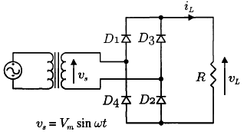
4. Three phase full wave Rectifier (semi-converter Bridge configuration)
Most industrial power supplies for motor drives and welding applications use three-phase ac voltage. This means that the rectifier for these circuits must use a three-phase bridge, which has six diodes to provide full-wave rectification (two diodes for each line of the three phases). Fig. 1 shows the electrical diagram for a three-phase bridge rectifier. From this diagram, notice that the secondary winding of a three-phase transformer is shown connected to the diode rectifier. Phase A of the three-phase voltage from the transformer is connected to the point where the cathode of diode 1D is connected to the anode of diode 2D. Phase B is connected to the point where the cathode of diode 3D is connected to the anode of diode 4D, and phase C is connected to the point where the cathode of diode 5D is connected to the anode of diode 6D. The anodes of diodes 1D, 3D, and 5D are connected together to provide a common point for the dc negative terminal of the output power. The cathodes of diodes 2D, 4D, and 6D are connected to provide a common point for the dc positive terminal of the output power.
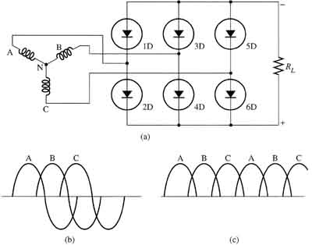
Above: Fig. 1 (a) Electronic schematic of the three-phase bridge rectifier that is connected to the secondary winding of a three-phase transformer. (b) Three-phase input sine waves. (c) Six half-waves for the dc output.
A good rule-of-thumb for determining the connections on diode rectifiers is that the ac input voltage will be connected to the bridge where the anode and cathode of any two diodes are joined. Since this occurs at two points in the bridge, in a four diode bridge the two ac lines will be connected there without respect to polarity since the incoming ac voltage does not have a specific polarity. The positive terminal for the power supply will be connected to the bridge where the two cathodes of the diodes are joined, and the negative terminal will be connected to the bridge where the two anodes of the diodes are joined.
This diagram also shows the waveforms for the three-phase sine waves that supply power to the bridge, and for the six half-waves of the output pulsing dc voltage. Notice that since the six half-waves overlap, the dc voltage does not have a chance to get to the zero-voltage point; thus, the average dc output voltage is very high.
The three-phase full-wave bridge rectifier is used where the required amount of dc power is high and the transformer efficiency must be high. Since the output waveforms of the half-waves overlap, they provide a low ripple percentage. In this circuit, the output ripple is six times the input frequency. Since the ripple percentage is low, the output dc voltage is usable without much filtering. This type of rectifier is compatible with transformers that are wye or delta connected.

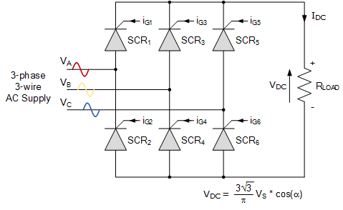
Three-phase rectification is the process of converting a 3-phase AC supply into a pulsating DC voltage as rectification converts the input power supply of a sinusoidal voltage and frequency into a fixed voltage DC power. Thus power rectification changes an alternating supply into a unidirectional supply.
But we have also seen that 3-phase half-wave uncontrolled rectifiers, which use one diode per phase, require a star connected supply as a fourth neutral (N) wire to close the circuit from load to source. The 3-phase full-wave bridge rectifier which use two diodes per phase requires just three mains lines, without neutral, such as that provided by a delta connected supply.
Another advantage of a full-wave bridge rectifier is that the load current is well balanced across the bridge improving efficiency (the ratio of output DC power to input power supplied) and reducing the ripple content, both in amplitude and frequency, as compared to the half-wave configuration.
By increasing the number of phases and diodes within the bridge configuration it is possible to obtain a higher average DC output voltage with less ripple amplitude as for example, in 6-phase rectification each diode would conduct for only one-sixth of a cycle

5. Single phase full wave Rectifier (Full converter Bridge configuration)
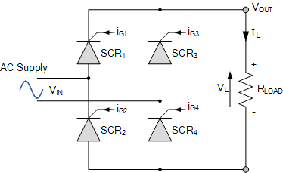
Single phase fully-controlled bridge rectifiers are known more commonly as AC-to-DC converters. Fully-controlled bridge converters are widely used in the speed control of DC machines and is easily obtained by replacing all four diodes of a bridge rectifier with thyristors as shown.
In the fully-controlled rectifier configuration, the average DC load voltage is controlled using two thyristors per half-cycle. Thyristors SCR₁ and SCR₄ are fired together as a pair during the positive half-cycle, while thyristors SCR₃ and SCR₄ are also fired together as a pair during the negative half-cycle. That is 180º after SCR₁ and SCR₄.
Then during continuous conduction mode of operation the four thyristors are constantly being switched as alternate pairs to maintain the average or equivalent DC output voltage.

6. Three phase full wave Rectifier (Full converter bridge configuration)
Three phase full wave rectifiers provide a higher average output voltage compared to single phase rectifiers. They are commonly used for high power applications because they have the highest possible transformer utilization factor for a three-phase system. The circuit of a three-phase bridge rectifier is shown in below. The diodes are numbered in the order of conduction sequences, and the conduction angle of each diode is 2π/3.
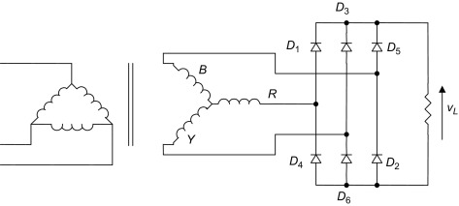
Three phase full converter is a fully controlled bridge-controlled rectifier using six thyristors connected in the form of a full wave bridge configuration. All the six thyristors are controlled switches which are turned on at an appropriate time by applying suitable gate trigger signals.
The three phase full converter is extensively used in industrial power applications up to about 120kW output power level, where two quadrant operations is required.
The figure shows a three phase full converter with highly inductive load. This circuit is also known as three phase full wave bridge or as a six-pulse converter.

7. Single phase half wave uncontrolled Rectifier
This is the simplest and probably the most widely used rectifier circuit albeit at relatively small power levels. The output voltage and current of this rectifier are strongly influenced by the type of the load. The switching device is diode which is turned on and off by the electrical circuit only, therefore it called uncontrolled rectifier.
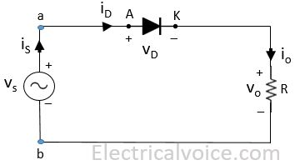

8. Single phase full wave uncontrolled Rectifier
Single phase uncontrolled half wave rectifiers suffer from poor output voltage and/or input current ripple factor. In addition, the input current contains a dc component which may cause problem (e.g. Transformer saturation etc) in the power supply system. The output dc voltage is also relatively less. Some of these problems can be addressed using a full wave rectifier. They use more number of diodes but provide higher average and rms output voltage. There are two types of full wave uncontrolled rectifiers commonly in use. If a split power supply is available (e.g. output from a split secondary transformer) only two diode will be required to produce a full wave rectifier. These are called split secondary rectifiers and are commonly used as the input stage of a linear dc voltage regulator. However, if no split supply is available the bridge configuration of the full wave rectifier is used. This is the more commonly used full wave uncontrolled rectifier configuration. Both these configurations are analyzed next.
In full wave rectifiers we can obtain output voltage during the positive and negative half cycles. Therefore, it delivers improved efficiency than the half wave rectifiers. It produces an output voltage that is purely DC. For the full wave rectifiers the average direct current output voltage is higher than that of half wave, the output of the full wave rectifier has much less ripple than that of the half wave rectifier producing a smoother output waveform.
In a single phase, Full Wave uncontrolled Rectifier circuit two diodes are now used. Only one diode will be forward biased and conducts during each half cycle.

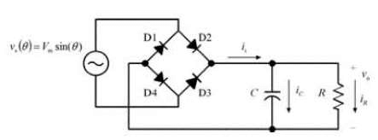

9. Single phase full wave uncontrolled Rectifier using centre tapped transformer
This is a type of rectifier which uses a center tapped transformer and two diodes to convert the complete AC signal into DC signal. The center tapped full wave rectifier is made up of an AC source, a center tapped transformer, two diodes and a load resistor.
The center tapped transformer works almost similar to a normal transformer. Like a normal transformer, the center tapped also increases or reduces the AC voltage, however, a center tapped transformer has another important feature that is the second winding of the center tapped transformer divides the Ac current or the AC signal into two parts.
When an additional wire is connected across the exact middle of the secondary winding of a transformer, it is known as a center tapped transformer.
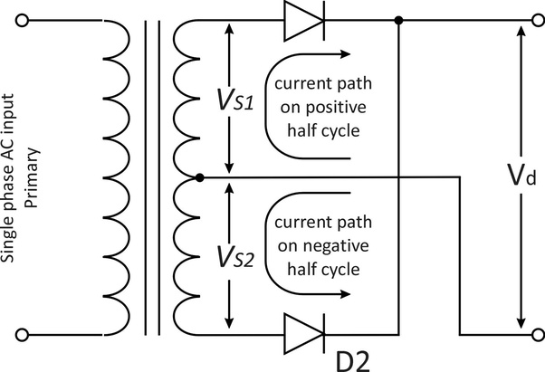

10.Single phase full wave uncontrolled Rectifier using bridge configuration

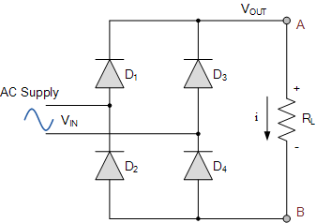
This bridge configuration of diodes provides full-wave rectification because at any time two of the four diodes are forward biased while the other two are reverse biased. Thus there are two diodes in the conduction path instead of the single one for the half-wave rectifier. Therefore, there will be a difference in voltage amplitude between V_{IN} and V_{OUT} due to the two forward voltage drops of the serially connected diodes. Here as before, for simplicity of the math we will assume ideal diodes.

11. Three phase full wave uncontrolled Rectifier using the bridge configuration.

This is the simplest of all three phase rectifier topologies.
3-phase rectification is the process of converting a balanced 3-phase power supply into a fixed DC supply using solid state diodes or thyristors
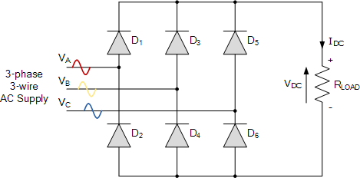

Three-phase rectification, also known as poly-phase rectification circuits are similar to the previous single-phase rectifiers, the difference this time is that we are using three, single-phase supplies connected together that have been produced by one single three-phase generator.
The advantage here is that 3-phase rectification circuits can be used to power many industrial applications such as motor control or battery charging which require higher power requirements than a single-phase rectifier circuit is able to supply.
3-phase supplies take this idea one step further by combining together three AC voltages of identical frequency and amplitude with each AC voltage being called a “phase”. These three phases are 120 electrical degrees out-of-phase from each other producing a phase sequence, or phase rotation of: 360º ÷ 3 = 120º

The full-wave three-phase uncontrolled bridge rectifier circuit uses six diodes, two per phase in a similar fashion to the single-phase bridge rectifier. A 3-phase full-wave rectifier is obtained by using two half-wave rectifier circuits. The advantage here is that the circuit produces a lower ripple output than the previous half-wave 3-phase rectifier as it has a frequency of six times the input AC waveform.
Diodes D₁ D₃ D₂ and D₄ form a bridge rectifier network between phases A and B, similarly diodes D₃ D₅ D₄ and D₆ between phases B and C and D₅ D₁ D₆ and D₂ between phases C and A.
Thus diodes D₁ D₃ and D₅ feed the positive rail and depending on which one has a more positive voltage at its anode terminal conducts. Likewise, diodes D₂ D₄ and D₆ feed the negative rail and whichever diode has a more negative voltage at its cathode terminal conducts.
Then we can see that for three-phase rectification, the diodes conduct in matching pairs giving a conduction pattern for the load current of: D₁₋₂ D₁₋₆ D₃₋₆ D₃₋₆ D₃₋₄ D₅₋₄ D₅₋₂ and D₁₋₂ as shown.

