EDIDIONG IME -ESSIEN
17/SCI01/041
CSC 314
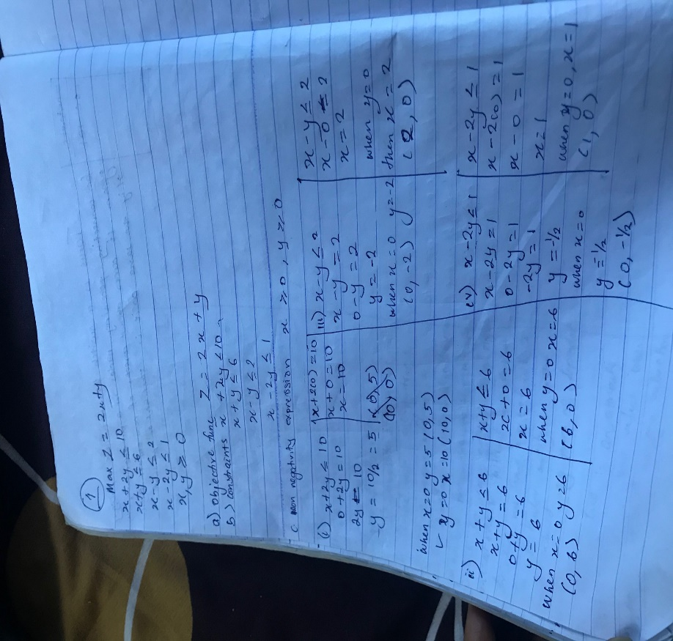
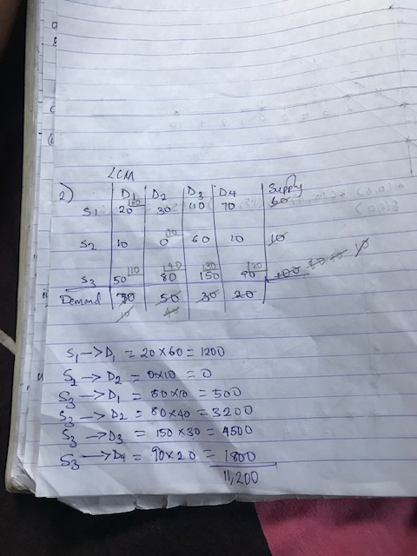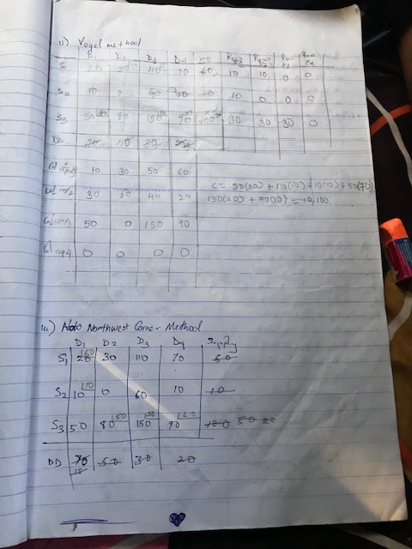 there’s degeneracy
3.
3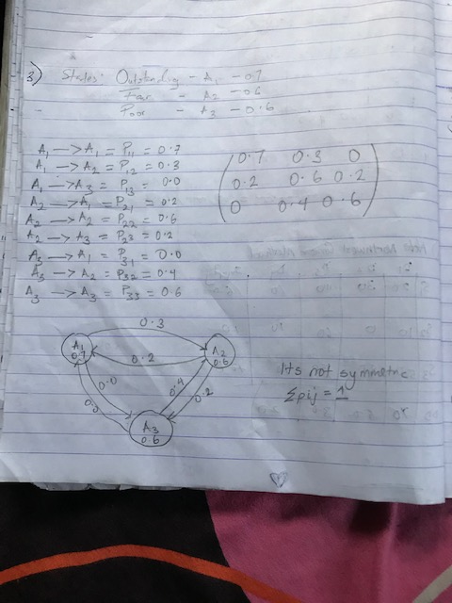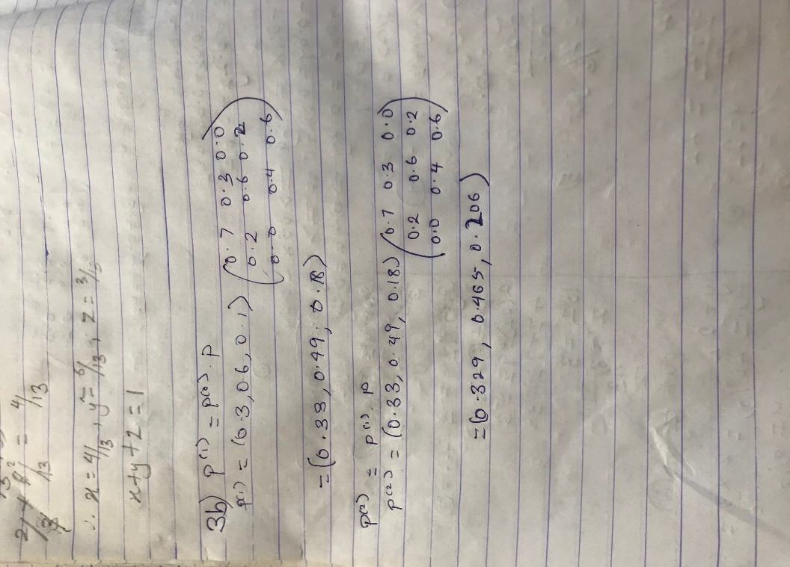
4
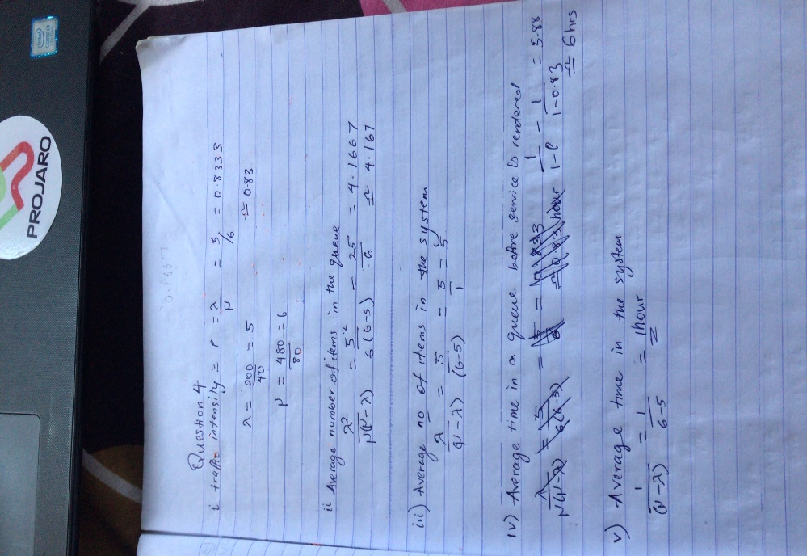
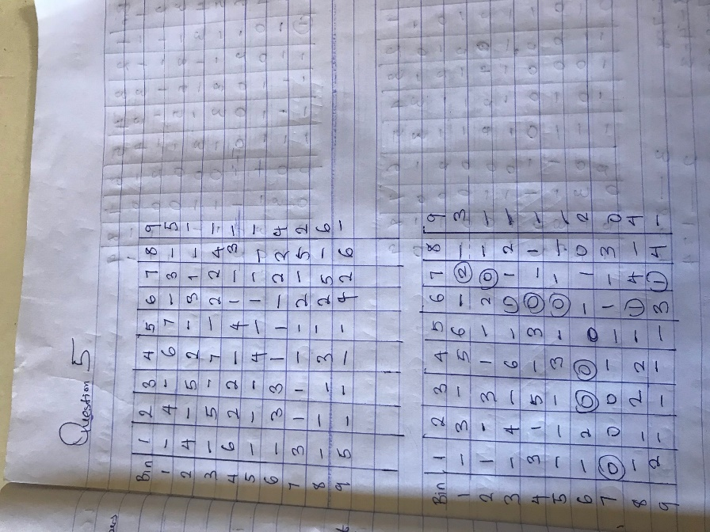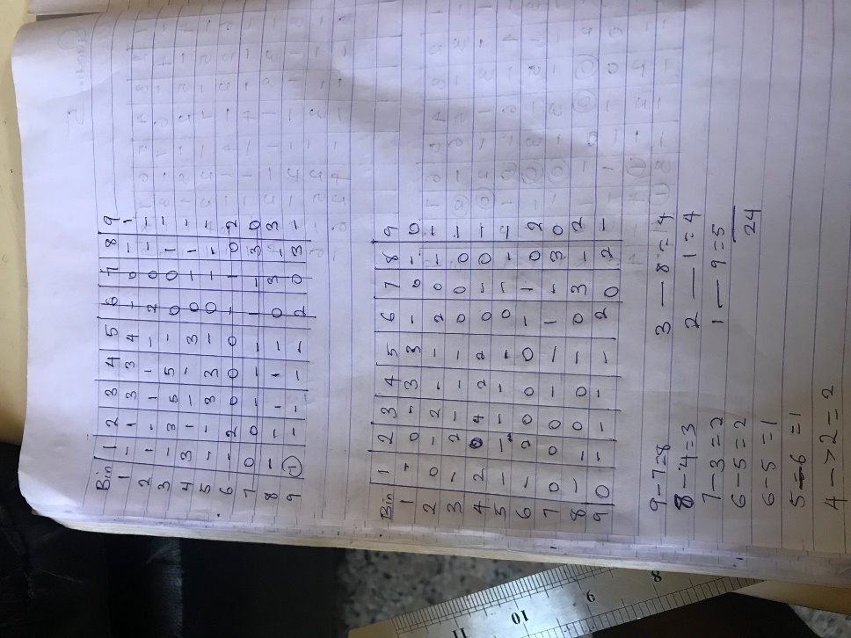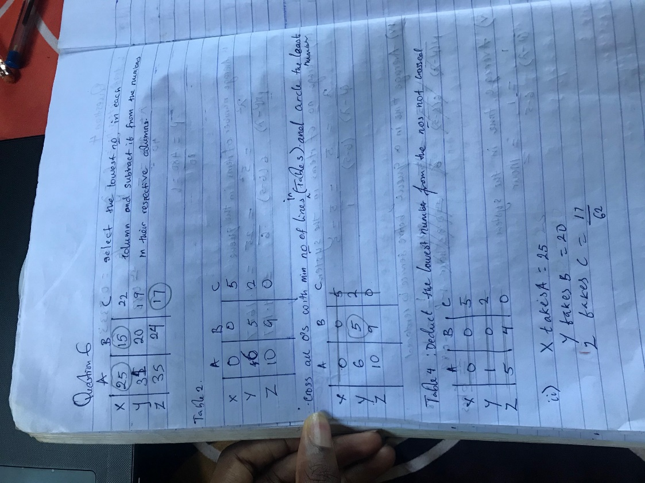
6b(i) Organization Behaviour:
Selection of personnel, determination of retirement age and skills.
Recruitment policies and assignment of jobs.
Scheduling of training programs.
Finance:
Capital requirements, cash flow analysis.
Credit policies, credit risks etc.
Investment decision.
Profit plan for the company.
Research and Development:
Product introduction planning.
Control of R&D projects.
Determination of areas for research and development.
Selection of projects and preparation of their budgets.

(ii) Tacobell used O.R to plan employee work schedules at their restaurant
Samsung applied O.R and it helped the to reduce manufacturing and inventory levels and they made $200m
P&G used O.R to design production and distribute on system and they made in excess, $200m.

