Name : Adugbo E Janet
Matric no: 17/mhs03/002

- I)Necroscopy: an examination and dissection of a dead body to determine cause of death or the changes produced by disease. autopsy,postmortem examination, post-mortem examination, postmortem, post-mortem. Necropsy is a surgical examination of a dead body, most commonly a dead animal. The purpose of a necropsy is typically to determine the cause of death, or extent of disease. This involves a careful process of dissection, observation, interpretation, and documentation. A thorough knowledge of normal anatomy is critical in distinguishing lesions from normal variations.
The Importance of the Necropsy
- Necropsy contributes to the body of scientific knowledge by increasing our understanding of anatomy and physiology in health and disease.
- Necropsies save lives! They can alert us to the presence of diseases that may be transmissible to other animals (or humans!), and guide treatment decisions for at-risk individuals.
- In some cases, necropsy findings can give comfort or closure to an owner, especially in the case of a seemingly sudden or unexplained death.
II) Radiography: Radiography is the art and science of using radiation to provide images of the tissues, organs, bones, and vessels that comprise the human body.
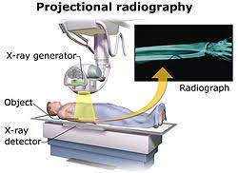
Radiology started with the X-ray. The ability to use imaging to see inside the body, diagnose a broken bone, diagnose diseases. X-rays use radiation to look through the body and see foreign objects and bones. This allows physicians to better diagnose anything wrong with the bone structure, which leads to the proper course of treatment. Other imaging technology, such as CT, MRI, Fluoroscopy, and Angiography. These different technologies allow for real-time imaging of the digestive system, looking at blood vessels, providing 2D and 3D maps of the tissue within the body and providing cross-section views of the body.

Without these technologies, it would be very difficult for physicians to diagnose many of the common diseases today.
III) Urinalysis: is a series of tests on your pee. Doctors use it to check for signs of common conditions or diseases. Other names for it are urine test, urine analysis. Urinalysis can reveal diseases that have gone unnoticed because they do not produce striking signs or symptoms. Examples include diabetes mellitus, various forms of glomerulonephritis, and chronic urinary tract infections. The most cost-effective device used to screen urine is a paper or plastic dipstick.
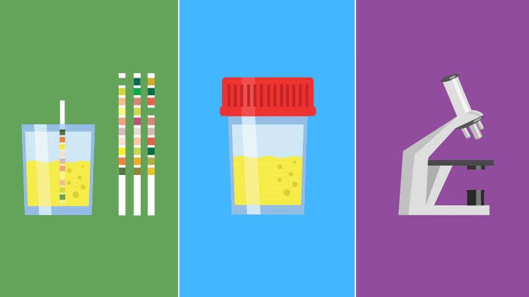
You may have a urinalysis as part of a routine check of your overall health, for instance as part of an annual physical. Urinalysis is one way to find certain illnesses in their earlier stages. They include:
Kidney disease
Liver disease
Diabetes
Your doctor may also want to test your pee if you’re getting ready to have surgery or are about to be admitted to the hospital. Urinalysis can be part of a pregnancy checkup, too.
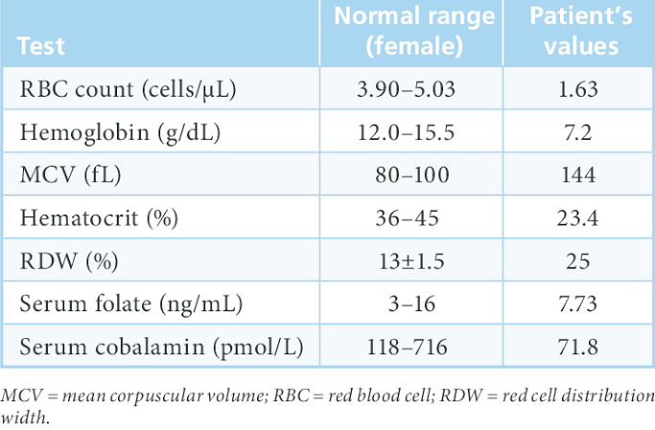
IV) Hematological Test: include tests on the blood, blood proteins and blood-producing organs. These tests can evaluate a variety of blood conditions including infection, anemia, inflammation, hemophilia, blood-clotting disorders, leukemia and the body's response to chemotherapy treatments.
A complete blood count (CBC) measures several components of your blood, including: White blood cells (WBC) - the body's primary defense system.
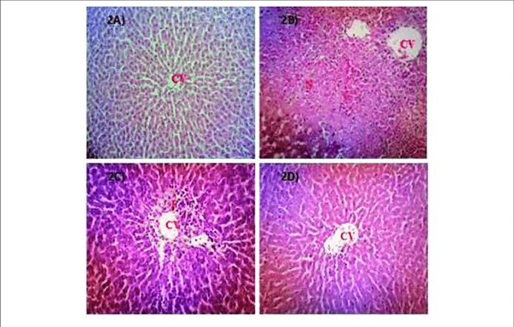
V) Microscopic Examination Of Tissues: Histopathology is the microscopic examination of biological tissues to observe the appearance of diseased cells and tissues in very fine detail. Hence histopathology is the study of microscopic changes or abnormalities in tissues that are caused as a result of diseases.
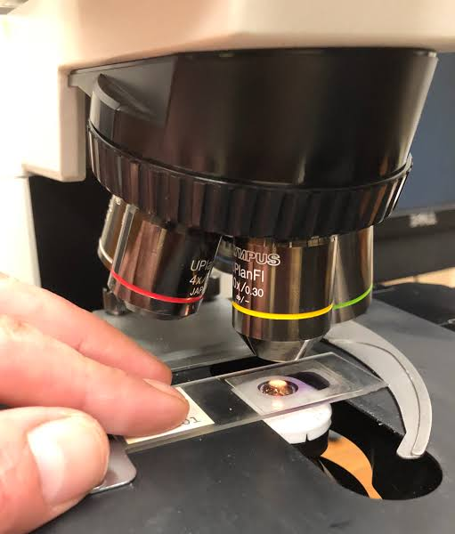
It allows scientists to view tissue changes or signs of infection, even if the pathogen is not present.

2) Cellular Adaptation precedes cell death, Discuss.
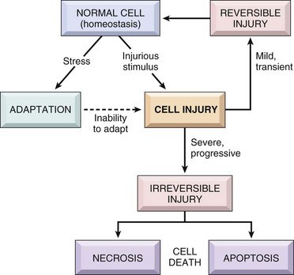

Overview of Cell Injury:
• Cells actively control the composition of their immediate environment and intracellular milieu within a narrow range of physiological parameters (“homeostasis”)
• Under physiological stresses or pathological stimuli (“injury”), cells can undergo adaptation to achieve a new steady state that would be compatible with their viability in the new environment.
• If the injury is too severe (“irreversible injury”), the affected cells die.
Causes of Cell Injury Include :
Hypoxia and ischemia (oxygen deficiency), Chemical agents (drugs and alcohol),
Physical agents (trauma and heat),
Infections,
Immunological reactions,
Genetic defects,
Nutritional defects,
Aging.

Cellular Adaptation to Injury:
• Cellular adaptations can be induced and/or regulated at any of a number of regulatory steps including receptor binding, signal transduction, gene transcription or protein synthesis
• The most common morphologically apparent adaptive changes are
– Atrophy (decrease in cell size): Atrophy is the shrinkage in cell size by loss of cellular substance with the involvement of a sufficient number of cells, an entire organ can become atrophic.
Causes of atrophy include decreased workload, pressure, diminished blood supply or nutrition, loss of endocrine stimulation, and agin.
Mechanisms of atrophy are not specific, but atrophic cells usually contain increased autophagic vacuoles with persistent residual bodies such as lipofus
– Hypertrophy (increase in cell size): Hypertrophy is an increase in cell size by gain of cellular substance with the involvement of a sufficient number of cells, an entire organ can become hypertrophic
Hypertrophy is caused either by increased functional demand or by specific endocrine stimulations. Not only the size, but also the phenotype of individual cells can be altered in hypertrophy with increasing demand, hypertrophy can reach a limit beyond which degenerative changes and organ failure can occur.
– Hyperplasia (increase in cell number): Hyperplasia constitutes an increase in the number of indigenous cells in an organ or tissue. Pathological hyperplasia if typically the result of excessive endocrine stimulation.
– Metaplasia (change in cell type):Metaplasia is a “reversible” change in which one adult cell type is replaced by another adult cell type. Metaplasia is a cellular adaptation in which indigenous cells are replaced by cells that are better suited to tolerate a specific abnormal environment. Because of metaplasia, normal protective mechanisms may be lost.
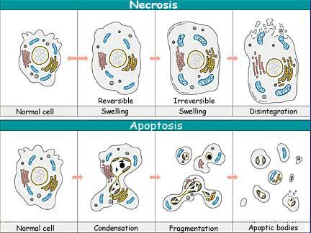
Cell Death:
Necrosis- pathologic, Necrotic cells are unable to maintain membrane integrity and their contents often leak out, a process that may elicit inflammation in the surrounding tissue.
Damage to membranes is severe, lysosomal enzymes enter the cytoplasm and digest the cell, and cellular contents leak out

Apoptosis- normal and pathologic, Programmed cell death, Apoptosis is a more orderly process of cell death. Apoptosis is individual cell necrosis, not simultaneous localized necrosis of large numbers of cells.
DNA or proteins are damaged beyond repair, the cell kills itself characterized by nuclear dissolution, fragmentation of the cell without complete loss of membrane integrity

Autophagy- normal and pathologic

In conclusion, all these explanations and diagrams above help understand that Cellular Adaptation precedes cell death because before there can be cell death, there has to be cell adaptation to injury.

