Adeniyi Muheebat Titilayo
17/mhs02/006
Nursing
NSC 308
ASSIGNMENT
- The 5 diagnostic techniques are:
  - Urinalysis
  - Diagnostic microbiology
  - Radiography
  - Hematologic tests
  - Microscopic examination of tissues
- Urinalysis: urinalysis is used to detect and manage a wide range of disorders, such as urinary tract infections, kidney disease and diabetes. A urinalysis involves checking the appearance, concentration and content of urine. Abnormal urinalysis results may point to a disease or illness. For example, a urinary tract infection can make urine look cloudy instead of clear. Increased levels of protein in urine can be a sign of kidney disease. To get the most accurate results, the sample may need to be collected midstream, using a clean-catch method. The patient/client can either be giving a sample bottle to pee in or the doctor insert a catheter to get the urine. The urine is then sent to the lab for analysis.
- Diagnostic microbiology: Diagnostic microbiology concentrates on the laboratory analysis of clinical specimens in cases when an infectious disease is suspected. The diagnosis of staphylococcal infections may involve clinical specimens isolated from humans, animals, or food products, as well as samples collected from the environment. A presented overview of the diagnosis of staphylococcal infections includes the following topics: specimen collection and direct specimen Gram staining; microscopic examination of Gram stained material; inoculation into general-purpose media as well as into selective-differential media; incubation, colony morphology identification, Gram staining, and isolation of pure culture; catalase testing; furazolidone susceptibility testing; detection of free coagulase and bound coagulase; identification of bacterial species based on biochemical tests; detection of resistance mechanisms (beta-lactamases, methicillin resistance, macrolide, and lincozamine resistance, or, the MLSB resistance mechanism); and antibiogram execution. Automated methods applied to staphylococcal diagnostics are presented.
- Radiography: Radiography is an imaging technique using X-rays, gamma rays, or similar ionizing radiation and non-ionizing radiation to view the internal form of an object. Applications of radiography include medical radiography ("diagnostic" and "therapeutic") and industrial radiography. Similar techniques are used in airport security (where "body scanners" generally use backscatter X-ray). To create an image in conventional radiography, a beam of X-rays is produced by an X-ray generator and is projected toward the object. A certain amount of the X-rays or other radiation is absorbed by the object, dependent on the object's density and structural composition. The X-rays that pass through the object are captured behind the object by a detector (either photographic film or a digital detector). The generation of flat two dimensional images by this technique is called projectional radiography. In computed tomography (CT scanning) an X-ray source and its associated detectors rotate around the subject which itself moves through the conical X-ray beam produced. Any given point within the subject is crossed from many directions by many different beams at different times. Information regarding attenuation of these beams is collated and subjected to computation to generate two dimensional images in three planes (axial, coronal, and sagittal) which can be further processed to produce a three-dimensional image.
- Hematologic tests: Hematology tests include laboratory assessments of blood formation and blood disorders. Some examples of these tests are:
  - Full blood count - A count of the total number of red blood cells, white blood cells and platelets present in blood.
  - Blood film - Blood is smeared over a glass slide that is stained with specific dyes and viewed under a microscope. The number, shape and size of blood cells and the presence of any abnormal cells or immature cells are noted. The stain used for reticulocytes or immature red blood cells is Heilmeyer's reticulocyte stain. Staining may flag up abnormally shaped red blood cells such as sickle cells or spherocytes.
  - Staining may also detect blood parasites such as malaria, toxoplasmosis, and microfiliariasis.
  - Assessment and staining of immature platelets or megakaryocytes may also be performed.
  - Assessment of granulocytosis.
  - The erythrocyte sedimentation rate (ESR) may be tested.
  - The bone marrow may be examined.
  - Iron status and anemias are assessed using tests such as serum ferritin, vitamin B12 and folate levels.
  - The Coombs' test or antiglobulin test may be used for blood typing and blood matching prior to blood transfusion, for example.
  - Platelet function in bleeding and coagulation may be checked using a test called prothrombin time.
  - Diascopy is a technique used to determine whether a lesion is vascular, nonvascular or hemorrhagic.
  - D-dimer assessment may be performed to check for thrombotic disorders.
  - Electrophoresis may be used to examine proteins in the blood such as hemoglobin and to check for hemoglobinopathies such as thalassemia or sickle cell anemia.
  - The enzyme G6PD may be assessed in sickle cell disease.
  - Fine-needle aspiration of lymph nodes and tumors.
  - Examination of spleen biopsy.
  - Immunocytochemical techniques for detecting antigens both inside and on the surface of cells.
  - Assessment of storage diseases such as Gaucher's disease, Niemann-Pick disease and glycogen storage disease.
  - Assessment of chronic myeloproliferative disorders using bone marrow and blood examination.
  - Assessment of hemophagocytic syndromes.
  - Karyotyping to look for chromosomal disorders and abnormalities
- Microscopic examination of tissues: it refers to the examination of a biopsy or surgical specimen by a pathologist, after the specimen has been processed and histological sections have been placed onto glass slides. In contrast, cytopathology examines free cells or tissue micro-fragments (as "cell blocks"). After the tissue has been taken and processed. The histological slides are examined under a microscope by a pathologist, a medically qualified specialist who has completed a recognised training program. This medical diagnosis is formulated as a pathology report describing the histological findings and the opinion of the pathologist. In the case of cancer, this represents the tissue diagnosis required for most treatment protocols. In the removal of cancer, the pathologist will indicate whether the surgical margin is cleared, or is involved (residual cancer is left behind). This is done using either the bread loafing or CCPDMA method of processing. Microscopic visual artifacts can potentially cause misdiagnosis of samples.
- Cellular adaptation: To maintain homeostasis, cells and tissues:
"Cope" with new demands placed on them by constantly adapting to changes in the tissue environment. Are usually capable of an amazing degree of cellular adaptability. Adapt in a way that may be beneficial in nature (physiological) or detrimental (pathological). Examples of physiological adaptation are: An increase in skeletal muscle cells in athletes due to exercise and increased metabolic demand. The increase in number and size of epithelial cells in breasts of women resulting from endocrine stimulation during pregnancy. When these cells or tissues are damaged, the body attempts to adapt and repair or limit the harmful effects. Often the adaptive changes result in cells or organs that cannot function normally. This imperfect adaptation is a pathological change. The specific types of cellular adaptations are:
  - Atrophy: Atrophy is a decrease in the size of cells. If a sufficient number of cells are involved, the tissue or organ may also decrease in size. When cells atrophy, they have:
    - Reduced oxygen needs.
    - Reduced protein synthesis.
    - Decreased number and size of the organelles.
The most common causes of atrophy are reduced use of the cells, lack of hormonal or nerve stimulation, decrease in nutrition, reduced blood flow to the tissue, and natural aging. An example of atrophy is the decrease in the size of muscles and muscle cells in persons whose legs are paralyzed, in a cast, or infrequently used as when a patient is on bedrest.
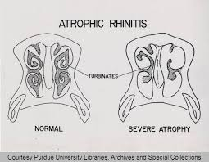

Hypertrophy: Hypertrophy is an increase in the size of individual cells. This frequently results in an increase in the size of a tissue or organ. When cells hypertrophy, components of the cell increase in numbers with increased functional capacity to meeting increased cell needs. Hypertrophy generally occurs in situations where the organ or tissue cannot adapt to an increased demand by formation of more cells. This is commonly seen in cardiac and skeletal muscle cells, which do not divide to form more cells. Common causes for hypertrophy are increased work or stress placed on an organ or hormonal stimulation. An example of hypertrophy is the compensatory increase in the size of cells in one kidney after the other kidney has been removed or is in a diseased state.
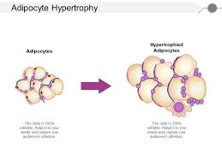

Hyperplasia: Hyperplasia is an increase in the number of cells in a tissue. This generally results in an enlargement of tissue mass and organ size. It occurs only in tissues capable of mitosis such as the epithelium of skin, intestine, and glands. Some cells do not divide and thus cannot undergo hyperplasia, for example, nerve and muscle cells. Hyperplasia is often a compensatory measure to meet an increase in body demands. Hyperplasia is a frequent response to toxic agents and damage to tissues such as wounds or trauma. In wound healing, hyperplasia of connective tissue (for example, fibroblasts and blood vessels) contributes to the wound repair. In many cases, when the toxic stress is removed, the tissue returns to normal. Hyperplasia may result from hormonal stimulation, for example, breast and uterine enlargement due to increased estrogen production during pregnancy.
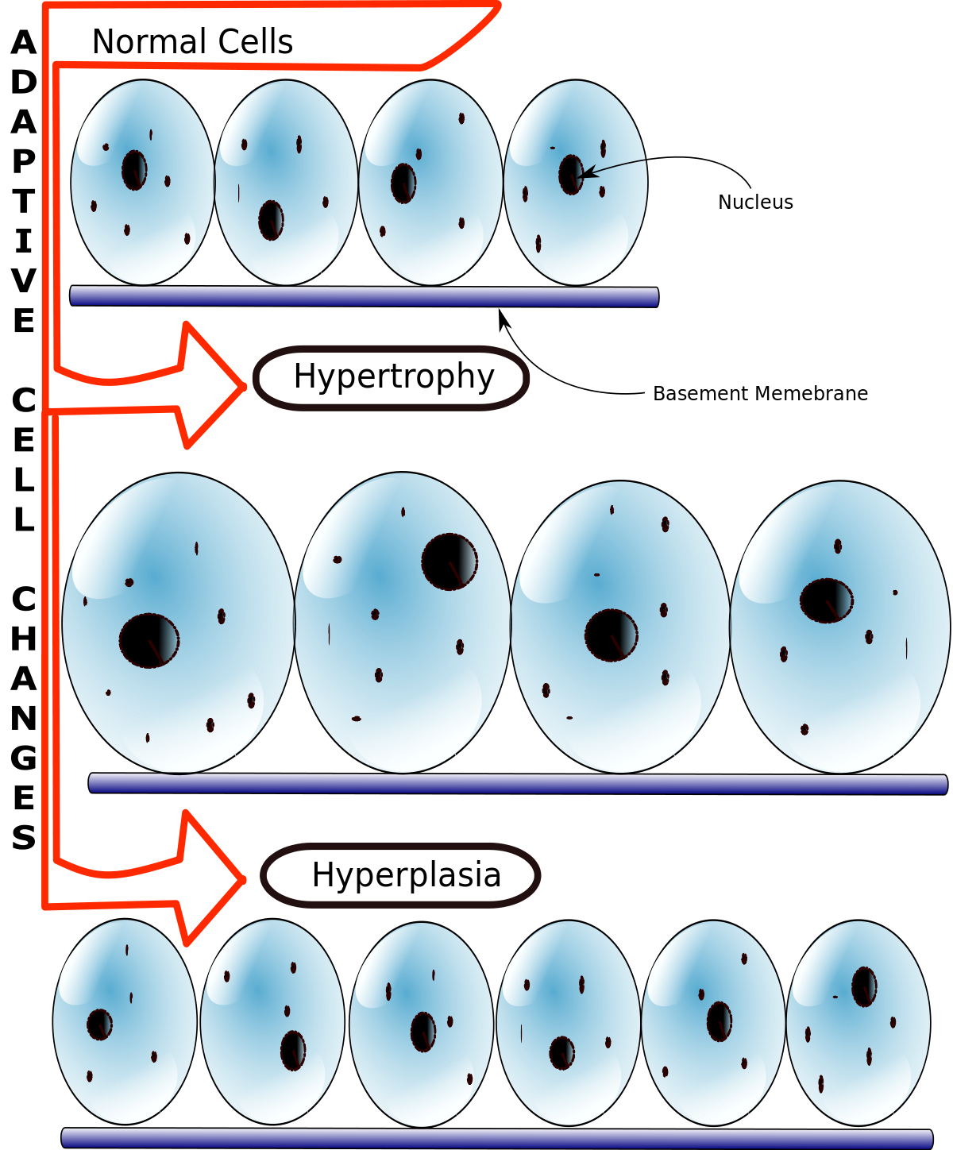

Metaplasia: Metaplasia is the conversion from one type of mature cell to another type of mature cell. It is a cellular replacement process. A metaplastic response often occurs with chronic irritation and inflammation. This results in a tissue more resistant to the external stress since the replacement cells are capable of survival under circumstances in which the original cell type could not survive. However, the cellular changes usually result in a loss of function, which was performed by the original cells that were lost and replaced. Examples of metaplasia are:
    - The common condition in which a person suffers from chronic reflux of acid from the stomach into the esophagus (Gastroesophageal Reflux Disease). The normal esophageal cells (squamous epithelium) are sensitive to the refluxed acid and die. They are replaced with the columnar cells of the stomach that are resistant to the stomach's acidity. This pathological condition is known as "Barrett's Esophagus."
    - The change in the cells of the trachea and bronchi of chronic cigarette smokers from ciliated columnar epithelium to non-ciliated stratified squamous epithelium. The sites of metaplasia frequently are also sites for neoplastic transformations. The replacement cells lack the defense mechanism performed by the cilia in moving particles up and out of the trachea.
    - With cirrhosis of the liver, which is a common condition of chronic alcoholics, the normal functional hepatic cells are replaced by nonfunctional fibrous tissue.
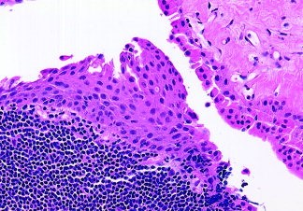

Dysplasia: Dysplasia is a condition of abnormal cell changes or deranged cell growth in which the cells are structurally changed in size, shape, and appearance from the original cell type. Cellular organelles also become abnormal. A common feature of dysplastic cells is that the nuclei are larger than normal and the dysplastic cells have a mitotic rate higher than the predecessor normal cells. Causes of dysplasia include chronic irritation and infection. In many cases, the dysplasia can be reversed if the stress is removed and normal cells return. In other cases, dysplasia may be permanent or represent a precancerous change.
    - An example of dysplasia is the atypical cervical cells that precede cervical cancer. Routine examination of cervical cells is a routine screening test for dysplasia and possible early stage cervical cancer (Papanicolaou test).
    - Cancer occurs at the site of Barrett's syndrome and in the bronchi of chronic smokers (bronchogenic squamous cell carcinoma).
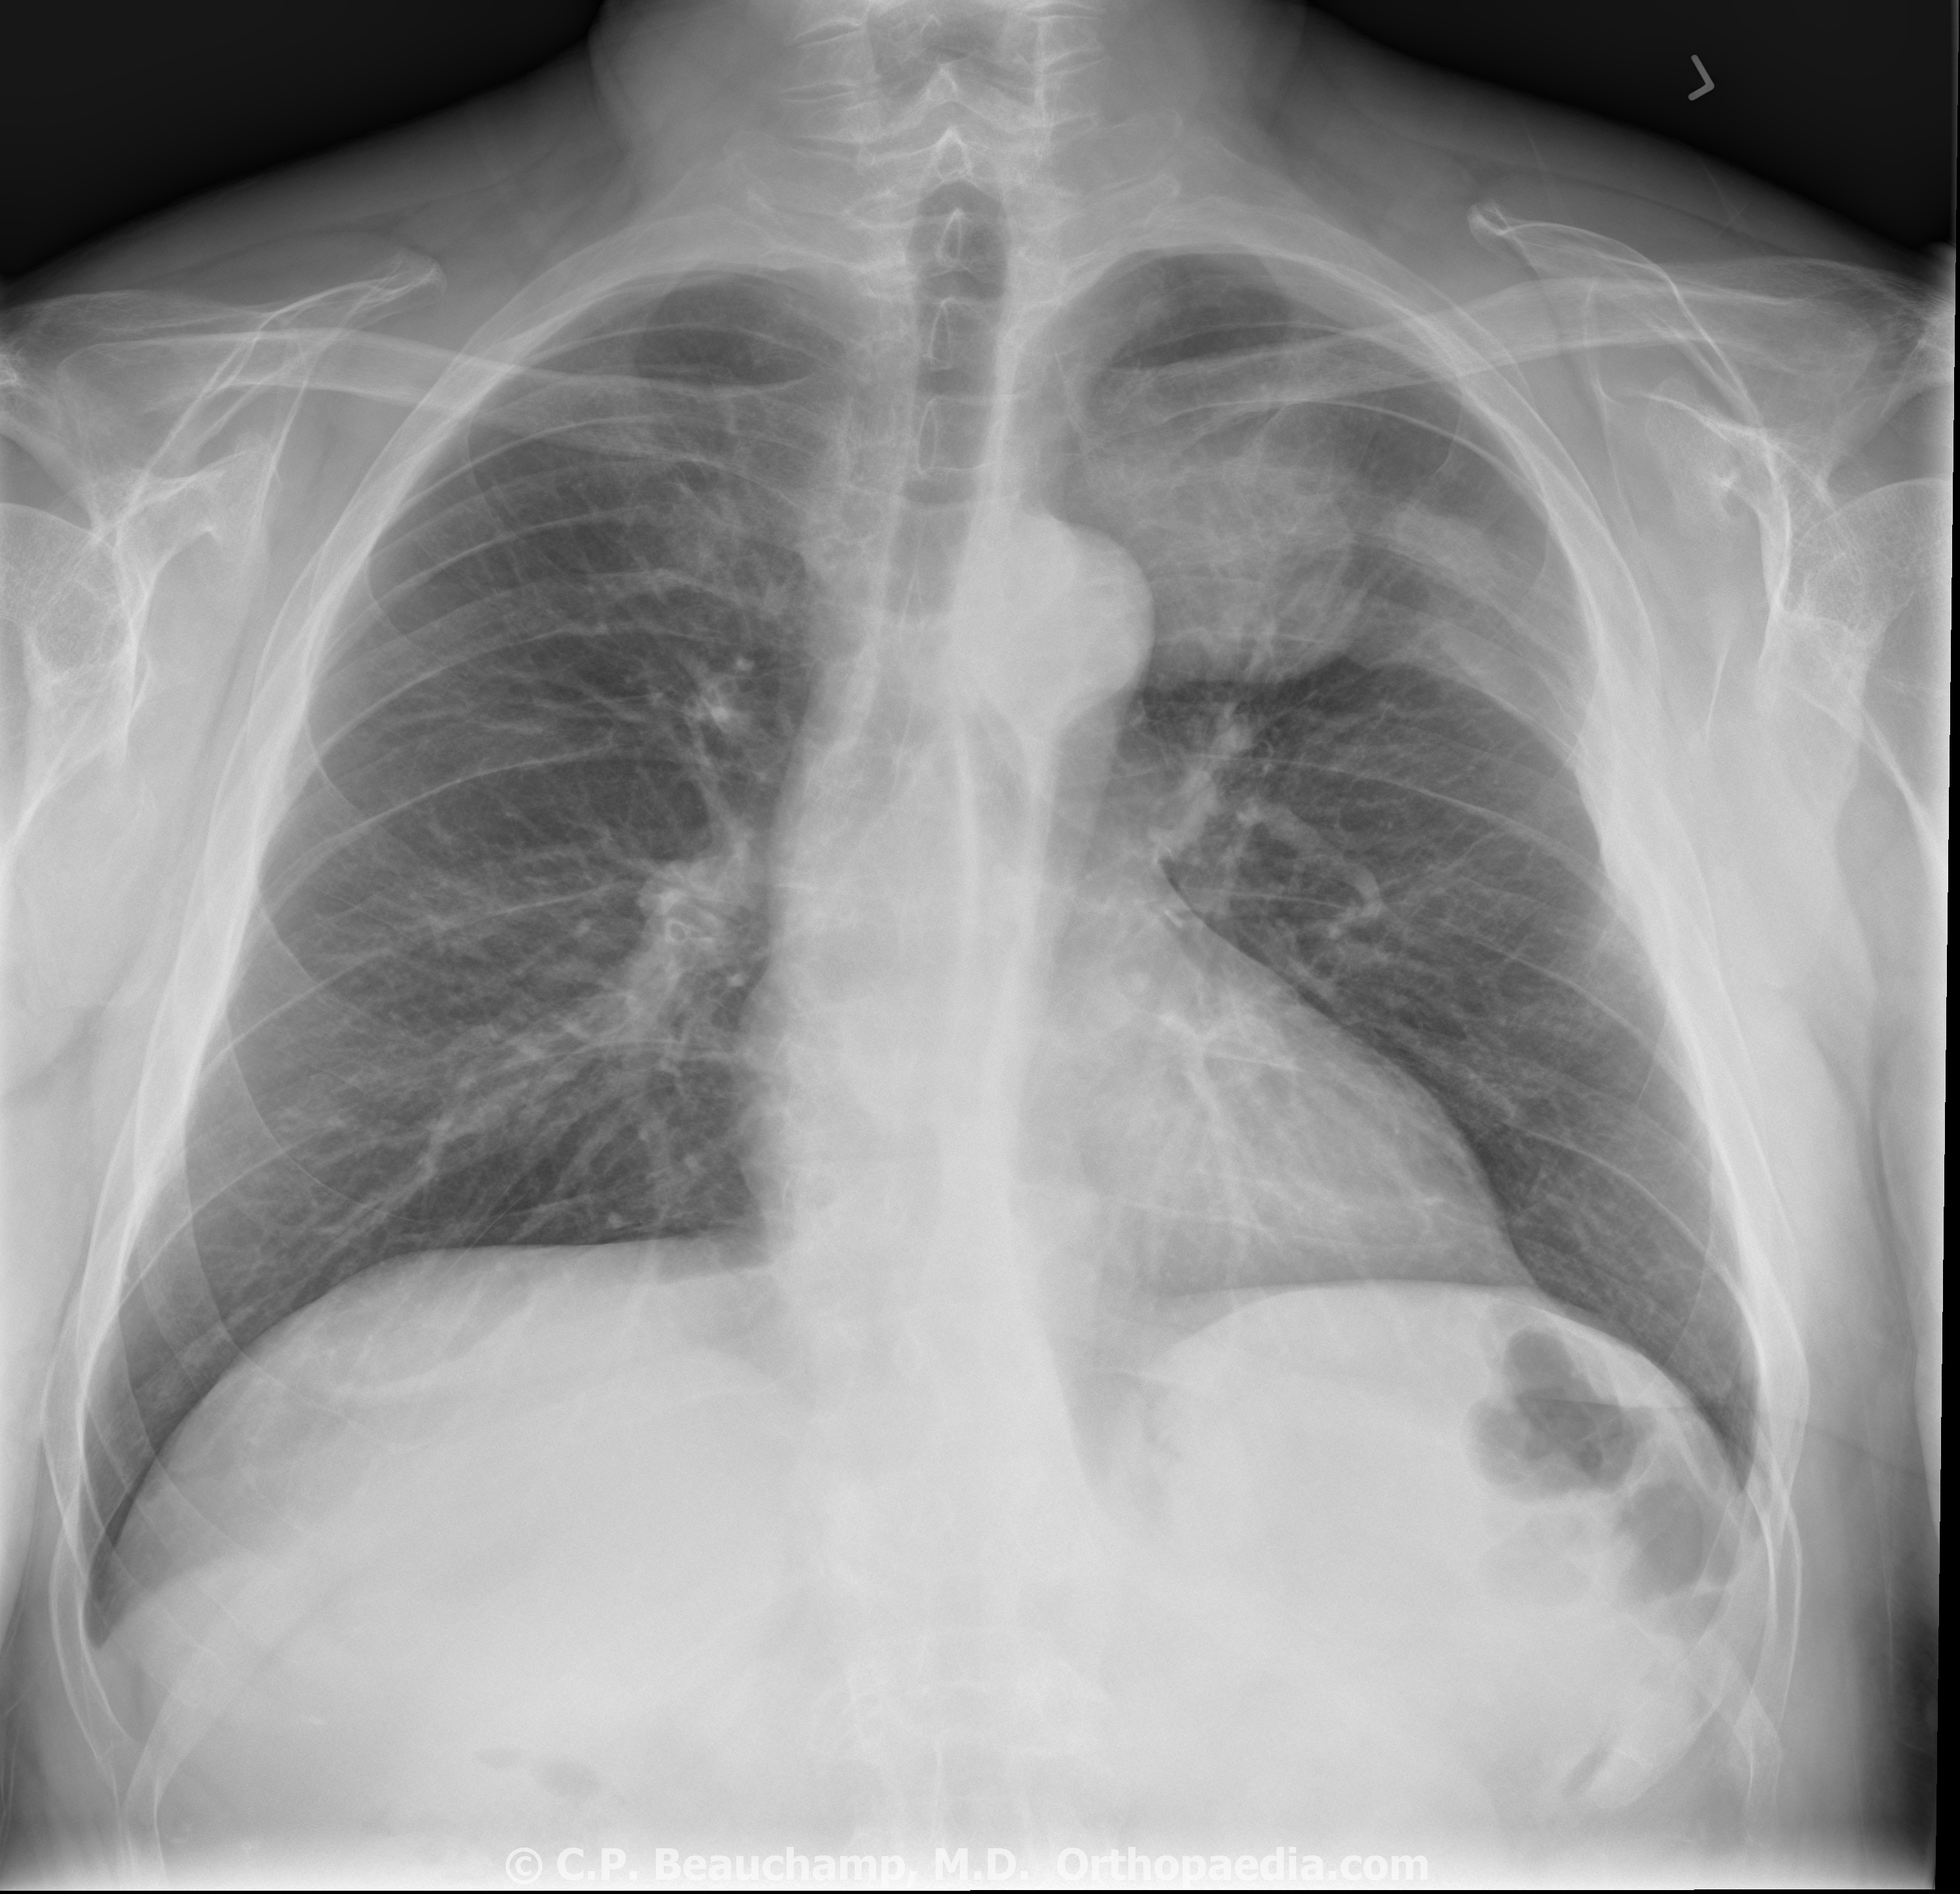

Anaplasia: Anaplasia refers to cells that are undifferentiated. They have irregular nuclei and cell structure with numerous mitotic figures. Anaplasia is frequently associated with malignancies and serves as one criterion for grading the aggressiveness of a cancer. For example, an anaplastic carcinoma is one in which the cell appearance has changed from the highly differentiated cell of origin to a cell type lacking the normal characteristics of the original cell. In general, anaplastic cells have lost the normal cellular controls, which regulate division and differentiation.
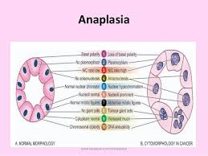

Neoplasia: Neoplasia is a new growth of tissue and is commonly referred to as a tumor. There are two types of neoplasia: benign and malignant. Malignant neoplasia are cancers. Since cancer is such an important and complex medical problem, a separate section is devoted to cancer.
