Rufus-Jegede Opemipo
17/MHS01/289
Nursing Science
300 Level
Cellular Pathology

Immunohistochemistry
A major change in histopathology in recent times has been the development of immunohistochemistry. Where special stains are a relatively crude and, in most cases, relatively non-specific way of staining tissue components, immunohistochemical stains are by comparison far more specific in what they stain.
This technique involves attaching a dye to an antibody that will only bind to a certain protein type on or within a cell. Antibodies are like keys that can only open a certain lock (cell protein or antigen). Hundreds of antibodies are available which allow labelling of hundreds or even thousands of different protein types. Where a special stain may allow the pathologist to identify, for example, a cell as being cancerous, immunohistochemistry can identify which organ in the body that cancerous cell came from and how aggressively it may behave.
The dyes that attach to the labelling antibody can be also altered, including using different coloured dyes or even fluorescent dyes that are easier to see on microscopy. Some laboratories can use fluorescence-labelled antibodies to allow for computerised slide analysis, reducing the time taken to examine large numbers of slides and identifying which slides need to be reviewed by a pathologist and which are within the normal range.

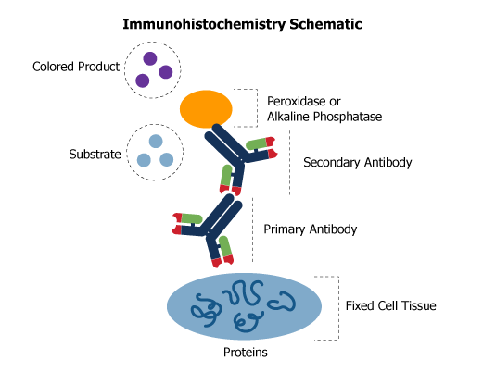
Molecular Pathology and Cytogenetics
With the explosion of information about cell DNA (the genetic coding material) and genes that has resulted since the completion of the Human Genome Project, increasing numbers of genes are being recognised that, if faulty, may be involved in the development of disease including cancers. This is shaping up to change the way that disease is thought of, diagnosed and treated.
Molecular pathology is an umbrella term for the analysis of the genetic material (chromosomes and their DNA) of cells, and is becoming an increasingly widely requested component of the pathology workup of a submitted tissue. One of the subdivisions of molecular pathology is cytogenetics, which is the analysis of chromosomes (the form in which DNA is found in the cell nucleus). The two most commonly used techniques in molecular pathology and cytogenetics are fluorescence in situ hybridisation (FISH) and direct sequencing of DNA.
FISH is a technique used to stain chromosomes to reveal areas where genes may have been deleted, duplicated or broken. Fluorescent labels are attached to specific DNA sequences (parts of specific genes) which allow faulty genes to be seen when examining the cells under a special type of microscope. Direct sequencing of cell DNA is a way of looking at individual genes or groups of genes, to detect and characterise which mutation is present in a particular patient’s tumour. This can be done in the traditional manner (Sanger sequencing, capillary electrophoresis), or by the newer and much faster method of Next Generation Sequencing.
As an example of the usefulness of cytogenetics one can look at breast cancer. Anatomical pathology can give a diagnosis of what type of breast cancer a patient may have, how far it has spread, whether or not it is likely to be an aggressive tumour and whether it will respond to hormone and targeted therapies. Cytogenetics can add to this information by identifying whether the patient has a faulty gene(s) which predisposed them to the development of breast cancer. If present, this would mean that they have an increased chance of developing cancer in the opposite breast and of developing other specific cancer types (e.g. ovarian cancer). It also has implications for the patient’s direct relatives and offspring. Did they inherit the faulty gene(s) and what are the chances that they will develop cancer in the future? By direct sequencing of the faulty gene, the close relatives of the patient can be screened for the mutation, after appropriate consent, allowing for preventative steps to be taken to minimise their chances of developing a similar cancer in the future. There are also treatments being developed which will target the products of specific gene mutations in a patient.

Electron Microscopy: Electron microscopy (EM) is a technique for obtaining high resolution images of biological and non-biological specimens. It is used in biomedical research to investigate the detailed structure of tissues, cells, organelles and macromolecular complexes. The high resolution of EM images results from the use of electrons (which have very short wavelengths) as the source of illuminating radiation. Electron microscopy is used in conjunction with a variety of ancillary techniques (e.g. thin sectioning, immuno-labeling, negative staining) to answer specific questions. EM images provide key information on the structural basis of cell function and of cell disease.
There are two main types of electron microscope – the transmission EM (TEM) and the scanning EM (SEM). The transmission electron microscope is used to view thin specimens (tissue sections, molecules, etc) through which electrons can pass generating a projection image. The TEM is analogous in many ways to the conventional (compound) light microscope. TEM is used, among other things, to image the interior of cells (in thin sections), the structure of protein molecules (contrasted by metal shadowing), the organization of molecules in viruses and cytoskeletal filaments (prepared by the negative staining technique), and the arrangement of protein molecules in cell membranes (by freeze-fracture).
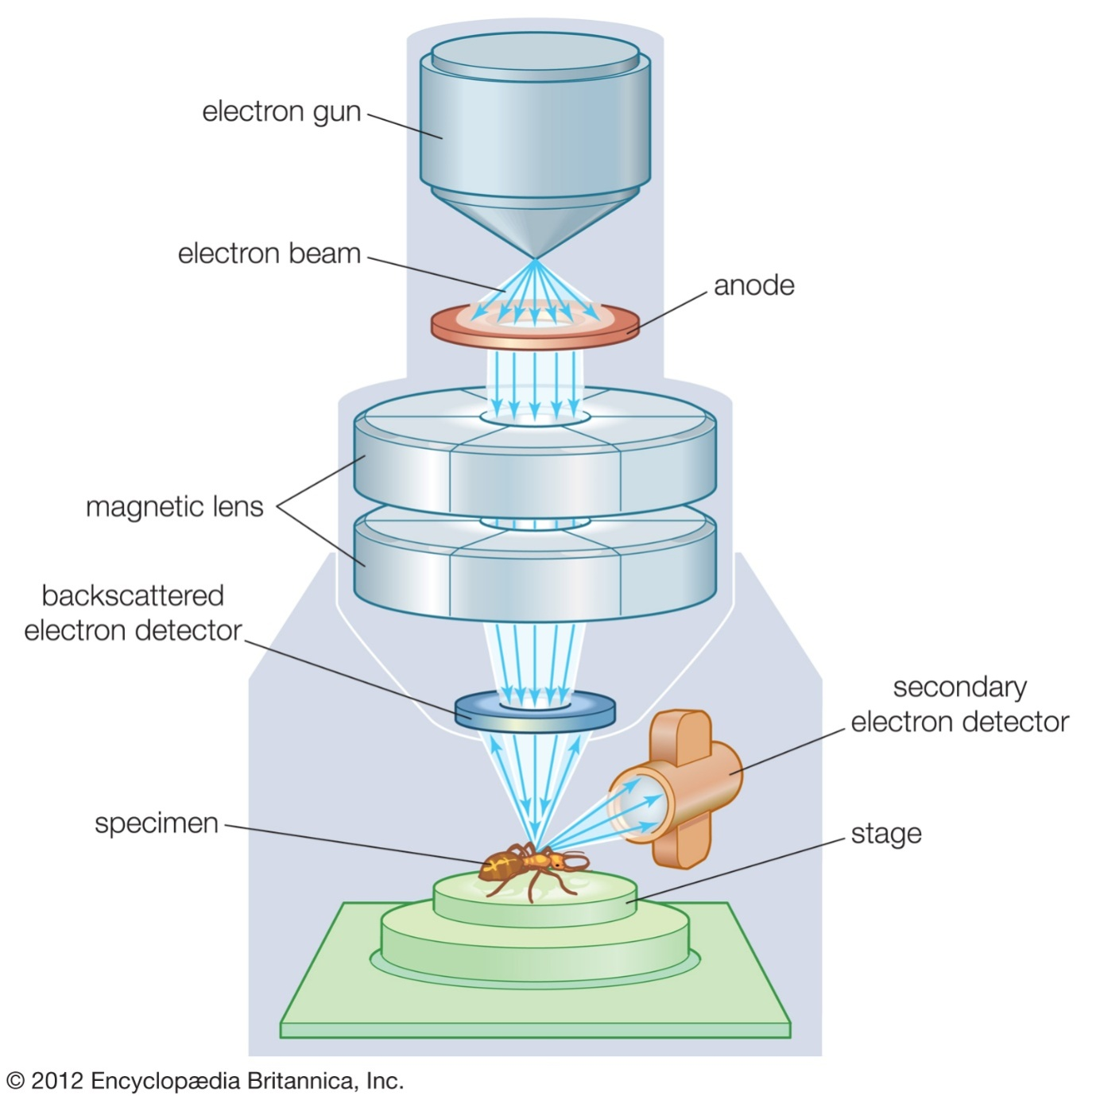

An Electron Microscope

Flow Cytometry
Flow cytometry is a technology that provides rapid multi-parametric analysis of single cells in solution. Flow cytometers utilize lasers as light sources to produce both scattered and fluorescent light signals that are read by detectors such as photodiodes or photomultiplier tubes. These signals are converted into electronic signals that are analysed by a computer and written to a standardized format (.fcs) data file. Cell populations can be analysed and/or purified based on their fluorescent or light scattering characteristics. A variety of fluorescent reagents are utilized in flow cytometry. These include, fluorescently conjugated antibodies, DNA binding dyes, viability dyes, ion indicator dyes and fluorescent expression proteins.
Flow cytometry is a powerful tool that has applications in immunology, molecular biology, bacteriology, virology, cancer biology and infectious disease monitoring. It has seen dramatic advances over the last 30 years, allowing unprecedented detail in studies of the immune system and other areas of cell biology. Flow cytometry is a technology that rapidly analyses single cells or particles as they flow past single or multiple lasers while suspended in a buffered salt-based solution. Each particle is analysed for visible light scatter and one or multiple fluorescence parameters. Visible light scatter is measured in two different directions, the forward direction (Forward Scatter or FSC) which can indicate the relative size of the cell and at 90° (Side Scatter or SSC) which indicates the internal complexity or granularity of the cell. Light scatter is independent of fluorescence. Samples are prepared for fluorescence measurement through transfection and expression of fluorescent proteins (ex. Green Fluorescent Protein, GFP), staining with fluorescent dyes (e.g., Propidium Iodide, DNA) or staining with fluorescently conjugated antibodies (e.g., CD3 FITC).
Flow cytometry is a powerful tool that has applications in multiple disciplines such as immunology, virology, molecular biology, cancer biology and infectious disease monitoring. For example, it is very effective for the study of the immune system and its response to infectious diseases and cancer. It allows for the simultaneous characterization of mixed populations of cells from blood and bone marrow as well as solid tissues that can be dissociated into single cells such as lymph nodes, spleen, mucosal tissues, solid tumours etc. In addition to analysis of populations of cells, a major application flow cytometry is sorting cells for further analysis. A more detailed look at applications will be discussed later in this unit.
The instrumentation used for flow cytometry has evolved over the last several decades. Multiple laser systems are common as are instruments that are designed for specific purposes, such as systems with 96-well loaders designed for bead analysis, systems that combine microscopy and flow cytometry and systems that combine mass spectrometry and flow cytometry. An overview of current instrumentation platforms will be discussed in this unit.
The increase in available reagents over the last several years has led to explosive growth in the number of parameters used in flow cytometry experiments. There has been a dramatic increase in the fluorochromes used to conjugate monoclonal antibodies, such as tandem dyes and polymer dyes. In addition, there has been an increase in the available fluorescent proteins used for transfection beyond GFP, such as mCherry, mBanana, mOrange, mNeptune, etc. These advances in fluorochromes and instrumentation has led to experiments with the possibility of 30+ parameters.
The final part of a flow cytometry experiment is data analysis. Traditional two parameter histogram (dot plot) gating and analysis is still being used frequently. However, the increase in number of parameters and complexity in experiments is leading to the use of newer cluster data analysis algorithms such a PCA, SPADE and tSNE. These improved methods of data mining allow useful information to be extracted from the high-dimensional data now available from flow cytometry.

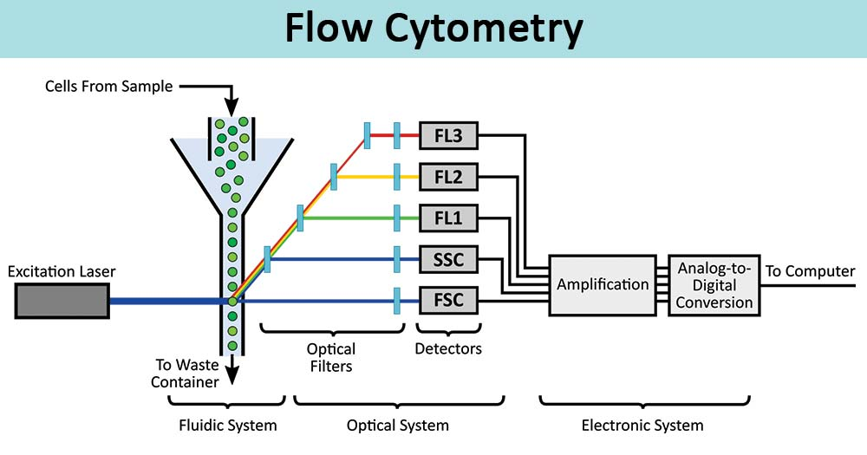

Special stains
Pathologists use the chemical properties of components of the tissues being studied in their choice of different stains. The stain(s) are applied to the thin sections on glass slides to allow the pathologist to see the cells under the microscope. The most widely used stain is haematoxylin and eosin. This stain is a combination of a basic stain (haematoxylin) and an acidic stain (eosin), which react with acidic and basic cell components in the tissue on the slide to give purple and pink colours to the tissues. Other stains available highlight fats, different tissue fibres, different types of mucus, microorganisms, proteins etc.
There are a wide variety of special stains to demonstrate pathologic processes. They generally employ a dye or chemical which has an affinity for the particular tissue component. Examples include:-

1. Connective Tissue Stains
Massons Trichrome
The trichrome stain helps to highlight the supporting collagenous stroma in sections from a variety of organs. This helps to determine the pattern of tissue injury. Trichrome will also aid in identifying normal structures, such as connective tissue capsules of organs, the lamina propria of gastrointestinal tract, and the bronchovascular structures in lung.
Verhoff’s Elastic Stain
An elastic tissue stain helps to outline arteries, because the elastic lamina of muscular arteries, and the media of the aorta, contain elastic fibers. The van Gieson method for elastic fibers provides good contrast
Reticulin Stain
The reticulin stain is useful in parenchymal organs such as liver and spleen to outline the architecture. Delicate reticular fibers, which are argyrophilic, can be seen. A reticulin stain occasionally helps to highlight the growth pattern of neoplasms.
Giemsa Stain
There are a variety of “Romanowsky-type” stains with mixtures of methylene blue, azure, and eosin compounds. Among these are the giemsa stain and the Wright’s stain (or Wright-Giemsa stain). The latter is utilized to stain peripheral blood smears. The giemsa stain can be helpful for identifying components in a variety of tissues. One property of methylene blue and toluidine blue dyes is metachromasia. This means that a tissue component stains a different color than the dye itself. For example, mast cell graules, cartilage, mucin, and amyloid will stain purple and not blue, which is helpful in identifying these components.

2. Microrganisms
Brown and Hopps
Bacteria appear on H and E as blue rods or cocci regardless of gram reaction. Colonies appear as fuzzy blue clusters. Tissue gram stains are all basically the same as that used in the microbiology lab except that neutral red is used instead of safranin. Gram positive organisms usually stain well, but gram negatives do not (because the lipid of the bacterial walls is removed in tissue processing).
AFB (acid fast bacilli) stain
This stain uses carbol-fuchsin to stain the lipid walls of acid fast organisms such as M. tuberculosis. The most commonly used method is the Ziehl-Neelsen method, though there is also a Kinyoun’s method. A modification of this stain is known as the Fite stain and has a weaker acid for supposedly more delicate M. leprae bacilli. However, much of the lipid in mycobacteria is removed by tissue processing, so this stain can, at times, be very frustrating and cause you to search extensively for organsisms you are sure are in a big granuloma. The most sensitive stain for mycobacteria is the auramine stain which requires a fluorescence microscope for viewing. There are things other than mycobacteria that are acid fast. Included are cryptosporidium, isospora, and the hooklets of cysticerci.
Gomori methenamine silver stain
This stain, often abbreviated as “GMS”, is used to stain for fungi and for Pneumocystis carinii. The cell walls of these organisms are stained, so the organisms are outlined by the brown to black stain. There is a tendency for this stain to produce a lot of artefact from background staining, so it is essential to be sure of the morphology of the organism being sought.
PAS (periodic acid-Schiff)
This an all-around useful stain for many things. It stains glycogen, mucin, mucoprotein, glycoprotein, as well as fungi. A predigestion step with amylase will remove staining for glycogen. PAS is useful for outlining tissue structures–basement membranes, capsules, blood vessels, etc. It does stain a lot of things and, therefore, can have a high background. It is very sensitive, but specificity depends upon interpretation.
3. Carbohydrate Stains
Colloidal iron (“AMP”)
Iron particles are stabilized in ammonia and glycerin and are attracted to acid mucopolysaccharides. It requires formalin fixation. Phospholipids and free nucleic acids may also stain. The actual blue color comes from a Prussian blue reaction. Tissue can be pre-digested with hyaluronidase to provide more specificity.
Alcian blue
The pH of this stain can be adjusted to give more specificity.
PAS (peroidic acid-Schiff)
Stains glycogen as well as mucins, but tissue can be pre-digested with diastase to remove glycogen.
Mucicarmine
Very specific for epithelial mucins.
4. Pigments, Minerals and Cytoplasmic Granules
Fontana-Masson for Melanin
Method relies upon the melanin granules to reduce ammoniacal silver nitrate (but argentaffin, chromaffin, and some lipochrome pigments also will stain black as well).
Melanin Bleach
Bleaching techniques remove melanin in order to get a good look at cellular morphology. They make use of a strong oxidizing agent such as potassium permanganate or hydrogen peroxide. Ocular melanin takes hours to bleach, while that from skin takes minutes.
Iron Stain
Classic method for demonstrating iron in tissues. The section is treated with dilute hydrochloric acid to release ferric ions from binding proteins. These ions then react with potassium ferrocyanide to produce an insoluble blue compound (the Prussian blue reaction). Mercurial fixatives seem to do a better job of preserving iron in bone marrow than formalin.
VonKossa Stain
Silver reduction method that demonstrates phosphates and carbonates, but these are usually present along with calcium.
5. Fat Stains
Oil Red O (ORO):- Stain Identifies neutral lipids and fatty acids in smears and tissues. Fresh smears or cryostat sections of tissue are necessary because fixatives containing alcohols, or routine tissue processing with clearing, will remove lipids. The ORO is a rapid and simple stain. It can be useful in identifying fat emboli in lung tissue or clot sections of peripheral blood.

CELL ADAPTATION PRECEDES CELL DEATH

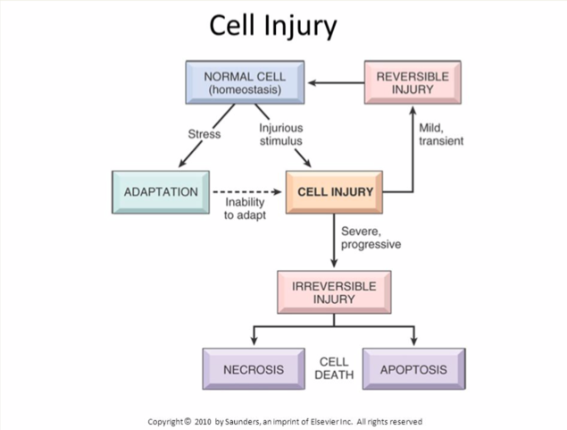
Cellular adaptation is the ability of cells to respond to various types of stimuli and adverse environmental changes. These adaptations include hypertrophy (enlargement of individual cells), hyperplasia (increase in cell number), atrophy (reduction in size and cell number), metaplasia (transformation from one type of epithelium to another), and dysplasia (disordered growth of cells). Tissues adapt differently depending on the replicative characteristics of the cells that make up the tissue. For example, labile tissue such as the skin can rapidly replicate, and therefore can also regenerate after injury, whereas permanent tissue such as neural and cardiac tissue cannot regenerate after injury. If cells are not able to adapt to the adverse environmental changes, cell death occurs physiologically in the form of apoptosis, or pathologically, in the form of necrosis. This learning card provides an overview of the main cellular adaptive mechanisms and their different consequences in the human body.

