1. Single Phase Half-Wave Controlled Rectifier
The single phase half-wave controlled rectifier is a rectifier circuit that converts AC input into DC output ONLY for the positive half cycle of the AC input supply. It is “controlled” in the sense that the starting point of the load current can be changed by controlling the firing angle of the rectifier.
A single phase half-wave controlled rectifier circuit consists of a thyristor, an AC voltage source and load. A simple circuit diagram of a single phase half-wave controlled rectifier is shown in the figure below.
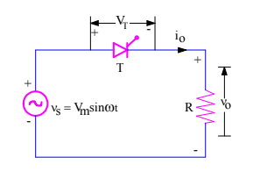
Figure 1: Single Phase Half-Wave Controlled Rectifier
v₀ = Load output voltage
i₀ = Load current
V_{T} = Voltage across the thyristor T

2. Single Phase Full-Wave Controlled Rectifier Using A Centre Tapped Transformer
When an additional wire is connected exactly across the middle of the secondary windings of a transformer, it is known as a centre tapped transformer. The full-wave rectifier circuit unlike the half-wave uses two diodes. A diagram of a single phase full-wave controlled rectifier using a centre-tapped transformer is shown in Figure 2. The centre-tap is usually taken as the ground or zero voltage reference point.
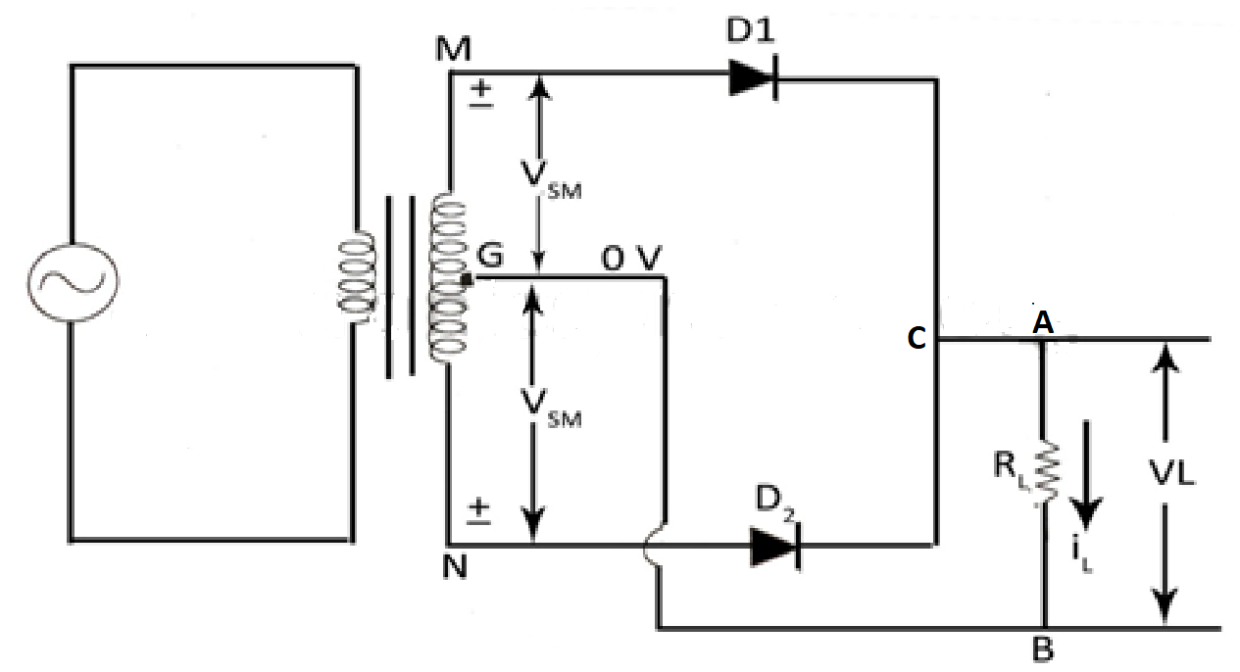
Figure 2: Single Phase Full-Wave Controlled Rectifier Using A Centre Tapped Transformer
During the positive half-cycle of the ac input, terminal M is +ve, G is at zero potential and N is at –ve potential. Hence, being forward-biased, diode D₁ conducts and current flows along MD₁CABG. As a result, positive half-cycle of the voltage appears across R_{L}.
During the negative half-cycle, when the terminal N becomes +ve, only D₂ conducts and current flows along ND₂CABG. So, we find that the current keeps on flowing through R_{L} in the same direction (i.e. from A to B) in both half-cycles of ac input. Also, the frequency of the rectified output voltage is twice the supply frequency.

3. Single phase Full wave Rectifier (Semi -converter Bridge configuration)
In a single-phase full wave semi-controlled bridge converter, two of the bridge arm thyristors are diodes. A third, freewheeling, diode is normally used to prevent the load current from circulating through two devices in a bridge arm. The input AC source is then relieved from supplying the lagging component of the load current. The absence of this lagging component of the source current implies that this converter operates with a higher power factor than the fully controlled converter.

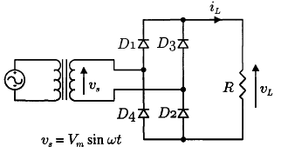
Figure 3: Single-Phase Full Wave Semi-Controlled Bridge Converter

4. Three Phase Full Wave Rectifier (Semi-Converter Bridge Configuration)
The 3-phase full-wave bridge rectifier uses two diodes per phase and requires just three mains lines, without neutral, such as that provided by a delta connected supply.
Another advantage of a full-wave bridge rectifier is that the load current is well balanced across the bridge improving efficiency (the ratio of output DC power to input power supplied) and reducing the ripple content, both in amplitude and frequency, as compared to the half-wave configuration.
By increasing the number of phases and diodes within the bridge configuration it is possible to obtain a higher average DC output voltage with less ripple amplitude.

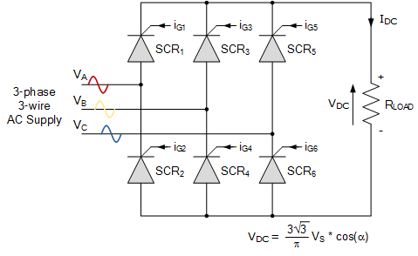
Figure 4: Three-Phase Full Wave Semi-Controlled Bridge Converter

5. Single Phase Full Wave Rectifier (Full Converter Bridge Configuration)
Single phase fully-controlled bridge rectifiers are known more commonly as AC-to-DC converters. Fully-controlled bridge converters are widely used in the speed control of DC machines and can be easily obtained by replacing all four diodes of a bridge rectifier with thyristors as shown in Figure 4.
In the fully-controlled rectifier configuration, the average DC load voltage is controlled using two thyristors per half-cycle. Thyristors SCR₁ and SCR₄ are fired together as a pair during the positive half-cycle, while thyristors SCR₃ and SCR₄ are also fired together as a pair during the negative half-cycle. That is 180º after SCR₁ and SCR₄.
Then during continuous conduction mode of operation the four thyristors are constantly being switched as alternate pairs to maintain the average or equivalent DC output voltage.

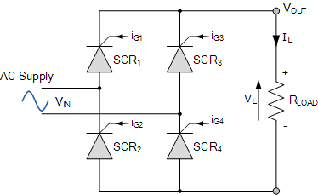
Figure 5: Single Phase Full-Wave Fully-Controlled Bridge Rectifier

6. Three Phase Full Wave Rectifier (Full Converter Bridge Configuration)
The 3 phase fully controlled converter is a fully controlled bridge rectifier using six thyristors connected in the form of a full wave bridge configuration. All the six thyristors are controlled switches which are turned on at appropriate times by applying suitable gate trigger signals.
The three phase full converter is extensively used in industrial power applications up to about 120kW output power level, where two quadrant operations are required.
Figure 5 shows a three phase full converter with highly inductive load.
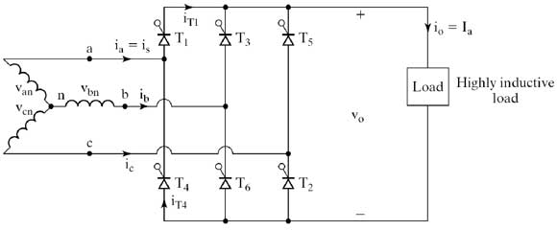
Figure 6: Three Phase Full Converter with Highly Inductive Load
7. Single Phase Half Wave Uncontrolled Rectifier
This is the simplest and the most widely used rectifier circuit albeit at relatively small power levels. The output voltage and current of this rectifier are strongly influenced by the type of the load. The switching device is diode which is turned on and off by the electrical circuit only, therefore it called uncontrolled rectifier.
Figure 7: Single Phase Half Wave Uncontrolled Rectifier
8. Single Phase Full Wave Uncontrolled Rectifier
In full wave rectifiers we can obtain output voltage during the positive and negative half cycles. Therefore it delivers improved efficiency compared to the half wave rectifiers. It produces an output voltage that is purely DC. For the full wave rectifiers the average direct current output voltage is higher than that of half wave, the output of the full wave rectifier has much less ripple than that of the half wave rectifier producing a smoother output waveform.
In a single phase full wave uncontrolled Rectifier circuit two diodes are used. Only one diode will be forward biased and conducts during each half cycle.
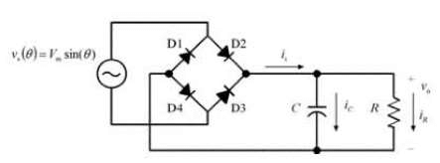
Figure 8: Single Phase Full Wave Uncontrolled Rectifier
9. Single Phase Full Wave Uncontrolled Rectifier Using Centre Tapped Transformer
When an additional wire is connected across the exact middle of the secondary winding of a transformer, it is known as a center tapped transformer.
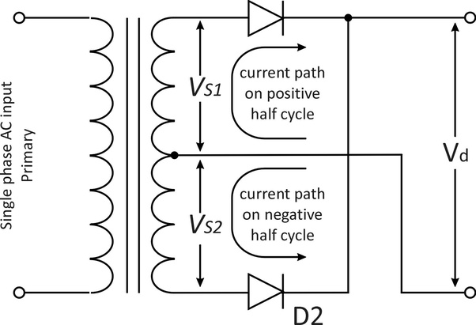
Figure 9: Single Phase Full Wave Uncontrolled Rectifier Using Centre Tapped Transformer
10. Single Phase Full Wave Uncontrolled Rectifier Using Bridge Configuration
This bridge configuration of diodes provides full-wave rectification because at any time two of the four diodes are forward biased while the other two are reverse biased. Thus there are two diodes in the conduction path instead of the single one for the half-wave rectifier. Therefore there will be a difference in voltage amplitude between V_{IN} and V_{OUT} due to the two forward voltage drops of the serially connected diodes. A circuit diagram is shown in Figure 8
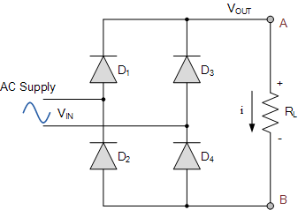
Figure 10: Single Phase Full Wave Uncontrolled Rectifier Using Bridge Configuration

11. Three Phase Full Wave Uncontrolled Rectifier Using The Bridge Configuration.
The full-wave three-phase uncontrolled bridge rectifier circuit uses six diodes, two per phase in a similar fashion to the single-phase bridge rectifier. A 3-phase full-wave rectifier is obtained by using two half-wave rectifier circuits. The advantage here is that the circuit produces a lower ripple output than the previous half-wave 3-phase rectifier as it has a frequency of six times the input AC waveform.
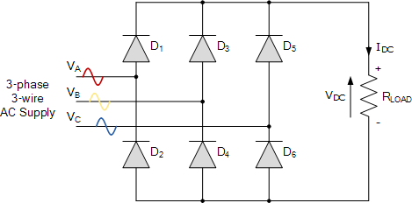
Figure 11: Three Phase Full Wave Uncontrolled Rectifier Using The Bridge Configuration.
Diodes D₁ D₃ D₂ and D₄ form a bridge rectifier network between phases A and B, similarly diodes D₃ D₅ D₄ and D₆ between phases B and C and D₅ D₁ D₆ and D₂ between phases C and A.
Thus diodes D₁ D₃ and D₅ feed the positive rail and depending on which one has a more positive voltage at its anode terminal conducts. Likewise, diodes D₂ D₄ and D₆ feed the negative rail and whichever diode has a more negative voltage at its cathode terminal conducts.
Then we can see that for three-phase rectification, the diodes conduct in matching pairs giving a conduction pattern for the load current of: D₁₋₂ D₁₋₆ D₃₋₆ D₃₋₆ D₃₋₄ D₅₋₄ D₅₋₂ and D₁₋₂ as shown.

