NAME: OLORUNTOBA OLAJUBU
MATRIC NO.: 15/ENG05/019
COURSE: MCT 510 (POWER ELECTRONICS AND DRIVERS)
DEPT.: MECHATRONICS ENGINEERING

ASSIGNMENT
Using a suitable circuit diagram explain the following:
- Single Phase Half Wave Controlled Rectifier:
A Single Phase Half Wave Controlled Rectifier circuit consists of SCR / thyristor, an AC voltage source and load. The load may be purely resistive, Inductive or a combination of resistance and inductance. For simplicity, we will consider a resistive load. A simple circuit diagram of Single Phase Half Wave Controlled Rectifier is shown in figure below.
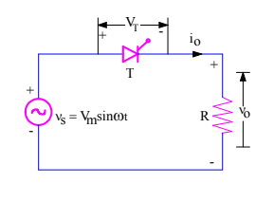
Fig 1.
v₀ = Load output voltage
i₀ = Load current
V_{T} = Voltage across the thyristor T

- Single Phase Full Wave Controlled Rectifier using a center tapped transformer:
For the center – tapped transformer rectifier, SCR1 is forward biased when Vs is positive, and SCR2 is forward –biased when Vs is negative, but each will not conduct until it receives a gate signal. The delay angle is the angle interval between the forward biasing of the SCR and the gate signal application. If the delay angle is zero, the rectifiers behave exactly as uncontrolled rectifiers with diodes.

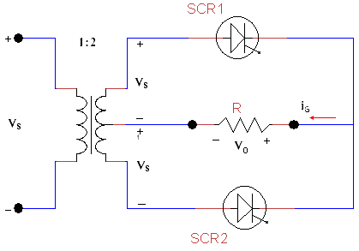
Fig 2.
- Single Phase Full Wave Rectifier (Semi – converter bridge configuration):
In a single-phase, half-controlled bridge converter, two of the bridge arm thyristors are diodes. A third, freewheeling, diode is normally used to prevent the load current from circulating through two devices in a bridge arm. Note that the output voltage for this converter can not become negative, because whenever it tends to do so, the load current commutates to the freewheeling diode and the output voltage becomes zero. The input AC source is then relieved from supplying the lagging component of the load current. The absence of this lagging component of the source current implies that this converter operates with a higher power factor than the fully controlled converter.
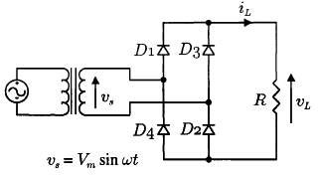
Fig 3.
- Three phase full wave Rectifier (semi-converter Bridge configuration):
Three-phase rectification is the process of converting a 3-phase AC supply into a pulsating DC voltage as rectification converts the input power supply of a sinusoidal voltage and frequency into a fixed voltage DC power. Thus power rectification changes an alternating supply into a unidirectional supply.
But we have also seen that 3-phase half-wave uncontrolled rectifiers, which use one diode per phase, require a star connected supply as a fourth neutral (N) wire to close the circuit from load to source. The 3-phase full-wave bridge rectifier which use two diodes per phase requires just three mains lines, without neutral, such as that provided by a delta connected supply.
Another advantage of a full-wave bridge rectifier is that the load current is well balanced across the bridge improving efficiency (the ratio of output DC power to input power supplied) and reducing the ripple content, both in amplitude and frequency, as compared to the half-wave configuration.
By increasing the number of phases and diodes within the bridge configuration it is possible to obtain a higher average DC output voltage with less ripple amplitude as for example, in 6-phase rectification each diode would conduct for only one-sixth of a cycle
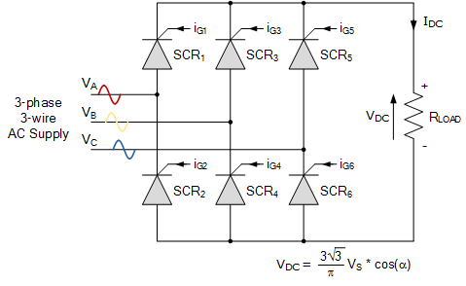
Fig 4.
- Single phase full wave Rectifier (Full converter Bridge configuration):
Single phase fully-controlled bridge rectifiers are known more commonly as AC-to-DC converters. Fully-controlled bridge converters are widely used in the speed control of DC machines and are easily obtained by replacing all four diodes of a bridge rectifier with thyristors as shown.
In the fully-controlled rectifier configuration, the average DC load voltage is controlled using two thyristors per half-cycle. Thyristors SCR1 and SCR4 are fired together as a pair during the positive half-cycle, while thyristors SCR3 and SCR4 are also fired together as a pair during the negative half-cycle. That is 180o after SCR1 and SCR4. Then during continuous conduction mode of operation the four thyristors are constantly being switched as alternate pairs to maintain the average or equivalent DC output voltage.
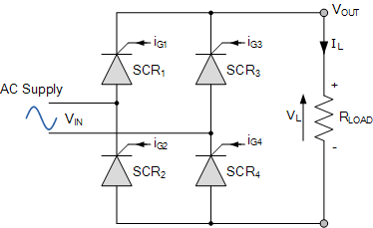
Fig 5.
- Three phase full wave Rectifier (Full converter bridge configuration):
Three phase full converter is a fully controlled bridge controlled rectifier using six thyristors connected in the form of a full wave bridge configuration. All the six thyristors are controlled switches which are turned on at a appropriate times by applying suitable gate trigger signals.
The three phase full converter is extensively used in industrial power applications upto about 120kW output power level, where two quadrant operations is required.
The figure shows a three phase full converter with highly inductive load. This circuit is also known as three phase full wave bridge or as a six pulse converter.
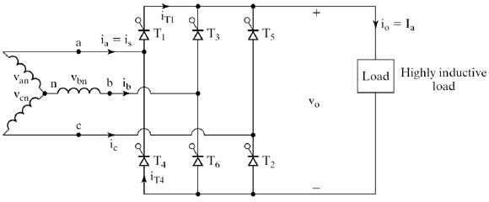
Fig 6.
- Single phase half wave uncontrolled Rectifier:
The single-phase half-wave uncontrolled rectifier is the simplest possible rectifier arrangement. It has little practical use, but serves as an introduction to the subject. The switching device is diode which is turned on and off by the electrical circuit only, therefore it called uncontrolled rectifier.
The single-phase half-wave rectifier configuration below passes the positive half of the AC supply waveform with the negative half being eliminated. By reversing the direction of the diode we can pass negative halves and eliminate the positive halves of the AC waveform. Therefore the output will be a series of positive or negative pulses.
Thus there is no voltage or current applied to the connected load, R_{L} for half of each cycle. In other words, the voltage across the load resistance, R_{L} consists of only half waveforms, either positive or negative, as it operates during only one-half of the input cycle, hence the name of half-wave rectifier.
The diode allows current to flow in one direction only producing an output which consists of half-cycles. This pulsating output waveform not only varies ON and OFF every cycle, but is only present 50% of the time and with a purely resistive load, this high voltage and current ripple content is at its maximum.
This pulsating DC means that the equivalent DC value dropped across the load resistor, R_{L} is therefore only one half of the sinusoidal waveforms average value. Since the maximum value of the waveforms sine function is 1 ( sin(90º) ), the Average or Mean DC value taken over one-half of a sinusoid is defined as: 0.637 x maximum amplitude value.
So during the positive half-cycle, A_{AVE} equals 0.637*A_{MAX}. However as the negative half-cycles are removed due to rectification by the diode, the average value during this period will be zero as shown

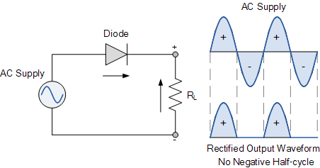
Fig 7.
- Single phase full wave uncontrolled Rectifier:
The working & operation of a full wave bridge rectifier is pretty simple. The circuit diagrams and waveforms we have given below will help you understand the operation of a bridge rectifier perfectly. In the circuit diagram, 4 diodes are arranged in the form of a bridge. The transformer secondary is connected to two diametrically opposite points of the bridge at points A & C. The load resistance R_{L} is connected to bridge through points B and D.
During the first half cycle of the input voltage, the upper end of the transformer secondary winding is positive with respect to the lower end. Thus during the first half cycle diodes D1 and D₃ are forward biased and current flows through arm AB, enters the load resistance R_{L}, and returns back flowing through arm DC. During this half of each input cycle, the diodes D₂ and D₄ are reverse biased and current is not allowed to flow in arms AD and BC. The flow of current is indicated by solid arrows in the figure above. We have developed another diagram below to help you understand the current flow quickly. See the diagram below – the green arrows indicate the beginning of current flow from the source (transformer secondary) to the load resistance. The red arrows indicate the return path of current from load resistance to the source, thus completing the circuit.
During the second half cycle of the input voltage, the lower end of the transformer secondary winding is positive with respect to the upper end. Thus diodes D₂ and D₄ become forward biased and current flows through arm CB, enters the load resistance R_{L}, and returns back to the source flowing through arm DA. The flow of current has been shown by dotted arrows in the figure. Thus the direction of flow of current through the load resistance R_{L} remains the same during both half cycles of the input supply voltage. See the diagram below – the green arrows indicate the beginning of current flow from the source (transformer secondary) to the load resistance. The red arrows indicate the return path of current from load resistance to the source, thus completing the circuit.
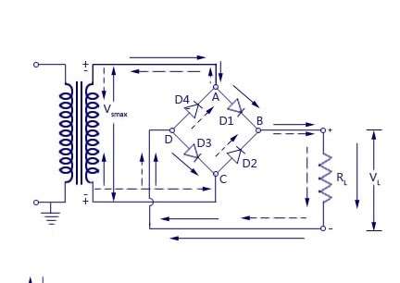
Fig 8.
- Single phase full wave uncontrolled Rectifier using center tapped transformer:
Single phase full wave uncontrolled Rectifier using center tapped transformer also known as center tapped full wave rectifier is a type of rectifier which uses a center tapped transformer and two diodes to convert the complete AC signal into DC signal. The center tapped full wave rectifier is made up of an AC source, a center tapped transformer, two diodes, and a load resistor. The AC source is connected to the primary winding of the center tapped transformer. A center tap (additional wire) connected at the exact middle of the the secondary winding divides the input voltage into two parts.
The upper part of the secondary winding is connected to the diode D₁ and the lower part of the secondary winding is connected to the diode D₂. Both diode D₁ and diode D₂ are connected to a common load R_{L} with the help of a center tap transformer. The center tap is generally considered as the ground point or the zero voltage reference point.
The center tapped full wave rectifier uses a center tapped transformer to convert the input AC voltage into output DC voltage. When input AC voltage is applied, the secondary winding of the center tapped transformer divides this input AC voltage into two parts: positive and negative.
During the positive half cycle of the input AC signal, terminal A become positive, terminal B become negative and center tap is grounded (zero volts). The positive terminal A is connected to the p-side of the diode D₁ and the negative terminal B is connected to the n-side of the diode D₁. So the diode D₁ is forward biased during the positive half cycle and allows electric current through it. The negative terminal B is connected to the p-side of the diode D₂ and the positive terminal A is connected to the n-side of the diode D₂. So the diode D₂ is reverse biased during the positive half cycle and does not allow electric current through it. Thus, the diode D₁ allows electric current during the positive half cycle and diode D₂ allows electric current during the negative half cycle of the input AC signal. As a result, both half cycles (positive and negative) of the input AC signal are allowed. So the output DC voltage is almost equal to the input AC voltage. The average output DC voltage across the load resistor is double that of the single half wave rectifier circuit.
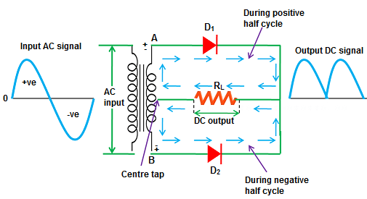
Fig 9.

- Single phase full wave uncontrolled Rectifier using bridge configuration:
The working & operation of a full wave bridge rectifier is pretty simple. The circuit diagrams and waveforms we have given below will help you understand the operation of a bridge rectifier perfectly. In the circuit diagram, 4 diodes are arranged in the form of a bridge. The transformer secondary is connected to two diametrically opposite points of the bridge at points A & C. The load resistance R_{L} is connected to bridge through points B and D.
During the first half cycle of the input voltage, the upper end of the transformer secondary winding is positive with respect to the lower end. Thus during the first half cycle diodes D1 and D₃ are forward biased and current flows through arm AB, enters the load resistance R_{L}, and returns back flowing through arm DC. During this half of each input cycle, the diodes D₂ and D₄ are reverse biased and current is not allowed to flow in arms AD and BC. The flow of current is indicated by solid arrows in the figure above. We have developed another diagram below to help you understand the current flow quickly. See the diagram below – the green arrows indicate the beginning of current flow from the source (transformer secondary) to the load resistance. The red arrows indicate the return path of current from load resistance to the source, thus completing the circuit.
During the second half cycle of the input voltage, the lower end of the transformer secondary winding is positive with respect to the upper end. Thus diodes D₂ and D₄ become forward biased and current flows through arm CB, enters the load resistance R_{L}, and returns back to the source flowing through arm DA. The flow of current has been shown by dotted arrows in the figure. Thus the direction of flow of current through the load resistance R_{L} remains the same during both half cycles of the input supply voltage. See the diagram below – the green arrows indicate the beginning of current flow from the source (transformer secondary) to the load resistance. The red arrows indicate the return path of current from load resistance to the source, thus completing the circuit.
Fig 10.
- Three phase full wave uncontrolled Rectifier using the bridge configuration:
The full-wave three-phase uncontrolled bridge rectifier circuit uses six diodes, two per phase in a similar fashion to the single-phase bridge rectifier. A 3-phase full-wave rectifier is obtained by using two half-wave rectifier circuits. The advantage here is that the circuit produces a lower ripple output than the previous half-wave 3-phase rectifier as it has a frequency of six times the input AC waveform.
Diodes D₁ D₃ D₂ and D₄ form a bridge rectifier network between phases A and B, similarly diodes D₃ D₅ D₄ and D₆ between phases B and C and D₅ D₁ D₆ and D₂ between phases C and A.
Thus diodes D₁ D₃ and D₅ feed the positive rail and depending on which one has a more positive voltage at its anode terminal conducts. Likewise, diodes D₂ D₄ and D₆ feed the negative rail and whichever diode has a more negative voltage at its cathode terminal conducts. Then we can see that for three-phase rectification, the diodes conduct in matching pairs giving a conduction pattern for the load current of: D₁₋₂ D₁₋₆ D₃₋₆ D₃₋₆ D₃₋₄ D₅₋₄ D₅₋₂ and D₁₋₂ as shown.
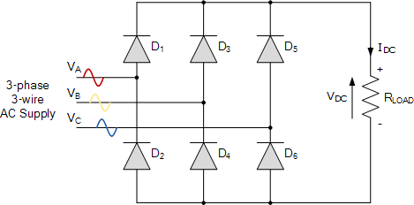
Fig 11.

