NAME: BOBOLA PRAISE IFEOLUWA
MATRIC NO: 18/MHS02/200.
DIAGNOSTIC TECHNIQUE USED IN CELLULAR PATHOLOGY
- CYTOPATHOLOGY
It is a diagnostic technique that examines cells from various body sites to determine the cause or nature of the disease. The first cytopathology test developed was the Pap test, which has been widely utilized in the last 50yrs for screening and diagnosing of cervical cancer and its precursors. The Pap test is considered the most successful screening in medical history. Since the development of the Pap test the practice of cytopathology has expanded to include samples from nearly all body sites. Cell samples are taken for analysis as part of many diagnostic tests such as bronchoscopy or cystoscopy. In addition, nearly any tissue mass can be sampled and diagnosed by fine needle aspiration biopsy. In this procedure, cells are aspirated from the masses just below the skin in the doctor’s office or during a radiologic examination. This approach allows diagnosis of lesion with minimal discomfort to the patient and gives the primary physician the next step in patients follow up. 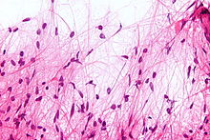
2). HEMATOPATHOLOGY
This is the method by which abnormalities of the cells of the blood and their precursors in the bone marrow are investigated to diagnose the different kinds of anemia and leukemia. Hematopathology serves both the physician and laboratory clients through testing and interpreting results to provide accurate diagnoses and relevant prognosis information. Testes are used to detect a broad gamut of hematologic diseases, including lymphomas, leukemia, plasma cell dyscrasias, hemoglobulinopathies, red blood cell enzyme deficiencies, bleeding diatheses and hypercoagulable states
Laboratories: the six subspecialty laboratories of the division of hematopathology are:
- Cell kinetics: uses multicolor flow cytometry to immunophenotypically MM detect and characterize neoplastic hematolymphoid cells
- Metabolic Hematology: detects abnormal hemoglobin’s (e.g. sickle cell disease), red blood cell enzyme deficiencies (e.g. G-6-PD) and cytoskeletal abnormalities (e.g. hereditary spherocytosis) and also screens for and characterizes thalassemia
- Metabolic Hematopathology: analyzes RNA or DNA to detect and quantify genetic abnormalities useful in the diagnosis and monitoring of hematologic malignancies.
- Hematopathology Morphology: performs complete blood counts (CBC) and analyzes cellular morphology in peripheral blood and some body fluids. The laboratory also performs a wide range of cytochemical stains.
- Special Coagulation: performs testing to aid in the diagnosis and treatment of patients who may have bleeding or clotting disorders.
- Special DNA coagulation concentrates on the identification of genetic abnormalities associated with hereditary bleeding and clotting disorders. 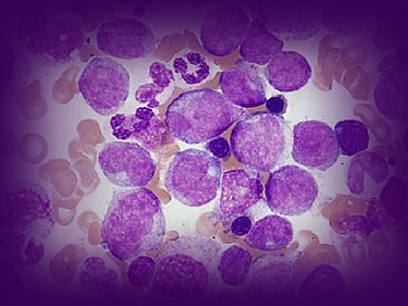
HEMATOLOGY

- HISTOPATHOLOGY
This studies tissue under the microscope. During this study, the pathologist looks for abnormal structures in the tissue. Tissues for histopathological examinations are obtained by biopsy. Biopsy is a tissue sample from a living person to identify the disease. Biopsy can either be incisional or excisional. Once the tissue is removed from the patient, it has to be immediately fixed by putting into adequate amount of 10% Formaldehyde (10% formalin) before sending it to the pathologist
The purpose of fixation is:
- To prevent autolysis and bacterial decomposition and putrefaction
- To coagulate the tissue to prevent loss of easily diffusible substances
- To fortify the tissue against the deleterious effects of the various stages in the preparation of sections and tissue processing.
- To leave the tissues in a condition, this facilitates differential staining with dyes and other reagents. 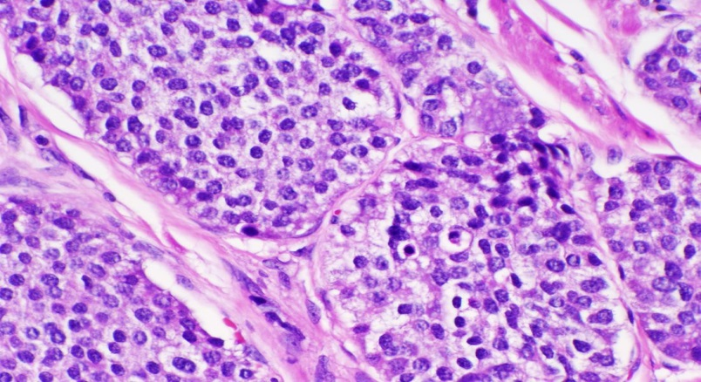
4. BIOCHEMICAL TESTS
Biochemical tests are the test used in identification of bacterial species based on the differences in the biochemical activities of different bacteria. Bacteria physiology differs from one type of organism to another. The ability of bacteria to form organic compounds by metabolizing certain carbohydrates and related compounds is a widely used method for the identification of microorganism. One of such test is the pyruvate broth test which tests for the ability of some specific species to utilize the substrate pyruvate. Objective: to determine the ability of an organism to utilize pyruvate to produce acidic end products. 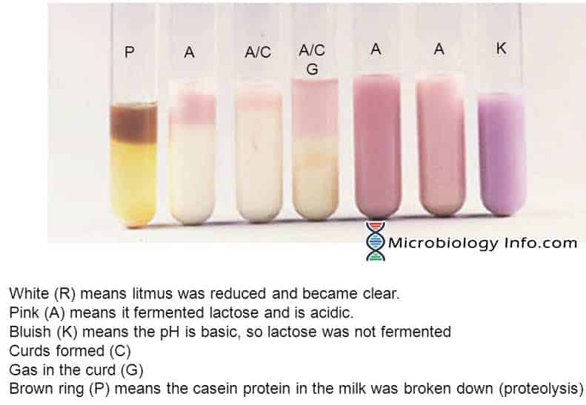
BIOCHEMICAL TEST FOR BACTERIA

5. IMMUNOHISTOCHEMISTRY.
It is the most common application of immunostaining. It involves the process of selectively identifying antigens (proteins) in cells of a tissue section by exploiting the principle of antibodies binding specifically to antigens in biological tissues. Visualizing an antibody-antigen interaction can be accomplished in a number of ways, mainly either of the following
- Chromogenic immunohistochemistry (CIH), wherein an antibody is conjugated to an enzyme, such as peroxidase (the combination being termed immunoperoxidase), that can catalyze a color producing reaction
- Immunofluorescence, where the antibody is tagged to a fluorephore, such as fluorescein or rhodamine.
Immunohistochemical staining is widely used in the diagnosis of abnormal cells such as those found in cancerous tumors. Specific molecular markers are characteristics of particular cellular events such as proliferation or cell death (apoptosis). Immunohistochemisttry is also widely used in basic research to understand the distribution and localization of biomarkers and differentially expressed proteins in different parts of a biological tissue.
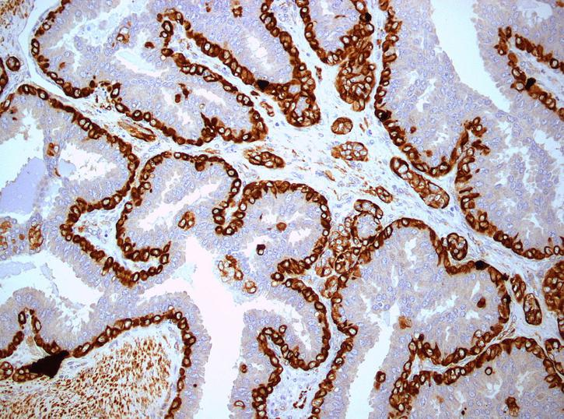

II). Cellular Adaptation Precedes Cell Death Explain.
Cellular adaptation is the ability of cells to respond to various types of stimuli and environmental changes. These adaptations include hypertrophy (enlargement of individual cells), hyperplasia (increase in cell number), atrophy (reduction in size and cell number), metaplasia (transformation from one type of epithelium to another) and dysplasia (disordered growth of cells). Tissues adapt differently depending on the replicative characteristics of the cells that make up the tissue. E.g. labile tissue such as skin can replicate and can also regenerate after injury. If cells are not able to adapt to the adverse environmental changes cell death occurs physiologically in the form of apoptosis, or pathologically in the form of necrosis. 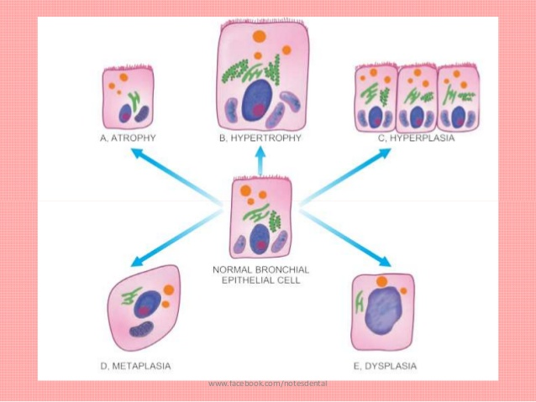
Cell Injury: means cellular damage due to internal and external environmental changes
- Early stages (reversible): results in cellular swelling (e.g. hydropic degeneration). Tissue hypoxia; decreased ATP production. Diffusion of Na and water into the cell passive Ca²⁺ efflux and cellular/mitochondria swelling. Disrupted Ca²⁺ ATPase pump activity active Ca²⁺ removal from the cytoplasm into extracellular space Ca²⁺ accumulates inside the cell and activates degradative enzymes. Low oxygen and ATP result in anaerobic respiration lactate and Decrease intracellular pH. Detachment of ribosomes and polysomes decreased protein synthesis.
- Late stage (irreversible) results in membrane damage and cell death. Mechanism: degradation of phospholipids in the plasma membrane leads to rupture of the cell membrane leads to release of cystolic enzymes into the serum and influx of Ca²⁺ into the cytoplasm leads to activation of lysosomal enzymes and protease(e.g. caplpapin leads to breakdown of cellular proteins and damaged cytoskeleton (autolysis). Rupture of lysosomes and release of lysosomal enzymes, increased in mitochondrial membrane permeability leads to cytochrome release from mitochondria activates apoptosis. Nuclear changes: 1. Pyknosis: shrinkage of the nucleus due to chromatin condensation 2. Karyorrhexis: fragmentation of the nucleus (mediated by endonucleases) 3.Karyolyssis: disintegration or dissolution of the nucleus